Class_10_visuallization_ggplot2

Sajib saha

2025-01-27

# packages

loading required packages

# echo is used to hide the section

# header

## Scatter plot

**relation between the x and y value**

data("iris")

ggplot(data = iris) + geom_point(mapping= aes(x = Sepal.Length, y= Sepal.Width))+  
 labs(title = "scatter plot of the sepal length and sepal width", x = "Sepal Length", y= "sepal widrh")

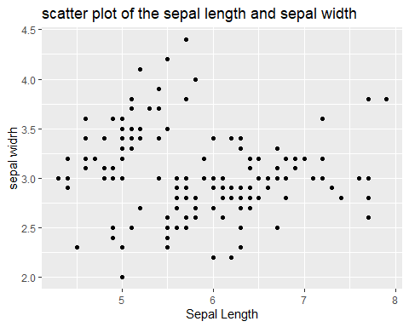

ggplot(data = iris)+  
 aes(x= Sepal.Length, y= Sepal.Width)+  
 geom_point()

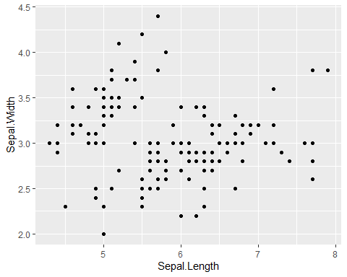

ggplot(data = iris, aes(x=Sepal.Length, y=Sepal.Width))+  
 geom_point(color = "red")

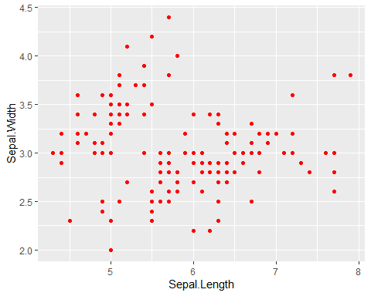

ggplot(data = iris, aes(x=Sepal.Length, y=Sepal.Width))+  
 geom_point(size= 3, col= "blue")

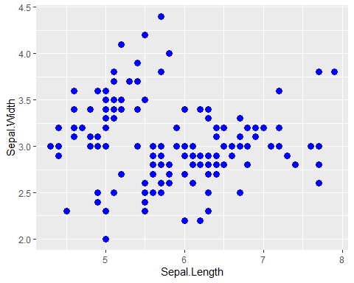

ggplot(data = iris, aes(x=Sepal.Length, y=Sepal.Width))+  
 geom_point(size= 3, shape=18)

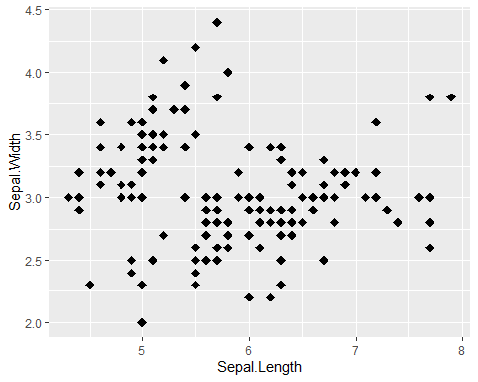

ggplot(data = iris, aes(x=Sepal.Length, y=Sepal.Width))+  
 geom_point(size= 3, shape=18)



ggplot(data = iris, aes(x=Sepal.Length, y=Sepal.Width))+  
 geom_point(size= 3, shape="diamond filled", col= "blue")

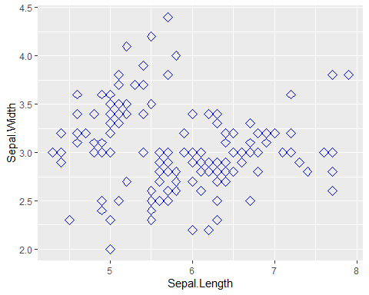

ggplot(data = iris, aes(x=Sepal.Length, y=Sepal.Width,col= Species))+  
 geom_point()

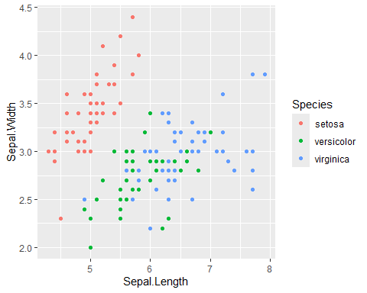

ggplot(data = iris, aes(x=Sepal.Length, y=Sepal.Width,col= Species))+  
 geom_point()+  
 labs(title = "scatter plot of the sepal length and sepal width", x = "Sepal", y= "sepal widrh")

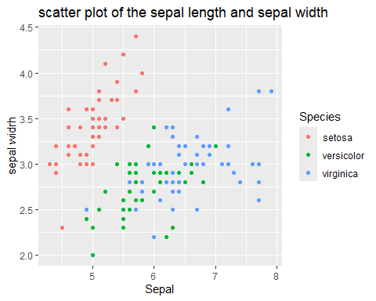 #Histogram

ggplot(data = iris, aes(x= Sepal.Length))+  
 geom_histogram(binwidth =.3, fill= "lightgreen", col="black")

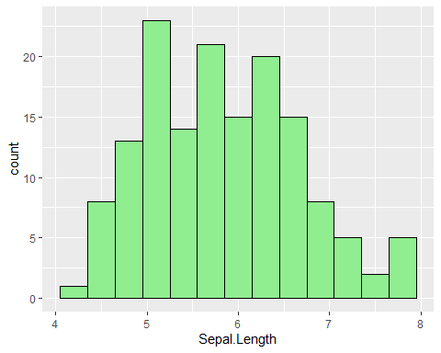

ggplot(data = iris, aes(x= Sepal.Length))+  
 geom_histogram(bins =15, fill= "lightgreen", col="black")

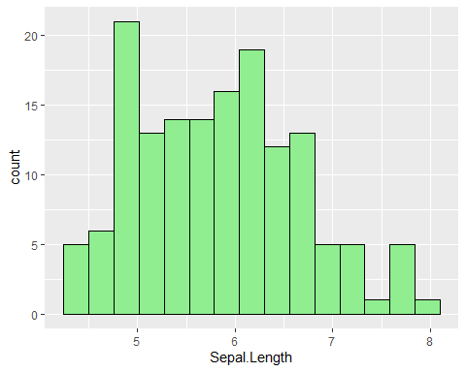

ggplot(data = iris, aes(x= Sepal.Length,fill= Species))+  
 geom_histogram(binwidth =.3, col="black")

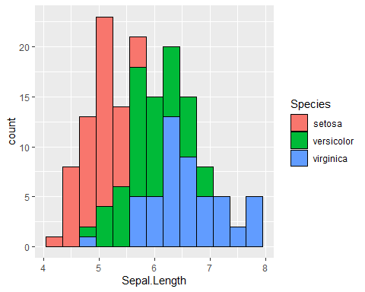

ggplot(data = iris, aes(x= Sepal.Length,fill= Species))+  
 geom_histogram(binwidth =.3, col="black", alpha= .5)

