Signature

|  |  |  |  |
| --- | --- | --- | --- |
| Nazmus Shakib Riad [1607096]  Sajib Talukder [1607114] | |  |  | | --- | --- | |  | **System Development Project**  CSE 3200 |   Under Supervision of:  Shaikh Akib Shahriyar  Department of Computer Science and Engineering,  Khulna University of Engineering & Technology |

Acknowledgment

With the blessings of Almighty, we are able to do our project successfully. We express our heartiest gratitude to Almighty for this.

We are thankful and greateful to our project supervisor **Shaikh Akib Shahriyar**, Lecturer , Department of Computer Science and Engineering, KUET, for his heartiest support and excellent advices. Without his support our project may not have reached as accepted. His inspiration and advices helped us to implement different ideas and work with these ideas throughout this project.

Index

|  |  |
| --- | --- |
| 1. Introduction | 4 |
| 1. Methodlogy | 5 |
| 1. Implementation | 6 |
| 1. Result Analysis | 7 |
| 1. Discussion | 8 |
| 1. Conclusion | 9 |
| 1. Limitations | 10 |
| 1. Future Plan | 18 |
| 1. References | 20 |

Introduction

**HR Monitor** or **Heart Rate Monitor** is a noncontact based heart rate monitoring system by using this one can check or monitor his own heart rate in real time by only sitting infront of webcam of his laptop .

When the heart beats, blood is pumped around the body causing a momentary change in skin colour. This is not visible to the human-eye but surprisingly it is visible to the camera or webcam. Using simple signal processing techniques, the frequency at which the colour of the skin changes, and thus the heart-rate can be extracted and monitored completely non-invasive.

Heart Rate (HR) is one of the most important Physiological parameter and a vital indicator of people’s physiological state and is therefore important to monitor. Monitoring of HR often involves high costs and complex application of sensors and sensor systems. Research progressing during last decade focuses more on noncontact based systems which are simple, low-cost and comfortable to use. Still most of the noncontact based systems are fit for lab environments in offline situation but needs to progress considerably before they can be applied in real time applications.

The non-contact physiological parameters monitoring idea has come from the cardiovascular system of human body. The cardiovascular system permits blood to circulate in the body due to continuous blood pumping by heart. Our Heart pumps blood through the blood vessels of this system and for each heart beat blood circulation creates color variation in Facial skin. Therefore, it is possible to extract HR from the color variation of the facial skin .

In 1995, the first noncontact health monitoring system was investigated by Costa et al. [1]. They used camera images in order to extract physiological parameters using color variation of the skin. But their approaches did not report quantitative results; they reported only a graph of heartbeats and also failed to show any correlation with reference ECG signals. After this first attempt further progress was moderate and in 2005 another novel method was introduced for the measurement of computer user’s emotional state using the facial thermal image using a thermal camera [2]. The experiment was conducted by 12 users and the authors found some interesting fact between stress and blood flow . In 2006, Takano et al. shows that RR (Respiratory Rate), HR and BVP are possible to extract simultaneously using a camera [3]. They captured images of a part of the subject’s skin and then the changes in the average image brightness of the region of interest (ROI) are measured for a short time. Later in 2007, Garbey et al. developed a contact-free measurement of cardiac pulse based on the analysis of thermal images using FFT algorithm . The noncontact methods using camera further improved in the same year by Kenneth et al . A novel method was presented by Banitsas et al. in 2009 which is able to extract HR information from a user using the camera of a smart phone using user’s finger . The most successful noncontact based physiological parameters extraction system has been proposed by Rahman et al. in 2015 [3]. They have developed a simple laptop web camera based method to detect HR, RR and IBI (inter bit interval). The results show about 90% accuracy for physiological parameters extraction using this system. This paper presents a noncontact HR monitoring system in real time for unlimited amount of time using a web camera .

Methodology

Heart Rate Monitor uses webcam to check the pulse of the human using face recognition. The program tries to find the face of a human. When it succeeds it selects the forehead and lower half of the face. Next program uses RGB separation, RGB component calculation, colour average matrix preprocessing, independent component analysis and signal filtering to find the pulse of the human. If the human moves away from the center of the camera, the camera tries to rotate to catch the face of the human and measure the heart rate.

FFT have been applied to extract HR in real time using only facial video. The average of the R, G and B signals were calculated by FFT method .

The main features of the proposed method is 3 independent signals which are called Red signals, Green signals and Blue signals and these signals were produced from the red, blue and green color values of each pixel of all the facial image frames.

**Finding the Face:**

The first task faced by the program is to work out where the face is in its field of view. Many techniques exist for quickly finding faces in pictures, these are often so good that cheap digital cameras with little on board processing power can find faces in the frame in real-time. In particular we have used a function provided by the computer vision library OpenCV.

Once the face is found we simply select a square of skin on the forehead as it is a convenient and large area of just skin.

**Color of Skin:**

Human eye has an impressive amount of 'spatial' resolution. That is, you can make out distinct shapes that are very small. What most people don't realise is that the human eye has remarkably limited poor 'chromatic' resolution, that is, we're not very good at seeing colours. As it happens this is something webcams are comparatively very good at. So good in fact that they can detect the colour of skin changing with heart beats.

Based on the section of forehead found in the previous step, the average colour of this patch of skin is used. Webcams give us this colour in a form known as "RGB" format. That is, the amount of red, green and blue light which when mixed together make that colour[1](http://jhnet.co.uk/projects/heart_monitor#fn:rgb). Of these three colours, it is the amount of green which changes the most when the heart beats and so in our program we only look at this number.

**Finding the Pulse:**

The next challenge is to work out the heart rate by watching how the amount of green in the picture changes over time. In signal-processing terminology we want to turn information in the time-domain, that is, how the green changes over time, into the frequency domain: the frequency at which the colour is changing. This is a surprisingly tricky task but luckily a technique known as the Fast Fourier Transform or FFT can be used to quickly do exactly this.

The FFT sadly doesn't just give us the heart-beat without a fight. Though the colour of the skin changes due to the heart rate it also changes due to other factors such as the changing light in a room and the low-quality in the webcam picture. These other factors also contribute to the way that the skin changes colour over time. As a result, the FFT also picks out the frequencies at which these change too. To filter out these extraneous frequencies my program simply ignores "impossible" frequencies at which no heart-rate would ever beat.

Implementation :

Mainly we have used python and it’s different kinds of modules to develop or implement this project . Used modules and their actions is given below,

**OpenCV** : we have used Open CV to read image data through the camera . By Using the Open CV we detect the face in real time and the rectangle shape for the forehead and take data from the forehead.

**Numpy** : In numpy images are represented as rectangular arrays of individually-colored square pixels, and that the color of each pixel can be represented as an RGB triplet of numbers. The rectangular shape of the array corresponds to the shape of the image, although the order of the coordinates are reversed.

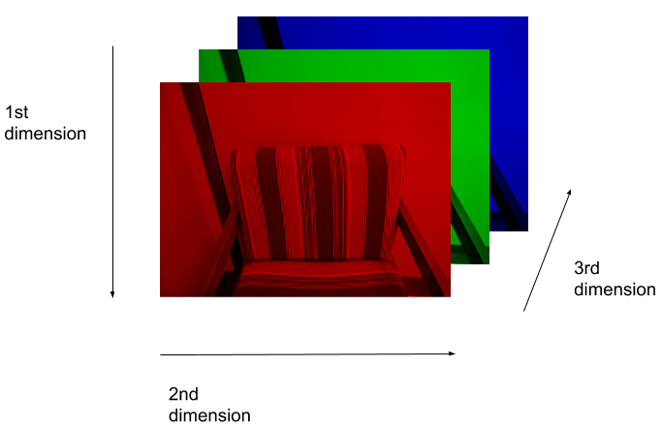

A visual representation of how this image is stored as a NumPy array

**Matplotlib**: As Matplotlib provides an object-oriented API for embedding plots into applications using general-purpose . It is used on those cases where Axis, Figure, Plots) are similar like matlab axis,figure,plots.

**PyPlot**: Pyplot is a shell like interface which is used to make the result easier for plot.

**Pylab**: The combination of Pyplot and NumPy is Pylab which is used to plot the users data in real time on the application.

Github Rep. link : <https://github.com/SajibTalukder2k16/HR-Monitor>

**Implementation of this project is given below step by step**:

This application uses OpenCV to find the location of the user's face, then isolate the forehead region. Data is collected from this location over time to estimate the user's heart rate. This is done by measuring average optical intensity in the forehead location, in the subimage's green channel alone ,a better color mixing ratio may exist, but the blue channel tends to be very noisy.

With good lighting and minimal noise due to motion, a stable heartbeat should be isolated in about 10 seconds. Other physiological waveforms should also be visible in the raw data stream.

Once the user's heart rate has been estimated, real-time phase variation associated with this frequency is also computed. This allows for the heartbeat to be exaggerated in the post-process frame rendering, causing the highlighted forehead location to pulse in sync with the user's own heartbeat.

The dataflow is given below.

**The overall dataflow/execution order for the real-time signal processing looks like:**

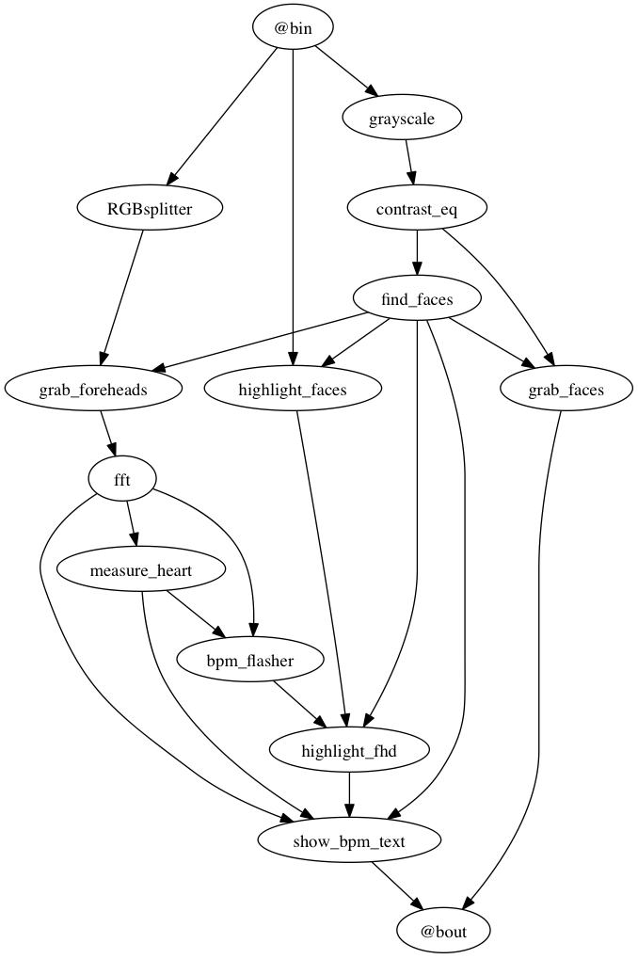

Result Analysis:

Discussion:

A real time noncontact based HR extraction method is implemented in this project using web camera which is easy to implement, low cost and comfortable for real time applications. Here, the main idea is to extract HR from the color variation in the facial skin due to cardiac pulse and the implementation has been done using a simple webcam in indoor environment with constant ambient light . This non-contact technology is promising for medical care and others indoor applications due to widespread availability of camera specially webcams. For applications in outdoor environment for example driver monitoring, few things such as variable environmental illumination or head movement should be considered. Also to increase the efficiency, the experiment needs to be done by more test subjects and more verifying systems. Although this project only addressed the recovery of the cardiac HR, many other important physiological parameters such as, RR, HRV and arterial blood oxygen saturation can potentially be estimated using the proposed technique. However , the project is successfully done.

Conclusion:

**HR Monitor** or **Heart Rate Monitor** is a noncontact based heart rate monitoring system by using this one can check or monitor his own heart rate in real time by only sitting infront of webcam of his laptop . One can monitor on the plot option of this application . He/She can also check how the pulse frequencies changes in real time .

Limitations :

In our project, we have only work with single face and work with it’s data . Muliple people can’t monitor their pulse with this current project . Multiple face detection , simultaneously individuals in a single camera's image stream and give output for everyone is definitely possible, but at the moment only the information from one face is extracted due to short time .

Future Plan :

We have planned to develop this project by adding multiple face detection , work with these data simultaneously and give output accurately . As well as we have thought to make an android version of this application . Moreover , we have thought to make a phone lock system by using this application , As far we know the changes of pulse frequencies is unique. It can also be used for uniquely identification .

References:

1. G. D. Costa, "Optical remote sensing of heartbeats," Optics Communications, vol. 117, pp. 395-398, 6/15/ 1995
2. C. Puri, J. Levine, L. Olson, I. Pavlidis, and J. Starren, "StressCam: Non-contact Measurement of Users’ Emotional States through Thermal Imaging," presented at the Extended Abstracts Proceedings of the 2005 Conference on Human Factors in Computing Systems, CHI 2005, Portland, Oregon, USA, 2005.
3. H. Rahman, M. U. Ahmed, and S. Begum, "Noncontact Physiological Parameters Extraction using Camera," in The 1st Workshop on Embedded Sensor Systems for Health through Internet of Things (ESS-H IoT), Oct., 2015.
4. H. Rahman, M. U. Ahmed, P. Funk and S. Begum Real Time Heart Rate Monitoring from Facial RGB Color Video Using Webcam in The 29th Annual Workshop of the Swedish Artificial Intelligence Society (SAIS 2016), At Malmö.
5. <https://devpost.com/software/webcam-heart-rate-monitor>
6. <https://medium.com/@neurodatalab/every-beat-counts-comparing-remote-heart-rate-webcam-detector-to-wearables-d8d59aab863c>
7. <http://jhnet.co.uk/projects/heart_monitor>
8. <https://datacarpentry.org/image-processing/aio/index.html>
9. <https://github.com/thearn/webcam-pulse-detector>