**Number: 1**

Write a program to display the following output using single cout statement.

Maths = 90

Physics = 77

Chemistry =69

**Source Code:**

#include<iostream>

using namespace std;

int main ()

{

cout <<"Maths=90\n"<<"Physics=77\n"<<"Chemistry=69";

return 0;

}

**Output:**

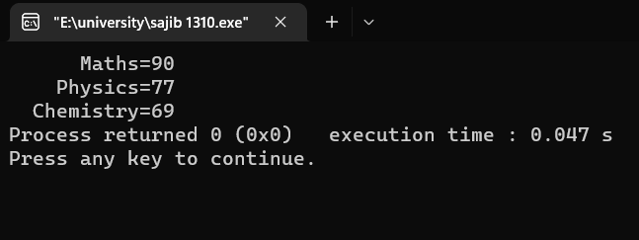

**Number: 2**

Write a program to read two numbers from the keyboard and display the larger value on the screen.

**Source Code:**

#include<iostream>

using namespace std;

int main ()

{

int a,b;

cout<<"Enter a:";

cin>>a;

cout<<"Enter b:";

cin>>b;

if (a>b)

{

cout<<"a is larger";

}

else

cout<<"b is larger";

return 0;

}

**Output:**

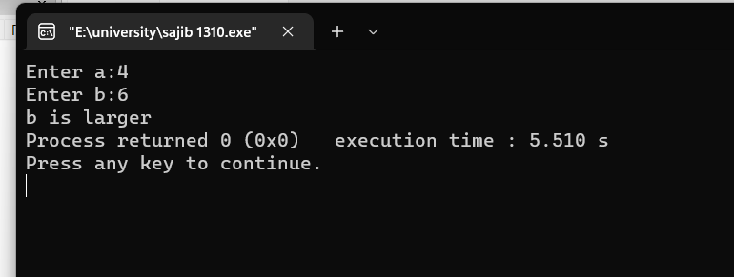

**Number: 3**

Write a program that inputs a character from keyboard and display its corresponding ASCII value on the screen.

**Source Code:**

#include <iostream>

using namespace std;

int main() {

char c;

cout << "Enter a character: ";

cin >> c;

cout << "ASCII Value of " << c << " is " << int(c);

return 0;

}

**Output:**

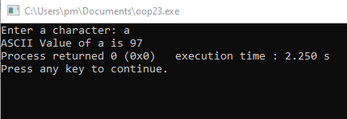

**Number: 4**

Write a program to read the value of a, b and c and display the value of x, where

X = a/b – c

**Source Code:**

#include<iostream>

using namespace std;

int main ()

{

int a,b,c;

float x;

cout<<"Enter three number:\n";

cin>>a>>b>>c;

x= a / b - c;

cout<<x;

return 0;

}

**Output:**

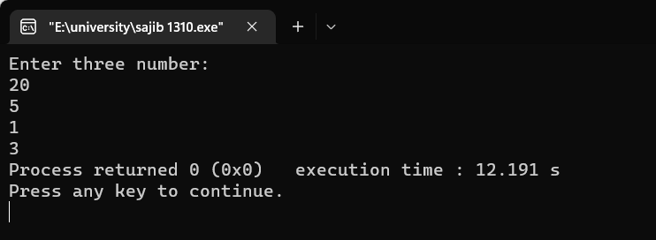

**Number: 5**

Write a C ++ program that will ask for a temperature in Fahrenheit and display it in Celsius.

**Source Code:**

#include <iostream>

using namespace std;

int main() {

float f, c;

cout << "Enter the temperature in fahrenheit\n";

cin >> f;

c = 5 * (f - 32) / 9;

cout << f <<" Fahrenheit is equal to " << c <<" Centigrade";

return 0;

}

**Output:**

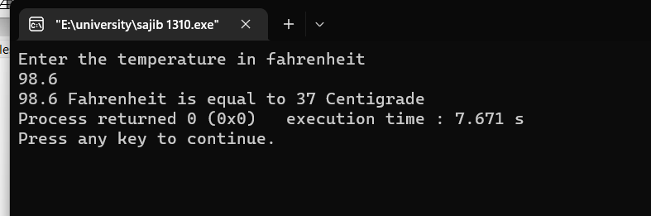

**Number: 6**

Write a program in C++ that will ask for temperature in Fahrenheit and display it in Celsius, (using a class called temp and member functions.)

**Source Code:**

#include <iostream>

using namespace std;

class Temp

{ private:

double fahrenheit;

public:

Temp(){

fahrenheit = 0;

}

void setFahrenheit(double f){

fahrenheit = f; }

double getFahrenheit(){

return fahrenheit; }

double getCelsius(){

return (fahrenheit - 32) * 5/9; }

};

int main()

{

double tempF;

cout << "Enter temperature in Fahrenheit: ";

cin >> tempF;

Temp temp;

temp.setFahrenheit(tempF);

cout << "Temperature in Celsius is: " << temp.getCelsius() << endl;

return 0;

}

**Output:**

