# Analysis of Trends in Anime

## 1. Top 10 Genres Overall

This bar chart provides a holistic view of the overall popularity of genres across all anime types. The chart ranks the genres based on their total count.  
  
Key Observations:  
- Comedy is the most prevalent genre by a significant margin, followed by Action and Adventure.  
- Fantasy and Sci-Fi are moderately popular, appealing to audiences with an interest in imaginative and futuristic themes.  
- Shounen, a genre targeted at young male audiences, holds a strong position.  
- Romance and School genres cater to specific niches but maintain steady popularity.

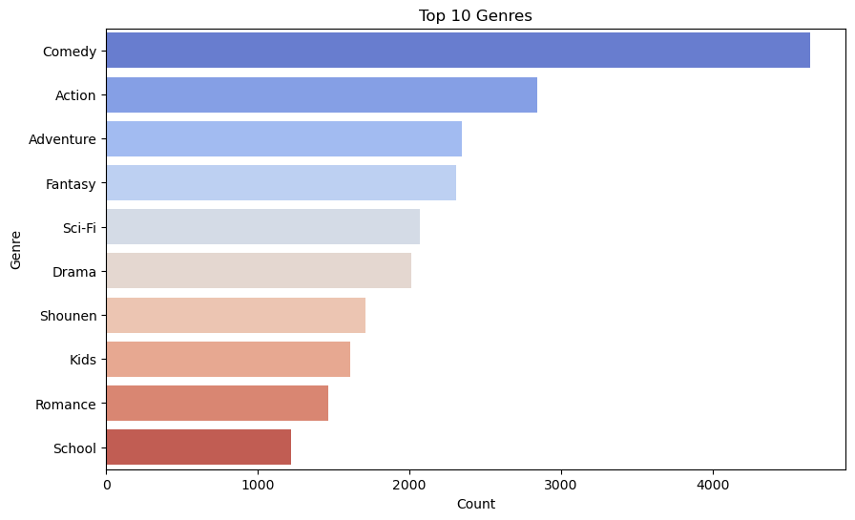

## 2. Top 10 Genre Co-occurrence Heatmap

This heatmap explores the co-occurrence of genres, showing how frequently different genres appear together in anime.  
  
Key Observations:  
- Action frequently co-occurs with Adventure, indicating a strong correlation between these two genres.  
- Comedy often pairs with Romance and School, reflecting its versatility.  
- Sci-Fi and Shounen also show high co-occurrence with Action and Adventure, suggesting overlap in audience preferences.  
- The heatmap highlights complementary genre combinations that could guide content recommendations or development.

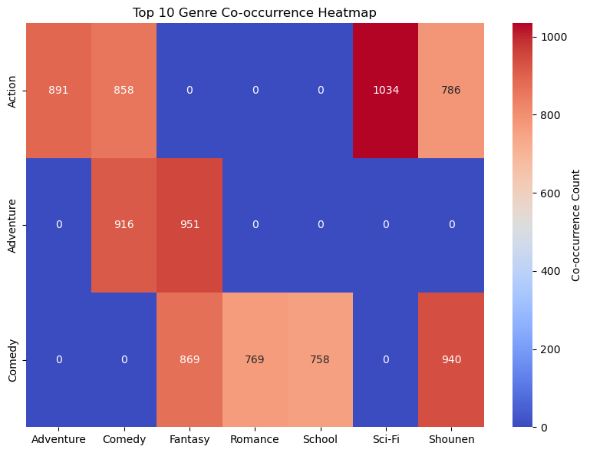

## 3. Top 5 Genres by Type

This visualization provides an in-depth analysis of the top 5 genres for various types of anime content, including TV shows, Specials, OVAs, ONAs, Music, and Movies. The bar charts reveal the genre distribution across these categories.  
  
Key Observations:  
- Comedy is the dominant genre across most types, with a particularly strong presence in TV and Movies.  
- Action and Adventure also show significant popularity, especially in TV and OVAs.  
- OVAs have a unique genre dominance with Hentai being a significant contributor.  
- The Music category is dominated by its namesake genre, followed by Kids and Fantasy.

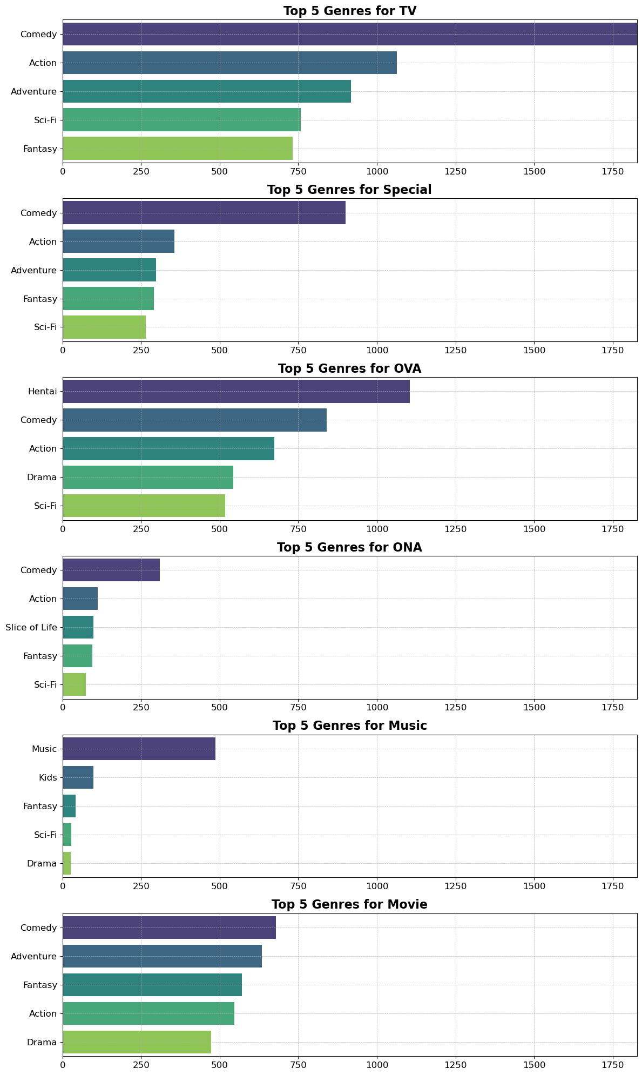

## 4. Top 5 Anime with the Highest Scores

This bar chart visualizes the top 5 anime with the highest individual scores. Each bar represents an anime title and its corresponding score.

Key Observations:  
 - All scores are at the maximum level of 10.  
 - The titles range from popular movies like "Kimi no Na wa." to lesser-known series such as "Taka no Tsume 8: Yoshida-kun no X-Files."  
 - Such charts help highlight excellence in terms of viewer ratings.

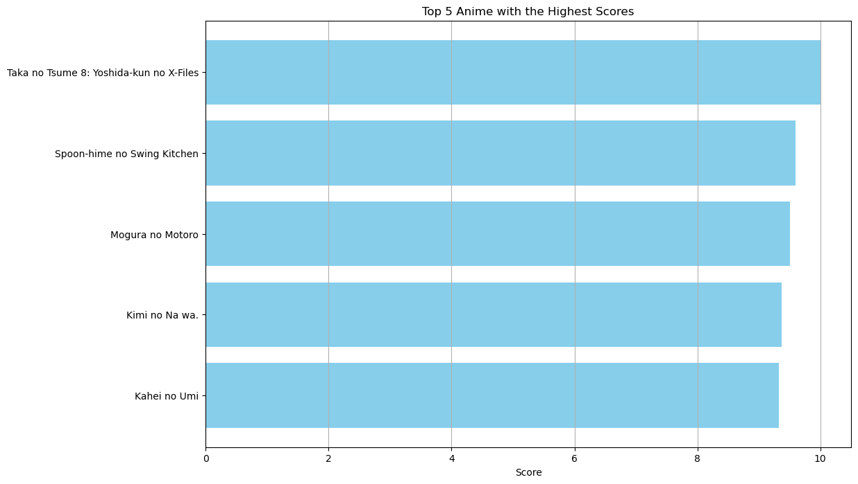

## 5. Top 10 Anime by Sum of Ratings

This horizontal bar chart showcases the top 10 anime ranked by the sum of all ratings they received.

Key Observations:  
 - "Death Note" leads by a significant margin, followed by other popular titles like "Shingeki no Kyojin" and "Code Geass: Hangyaku no Lelouch."  
 - This metric highlights the overall popularity of anime across a large audience base.  
 - Useful for understanding mainstream popularity in the anime community.

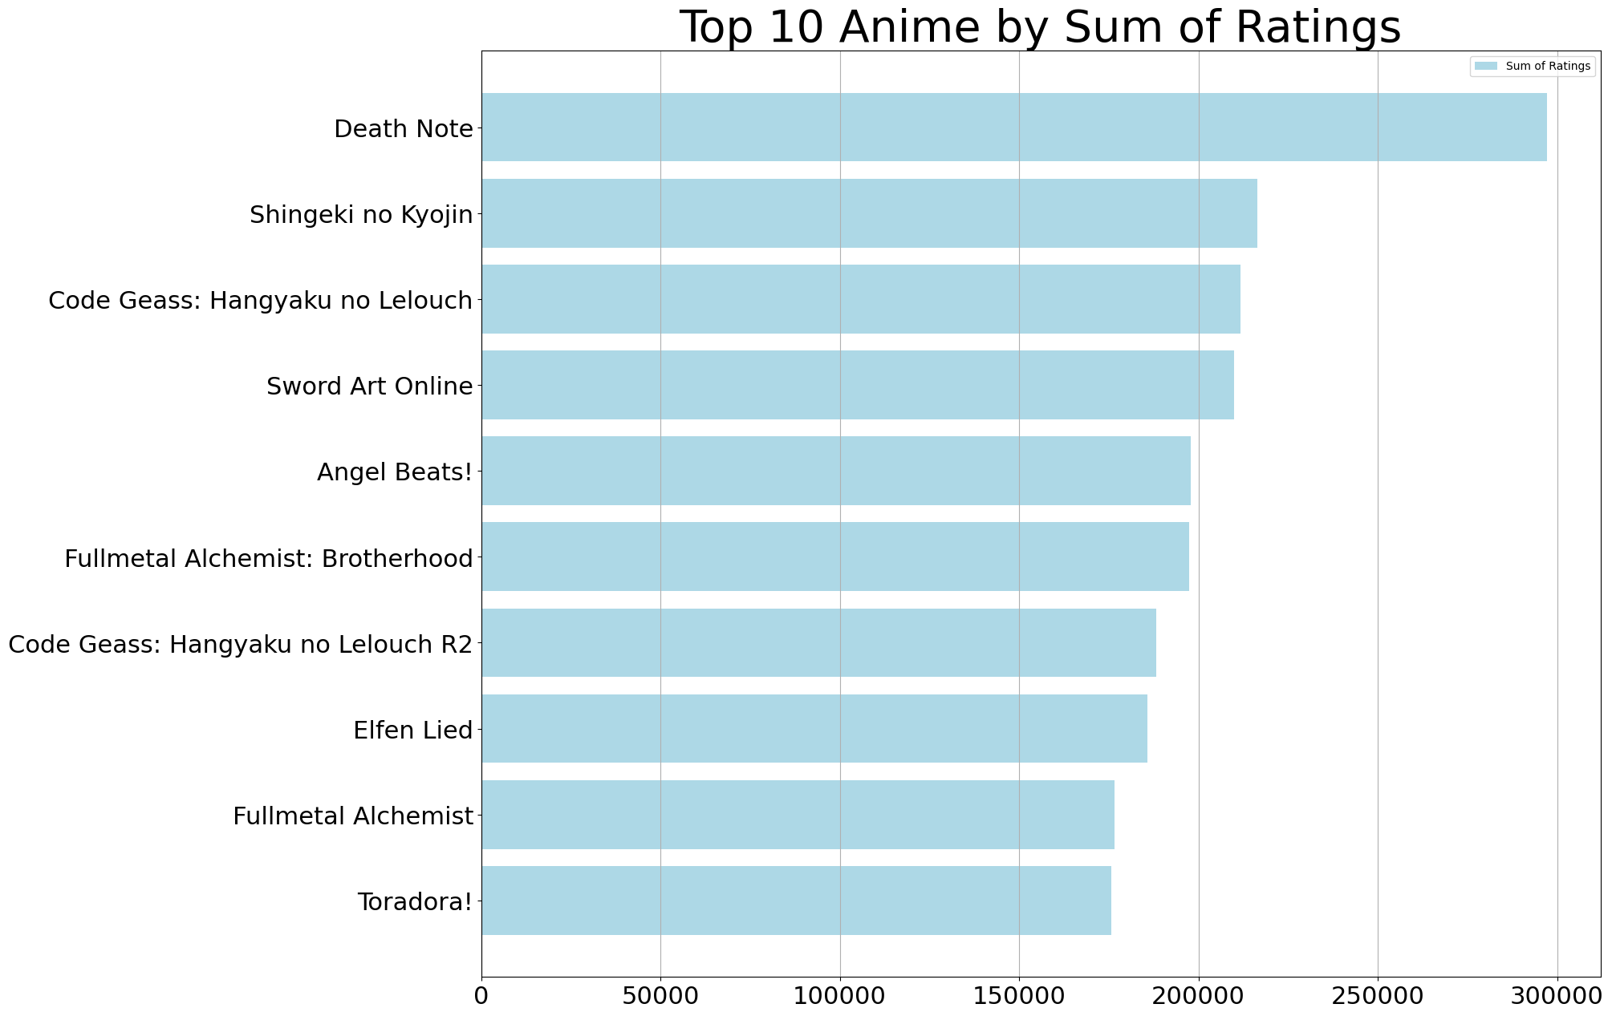

## 6. Top 10 Anime by Average of Ratings

This horizontal bar chart displays the top 10 anime based on the average of ratings from viewers.

Key Observations:  
 - Anime such as "Choegang Top Plate" and "Warui no wo Taose!! Salaryman Man" lead with the highest average ratings.  
 - The uniformity in high average ratings suggests this anime are universally well-received.  
 - Ideal for analyzing how anime performs over various user demographics.

