# Comprehensive Analysis Report

## Frequency of Trips by Purpose

Overview  
This bar chart presents a breakdown of trip frequencies based on their purpose. The data reveals that meetings are the most common reason for trips, followed by meals/entertainment and errands/supplies. Customer visits, temporary site visits, and trips between offices have significantly lower frequencies.  
  
Key Observations  
- Meeting Dominance: Meetings constitute the highest proportion of trips, accounting for 81 instances. This suggests that meetings are a core activity requiring travel.  
- Meal/Entertainment: Ranking second with 64 trips, this could indicate business lunches, dinners, or other social events related to work.  
- Errands/Supplies: Contributing to 47 trips, this highlights the necessity of physical procurement or deliveries.  
- Customer Visits: Responsible for 46 trips, emphasizing the importance of face-to-face client interactions.  
- Temporary Site Visits: These account for 14 trips, likely related to project inspections or site assessments.  
- Between Offices: The least frequent with only 9 instances, possibly due to remote work practices or efficient internal communication.  
  
Recommendations  
1. Meeting Optimization: Consolidate or transition some meetings to virtual formats.  
2. Remote Work Exploration: Promote remote work policies to reduce inter-office trips.  
3. Local Procurement: Implement strategies for local procurement to minimize supply trips.

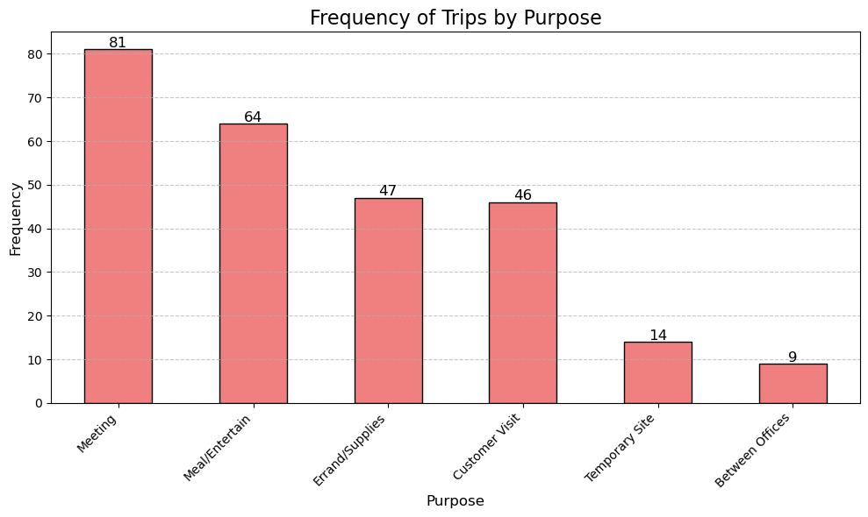

## Miles vs Duration Correlation

Overview  
This scatter plot examines the relationship between the distance traveled (miles) and the duration of trips (minutes). The plot reveals a positive correlation, indicating longer distances generally correspond to longer trip durations.  
  
Key Observations  
- Positive Correlation: Longer distances correspond to increased durations.  
- Linear Relationship: The data follows an approximately linear trend.  
- Outliers: A few deviations suggest unusual circumstances like severe traffic or detours.  
  
Recommendations  
1. Further Analysis: Examine additional factors like traffic conditions, mode of transportation, and time of day.  
2. Statistical Modeling: Quantify this relationship for better predictive capabilities.  
3. Visualization Enhancements: Use density plots or heatmaps for deeper insights.

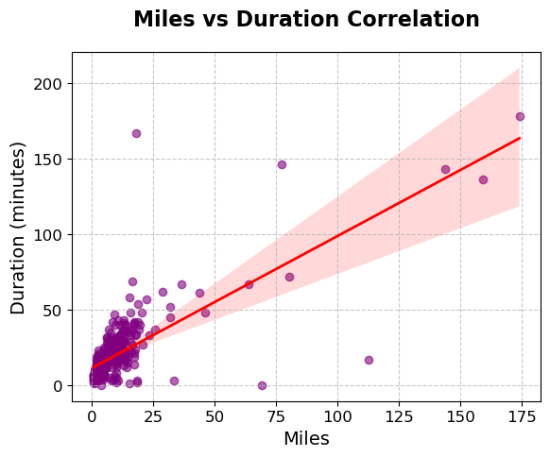

## Top 10 Routes by Average Miles

Overview  
This bar chart presents the top 10 routes based on their average distance. The data reveals significant variations, with some routes exceeding 150 miles while others hover around 50 miles.  
  
Key Observations  
- Long-Distance Dominance: The top three routes exceed 150 miles.  
- Regional Clusters: Shorter routes are clustered within specific geographic areas, like Florida.  
  
Recommendations  
1. Data Completeness: Address any missing information.  
2. Geographic Analysis: Map these routes for visual insights.  
3. Comparative Analysis: Benchmark against similar routes in other regions.

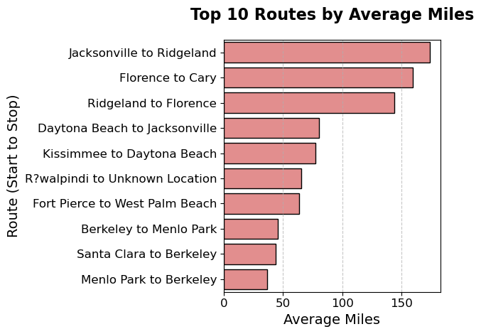

## Top 10 Start and Stop Locations

Overview  
This visualization showcases the most frequent origins and destinations for trips.  
  
Key Observations  
- Regional Hubs: Cary, Morrisville, and Whitebridge dominate starting and stopping locations.  
- Commuter Traffic: Cities like Raleigh and Durham highlight strong commuter patterns.  
  
Recommendations  
1. Geographic Mapping: Visualize trip origins and destinations spatially.  
2. Data Quality Improvements: Address unknown locations.  
3. Time-Based Trends: Explore temporal variations.

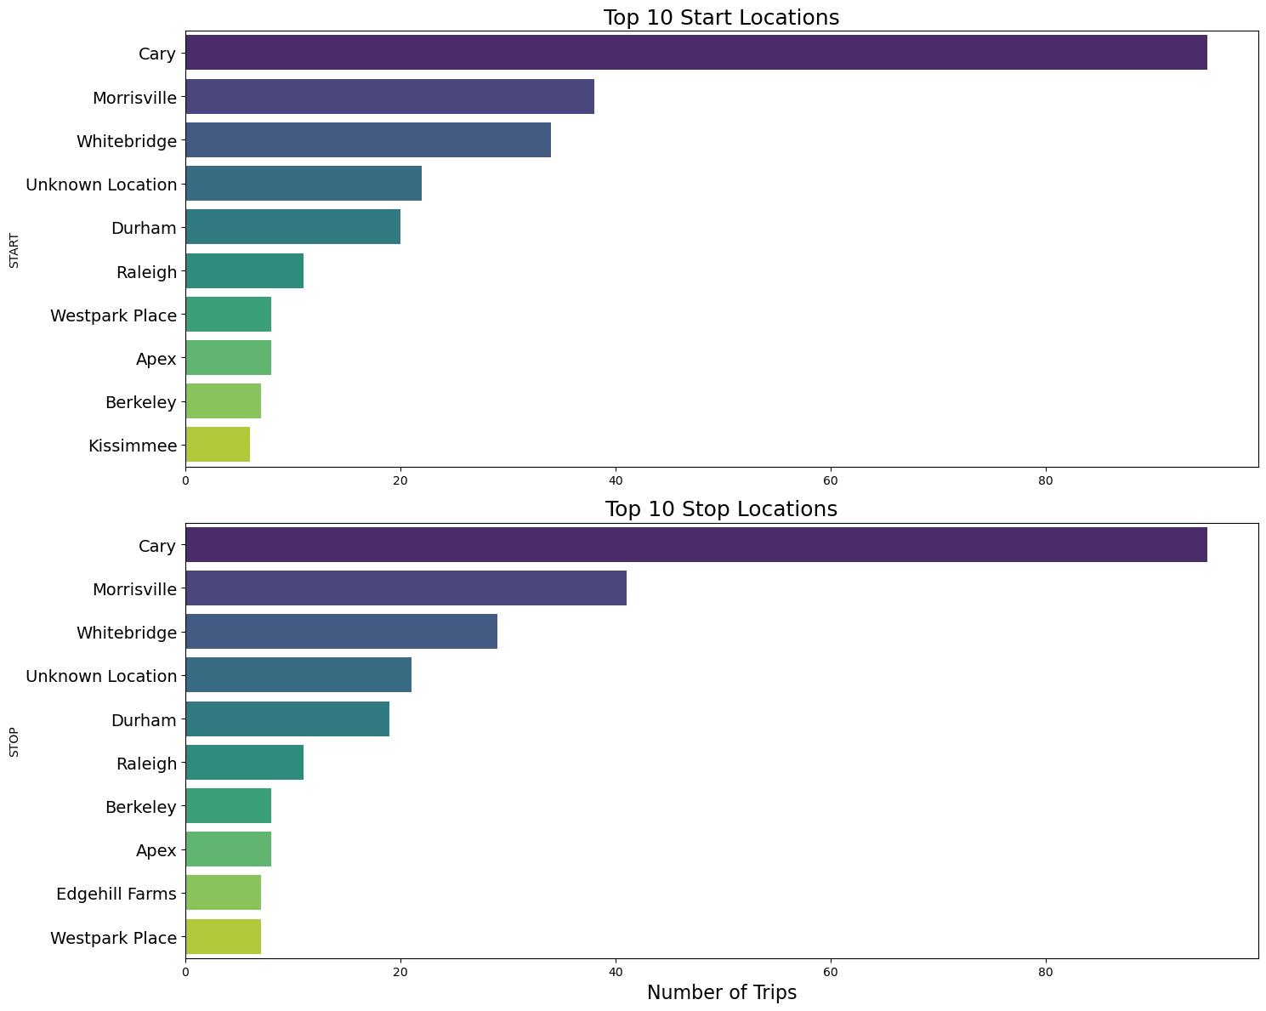

## Monthly Statistics Summary: Total Trips vs Total Miles

Overview  
This visualization compares total trips and total miles over 12 months. It uses a bar chart for trips and a heatmap for miles.  
  
Key Observations  
- Seasonality: Peak trips occur in November, with the highest mileage in April.  
- Discrepancies: Some months exhibit high mileage but fewer trips, indicating longer average trip lengths.  
  
Recommendations  
1. Seasonal Analysis: Dive deeper into the factors driving these seasonal trends.  
2. Time Series Modeling: Model trends to predict future patterns.  
3. Contextual Analysis: Incorporate additional data like weather or holidays.

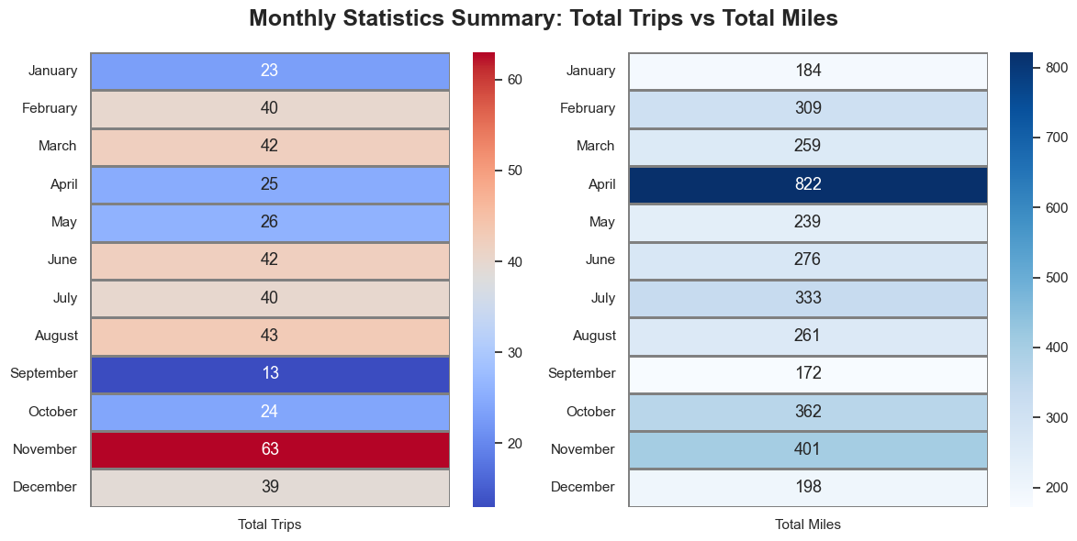

## Most Popular Destinations by Month

Overview  
This bar chart highlights the most frequently visited destinations by month.  
  
Key Observations  
- Seasonality: Peaks in December and troughs in May-July.  
- Dominant Destinations: Cary, Fort Pierce, and Berkeley are consistently popular.  
  
Recommendations  
1. Event Analysis: Identify events influencing travel spikes.  
2. Geographic Distribution: Map destinations for regional insights.  
3. Time Series Analysis: Examine monthly trends in detail.

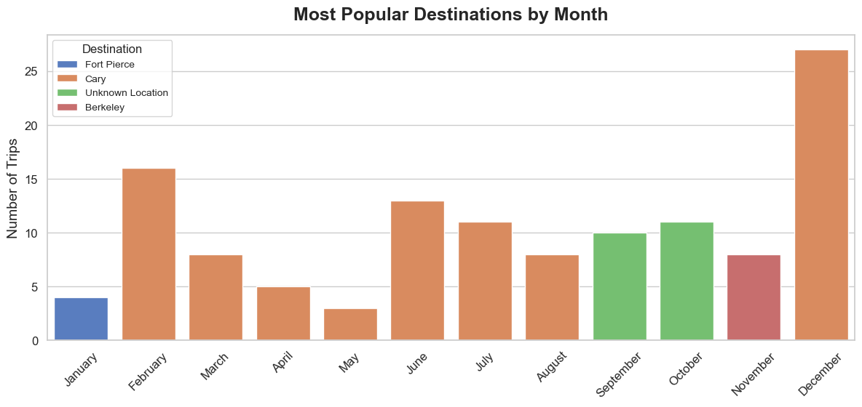

## Top 5 Trip Purposes Distribution by Month

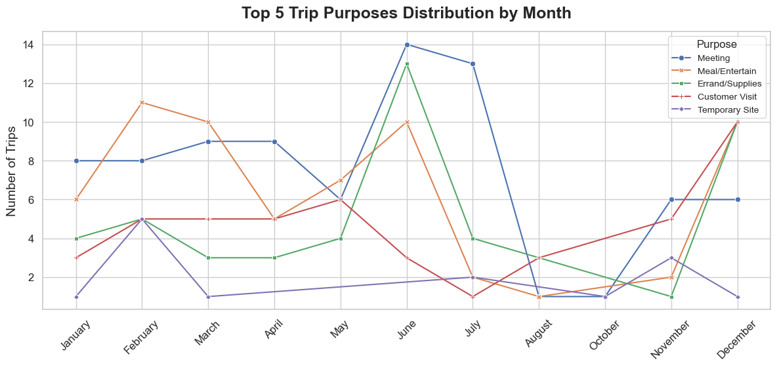  
Overview  
This line chart visualizes the seasonal trends in trip purposes across the year.  
  
Key Observations  
- Meeting Consistency: Meetings are the dominant trip purpose year-round.  
- Emerging Trends: Increases in customer visits and site visits in later months.  
  
Recommendations  
1. Seasonal Analysis: Investigate reasons behind peaks and troughs.  
2. Business Trends: Analyze how business cycles impact travel.  
3. Policy Adjustments: Adjust travel policies based on observed patterns.

## Conclusion

This comprehensive analysis highlights distinct travel patterns across various metrics. Organizations can optimize operations, enhance efficiency, and make data-driven decisions by implementing the outlined recommendations.  
  
Note:  
Leave designated spaces to attach each graph adjacent to its respective analysis.