1.Are the HTML tags and elements the same thing?

ANS:- The html tags are building blocks of HTML page.they

Tell the browser how it should display content to the user.

opening tag: <tag name>

closing tag :</tagname>

Html element includes a start tag,content,and an end tag.

<p>this is an element</p>

2.What are tags and attributes in html?

ANS:- the <html>tag represent the root of an html document.

tag:<a></a>

the tag is a way of representing an HTML elementin the

program,while an attribute is way of describing the

Characteristics of an html element.

the html attributes provide additional information about html elements.

all html tag can have attributes.

attributes are alwayes specified in start tag.

for ex:-<a href="type link">

“Href” attribute is used for link.

<img src="type image> “src attribute is used for image.

3.what are void elements in html?

Ans:-The <br>,<hr> btag defines a line break, and is an empty element without a closing tag

HTML elements with no content are called empty element

4.What are HTML Entities?

Ans:-the entities in html must be replaced with biography entities.

Some characters are reserved in HTML. If you use the less than (<) or greater than

(>) signs in your text, the browser might mix them with tags.

Character entities are used to display reserved characters in HTML.

Symbols that are not present on your keyboard can also be added by using entities

entities type:-&entity_name;

&#entity_number;

entities look like:-@ & reg

C &copy right

£ &pound

5.What are different types of lists in HTML?

Ans:-There are three types of list in html

1 unordered list(ul)

2 ordered list(ol)

3 description list(dl)

1.unordered list(ul)

<ul>

<li>coffee</li>

<li>tea</li>

<li>milk</li>

</ul>

2.ordered list

<ol>

<li>coffee</li>

<li>tea</li>

<li>milk</li>

</ol>

3.description list

<dl>

<dt>name</dt>

<dd> black hot drink</dd>

</dl>

<dt> is define the name

<dd>is define the describe

6. What is the ‘class’ attribute in HTML?

Ans:-The class attribute specifies one or more class names for an element.

The class attribute is mostly used to point to a class in a style sheet.

<h1 class="two">gdyu</h1>

<h1 id="one">hdgwef</h1>

<h1 class="two"></h1>

7. What is the difference between the ‘id’ attribute and the ‘class’ attribute of HTML

elements?

ANS:- HTML id attribute:-the id attribute is a identifier that is used to specify the

document.it is used by CSS to proform a certain task for a unique element.

the id attribute is written using the # symbol followed by id

ex:-<h1 id="one">heading</h1>

in css

#id_name{

property

}

HTML Class attribute:-the class attribut is used to specify one or more class name

for an HTML element. the class attribute can be used on any html element.

the class name in CSS stylesheet using "." symbol.

ex:-<h1 class=" one or more">heading</h1>

in use css: .class{

peoperty

}

difference :- the id is apply to at one element. then class is apply to multiple elements.

8.What are the various formatting tags in HTML?

ans:-the various formatting tag are defining text with a spacial meaning

HTML formatting elements :- <b> - Bold text.

<strong> - Important text.

<i> - Italic text.

<em> - Emphasized text.

<mark> - Marked text.

<small> - Smaller text.

<del> - Deleted text.

<ins> - Inserted text.

9.How is Cell Padding different from Cell Spacing?

ans:-

Cell padding:-the cell padding is space between a two table .and the content present in it.

Cell spacing:- the space present between individual adjacent cells.

**Call padding** **cell spasing** 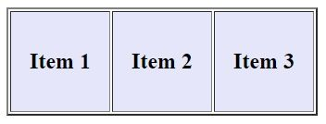 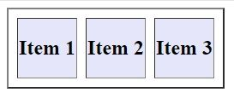

10.How can we club two or more rows or columns into a single row or column in an HTML table?

Ans:- the html two or more table cells in a column using the cols pan attribute in a <td> HTML tag . To merge two or more row cells, use the row span attribute.

Cols pan :- The cols pan attribute defines the number of columns a cell should span.

An html table with a table cell that spans two column. Cols pan tag:-<table>

<td></td>

</table>

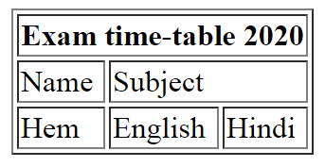

Rowspan:- an html table with a table cell that spans two row

The rowspan attribute spacify the number of rows a shell should span

Rowspan tag:<table><tr></tr></table>

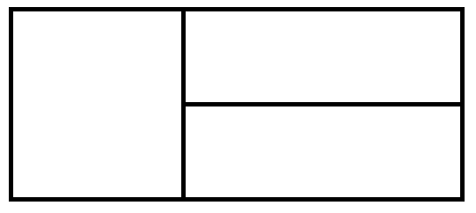

11.What is the difference between a block-level element and an inline element?

Ans:-the block element always start a new line. inline elements never start from a new line.block elements cover space from left to right as far as it can go. inline elements only

cover the space as bounded by the tags in the HTML element. an inline element only takes up as much width as necessary.

Block element:-<p> and <div>

The <p> element defines a paragraph in an HTML document.

The <div> element defines a division or a section in an HTML document.

The <div> element is a block-level and is often used as a container for other HTML

element .

Inline element:- inline element does not start on a new line.

This is a <span> element a paragraph.

The <span> element is an inline container used to mark up a part of a text, or a part of a Document.

12.How to create a Hyperlink in HTML?

Ans:- Links are found in nearly all web pages. Links allow users to click their way

From page to page HTML links are hyperlinks.You can click on a link and jump

to another document.

When you move the mouse over a link, the mouse arrow will turn into a little

hand.

 _self- Default. Opens the document in the same window/tab as it was clicked

_blank- Opens the document in a new windowor tab

_parent- Opens the document in the parent frame

_tops- Opens the document in the full body of the window

13.What is the use of an iframe tag?

Ans:- An HTML iframe is used to display a web page within a web page.

The <iframe> tag specifies an inline frame. An inline frame is used to embed another

document within the current HTML document. The<iframe> tag specifies an inline frame.

An inline frame is used to embed another document within the current HTML document.

**Tip:** Use CSS to style the <iframe>

**Tip:** It is a good practice to always include a title attribute for the <iframe>. This is used by

screen readers to read out what the content of the <iframe> is.

<iframe> define an inline frame.

14. What is the use of a span tag? Explain with example?

Ans:-a <span>element which is used to color part of a text.

The<span> tag is an inline container used to mark up a part of a text, or a part of a document

Ex:-<p> This paragraph contains a <span style = ”color : blue”>lot of lines in the

source code</span>, but the browser ignores It </p>

15. How to insert a picture into a background image of a web page?

Ans:- A background image can be specified for almost any HTML element

To add a background image on an HTML element, use the HTML style attribute and

The CSS background-image property

Ex:-<p style="background-image: url('img_girl.jpg');">

16. How are active links different from normal links?

Ans:-An HTML link is displayed in a different color depending on whether it has been Visited, is unvisited, or is active

1 link

2 visited

3 active

4 hover

An unvisited link is underlined and blue

A visited link is underlined and purple

An active link is underlined and red

Change link color by using the CSS

17.What are the different tags to separate sections of text?

Ans:- The <section> tag defines a section in a document.

<br> tag – It is used to separate the line of text. It breaks the current line and

shifts the flow of the text to a new line.

<p> tag–This tag is used to write a paragraph of text.

18.What is SVG?

Ans:-SVG stands for Scalable Vector Graphics

SVG is used to define vector-based graphics for the Web

Every element and every attribute in SVG files can be animated

**you have some basic understanding of the following**:

- HTML

- Basic XML

19.What is difference between HTML and XHTML?

Ans:- difference between html and xhtml

html:-HTML is not a case-sensitive language.

Some HTML elements may function properly without a closing tag

The webpage is displayed even if the HTML document has some errors in it.

It is not mandatory to put quotes while using the attributes in HTML

Xhtml:- XHTML is a case-sensitive language

  All the XHTML elements must be closed. Even the empty elements also

require a closing tag.

There is a more strict error handling in XHTML

It is mandatory to put quotes around an attribute in XHTML

20.What are logical and physical tags in HTML?

Ans:-

The example of the logical tag is <strong> </strong> tag. When we enclose the

text in the strong tag, it tells the browser that enclosed text is more important than

other texts.

Physical tags  Physical tags are used to tell the browser how to display the text

enclosed in the physical tag.