**What is HTML?**

* HTML stands for Hyper Text Markup Language
* HTML is the standard markup language for creating Web pages
* HTML describes the structure of a Web page
* HTML consists of a series of elements
* HTML elements tell the browser how to display the content
* HTML elements label pieces of content such as "this is a heading", "this is a paragraph", "this is a link", etc.

**A Simple HTML Document**

<!DOCTYPE html>

<html>

<head>

<title>Page Title</title>

</head>

<body>

<h1>My First Heading</h1>

<p>My first paragraph.</p>

</body>

</html>

**Example Explained**

* The <!DOCTYPE html> declaration defines that this document is an HTML5 document
* The <html> element is the root element of an HTML page
* The <head> element contains meta information about the HTML page
* The <title> element specifies a title for the HTML page (which is shown in the browser's title bar or in the page's tab)
* The <body> element defines the document's body, and is a container for all the visible contents, such as headings, paragraphs, images, hyperlinks, tables, lists, etc.
* The <h1> element defines a large heading
* The <p> element defines a paragraph

**What is an HTML Element?**

An HTML element is defined by a start tag, some content, and an end tag:

<tagname>Content goes here...</tagname>

The HTML **element** is everything from the start tag to the end tag:

<h1>My First Heading</h1>

<p>My first paragraph.</p>

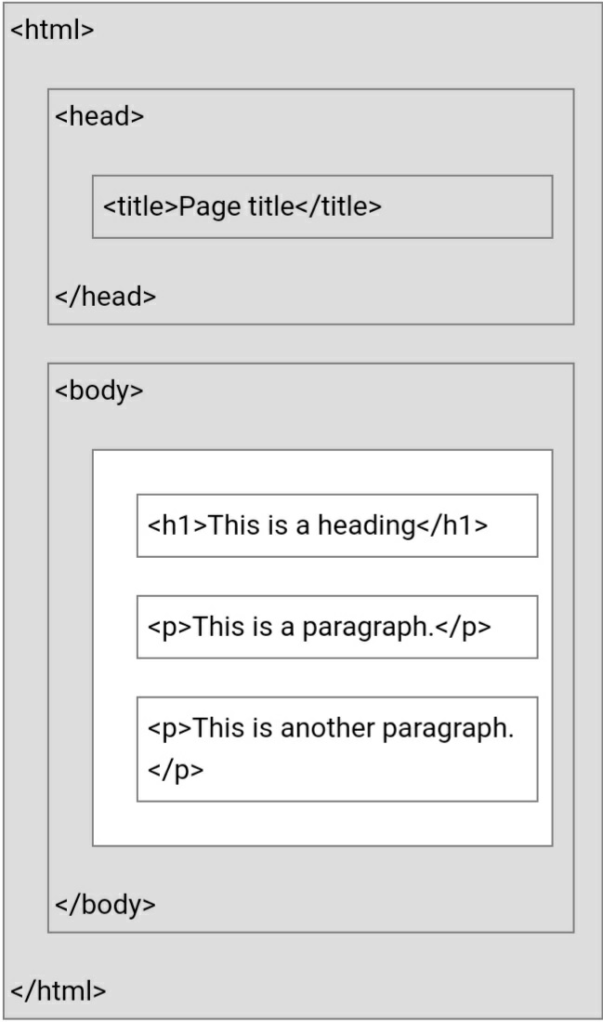

**Learn HTML Using Notepad or TextEdit**

Web pages can be created and modified by using professional HTML editors.

However, for learning HTML we recommend a simple text editor like Notepad (PC) or TextEdit (Mac).

We believe in that using a simple text editor is a good way to learn HTML.

Follow the steps below to create your first web page with Notepad or TextEdit.

**Step 1: Open Notepad (PC)**

**Windows 8 or later:**

Open the **Start Screen** (the window symbol at the bottom left on your screen). Type **Notepad**.

**Windows 7 or earlier:**

Open **Start** >**Programs >** **Accessories >** **Notepad**

**Step 1: Open TextEdit (Mac)**

Open **Finder > Applications > TextEdit**

Also change some preferences to get the application to save files correctly. In **Preferences > Format >**choose**"Plain Text"**

Then under "Open and Save", check the box that says "Display HTML files as HTML code instead of formatted text".

**Then open a new document to place the code.**

**Step 2: Write Some HTML**

Write or copy the following HTML code into Notepad:

<!DOCTYPE html>

<html>

<body>

<h1>My First Heading</h1>

<p>My first paragraph.</p>

</body>

</html>

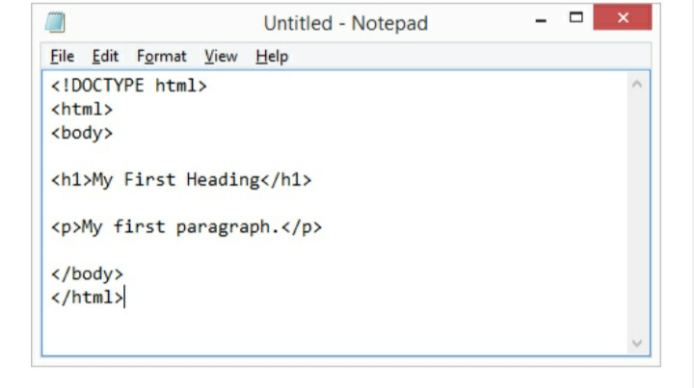

**Step 3: Save the HTML Page**

Save the file on your computer. Select **File > Save as** in the Notepad menu.

Name the file **"index.htm"** and set the encoding to **UTF-8** (which is the preferred

encoding for HTML files).

**Step 4: View the HTML Page**

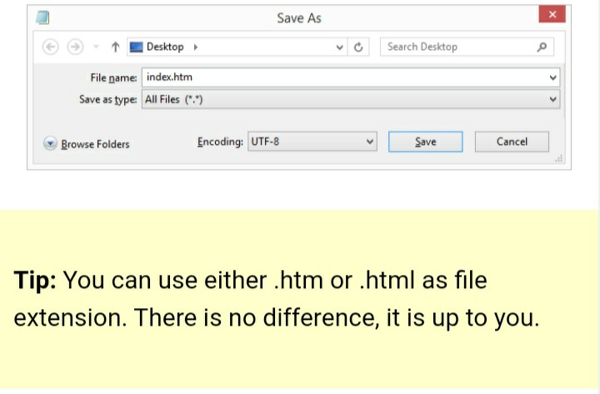

**in Your Browser**

Open the saved HTML file in your favorite browser (double click on the file, or right-click - and choose "Open with").

The result will look much like this:

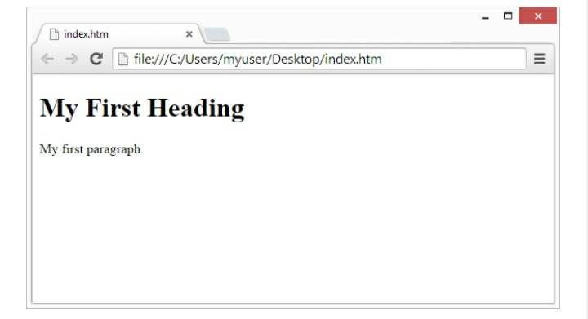

**HTML Documents**

All HTML documents must start with a document type declaration: <!DOCTYPE html>.

The HTML document itself begins with <html> and ends with </html>.

The visible part of the HTML document is between <body> and </body>.

**Example**

<!DOCTYPE html>

<html>

<body>

<h1>My First Heading</h1>

<p>My first paragraph.</p>

</body>

</html>

**The <!DOCTYPE> Declaration**

The <!DOCTYPE> declaration represents the document type, and helps browsers to display web pages correctly.

It must only appear once, at the top of the

page (before any HTML tags).

The <!DOCTYPE> declaration is not case sensitive.

The <!DOCTYPE> declaration for HTML5 is:

<!DOCTYPE html>

**HTML Headings**

HTML headings are defined with the <h1> to <h6> tags.

<h1> defines the most important heading. <h6> defines the least important heading:

**Example**

<h1>This is heading 1</h1>

<h2>This is heading 2</h2>

<h3>This is heading 3</h3>

**HTML Paragraphs**

HTML paragraphs are defined with the <p> tag:

**Example**

<p>This is a paragraph.</p>

<p>This is another paragraph.</p>

**HTML Links**

HTML links are defined with the <a> tag:

**Example**

<a href="https://www.paradisecomputerinstitute.com">This is a link</a>

**HTML Basic Examples**

In this chapter we will show some basic HTML examples.

Don't worry if we use tags you have not learned about yet.

**HTML Documents**

All HTML documents must start with a document type declaration: <!DOCTYPE html>.

The HTML document itself begins with <html> and ends with </html>.

The visible part of the HTML document is between <body> and </body>.

**Example**

<!DOCTYPE html>

<html>

<body>

<h1>My First Heading</h1>

<p>My first paragraph.</p>

</body>

</html>

Try it Yourself »

**The <!DOCTYPE> Declaration**

The <!DOCTYPE> declaration represents the document type, and helps browsers to display web pages correctly.

It must only appear once, at the top of the page (before any HTML tags).

The <!DOCTYPE> declaration is not case sensitive.

The <!DOCTYPE> declaration for HTML5 is:

<!DOCTYPE html>

**HTML Headings**

HTML headings are defined with the <h1> to <h6> tags.

<h1> defines the most important heading. <h6> defines the least important heading:

**Example**

<h1>This is heading 1</h1>

<h2>This is heading 2</h2>

<h3>This is heading 3</h3>

Try it Yourself »

**HTML Paragraphs**

HTML paragraphs are defined with the <p> tag:

**Example**

<p>This is a paragraph.</p>

<p>This is another paragraph.</p>

Try it Yourself »

**HTML Links**

HTML links are defined with the <a> tag:

**Example**

<a href="https://www.w3schools.com">This is a link</a>

Try it Yourself »

The link's destination is specified in the href attribute.

Attributes are used to provide additional information about HTML elements.

You will learn more about attributes in a later chapter.

**HTML Images**

HTML images are defined with the <img> tag.

The source file (src), alternative text (alt), width, and height are provided as attributes:

**Example**

<img src="ccccc.jpg" alt="cccccc.com" width="104" height="142">

**How to View HTML Source?**

Have you ever seen a Web page and wondered "Hey! How did they do that?"

**View HTML Source Code:**

Right-click in an HTML page and select "View Page Source" (in Chrome) or "View Source" (in Edge), or similar in other browsers. This will open a window

containing the HTML source code of the page.

**Inspect an HTML Element:**

Right-click on an element (or a blank area), and choose "Inspect" or "Inspect Element" to see what elements are made up of (you will see both the HTML and the CSS). You can also edit the HTML or CSS on-the-fly in the Elements or Styles panel that opens.

**Nested HTML Elements**

HTML elements can be nested (this means that elements can contain other elements).

All HTML documents consist of nested HTML elements.

The following example contains four HTML elements (<html>, <body>, <h1> and <p>):

<!DOCTYPE html>

<html>

<body>

<h1>My First Heading</h1>

<p>My first paragraph.</p>

</body>

</html>

**Example Explained**

The <html> element is the root element and it defines the whole HTML document.

It has a start tag <html> and an end tag </html>.

Then, inside the <html> element there is a <body> element:

<body>

<h1>My First Heading</h1>

<p>My first paragraph.</p>

</body>

The <body> element defines the document's body.

It has a start tag <body> and an end tag </body>.

Then, inside the <body> element there are two other elements: <h1> and <p>:

<h1>My First Heading</h1>

<p>My first paragraph.</p>

The <h1> element defines a heading.

It has a start tag <h1> and an end tag </h1>

<h1>My First Heading</h1>

The <p> element defines a paragraph.

It has a start tag <p> and an end tag </p>:

<p>My first paragraph.</p>

**Never Skip the End Tag**

Some HTML elements will display

correctly, even if you forget the end tag:

<html>

<body>

<p>This is a paragraph

<p>This is a paragraph

</body>

</html>

**Empty HTML Elements**

HTML elements with no content are called empty elements.

The <br> tag defines a line break, and is an empty element without a closing tag:

<p>This is a <br> paragraph with a line

break.</p>

**HTML is Not Case Sensitive**

HTML tags are not case sensitive: <P> means the same as <p>.

The HTML standard does not require lowercase tags, but W3C **recommends** lowercase in HTML, and **demands** lowercase for stricter document types like XHTML.

**HTML Attributes**

**HTML Attributes**

All HTML elements can have **attributes**

Attributes provide **additional information** about elements

Attributes are always specified in **the start tag**

Attributes usually come in name/value pairs like: **name="value"**

**The href Attribute**

The <a> tag defines a hyperlink. The href attribute specifies the URL of the page the link goes to:

**Example**

<a href="https://www.w3schools.com">Visit W3Schools</

a>

**The src Attribute**

The <img> tag is used to embed an image in an HTML page. The src attribute specifies the path to the image to be displayed:

**Example**

<img src="img_girl.jpg">

There are two ways to specify the URL in the src attribute:

**1. Absolute URL** - Links to an external image that is hosted on another website. Example: src="https://

www.w3schools.com/images/img_girl.jpg".

**Notes:** External images might be under copyright. If you do not get permission to use it, you may be in violation of copyright laws. In addition, you cannot control external images; it can suddenly be removed or changed.

**2. Relative URL** - Links to an image that is hosted within the website. Here, the URL does not include the domain name. If the URL begins without a slash, it will be relative to the current page. Example: src="img_girl.jpg". If the URL begins with a slash, it will be relative to the domain. Example: src="/images/img_girl.jpg".

**Tip:** It is almost always best to use relative

URLs. They will not break if you change domain.

**The width and height Attributes**

The <img> tag should also contain the width and height attributes, which specifies the width and height of the image (in pixels):

**Example**

<img src="img_girl.jpg" width="500" height="600">

**The alt Attribute**

The required alt attribute for the <img> tag specifies an alternate text for an image, if the image for some reason cannot be displayed. This can be due to slow connection, or an error in the src attribute, or if the user uses a screen reader.

**Example**

<img src="img_girl.jpg" alt="Girl with a jacket">

**The style Attribute**

The style attribute is used to add styles to an element, such as color, font, size, and more.

**Example**

<p style="color:red;">This is a red paragraph.</p>

**The lang Attribute**

You should always include the lang attribute inside the <html> tag, to declare the language of the Web page. This is meant to assist search engines and browsers.

The following example specifies English as the language:

<!DOCTYPE html>

<html lang="en">

<body>

...

</body>

</html>

Country codes can also be added to the language code in the lang attribute. So, the first two characters define the language of the HTML page, and the last two characters define the country.

The following example specifies English as the language and United States as the country:

<!DOCTYPE html>

<html lang="en-US">

<body>

...

</body>

</html>

**The title Attribute**

The title attribute defines some extra information about an element.

The value of the title attribute will be displayed as a tooltip when you mouse over the element:

**Example**

<p title="I'm a tooltip">This is a paragraph.</p>

**We Suggest: Always Use Lowercase Attributes**

The HTML standard does not require

lowercase attribute names.

The title attribute (and all other attributes) can be written with uppercase or lowercase like **title** or **TITLE**.

However, W3C **recommends** lowercase attributes in HTML, and **demands** lowercase attributes for stricter document types like XHTML.

**We Suggest: Always Quote Attribute Values**

The HTML standard does not require quotes around attribute values.

However, W3C **recommends** quotes in HTML, and **demands** quotes for stricter

document types like XHTML.

**Good:**

<a href="https://www.paradise.com/html/">Visit our HTML tutorial</a>

**Bad:**

<a href=https://www.paradise.com/html/>Visit our HTML tutorial</a>

Sometimes you have to use quotes. This example will not display the title attribute correctly, because it contains a space:

**Example**

<p title=About W3Schools>

**Single or Double Quotes?**

Double quotes around attribute values are the most common in HTML, but single quotes can also be used.

In some situations, when the attribute value itself contains double quotes, it is necessary to use single quotes:

<p title='John "ShotGun" Nelson'>

Or vice versa:

<p title="John 'ShotGun' Nelson">

**Chapter Summary**

All HTML elements can have **attributes**

The href attribute of <a> specifies the URL of the page the link goes to

The src attribute of <img> specifies the path to the image to be displayed

The width and height attributes of <img> provide size information for images

The alt attribute of <img> provides an alternate text for an image

The style attribute is used to add styles to an element, such as color, font, size, and more

The lang attribute of the <html> tag

declares the language of the Web page

The title attribute defines some extra information about an element

**HTML Headings**

**Heading 1**

**Heading 2**

**Heading 3**

**Heading 4**

**Heading 5**

**Heading 6**

**HTML Headings**

HTML headings are defined with the <h1> to <h6> tags.

<h1> defines the most important heading. <h6> defines the least important heading.

**Example**

<h1>Heading 1</h1>

<h2>Heading 2</h2>

<h3>Heading 3</h3>

<h4>Heading 4</h4>

<h5>Heading 5</h5>

<h6>Heading 6</h6>

**Headings Are Important**

Search engines use the headings to index the structure and content of your web pages.

Users often skim a page by its headings. It is important to use headings to show the document structure.

<h1> headings should be used for main headings, followed by <h2> headings, then the less important <h3>, and so on.

**Bigger Headings**

Each HTML heading has a default size.

However, you can specify the size for any heading with the style attribute, using the CSS font-size property:

**Example**

<h1 style="font-size:60px;">Heading 1</h1>

**HTML Lists**

HTML Lists are used to specify lists of information. All lists may contain one or more list elements. There are three different types of HTML lists:

1. Ordered List or Numbered List (ol)
2. Unordered List or Bulleted List (ul)
3. Description List or Definition List (dl)

#### Note: We can create a list inside another list, which will be termed as nested List

## HTML Ordered List or Numbered List

In the ordered HTML lists, all the list items are marked with numbers by default. It is known as numbered list also. The ordered list starts with <ol> tag and the list items start with <li> tag.

1. <ol>
2. <li>Aries</li>
3. <li>Bingo</li>
4. <li>Leo</li>
5. <li>Oracle</li>
6. </ol>

Output:

1. Aries
2. Bingo
3. Leo
4. Oracle

## HTML Unordered List or Bulleted List

In HTML Unordered list, all the list items are marked with bullets. It is also known as bulleted list also. The Unordered list starts with <ul> tag and list items start with the <li> tag.

1. <ul>
2. <li>Aries</li>
3. <li>Bingo</li>
4. <li>Leo</li>
5. <li>Oracle</li>
6. </ul>

Output:

* Aries
* Bingo
* Leo
* Oracle

## HTML Description List or Definition List

HTML Description list is also a list style which is supported by HTML and XHTML. It is also known as definition list where entries are listed like a dictionary or encyclopedia.

The definition list is very appropriate when you want to present glossary, list of terms or other name-value list.

The HTML definition list contains following three tags:

1. **<dl> tag** defines the start of the list.
2. **<dt> tag** defines a term.
3. **<dd> tag** defines the term definition (description).
4. <dl>
5. <dt>Aries</dt>
6. <dd>-One of the 12 horoscope sign.</dd>
7. <dt>Bingo</dt>
8. <dd>-One of my evening snacks</dd>
9. <dt>Leo</dt>
10. <dd>-It is also an one of the 12 horoscope sign.</dd>
11. <dt>Oracle</dt>
12. <dd>-It is a multinational technology corporation.</dd>
13. </dl>
14. Output:
15. Aries
16. -One of the 12 horoscope sign.
17. Bingo
18. -One of my evening snacks
19. Leo
20. -It is also an one of the 12 horoscope sign.
21. Oracle
22. -It is a multinational technology corporation.

## HTML Nested List

A list within another list is termed as nested list. If you want a bullet list inside a numbered list then such type of list will called as nested list.

**Code:**

1. <!DOCTYPE html>
2. <html>
3. <head>
4. <title>Nested list</title>
5. </head>
6. <body>
7. <p>List of Indian States with thier capital</p>
8. <ol>
9. <li>Delhi
10. <ul>
11. <li>NewDelhi</li>
12. </ul>
13. </li>
14. <li>Haryana
15. <ul>
16. <li>Chandigarh</li>
17. </ul>
18. </li>
19. <li>Gujarat
20. <ul>
21. <li>Gandhinagar</li>
22. </ul>
23. </li>
24. <li>Rajasthan
25. <ul>
26. <li>Jaipur</li>
27. </ul>
28. </li>
29. <li>Maharashtra
30. <ul>
31. <li>Mumbai</li>
32. </ul>
33. </li>
34. <li>Uttarpradesh
35. <ul>
36. <li>Lucknow</li></ul>
37. </li>
38. </ol>
39. </body>
40. </html>

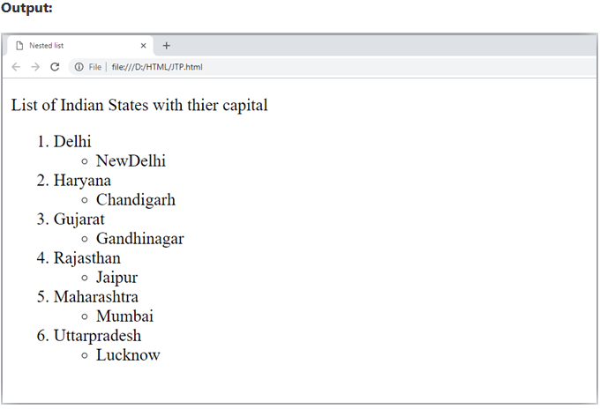

**HTML Ordered List | HTML Numbered List**

**HTML Ordered List** or Numbered List displays elements in numbered format. The HTML ol tag is used for ordered list. We can use ordered list to represent items either in numerical order format or alphabetical order format, or any format where an order is emphasized. There can be different types of numbered list:

* Numeric Number (1, 2, 3)
* Capital Roman Number (I II III)
* Small Romal Number (i ii iii)
* Capital Alphabet (A B C)
* Small Alphabet (a b c)

To represent different ordered lists, there are 5 types of attributes in <ol> tag.

|  |  |
| --- | --- |
| **Type** | **Description** |
| Type "1" | This is the default type. In this type, the list items are numbered with numbers. |
| Type "I" | In this type, the list items are numbered with upper case roman numbers. |
| Type "i" | In this type, the list items are numbered with lower case roman numbers. |
| Type "A" | In this type, the list items are numbered with upper case letters. |
| Type "a" | In this type, the list items are numbered with lower case letters. |

## HTML Ordered List Example

Let's see the example of HTML ordered list that displays 4 topics in numbered list. Here we are not defining type="1" because it is the default type.

1. <ol>
2. <li>HTML</li>
3. <li>Java</li>
4. <li>JavaScript</li>
5. <li>SQL</li>
6. </ol>

Output:

1. HTML
2. Java
3. JavaScript
4. SQL

## ol type="I"

Let's see the example to display list in roman number uppercase.

1. <ol type="I">
2. <li>HTML</li>
3. <li>Java</li>
4. <li>JavaScript</li>
5. <li>SQL</li>
6. </ol>

Output:

1. HTML
2. Java
3. JavaScript
4. SQL

## ol type="i"

Let's see the example to display list in roman number lowercase.

1. <ol type="i">
2. <li>HTML</li>
3. <li>Java</li>
4. <li>JavaScript</li>
5. <li>SQL</li>
6. </ol>

Output:

1. HTML
2. Java
3. JavaScript
4. SQL

## ol type="A"

Let's see the example to display list in alphabet uppercase.

1. <ol type="A">
2. <li>HTML</li>
3. <li>Java</li>
4. <li>JavaScript</li>
5. <li>SQL</li>
6. </ol>

Output:

1. HTML
2. Java
3. JavaScript
4. SQL

## ol type="a"

Let's see the example to display list in alphabet lowercase.

1. <ol type="a">
2. <li>HTML</li>
3. <li>Java</li>
4. <li>JavaScript</li>
5. <li>SQL</li>
6. </ol>

Output:

1. HTML
2. Java
3. JavaScript
4. SQL

## start attribute

The start attribute is used with ol tag to specify from where to start the list items.

**<ol type="1" start="5">** : It will show numeric values starting with "5".

**<ol type="A" start="5">** : It will show capital alphabets starting with "E".

**<ol type="a" start="5">** : It will show lower case alphabets starting with "e".

**<ol type="I" start="5">** : It will show Roman upper case value starting with "V".

**<ol type="i" start="5">** : It will show Roman lower case value starting with "v".

1. <ol type="i" start="5">
2. <li>HTML</li>
3. <li>Java</li>
4. <li>JavaScript</li>
5. <li>SQL</li>
6. </ol>

Output:

1. HTML
2. Java
3. JavaScript
4. SQL

## reversed Attribute:

This is a Boolean attribute of HTML <ol> tag, and it is new in HTML5 version. If you use the reversed attribute with

tag then it will numbered the list in descending order (7, 6, 5, 4......1).

## Example:

1. <ol reversed>
2. <li>HTML</li>
3. <li>Java</li>
4. <li>JavaScript</li>
5. <li>SQL</li>
6. </ol>

**Output:**

the reserved attribute

4.html

3.java

2.javascript

**HTML Unordered List | HTML Bulleted List**

**HTML Unordered List** or Bulleted List displays elements in bulleted format . We can use unordered list where we do not need to display items in any particular order. The HTML ul tag is used for the unordered list. There can be 4 types of bulleted list:

* disc
* circle
* square
* none

To represent different ordered lists, there are 4 types of attributes in <ul> tag.

|  |  |
| --- | --- |
| **Type** | **Description** |
| Type "disc" | This is the default style. In this style, the list items are marked with bullets. |
| Type "circle" | In this style, the list items are marked with circles. |
| Type "square" | In this style, the list items are marked with squares. |
| Type "none" | In this style, the list items are not marked . |

## HTML Unordered List Example

1. <ul>
2. <li>HTML</li>
3. <li>Java</li>
4. <li>JavaScript</li>
5. <li>SQL</li>
6. </ul>

Output:

* HTML
* Java
* JavaScript
* SQL

## ul type="circle"

1. <ul type="circle">
2. <li>HTML</li>
3. <li>Java</li>
4. <li>JavaScript</li>
5. <li>SQL</li>
6. </ul>

Output:

Competitive questions on Structures in Hindi

* HTML
* Java
* JavaScript
* SQL

## ul type="square"

1. <ul type="square">
2. <li>HTML</li>
3. <li>Java</li>
4. <li>JavaScript</li>
5. <li>SQL</li>
6. </ul>

Output:

* HTML
* Java
* JavaScript
* SQL

## ul type="none"

1. <ul type="none">
2. <li>HTML</li>
3. <li>Java</li>
4. <li>JavaScript</li>
5. <li>SQL</li>
6. </ul>

Output:

* HTML
* Java
* JavaScript
* SQL

#### Note: The type attribute is not supported in HTML5, instead of type you can use CSS property of list-style-type. Following is the example to show the CSS property for ul tag.

1. <ul style="list-style-type: square;">
2. <li>HTML</li>
3. <li>Java</li>
4. <li>JavaScript</li>
5. <li>SQL</li>
6. </ul>

**Code:**

1. <!DOCTYPE html>
2. <html>
3. <head>
4. </head>
5. <body>
6. <h2>The type attribute with CSS property</h2>
7. <ul style="list-style-type: square;">
8. <li>HTML</li>
9. <li>Java</li>
10. <li>JavaScript</li>
11. <li>SQL</li>
12. </ul>
13. </body>
14. </html>

# HTML Table

**HTML table tag** is used to display data in tabular form (row * column). There can be many columns in a row.

We can create a table to display data in tabular form, using <table> element, with the help of <tr> , <td>, and <th> elements.

In Each table, table row is defined by <tr> tag, table header is defined by <th>, and table data is defined by <td> tags.

HTML tables are used to manage the layout of the page e.g. header section, navigation bar, body content, footer section etc. But it is recommended to use div tag over table to manage the layout of the page .

## HTML Table Tags

|  |  |
| --- | --- |
| **Tag** | **Description** |
| <table> | It defines a table. |
| <tr> | It defines a row in a table. |
| <th> | It defines a header cell in a table. |
| <td> | It defines a cell in a table. |
| <caption> | It defines the table caption. |
| <colgroup> | It specifies a group of one or more columns in a table for formatting. |
| <col> | It is used with <colgroup> element to specify column properties for each column. |
| <tbody> | It is used to group the body content in a table. |
| <thead> | It is used to group the header content in a table. |
| <tfooter> | It is used to group the footer content in a table. |

## HTML Table Example

Let's see the example of HTML table tag. It output is shown above.

1. <table>
2. <tr><th>First_Name</th><th>Last_Name</th><th>Marks</th></tr>
3. <tr><td>Sonoo</td><td>Jaiswal</td><td>60</td></tr>
4. <tr><td>James</td><td>William</td><td>80</td></tr>
5. <tr><td>Swati</td><td>Sironi</td><td>82</td></tr>
6. <tr><td>Chetna</td><td>Singh</td><td>72</td></tr>
7. </table>
8. **Output:**

|  |  |  |
| --- | --- | --- |
| **First_Name** | **Last_Name** | **Marks** |
| Sonoo | Jaiswal | 60 |
| James | William | 80 |
| Swati | Sironi | 82 |
| Chetna | Singh | 72 |

1. In the above html table, there are 5 rows and 3 columns = 5 * 3 = 15 values

## HTML Table with Border

There are two ways to specify border for HTML tables.

1. By border attribute of table in HTML
2. By border property in CSS

## 1) HTML Border attribute

You can use border attribute of table tag in HTML to specify border. But it is not recommended now.

1. <table border="1">
2. <tr><th>First_Name</th><th>Last_Name</th><th>Marks</th></tr>
3. <tr><td>Sonoo</td><td>Jaiswal</td><td>60</td></tr>
4. <tr><td>James</td><td>William</td><td>80</td></tr>
5. <tr><td>Swati</td><td>Sironi</td><td>82</td></tr>
6. <tr><td>Chetna</td><td>Singh</td><td>72</td></tr>
7. </table>

**Output:**

|  |  |  |
| --- | --- | --- |
| **First_Name** | **Last_Name** | **Marks** |
| Sonoo | Jaiswal | 60 |
| James | William | 80 |
| Swati | Sironi | 82 |
| Chetna | Singh | 72 |

## HTML Table with cell padding

You can specify padding for table header and table data by two ways:

1. By cellpadding attribute of table in HTML
2. By padding property in CSS

The cellpadding attribute of HTML table tag is obselete now. It is recommended to use CSS. So let's see the code of CSS.

1. <style>
2. table, th, td {
3. border: 1px solid pink;
4. border-collapse: collapse;
5. }
6. th, td {
7. padding: 10px;
8. }
9. </style>

We can adjust our table width as per our requirement. Following is the example to display table with width.

1. table{
2. width: 100%;
3. }

## Example:

1. <!DOCTYPE html>
2. <html>
3. <head>
4. <title>table</title>
5. <style>
6. table{
7. border-collapse: collapse;
8. width: 100%;
9. }
10. th,td{
11. border: 2px solid green;
12. padding: 15px;
13. }
15. </style>
16. </head>
17. <body>
18. <table>
19. <tr>
20. <th>1 header</th>
21. <th>1 header</th>
22. <th>1 header</th>
23. </tr>
24. <tr>
25. <td>1data</td>
26. <td>1data</td>
27. <td>1data</td>
28. </tr>
29. <tr>
30. <td>2 data</td>
31. <td>2 data</td>
32. <td>2 data</td>
33. </tr>
34. <tr>
35. <td>3 data</td>
36. <td>3 data</td>
37. <td>3 data</td>
38. </tr>
39. </table>
40. </body>
41. </html>

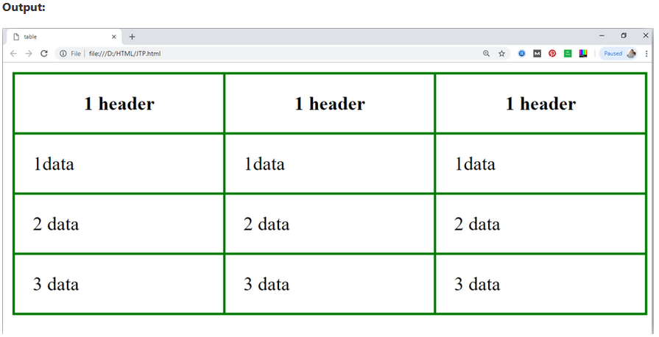

## HTML Table with colspan

If you want to make a cell span more than one column, you can use the colspan attribute.

It will divide one cell/row into multiple columns, and the number of columns depend on the value of colspan attribute.

Let's see the example that span two columns.

CSS code:

1. <style>
2. table, th, td {
3. border: 1px solid black;
4. border-collapse: collapse;
5. }
6. th, td {
7. padding: 5px;
8. }
9. </style>

HTML code:

1. <table style="width:100%">
2. <tr>
3. <th>Name</th>
4. <th colspan="2">Mobile No.</th>
5. </tr>
6. <tr>
7. <td>Ajeet Maurya</td>
8. <td>7503520801</td>
9. <td>9555879135</td>
10. </tr>
11. </table>

# HTML <tbody> tag

HTML <tbody> tag is used to group the table rows (<tr>) together, which indicates that this is body part of a table (<table>).

The <tbody> tag must be a child of <table> element.

The <tbody> is used along with <thead> and <tfoot> which shows the different part of the table that are table head, table body, and table footer, however, it does not affect the layout of the table.

These elements can be used for providing semantic information which can be helpful in accessibility purpose, or rendering the header at top and footer at the bottom while printing a large table.

#### Tips: The <tbody> tag must contain one or more <tr> elements.

### Syntax

1. <tbody>............</tbody>

**Following are some specifications about the HTML <tbody> tag**

|  |  |
| --- | --- |
| **Display** | **Inline** |
| **Start tag/End tag** | Both Start and End tag |
| **Usage** | Table body |

### Example

1. <!DOCTYPE html>
2. <html>
3. <head>
4. <title>HTML tbody tag</title>
5. <style>
6. body{
7. margin-left: 195px;"
8. }
9. </style>
10. </head>
11. <body>
12. <h2>Example of the tbody tag</h2>
13. <table border="1" bgcolor="#98f5ff">
14. <thead>
15. <tr>
16. <th>EmpId</th>
17. <th>Name</th>
18. <th>Email-Id</th>
19. </tr>
20. </thead>
21. <tbody>
22. <tr>
23. <td>121</td>
24. <td>John</td>
25. <td>john123@gmail.com</td>
26. </tr>
28. <tr>
29. <td>122</td>
30. <td>William </td>
31. <td>william56@gmail.com</td>
32. </tr>
34. <tr>
35. <td>123</td>
36. <td>Amit</td>
37. <td>amitk98@gmail.com</td>
38. </tr>
39. </tbody>
40. </table>
41. </body>
42. </html>

# HTML <td> tag

HTML <td> tag is used to specify the cells of an HTML table which contain data of the table. The <td> tag must be the child element of <tr> (table row) tag. Each table row can contain multiple <td> data elements.

The grouped <td> elements of a <tr> tag renders as a single row in the table. The content of the <td> elements is regular and left-aligned in the table by default.

### Syntax

1. <td>.......</td>

|  |  |
| --- | --- |
| **Display** | **Inline** |
| **Start tag/End tag** | Start and End tag |
| **Usage** | Table content |

### Example

1. <!DOCTYPE html>
2. <html>
3. <head>
4. <title>HTML td tag</title>
5. <style>
6. th{
7. background-color: #6495ed;
8. }
9. th,td{
10. border: 1px solid black;
11. padding: 10px;
12. }
13. </style>
14. </head>
15. <body>
16. <h2>Example of td Tag</h2>
17. <table style=" border-collapse: collapse; background-color:#dcdcdc;">
18. <tr>
19. <th>Product</th>
20. <th>Quantity</th>
21. <th>Price</th>
22. </tr>
24. <tr>
25. <td>Books</td>
26. <td>5</td>
27. <td>589</td>
28. </tr>
30. <tr>
31. <td>T-shirt</td>
32. <td>5</td>
33. <td>3500</td>
34. </tr>
36. <tr>
37. <td>Jeans</td>
38. <td>2</td>
39. <td>5000</td>
40. </tr>
41. </table>
42. </body>
43. </html>

## Attribute:

### Tag-specific attributes:

|  |  |  |
| --- | --- | --- |
| **Attribute** | **Value** | **Description** |
| abbr | text | It defines the abbreviated version of content of the cell. **(Not Supported in HTML5)** |
| align | left right center justify char | It specifies the alignment of the content of the cell. **(Not Supported in HTML5)** |
| axis | category_name | It Categorizes Cells. . **(Not Supported in HTML5)** |
| bgcolor | rgb(x,x,x) #xxxxxx Color_name | It sets the background color of the cell. **(Not Supported in HTML5)** |
| char | character | It specifies the alignment of the content of cell to the character. **(Not Supported in HTML5)** |
| charoff | number | It determines the number of characters the content aligned from the character specified by the char attribute. **(Not Supported in HTML5)** |
| colspan | number | It determines the number of columns a cell should span. |
| headers | header_id | It determines one or more header cells to which a cell is related. |
| height | % pixels | It determines the height of a table cell. **(Not Supported in HTML5)** |
| nowrap | nowrap | If it sets then content inside the cell should not wrap. **(Not Supported in HTML5)** |
| rowspan | number | It determines the number of rows a cell should span. |
| scope | col colgroup row rowgroup | It specifies the cells that the header element relates to. **(Not Supported in HTML5)** |
| valign | top middle bottom baseline | It determines the vertical alignment of the cell content. **(Not Supported in HTML5)** |
| width | % pixels | It determines the width of the cell.**(Not Supported in HTML5)** |

### Global attribute:

The <td> tag supports the Global attributes in HTML.

### Event attribute:

The <td> tag supports the Event attributes in HTML.

# HTML Form

An **HTML form** is *a section of a document* which contains controls such as text fields, password fields, checkboxes, radio buttons, submit button, menus etc.

An HTML form facilitates the user to enter data that is to be sent to the server for processing such as name, email address, password, phone number, etc. .

## Why use HTML Form

HTML forms are required if you want to collect some data from of the site visitor.

For example: If a user want to purchase some items on internet, he/she must fill the form such as shipping address and credit/debit card details so that item can be sent to the given address.

## HTML Form Syntax

1. <form action="server url" method="get|post">
2. //input controls e.g. textfield, textarea, radiobutton, button
3. </form>

## HTML Form Tags

Let's see the list of HTML 5 form tags.

|  |  |
| --- | --- |
| **Tag** | **Description** |
| <form> | It defines an HTML form to enter inputs by the used side. |
| <input> | It defines an input control. |
| <textarea> | It defines a multi-line input control. |
| <label> | It defines a label for an input element. |
| <fieldset> | It groups the related element in a form. |
| <legend> | It defines a caption for a <fieldset> element. |
| <select> | It defines a drop-down list. |
| <optgroup> | It defines a group of related options in a drop-down list. |
| <option> | It defines an option in a drop-down list. |
| <button> | It defines a clickable button. |

## HTML 5 Form Tags

Let's see the list of HTML 5 form tags.

|  |  |
| --- | --- |
| **Tag** | **Description** |
| <datalist> | It specifies a list of pre-defined options for input control. |
| <keygen> | It defines a key-pair generator field for forms. |
| <output> | It defines the result of a calculation. |

## HTML <form> element

The HTML <form> element provide a document section to take input from user. It provides various interactive controls for submitting information to web server such as text field, text area, password field, etc.

#### Note: The <form> element does not itself create a form but it is container to contain all required form elements, such as <input>, <label>, etc.

**Syntax:**

1. <form>
2. //Form elements
3. </form>

## HTML <input> element

The HTML <input> element is fundamental form element. It is used to create form fields, to take input from user. We can apply different input filed to gather different information form user. Following is the example to show the simple text input.

## Example:

1. <body>
2. <form>
3. Enter your name  <br>
4. <input type="text" name="username">
5. </form>
6. </body>

## HTML TextField Control

The type="text" attribute of input tag creates textfield control also known as single line textfield control. The name attribute is optional, but it is required for the server side component such as JSP, ASP, PHP etc.

1. <form>
2. First Name: <input type="text" name="firstname"/> <br/>
3. Last Name:  <input type="text" name="lastname"/> <br/>
4. </form>

## HTML <textarea> tag in form

The <textarea> tag in HTML is used to insert multiple-line text in a form. The size of <textarea> can be specify either using "rows" or "cols" attribute or by CSS.

**Example:**

1. <!DOCTYPE html>
2. <html>
3. <head>
4. <title>Form in HTML</title>
5. </head>
6. <body>
7. <form>
8. Enter your address:<br>
9. <textarea rows="2" cols="20"></textarea>
10. </form>
11. </body>
12. </html>

## Label Tag in Form

It is considered better to have label in form. As it makes the code parser/browser/user friendly.

If you click on the label tag, it will focus on the text control. To do so, you need to have for attribute in label tag that must be same as id attribute of input tag.

#### NOTE: It is good to use <label> tag with form, although it is optional but if you will use it, then it will provide a focus when you tap or click on label tag. It is more worthy with touchscreens.

1. <form>
2. <label for="firstname">First Name: </label> <br/>
3. <input type="text" id="firstname" name="firstname"/> <br/>
4. <label for="lastname">Last Name: </label>
5. <input type="text" id="lastname" name="lastname"/> <br/>
6. </form>

## HTML Password Field Control

The password is not visible to the user in password field control.

1. <form>
2. <label for="password">Password: </label>
3. <input type="password" id="password" name="password"/> <br/>
4. </form>

## HTML 5 Email Field Control

The email field in new in HTML 5. It validates the text for correct email address. You must use @ and . in this field.

1. <form>
2. <label for="email">Email: </label>
3. <input type="email" id="email" name="email"/> <br/>
4. </form>

## Radio Button Control

The radio button is used to select one option from multiple options. It is used for selection of gender, quiz questions etc.

If you use one name for all the radio buttons, only one radio button can be selected at a time.

Using radio buttons for multiple options, you can only choose a single option at a time.

1. <form>
2. <label for="gender">Gender: </label>
3. <input type="radio" id="gender" name="gender" value="male"/>Male
4. <input type="radio" id="gender" name="gender" value="female"/>Female <br/>
5. </form>

## Checkbox Control

The checkbox control is used to check multiple options from given checkboxes.

1. <form>
2. Hobby:<br>
3. <input type="checkbox" id="cricket" name="cricket" value="cricket"/>
4. <label for="cricket">Cricket</label> <br>
5. <input type="checkbox" id="football" name="football" value="football"/>
6. <label for="football">Football</label> <br>
7. <input type="checkbox" id="hockey" name="hockey" value="hockey"/>
8. <label for="hockey">Hockey</label>
9. </form>

#### Note: These are similar to radio button except it can choose multiple options at a time and radio button can select one button at a time, and its display.

## Submit button control

HTML **<input type="submit">** are used to add a submit button on web page. When user clicks on submit button, then form get submit to the server.

Syntax:

1. <input type="submit" value="submit">

The type = submit , specifying that it is a submit button

The value attribute can be anything which we write on button on web page.

The name attribute can be omit here.

**Example:**

1. <form>
2. <label for="name">Enter name</label><br>
3. <input type="text" id="name" name="name"><br>
4. <label for="pass">Enter Password</label><br>
5. <input type="Password" id="pass" name="pass"><br>
6. <input type="submit" value="submit">
7. </form>

## HTML <fieldset> element:

The <fieldset> element in HTML is used to group the related information of a form. This element is used with <legend> element which provide caption for the grouped elements.

**Example:**

1. <form>
2. <fieldset>
3. <legend>User Information:</legend>
4. <label for="name">Enter name</label><br>
5. <input type="text" id="name" name="name"><br>
6. <label for="pass">Enter Password</label><br>
7. <input type="Password" id="pass" name="pass"><br>
8. <input type="submit" value="submit">
9. </fieldset>
10. lt;/form>

**Output:**

## HTML Form Example

Following is the example for a simple form of registration.

1. <!DOCTYPE html>
2. <html>
3. <head>
4. <title>Form in HTML</title>
5. </head>
6. <body>
7. <h2>Registration form</h2>
8. <form>
9. <fieldset>
10. <legend>User personal information</legend>
11. <label>Enter your full name</label><br>
12. <input type="text" name="name"><br>
13. <label>Enter your email</label><br>
14. <input type="email" name="email"><br>
15. <label>Enter your password</label><br>
16. <input type="password" name="pass"><br>
17. <label>confirm your password</label><br>
18. <input type="password" name="pass"><br>
19. <br><label>Enter your gender</label><br>
20. <input type="radio" id="gender" name="gender" value="male"/>Male  <br>
21. <input type="radio" id="gender" name="gender" value="female"/>Female <br/>
22. <input type="radio" id="gender" name="gender" value="others"/>others <br/>
23. <br>Enter your Address:<br>
24. <textarea></textarea><br>
25. <input type="submit" value="sign-up">
26. </fieldset>
27. </form>
28. </body>
29. </html>

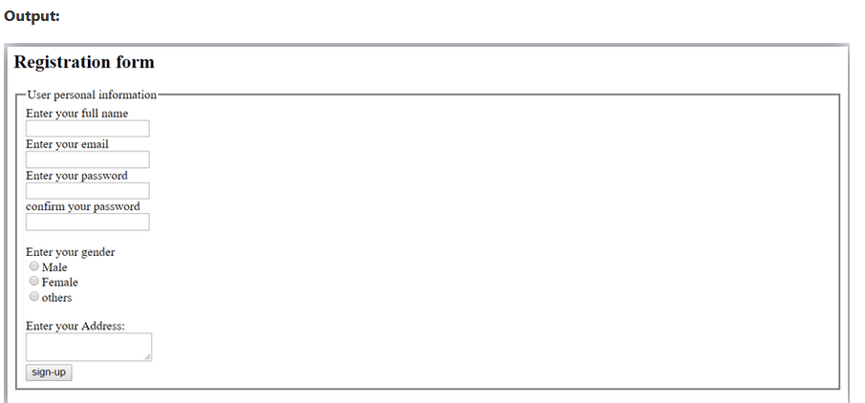

## HTML Form Example

Let's see a simple example of creating HTML form.

1. <form action="#">
2. <table>
3. <tr>
4. <td class="tdLabel"><label for="register_name" class="label">Enter name:</label></td>
5. <td><input type="text" name="name" value="" id="register_name" style="width:160px"/></td>
6. </tr>
7. <tr>
8. <td class="tdLabel"><label for="register_password" class="label">Enter password:</label></td>
9. <td><input type="password" name="password" id="register_password" style="width:160px"/></td>
10. </tr>
11. <tr>
12. <td class="tdLabel"><label for="register_email" class="label">Enter Email:</label></td>
13. <td
14. ><input type="email" name="email" value="" id="register_email" style="width:160px"/></td>
15. </tr>
16. <tr>
17. <td class="tdLabel"><label for="register_gender" class="label">Enter Gender:</label></td>
18. <td>
19. <input type="radio" name="gender" id="register_gendermale" value="male"/>
20. <label for="register_gendermale">male</label>
21. <input type="radio" name="gender" id="register_genderfemale" value="female"/>
22. <label for="register_genderfemale">female</label>
23. </td>
24. </tr>
25. <tr>
26. <td class="tdLabel"><label for="register_country" class="label">Select Country:</label></td>
27. <td><select name="country" id="register_country" style="width:160px">
28. <option value="india">india</option>
29. <option value="pakistan">pakistan</option>
30. <option value="africa">africa</option>
31. <option value="china">china</option>
32. <option value="other">other</option>
33. </select>
34. </td>
35. </tr>
36. <tr>
37. <td colspan="2"><div align="right"><input type="submit" id="register_0" value="register"/>
38. </div></td>
39. </tr>
40. </table>
41. </form>

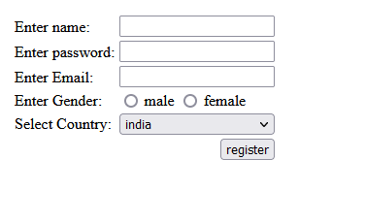

# HTML <frame> tag (Not supported in HTML5)

HTML <frame> tag define the particular area within an HTML file where another HTML web page can be displayed.

A <frame> tag is used with <frameset>, and it divides a webpage into multiple sections or frames, and each frame can contain different web pages.

#### Note: Do not use HTML <frame> tag as it is not supported in HTML5, instead you can use <iframe> or <div> with CSS to achieve similar effects in HTML.

### Syntax

1. < frame src = "URL" >

**Following are some specifications about the HTML <frame> tag**

|  |  |
| --- | --- |
| **Display** | **Block** |
| **Start tag/End tag** | Start tag(required), End tag(forbidden) |
| **Usage** | Frames |

### Example 1

#### Create Vertical frames:

1. <!DOCTYPE html>
2. <html>
3. <head>
4. <title>Frame tag</title>
5. </head>
6. <frameset cols="25%,50%,25%">
7. <frame src="frame1.html" >
8. <frame src="frame2.html">
9. <frame src="frame3.html">
10. </frameset>
11. </html>

<https://developer.mozilla.org/en-US/docs/Web/HTML/Element/form>

https://paradise-computer-institute.business.site/