Program Output
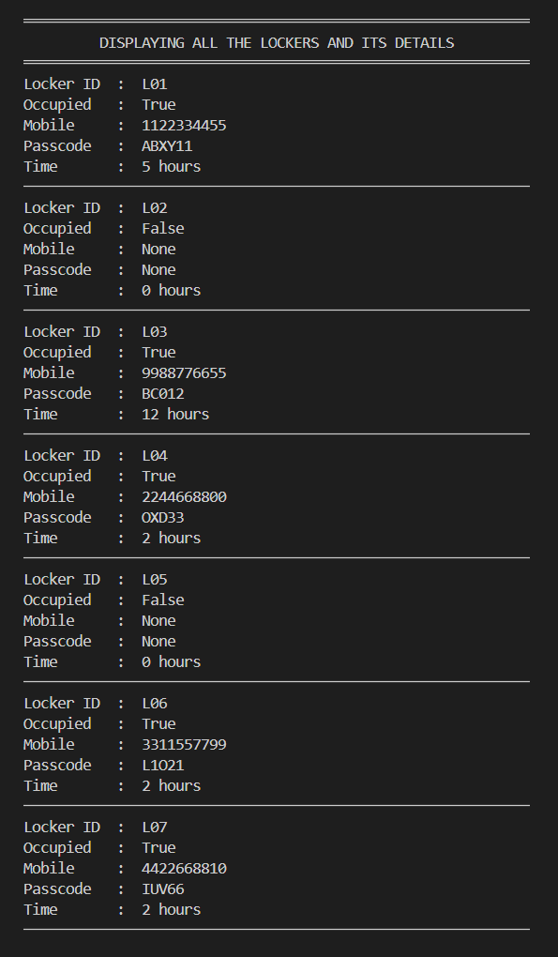
The screenshots provide evidence that the implemented program performs the required operations correctly and the locker records can be stored, accessed, and modified successfully.

Figure 1 : Program Output - Display All Locker Records
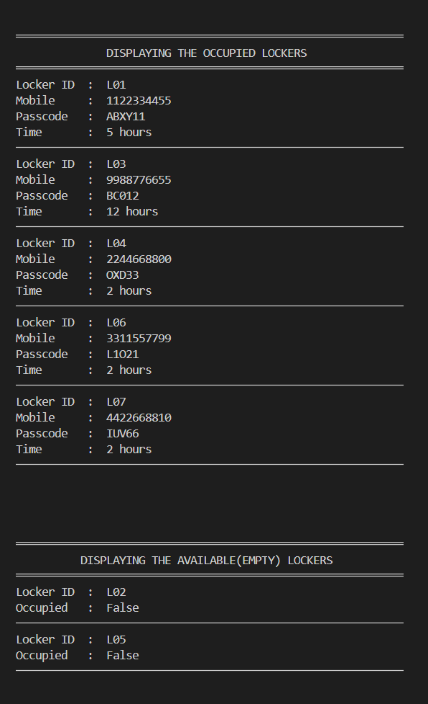
Figure 2: Program Output – Display Occupied and Available Lockers
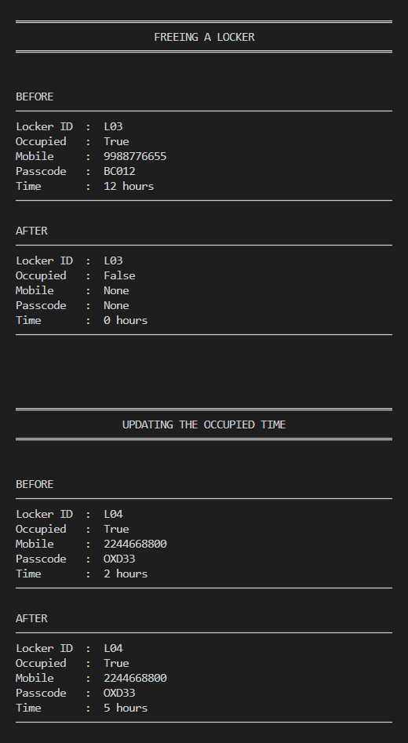
Figure 3: Program Output – Free a Locker and Update Locker Time
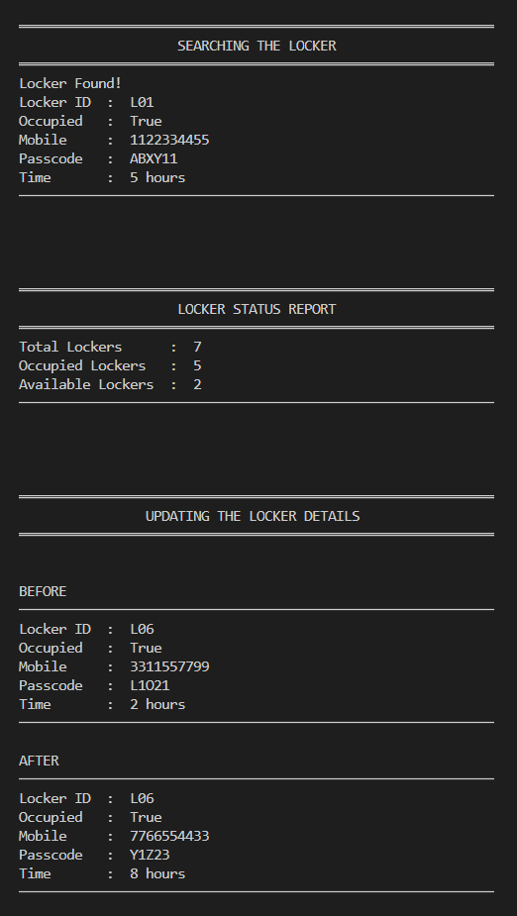

Figure 11: Program Output – Search Locker, Count Lockers, and Update Locker
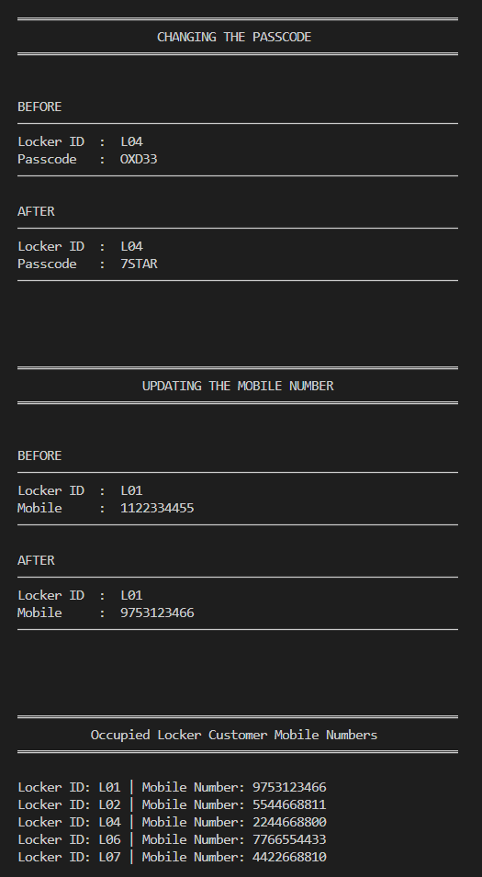

Figure 12: Program Output – Change Passcode, Update Mobile Number, and Display Mobile Numbers by ID’s

