EXP.NO - 8 | MINI PROJECT - Dog Adoption & Transport Intelligence

AIM:
To clean, analyze, and visualize adoptable dog listings and inter-state dog transport data using Python and an interactive dashboard in order to identify adoption trends, dog characteristics, time spent in listings, and the geographic movement of dogs between states and countries.
DOMAIN:
Animal Welfare Analytics / Pet Adoption Analytics / Business Intelligence.
PROBLEM STATEMENT:
Thousands of dogs are listed for adoption at any time, and many are moved long distances from areas with a surplus of dogs to areas with high demand. Understanding which dogs are listed, how long they wait, and where they travel helps shelters and rescues plan transport and outreach. This project analyzes dog listing, transport, and state-level movement data using Python and an interactive dashboard to generate meaningful insights and support data-driven comparison.
DATASET DESCRIPTION:
The project uses three public datasets of dog adoption listings collected in September 2019.
1. All Dog Descriptions Dataset (allDogDescriptions.csv)
The listing dataset contains 58,180 adoptable dog records and 36 fields covering information such as:
- Dog ID, name, and listing URL
- Primary and secondary breed, mixed-breed indicator
- Primary, secondary, and tertiary color
- Age group, sex, size, and coat
- Neutered/spayed status, house-trained, special needs, and current shots
- Compatibility with children, dogs, and cats
- Posted date, access date, and listing status
- Organization ID, contact city, state, ZIP code, and country
- Free-text description of the dog
2. Dog Travel Dataset (dogTravel.csv)
The travel dataset contains 6,194 records and 9 fields. Each record links a listing (dog ID) to a place named in its description, such as where the dog was found or transported from. Fields include:
- Record index and dog ID
- Contact city and contact state (destination)
- Description text
- Origin automatically extracted from the text (found)
- Manually verified origin (manual)
- Flags for removed (remove) and still-in-place (still_there) records
3. Moves By Location Dataset (movesByLocation.csv)
The movement summary dataset contains 90 locations (US states and other countries) with 6 fields: location, number of dogs exported, number of dogs imported, total dogs listed, and an indicator showing whether the location is inside the United States.
The three datasets describe different levels of detail. The listing and travel datasets were linked on the dog ID, and the movement summary was linked to the listings by state name. The datasets were not merged into a single table; instead, cleaned versions were analyzed separately and connected through the dashboard.
PROCEDURE:
- Loaded the three datasets using Python and Pandas.
- Inspected dataset structure, dimensions, data types, missing values, and duplicate records.
- Cleaned and standardized text, Boolean, and date fields.
- Removed malformed listing records and columns with no usable values.
- Validated and standardized state and country names and abbreviations.
- Extracted and standardized the origin of transported dogs.
- Created derived listing indicators such as days listed and special-needs flag.
- Created transport indicators such as route, state-crossing flag, and net export.
- Performed exploratory data analysis using Pandas, Matplotlib, and Seaborn.
- Analyzed dog age, size, sex, and breed distributions.
- Analyzed missing values and data quality across all listing columns.
- Analyzed the listing status and outcome fields.
- Analyzed transport routes, exporting states, and importing states.
- Created static Python visualizations.
- Exported cleaned datasets and summary tables.
- Created an interactive Adoptable Dog Market Intelligence dashboard with filters.
KEY INSIGHTS:
The analysis will investigate:
- Most common dog breeds in the listings.
- Distribution of dog age groups.
- Distribution of dog sizes.
- Distribution of dogs by sex.
- Missing data across listing fields.
- Listing status and adoption outcome.
- Time dogs have been listed.
- Share of dogs with special needs.
- Compatibility of dogs with children, dogs, and cats.
- States with the most adoptable dogs.
- Most common dog transport routes.
- States that send and receive the most dogs.
- Share of transported dogs that cross state lines.

PYTHON ANALYSIS
Python was used for data cleaning, processing, exploratory data analysis, feature engineering, and visualization.
The main libraries used were:
- Pandas
- NumPy
- Matplotlib
- Seaborn
DATA CLEANING
The datasets were loaded using Pandas.
The following operations were performed:
- Checked dataset structure and dimensions.
- Examined data types.
- Identified missing values.
- Identified duplicate records.
- Standardized text values by removing unnecessary spaces.
- Converted the posted and accessed fields into date format.
- Dropped the declawed column, which was 100% empty.
- Dropped the listing URL, description text, and duplicate type columns from the dashboard dataset.
- Removed 49 malformed listing records whose status or country fields contained misplaced values.
- Kept only listings with status "adoptable" and a valid US state or DC code.
- Standardized state abbreviations and country names in the travel data.
- Used the manually verified origin where available, otherwise the automatically extracted origin.
- Removed travel records flagged as removed or still in place, and records whose origin could not be matched to a known state or country.
- Treated blank exported and imported values in the movement data as zero.
The listing dataset contained 58,131 records after cleaning (from 58,180), the travel dataset contained 4,136 traced transport records after cleaning (from 6,194), and the movement dataset contained 90 locations. The 4,136 transport records represent 3,014 distinct dogs, because some listings mention more than one origin.
DATA PROCESSING / FEATURE ENGINEERING
1. Days Listed
Days Listed = Access Date - Posted Date
This indicator measures how long a dog had been listed when the data was collected. Negative values were converted to missing values.
2. Days Listed Band
Under a week, 1-4 weeks, 1-3 months, 3-6 months, 6-12 months, Over a year
Dogs were grouped into six bands to support dashboard comparison.
3. Special Needs Share
Special Needs Share = Special Needs Dogs / Total Dogs x 100
This provides the percentage of listings that are marked as special needs.
4. Compatibility Flag
Yes / No / Not stated
The children, dogs, and cats fields were converted into three categories because many listings leave them blank.
5. Transport Route
Route = Origin State -> Destination State
This combines the origin and the listing state to measure the most common transport routes.
6. Crossed State Flag
Crossed State = Origin is different from Destination
This separates transports that cross state lines from those that stay within one state.
7. Net Export
Net Export = Dogs Exported - Dogs Imported
This shows whether a state or country sends out more dogs than it receives.
EXPLORATORY DATA ANALYSIS
Python will be used to analyze:
- Missing values by column
- Dog age distribution
- Top 10 most common breeds
- Distribution of dogs by sex
- Distribution of dogs by size
- Listing status and outcome
- Age, breed, and sex by outcome
- Transport routes by origin and destination
- Exporting and importing states
- Time dogs have been listed
PYTHON VISUALIZATIONS
Python visualizations were created using Matplotlib and Seaborn to analyze data quality, dog age, breed, sex, size, and listing status. The results were used for the interactive dashboard.
Missing Values
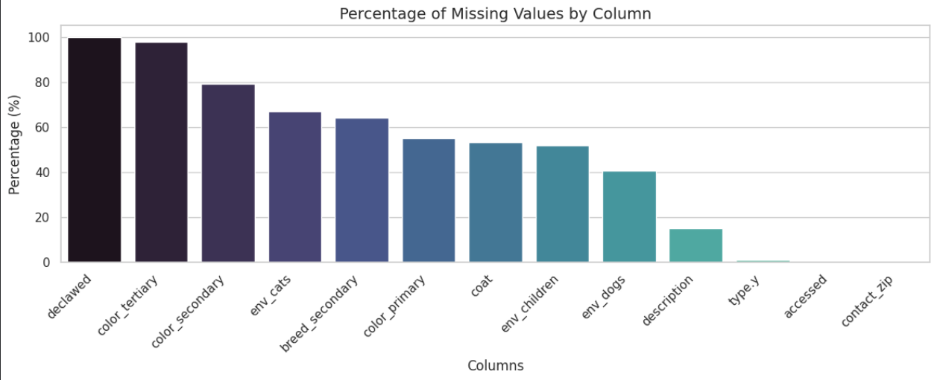
Figure 1: Percentage of missing values by column
The declawed column was completely empty (100%), and the tertiary and secondary color fields were mostly empty (98% and 79%). The compatibility fields were also often blank: cats 67%, children 52%, and dogs 40%.
Age Distribution
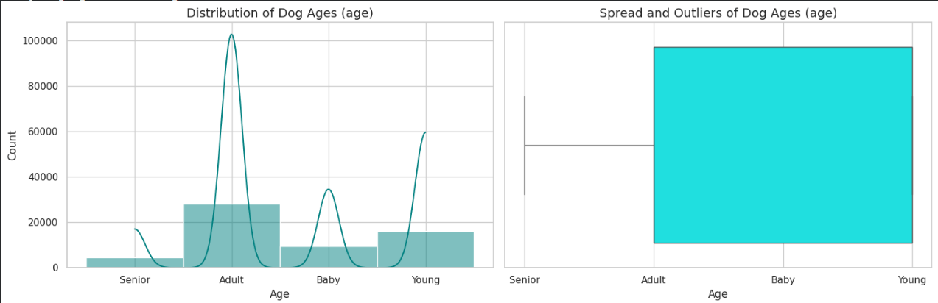
Figure 2: Distribution of dog ages
Adult dogs are the largest group with about 27,955 listings, followed by Young (16,194), Baby (9,397), and Senior (4,634). The curve overlaid on the histogram is a density estimate over four categories and should not be read as a continuous age curve. The box plot on the right is not meaningful for a categorical field.
Top 10 Breeds
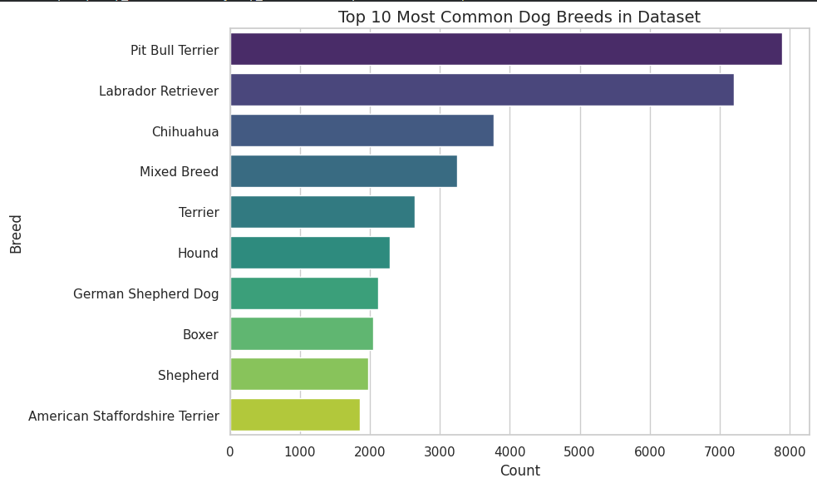
Figure 3: Top 10 most common dog breeds
Pit Bull Terrier (about 7,890) and Labrador Retriever (about 7,200) are the most listed breeds, followed by Chihuahua (about 3,770), Mixed Breed (about 3,240), and Terrier (about 2,640).
Sex Distribution
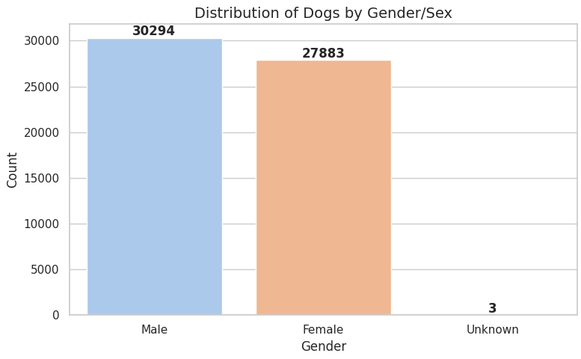
Figure 4: Distribution of dogs by sex
There are 30,294 male dogs and 27,883 female dogs. Only 3 records have an unknown sex.
Listing Status
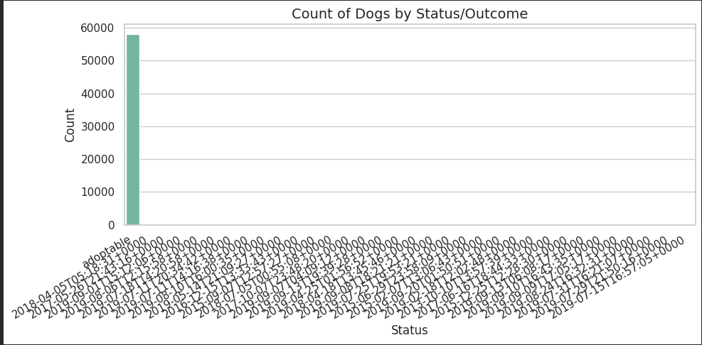
Figure 5: Count of dogs by status
Nearly all records (58,147) have the status "adoptable". The remaining 33 records contain timestamp-like values in the status field, which come from misaligned rows in the source file and were removed during cleaning.
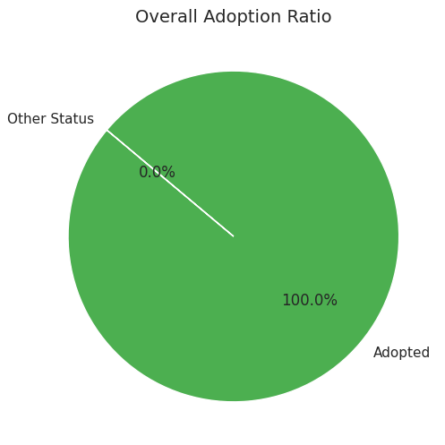
Figure 6: Overall adoption ratio
Because every valid record is an adoptable listing, the dataset contains no completed adoptions. The ratio chart therefore shows 100% for a single category.
Outcome by Age, Breed, and Sex
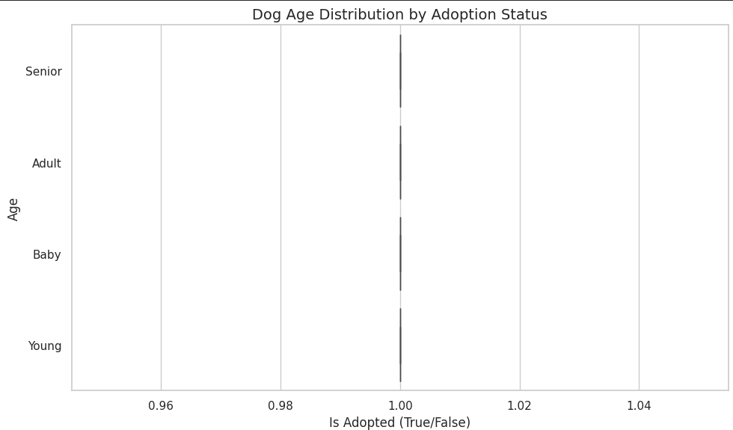
Figure 7: Dog age distribution by adoption status
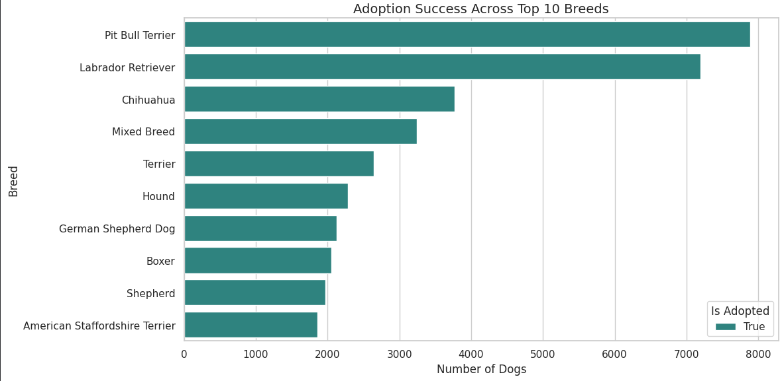
Figure 8: Adoption success across top 10 breeds
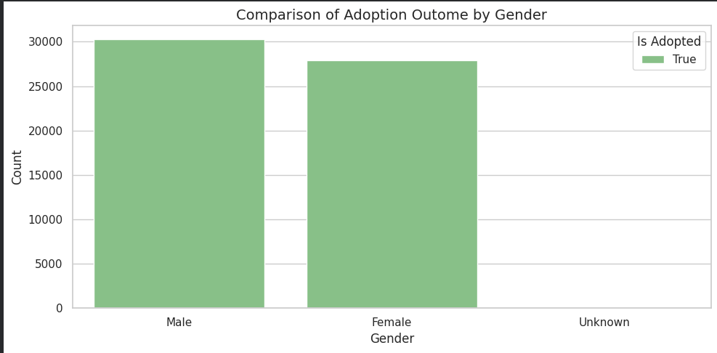
Figure 9: Comparison of adoption outcome by gender
These charts repeat the same single-outcome result across age, breed, and sex. They confirm that the outcome field has no variation, so differences in adoption success cannot be measured from this dataset. The charts are shown to document this limitation.
Size Distribution
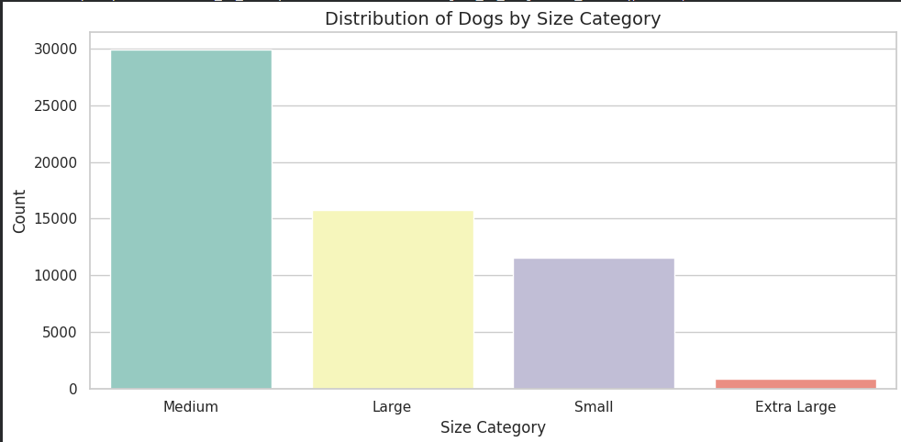
Figure 10: Distribution of dogs by size category
Medium dogs are the largest group (29,908), followed by Large (15,761), Small (11,580), and Extra Large (931).
Combined Overview
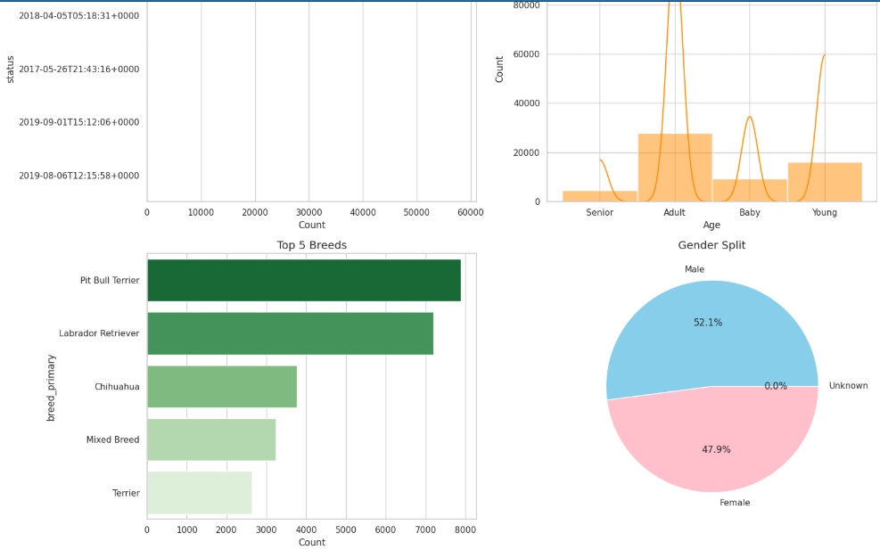
Figure 11: Combined overview of status, age, top 5 breeds, and gender split
The combined panel shows the same patterns together: nearly all dogs are adoptable, adults are the largest age group, and the gender split is 52.1% male and 47.9% female.

TABLEU Dashboard Output
The cleaned datasets were used to create an interactive Adoptable Dog Market Intelligence dashboard. KPI cards and visualizations are used to analyze adoptable dogs, breeds, transport routes, dog age, listing time, size, transport patterns, and the geographic distribution of dogs by state. Interactive filters are provided for age, size, sex, special needs, and state. The dashboard includes KPI cards, the top 10 breeds, the top 10 transport routes, dogs listed by age group, average days listed by size, a donut chart of transports that crossed state lines, and a state map in which darker states have more dogs.
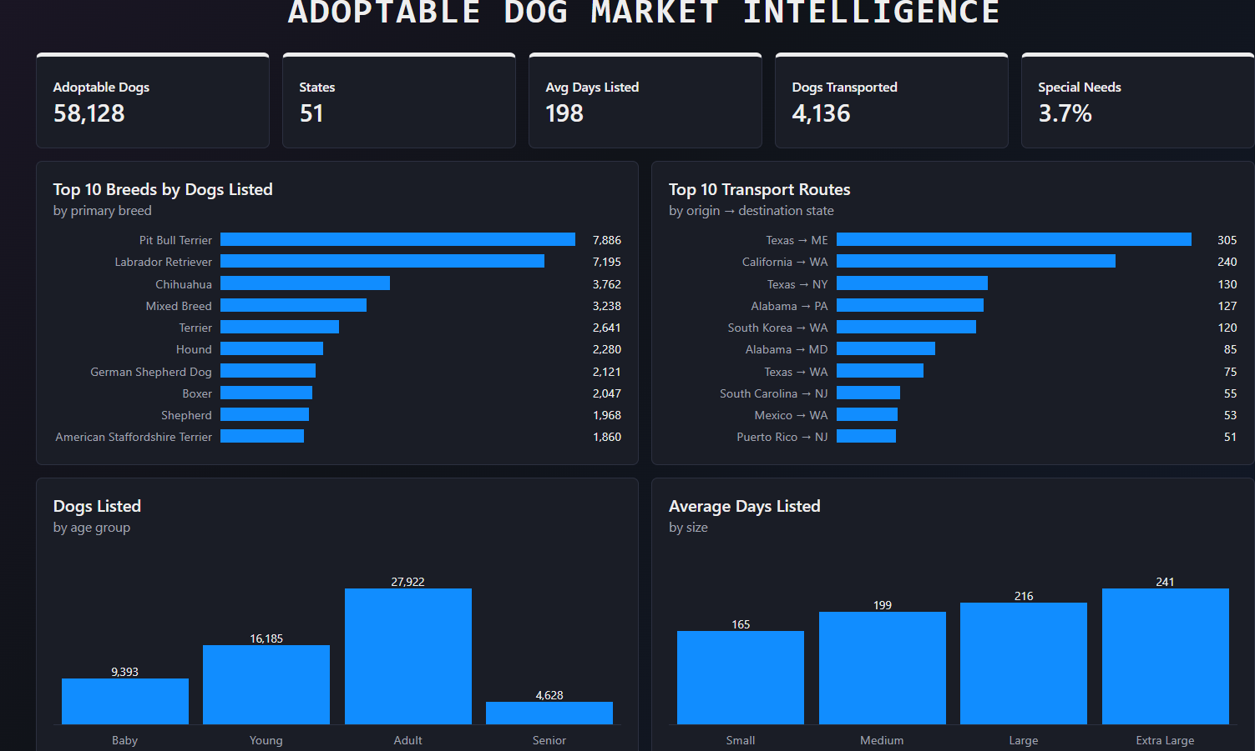
Figure 12: Adoptable Dog Market Intelligence dashboard - KPIs and charts
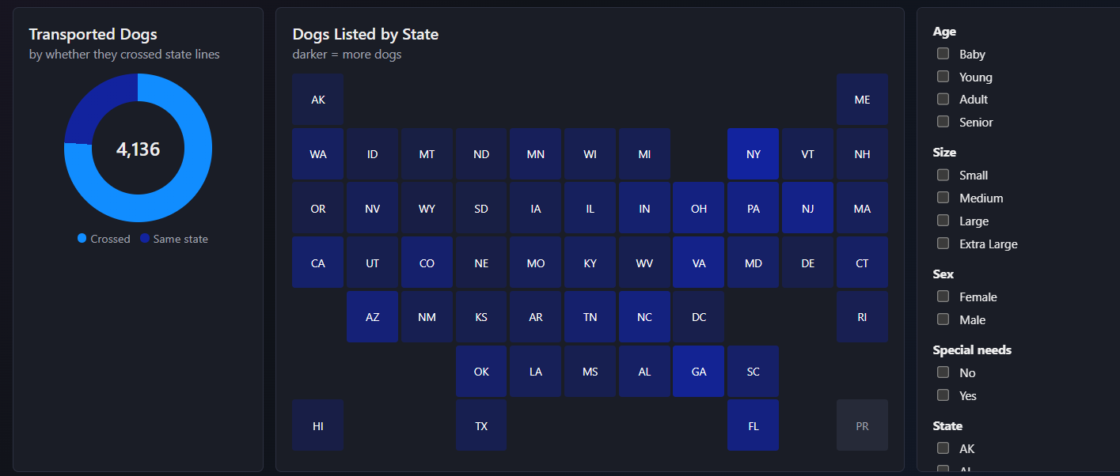
Figure 13: Dashboard - transport donut chart, state map, and filters
The dashboard shows 58,128 adoptable dogs across 51 states and DC, an average of 198 days listed, 4,136 traced transport records, and 3.7% of dogs listed as special needs. The largest transport routes are Texas to Maine (305), California to Washington (240), and Texas to New York (130).
RESULT:
The project successfully cleaned dog listing and transport data using Python and presented key insights through an interactive dashboard. Pit Bull Terriers and Labrador Retrievers were the most listed breeds, adult dogs accounted for nearly half of listings, and the median listing duration was 39 days. Around 76% of traced transports crossed state lines, with Texas, Alabama, and North Carolina being major exporting states and New York, Washington, and New Jersey being major receiving states. The analysis is limited by the lack of adoption outcome data and incomplete transport origin information.

