EXP NO: 2 Hotel Room Booking Reports Suite – Report Types in Zoho Creator

Aim
To design and build a complete suite of nine Reports in Zoho Creator on the existing “Room_Booking_Form” of the Hotel Room Booking & Front Office Management application, demonstrating the correct usage of every Report Type – List View, Spreadsheet View, Kanban View, Calendar View, Map View, Timeline View, Pivot Table, Chart View and Summary View – so that the hotel’s owner/manager, front office, housekeeping and marketing teams can view, analyze and act on booking data from multiple perspectives.
Theory
Zoho Creator is a low-code platform in which data captured through a Form is presented to users through Reports. A single default list of records cannot serve every stakeholder, so Zoho Creator provides nine different report types, each suited to a particular way of consuming data.
The Room_Booking_Form captures guest name, contact number, email, address, check-in and check-out dates, booking status, check-in status, check-out status and housekeeping status. The front office needs to update statuses in bulk, housekeeping needs to know the day’s arrivals, marketing needs to know where guests come from, and management needs summarized trends. Purpose-built reports meet each of these needs without any custom coding.
Application Details
Item | Details
Application Name | Hotel Room Booking & Front Office Management (Hotel Booking Site)
Base Form | Room_Booking_Form
Primary Users | Hotel Owner/Manager, Front Office, Housekeeping, Marketing Team
Deliverable | Nine purpose-built Reports, one for each Zoho Creator Report Type
Report Types and Their Mapping
Report Type | Report Name | Purpose | Key Configuration
List View | All_Bookings_List | Simple, scrollable, searchable list of every booking | Guest name, contact, room type, check-in date, booking status; sorted by check-in date (ascending)
Spreadsheet View | Bookings_Spreadsheet | Editable grid for bulk update of check-in, check-out and housekeeping status | Inline-editable status columns; grouped by room type
Kanban View | Booking_Status_Kanban | Draggable cards grouped by processing stage | Grouped by booking status; card shows guest name and contact
Calendar View | Checkin_Schedule_Calendar | Plans daily arrivals and room readiness | Based on check-in date
Map View | Guest_Origin_Map | Plots guest addresses to understand customer origin | Based on geocoded Address field
Timeline View | Booking_Activity_Timeline | Shows bookings along a time axis to track booking momentum | Based on date/time field; Week and Day scales
Pivot Table | RoomType_By_MealPlan_Pivot | Cross-tabulates one field against another | Rows, columns and count of bookings
Chart View | RoomType_Popularity_Chart | Visualizes bookings per category as a chart | Bar chart; X-axis category, Y-axis count
Summary View | Guest_Stay_Summary | Groups and summarizes bookings by guest | Grouped by guest name; count of bookings

Procedure
Part A – Opening the base form
- Log in to Zoho Creator and open the application “Hotel Booking Site”.
- Open the Room_Booking_Form and confirm that all fields are available: guest name, contact number, email, address, check-in date, check-out date, booking status, check-in status, check-out status and housekeeping status.
- Submit a few sample bookings so that every report has data to display.
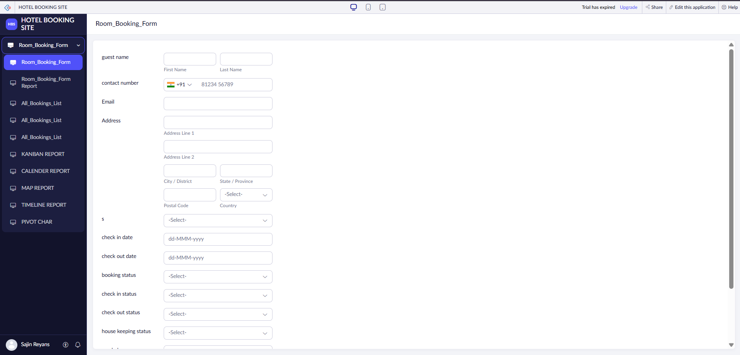
Figure 1: Room_Booking_Form (base form)
Part B – Creating the reports
- In the Design tab, click the “+” icon next to the application name and choose Report.
- Select Room_Booking_Form as the source form and choose the required report type.
- Choose the fields to display or group by, set the layout and save the report with the proper name.
- Open the application in access mode and verify the output of each report.
Implementation of Reports
1. List View – All_Bookings_List
The List View is the default landing report for the front office manager. It shows every booking as a flat, searchable list with columns for guest name, contact number, email, address, check-in date and check-out date. A search bar is available at the top, and column-level filters help narrow the data. The report was customized from the Report Customization panel by choosing the Modern display layout.
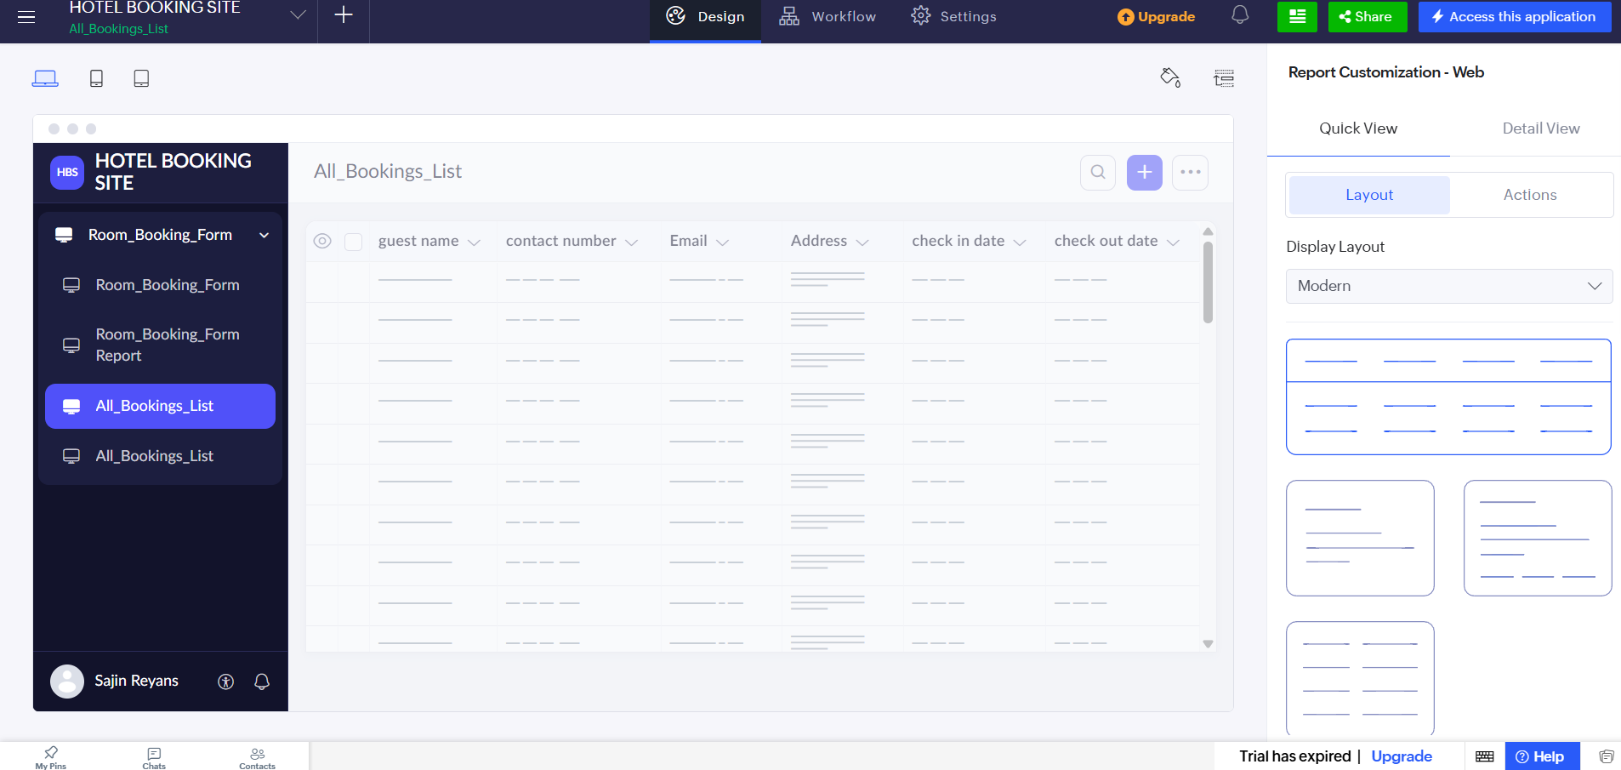
Figure 2: Report Customization – Layout options for All_Bookings_List
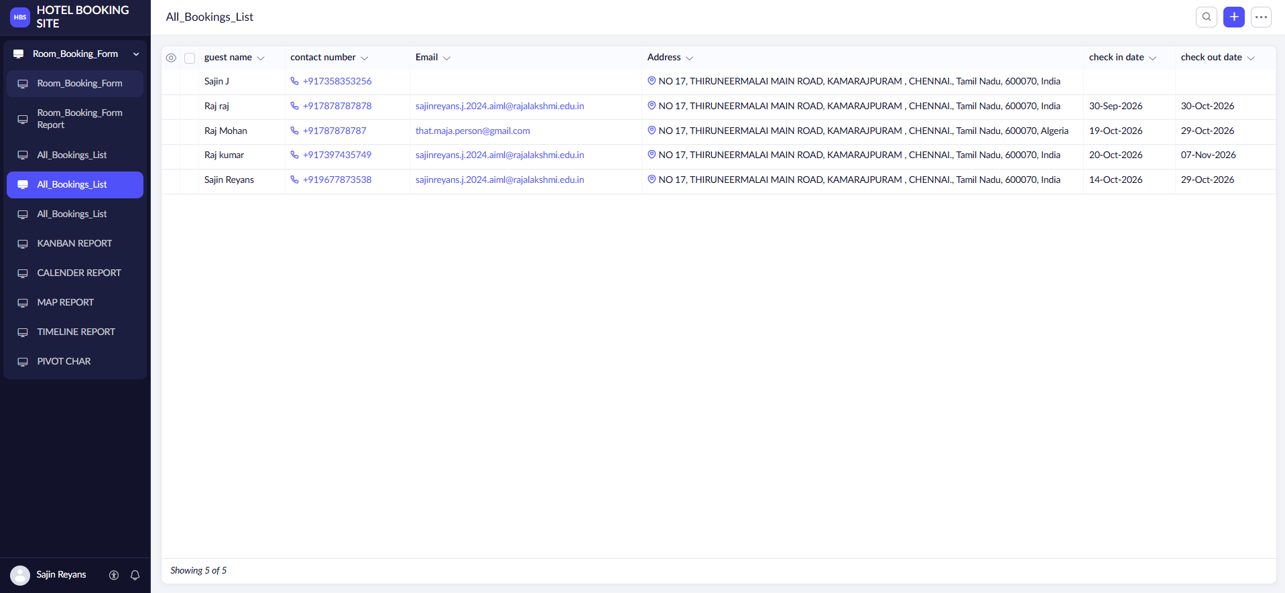
Figure 3: All_Bookings_List (List View) showing all 5 bookings
2. Spreadsheet View – Bookings_Spreadsheet
The Spreadsheet View presents the data in an editable grid. Front-office staff use it to update booking status, check-in status, check-out status and housekeeping status directly in the cells, in bulk, without opening each record. The status columns appear as drop-down fields so values can be changed inline.
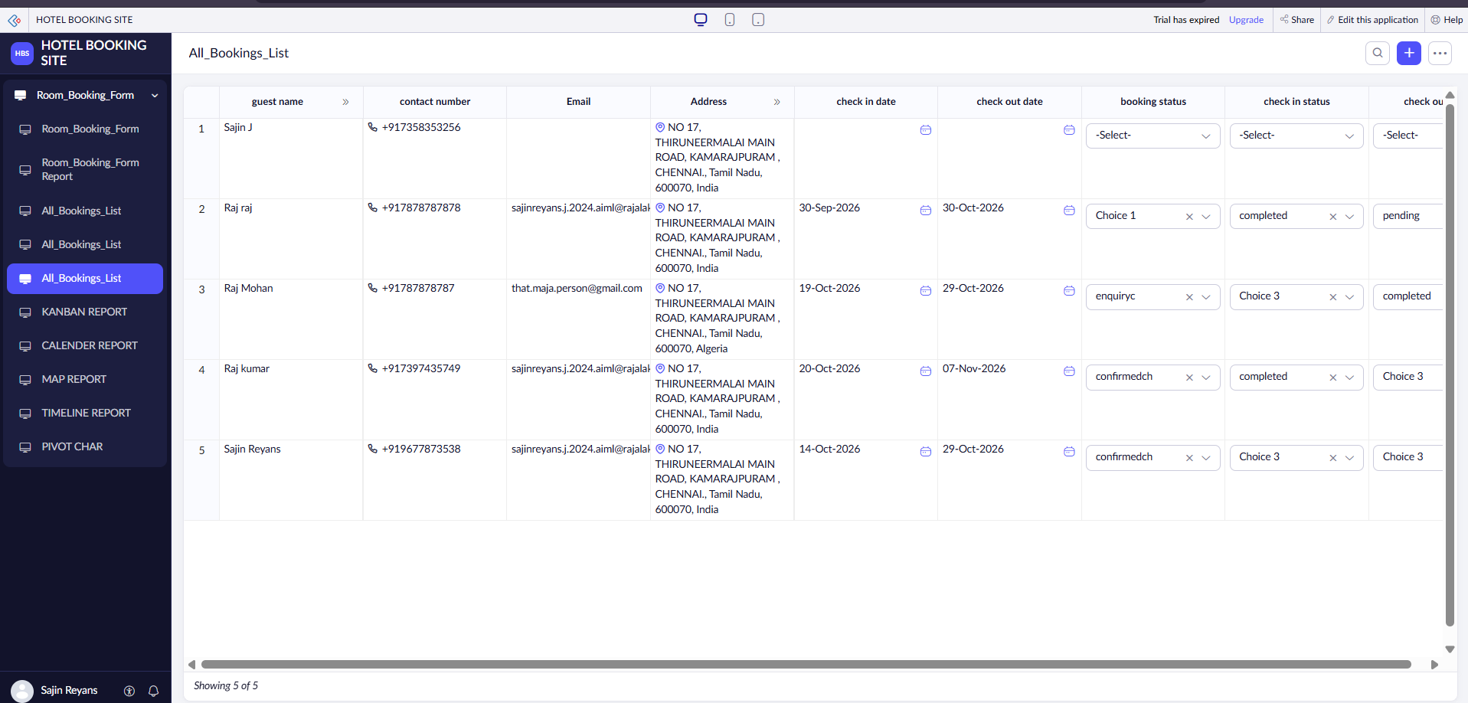
Figure 4: Spreadsheet View with inline-editable status columns
3. Kanban View – Booking_Status_Kanban
The Kanban View displays each booking as a card, grouped into columns by the booking status field. Each card shows the guest name and contact number. Staff can drag a card from one column to another as the booking progresses, and the underlying status field is updated automatically.
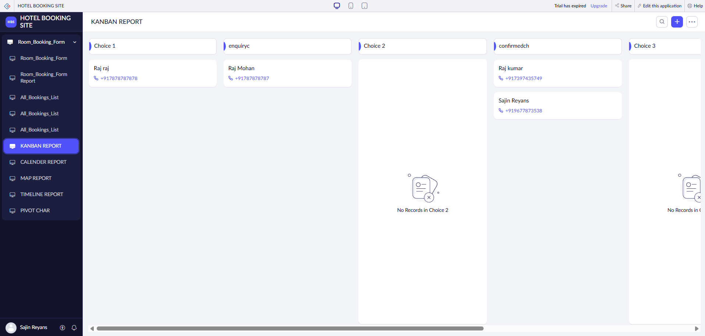
Figure 5: KANBAN REPORT – bookings grouped by booking status
4. Calendar View – Checkin_Schedule_Calendar
The Calendar View places each booking on the calendar using its date field. The report can be viewed by Month, Week or Day, and the Today button returns to the current date. Housekeeping and the front office use it to plan how many rooms must be ready on a given day.
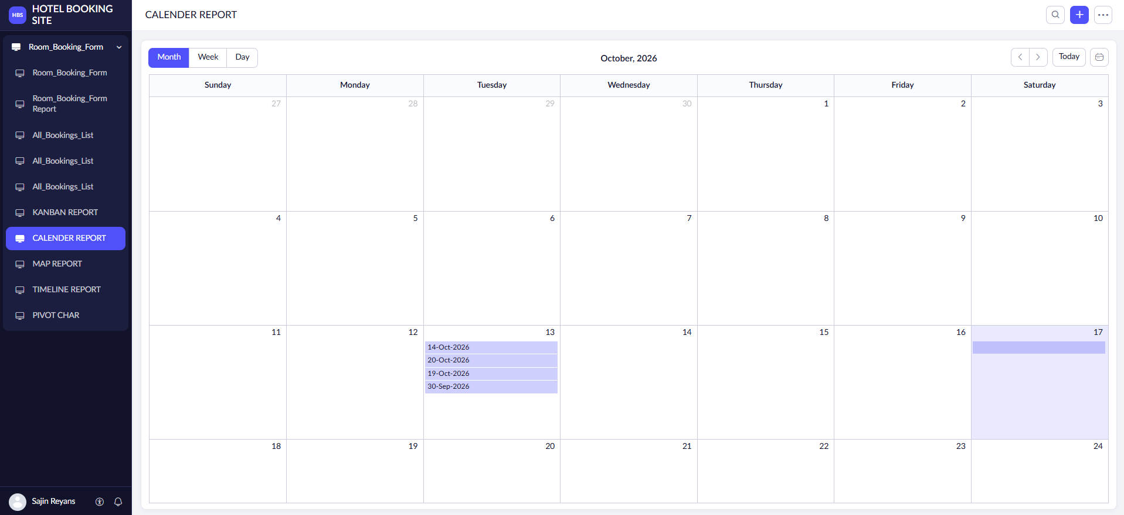
Figure 6: CALENDER REPORT – monthly view for October 2026
5. Map View – Guest_Origin_Map
The Map View plots the geocoded Address field of each booking as a location on a map. It includes a Search Location box, zoom controls and Basic, Satellite and Street map layers. The marketing team uses it to identify the cities and regions guests are travelling from, to plan regional campaigns.
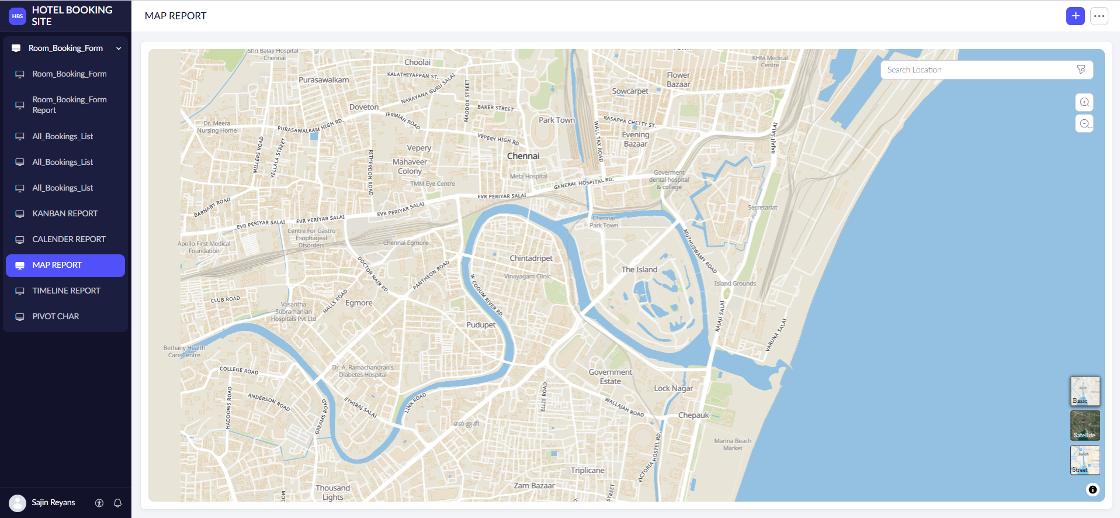
Figure 7: MAP REPORT – guest addresses plotted on the map
6. Timeline View – Booking_Activity_Timeline
The Timeline View arranges records along a time axis, with Week and Day scales and navigation arrows. Management uses it to monitor booking activity and momentum over time and to decide when to launch offers during low-booking periods.
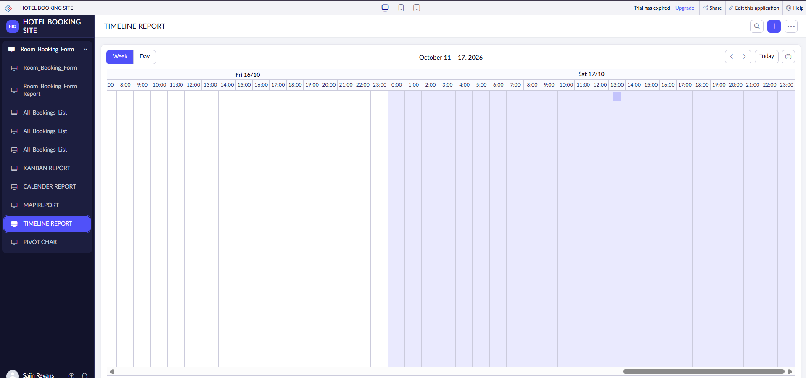
Figure 8: TIMELINE REPORT – weekly view (October 11 – 17, 2026)
7. Pivot Table / Analysis Report
The Pivot Table cross-tabulates one field against another (for example Room Type against Meal Plan) with a count of bookings as the value. In the report builder, the required columns are dragged from the Available Columns list to the axes, and the report is saved and regenerated to reflect new data. The screenshots below show the report builder and the generated output created for this application.
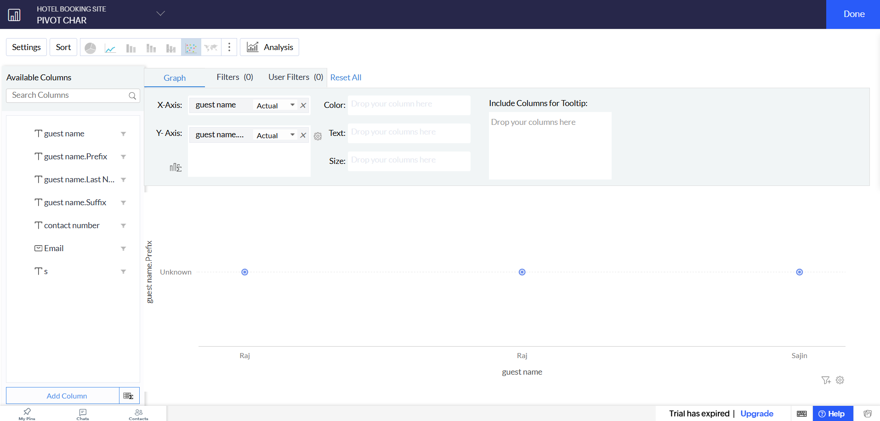
Figure 9: Pivot/analysis report builder with X-axis and Y-axis columns
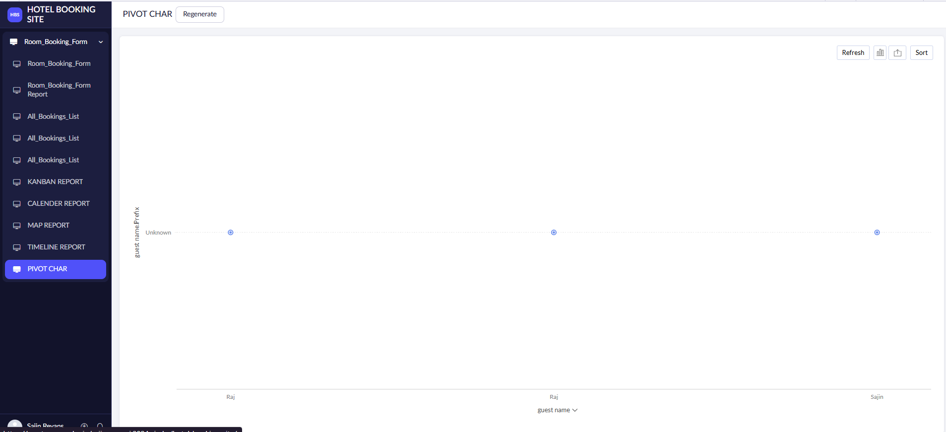
Figure 10: PIVOT CHAR – generated report output
8. Chart View – RoomType_Popularity_Chart
The Chart View displays the number of bookings per category as a bar chart, with the category on the X-axis and the count of bookings on the Y-axis. It is used in weekly review meetings to compare demand and to guide pricing and inventory decisions. It can be set to refresh whenever a new booking is submitted.
9. Summary View – Guest_Stay_Summary
The Summary View groups bookings by guest name and shows summary columns such as the count of bookings. The manager uses it to identify repeat guests for loyalty recognition and personalized offers. Grouping is case-insensitive and trimmed to avoid duplicate guest entries caused by inconsistent spelling.
Validation and Configuration Rules
- List View: default sort by check-in date, ascending, so the nearest arrivals appear first.
- Spreadsheet View: edit permission restricted to the Front Office role; all other fields are read-only.
- Kanban View: moving a card between columns automatically updates the status field.
- Calendar View: dates limited to the current and upcoming month for operational relevance.
- Map View: the Address field must be geocode-enabled for accurate pin placement.
- Timeline View: data refreshes daily to reflect the latest booking trend.
- Pivot Table: blank cells are displayed as zero rather than left empty.
- Chart View: set to auto-refresh whenever a new booking is submitted.
- Summary View: grouping is case-insensitive and trimmed to avoid duplicate guest entries.
Workflow Summary
- Guests submit bookings through the Room_Booking_Form.
- The front office manager monitors incoming bookings using the List View and Timeline View.
- Staff track progress visually using the Kanban View.
- Housekeeping uses the Calendar View to plan room turnover for each day.
- Marketing uses the Map View and Summary View to plan regional campaigns and loyalty outreach.
- Management reviews the Pivot Table and Chart View in weekly meetings to adjust pricing and packages.
- Daily, front-office staff use the Spreadsheet View to record check-in, check-out and housekeeping status in bulk.
Comparison of Report Types by Stakeholder
Stakeholder | Report Used | Decision Supported
Front Office | List, Spreadsheet, Kanban | Daily booking tracking and bulk status updates
Housekeeping | Calendar | Room readiness planning for arrivals
Marketing | Map, Summary | Regional campaigns and loyalty outreach
Management / Owner | Timeline, Pivot, Chart | Pricing, packages and seasonal offers
Result
Thus, a complete suite of Reports was successfully built on the Room_Booking_Form in Zoho Creator using the report types provided by the platform – List, Spreadsheet, Kanban, Calendar, Map, Timeline, Pivot Table, Chart and Summary views. Each report gives a specific stakeholder group a purpose-built view of the booking data without writing any code, demonstrating how Zoho Creator’s low-code approach enables quick, flexible and role-oriented reporting for the hotel.

