LifeCycle2

7.1

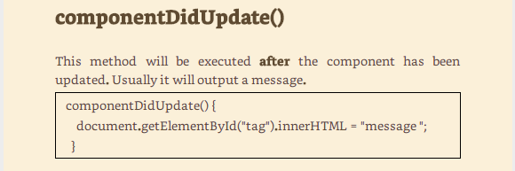

7.2

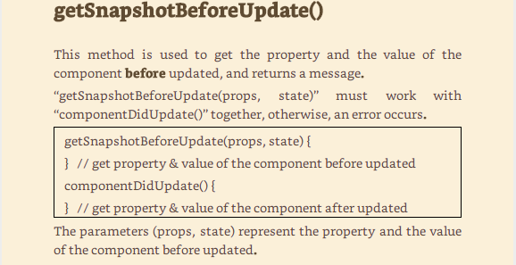

7.3

