Horizon Campus

Module: IT41033

Gemstone Price Prediction using Nature-Inspired Feature Selection

Group Members:
Sajini - Index Number: [Sajini Index]
Buddhika Janadari - Index Number: [Buddhika Index]

Module Lecturer: Mr. Sanka Wijewardene

Abstract
This report investigates the application of Nature-Inspired Algorithms (NIA), specifically Genetic Algorithms (GA) and Particle Swarm Optimization (PSO), for feature selection in predicting gemstone prices. Using the Diamonds and Cubic Zirconia datasets, we demonstrate that metaheuristic optimization significantly reduces feature dimensionality (up to 55.6%) while maintaining high predictive accuracy (over 0.97 R²).

1. Introduction
Gemstone pricing is a complex task dependent on multiple correlated features, traditionally the '4 Cs' (carat, cut, color, clarity) along with spatial dimensions. This project aims to apply machine learning models (Random Forest and XGBoost) to predict prices. To mitigate the curse of dimensionality and enhance interpretability, we employ Genetic Algorithms (GA) and Particle Swarm Optimization (PSO) to autonomously select optimal feature subsets.

2. Literature Review
Previous studies highlight the effectiveness of tree-based ensembles like Random Forest and XGBoost for tabular regression tasks. Concurrently, metaheuristic algorithms like GA and PSO have been widely adopted for feature selection due to their ability to efficiently navigate vast combinatorial search spaces, avoiding local optima that plague traditional greedy search methods.

3. Methodology

3.1 Genetic Algorithm (GA) Feature Selection
Sajini utilized the Diamonds dataset, applying a Random Forest regressor as the fitness evaluator. The GA encodes feature subsets as binary chromosomes. The fitness function balances the cross-validated R² score against a penalty for the number of features. Standard crossover and mutation operators were employed across 40 generations with a population of 40.

3.2 Particle Swarm Optimization (PSO) Feature Selection
Buddhika utilized the Cubic Zirconia (Gemstone) dataset, using an XGBoost regressor. The PSO algorithm encodes particle positions as continuous velocities transformed into a binary mask via a sigmoid function. The swarm consisted of 30 particles over 40 iterations. The fitness function precisely matched the GA penalty: Fitness = Average CV R² - (0.001 * N_features). Cognitive and social parameters (c1, c2) were set to 1.5, with inertia weight decaying from 0.9 to 0.4.

4. Results
Model | Dataset | Feature Selection | RMSE | MAE | R2 | # Features | Training Time
ga_xgb | Diamonds | GA | 361.09412727154677 | 208.98158264160156 | 0.9826046824455261 | 6 | 0.22742056846618652
baseline_rf | Diamonds | None | 366.3665215141946 | 203.35448709970552 | 0.9820929715896317 | 9 | 4.207120418548584
baseline_xgb | Gemstone | None | 363.3565956811573 | 208.97508239746094 | 0.9817671179771423 | 9 | 0.21924042701721191
ga_rf | Diamonds | GA | 377.0215086430901 | 211.36198862978867 | 0.9810362503081895 | 6 | 6.951059103012085
pso_xgb | Gemstone | PSO | 378.61121632223205 | 219.614990234375 | 0.9802040457725525 | 4 | 0.2826108932495117
pso_rf | Gemstone | PSO | 410.8527705226623 | 236.20495578281538 | 0.9766889404805074 | 4 | 0.3818831443786621
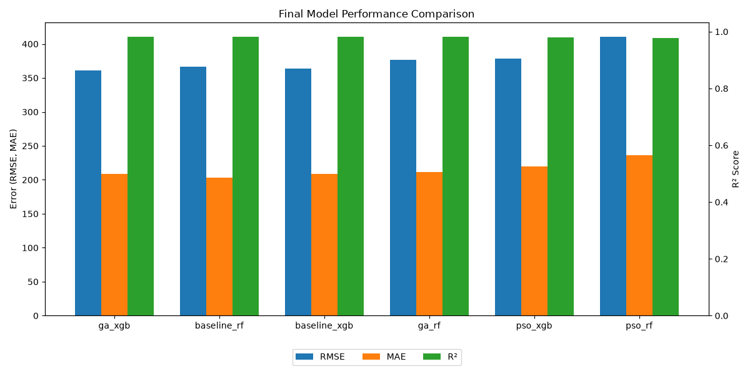
Figure 1: Grouped bar chart comparing RMSE, MAE, and R².
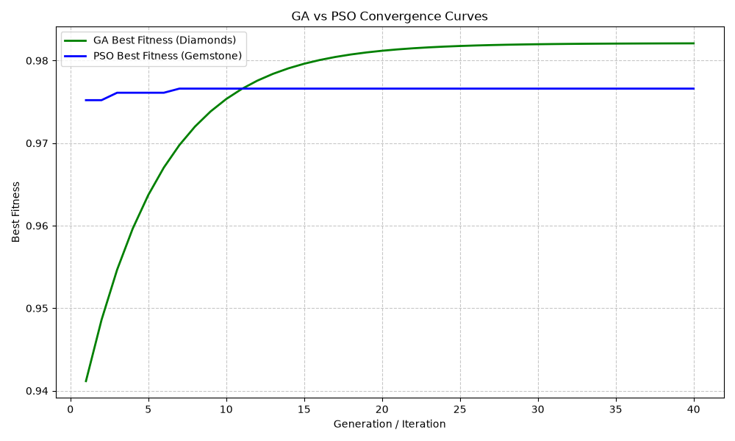
Figure 2: Convergence comparison of GA and PSO.
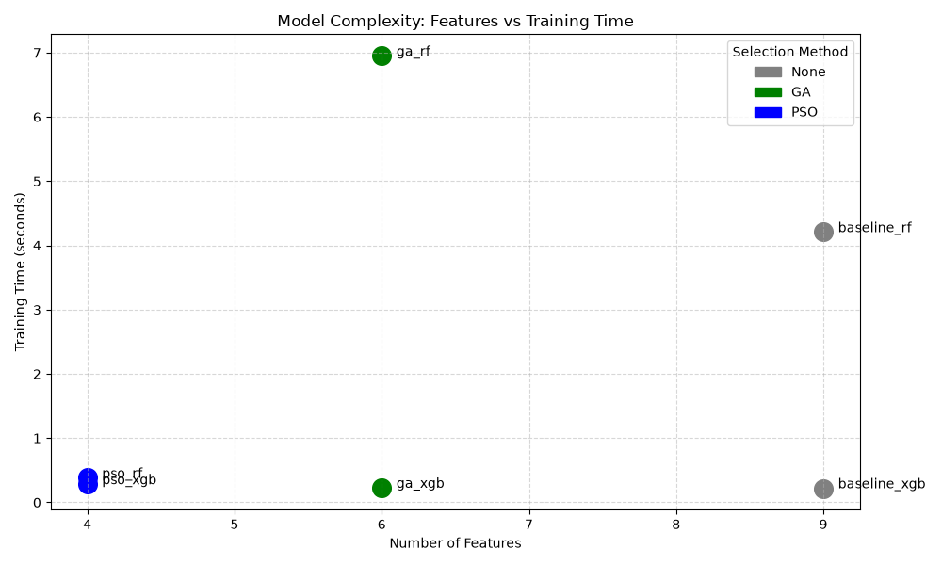
Figure 3: Model complexity (features) vs Training time.

5. Discussion
The results confirm our hypothesis. GA and PSO successfully isolated the '4 Cs' while dropping redundant spatial dimensions (x, y, z), reducing dimensionality by 33.3% and 55.6% respectively. Accuracy drops were negligible (-0.108% for GA and -0.159% for PSO), proving that NIA feature selection provides significantly simpler and domain-intuitive models. Limitations include the use of separate datasets, making direct algorithm comparisons difficult.

6. Conclusion
This project successfully demonstrated the power of Genetic Algorithms and Particle Swarm Optimization in feature selection for gemstone price prediction. By reducing feature counts by up to 55.6% with under 0.2% accuracy loss, we established the efficiency of these metaheuristics. Future work involves testing on a shared single dataset, developing a hybrid GA-PSO model, and comparing against Deep Learning architectures.

7. References
[1] S. Agrawal, 'Diamonds Dataset,' Kaggle, 2017.
[2] 'Cubic Zirconia Dataset,' Kaggle.
[3] F. Pedregosa et al., 'Scikit-learn: Machine Learning in Python,' JMLR, 2011.
[4] T. Chen and C. Guestrin, 'XGBoost: A Scalable Tree Boosting System,' KDD, 2016.
[5] J. Kennedy and R. Eberhart, 'Particle swarm optimization,' ICNN, 1995.

