A

Project Report on

**Virtual Stock Market**

By

Sajiri Mendjoge.

Nikita Jadhav.

In partial fulfillment of post-graduate course in

Master of Computer Application (semester IV)

2014-2015

University of Pune,

Fergusson College,

Pune – 411 004

# fergusson3_header_03

Deccan Education Society’s

Fergusson College, Pune

**Department Of Computer Science**

# CERTIFICATE

This is to certify that the project entitled ***Project Automation System***

Submitted by Sajiri Mnedjoge

In partial fulfillment of the requirement of the completion of

M.C.A II [Semester-4] to University of Pune, has been carried out

by them under our guidance satisfactorily during the academic year 2014-2015.

Place: Pune

Date: / /

**H.O.D**

**Department Of Compute Science**

**Fergusson College, Pune**

**Project Guide:**

1. **\_\_\_\_\_\_\_\_\_\_\_\_\_\_ 2. \_\_\_\_\_\_\_\_\_\_\_\_\_\_**

**Examiners’ Name Sign**

**1. \_\_\_\_\_\_\_\_\_\_\_\_\_\_\_\_\_\_\_\_\_\_\_\_\_\_\_ \_\_\_\_\_\_\_\_\_\_\_\_\_\_\_**

**2. \_\_\_\_\_\_\_\_\_\_\_\_\_\_\_\_\_\_\_\_\_\_\_\_\_\_\_** **\_\_\_\_\_\_\_\_\_\_\_\_\_\_\_**

**CERTIFICATE**

This is to certify that the project entitled TIME TABLE GENERATOR has been carried out by the team under my guidance in partial fulfillment of the Masters in Computer Application of University of Pune, Pune during the academic year 2015-2016.

**Project Guide Head, Computer Department**

**Date:**

**PROJECT APPROVAL SHEET**

Following team has done the appropriate work related to the TIMETABLE GENERATOR in partial fulfillment for the award of Bachelor of Science (Computer Science) of “University of Pune, Pune” and is being submitted to Fergusson College, Pune.

**Team:**

**Guide:**

**Date:**

**External Examiner Internal Examiner**

**ACKNOWLEDGEMENT**

The satisfaction that accompanies that the successful completion of any task would be incomplete without the mention of people whose ceaseless cooperation made it possible, whose constant guidance and encouragement crown all efforts with success.

We are grateful to our project guide Mr Tushar Deshmukh for the guidance, inspiration and constructive suggestions that helped us in the preparation of this project.

**INDEX**

|  |  |  |  |  |
| --- | --- | --- | --- | --- |
| Sr. No |  |  | Topic | Page No |
| 1 |  |  | Introduction | 1 |
|  | 1.1 |  | Objective of project |  |
|  | 1.2 |  | Problem Description |  |
|  | 1.3 |  | Scope of the Project |  |
|  | 1.4 |  | Hardware / Software Specifications |  |
| 2 |  |  | Software Development Lifecycle | 3 |
|  | 2.1 |  | Requirement Analysis |  |
|  | 2.2 |  | Feasibility Study |  |
|  |  | 2.2.1 | Technical feasibility |  |
|  |  | 2.2.2 | Economical feasibility |  |
|  |  | 2.2.3 | Operational feasibility |  |
|  | 2.3 |  | Modeling | 5 |
|  |  | 2.3.1 | Entity Relationship Diagrams |  |
|  |  | 2.3.2 | UML Diagram |  |
|  |  |  | Use Case Diagram |  |
|  |  |  | Sequence Diagram |  |
|  |  |  | Class Diagram |  |
|  |  |  | Activity Diagram |  |
|  |  |  | Component Diagram |  |
|  |  |  | Deployment Diagram |  |
|  | 2.4 |  | Design |  |
|  |  | 2.4.1 | Database tables designing |  |
|  |  | 2.4.2 | Screen Shots |  |
|  | 2.5 |  | Testing | 34 |
|  |  | 2.5.1 | Types of testing |  |
|  |  | 2.5.2 | Test Cases |  |
| 3 |  |  | Limitations | 37 |
| 4 |  |  | Future Enhancement | 37 |
| 5 |  |  | Bibliography | 38 |

1. **Introduction**
2. INTRODUCTION

When a fresh trader enters in the new world of investments in the stock market most commonly has a face a substantial loss. There are hardly any chances that a new trader can book a profit. Just not having a loss in the market is not enough, a trader should book at least minimum profit proportional to his total investments in the market. Since the fresh trader does not have any experience he actually don’t know ‘when’, ’how’ and ‘where’ to invest. A fresh user faces the most common mistakes or problems.

1.1

OBJECTIVES

1. It will be simple to use-trader will require a minimum of training.
2. It will be easy to learn user interface, designed for quick data entry.
3. Advanced system with customizable will pull down menus to speed data entry.
4. A unique id will be generated for every trader.
5. Up-to-the-minute Stock information and status to the faster collaboration.
6. Share trader will use RTD i.e. Real Time Data to get exact behavior of the market.
7. Restricted Access Levels to data modification will be done.
8. Auto generated Date and Time will be added to database for future references.
9. Daily Report will be given to the trader regarding the status of issues at stock market.
10. No risk will be taken without any real time money.
11. It should be a full featured trading environment to see if you have what it takes to be a real time professional day trader.
12. The system will be 100% security of investments.
13. Share trading system will aim at giving investors an easy and interactive platform.
14. It will be simple to use-trader will require a minimum of training.
15. It will be easy to learn user interface, designed for quick data entry.
16. Advanced system with customizable will pull down menus to speed data entry.
17. A unique id will be generated for every trader.
18. Up-to-the-minute Stock information and status to the faster collaboration.
19. Share trader will use RTD i.e. Real Time Data to get exact behavior of the market.
20. Restricted Access Levels to data modification will be done.
21. Auto generated Date and Time will be added to database for future references.
22. Daily Report will be given to the trader regarding the status of issues at stock market.
23. No risk will be taken without any real time money.
24. It should be a full featured trading environment to see if you have what it takes to be a real time professional day trader.
25. The system will be 100% security of investments.
26. Share trading system will aim at giving investors an easy and interactive platform.

1.2 PROBLEM DEFINATION

1. Without having any idea of the environment a trader can face a substantial loss.
2. If a new trader consults a professional adviser, he has to pay a huge amount from his own profit.
3. If a user earns some profit the basic human tendency or his grid to earn some more profit can lead the trader to loose his all profit.
4. If a user is already facing some loss, his efforts for profit can cause a huge substantial loss.
5. Unwanted tips or advises can mislead the user or can disturb his calculations.
6. Following other experienced traders can misguide the fresh trader.
7. One stroke investments/ one stroke disinvestments can cause more loss or less profit.
8. Sudden raise or sudden fall or sudden raise followed by sudden fall can misguide the fresh trader.
9. Unawareness about all other possible scripts or options in the market will not give any kind of benefit.
10. A single time investments can cause pecuniary loss.

1.3 SCOPE

It is really difficult to understand the science of the market. For one he could try his luck by straight investing his hard earn money at the stock market. Or else rather do practice on a share setup before actually entering the arena. Grid and fear when used in a combination or otherwise prove extremely fetal. While investing in market to know when to book a profit how to cut your losses is very important to be successful at this business. So for a new user to get used to these scenarios he would practice the art of investing. It is a better way to do this in a virtual environment rather than loosing hard earned money.

Share trading is the platform which depicts the real life live scenario at the market itself. Share trading offers you a full featured trading environment of share market. It is a tool which can be used for a beginner to practice and test his skills in the market. The Share Trading software provides the Real Time Data (R.T.D) which gives the actual experience of the market. Using this new trader can do the actual transactions in the market without using real money. So that a person can take decisions whether to invest in the stock market at that particular time. In short Share Trading gives you a complete trading education. By using which a trader can develop their skills and practice. It is a full featured trading environment to see if you have what it takes to be real time professional day trader.

1.4 DEFINATIONS, ACRONYNMS AND ABBREVIATIONS

uname: username

upass: user password

bquantity : brought share quantity.

bprice : brought share price.

squantity : sold share quantity.

sprice : sold share price.

1.5 HARDWARE AND SOFTWARE SPECIFICATIONS

Hardware Requirements

\* Processor: Pentium 3 or later.

\* Hard disk Space: 500 MB.

\* RAM: 256 MB.

\*Internet enabled computer.

Software Requirements

\* JDK 6 onwards.

\* Database: my sql /oracle.

2. SYSTEM DEVELOPMENT LIFE CYCLE

2.1 SYSTEM REQUIREMENTS ANALYSIS

This phase is the most important phase as it deals with the design and development of the proposed system. The design is developed in such a way that user will be able to operate the application easily and efficiently.

In the proposed system user has to login using his/her user ID and password which will be generated by administrator. Administrator generates user ID with a initial balance in users account. After logging in user can view the scrip of his/her choice in a tabular format. The scrip in table gives the continuous updates about the price, volume, change etc. User can edit columns which contains attributes of the scrip. User can save or load scrip lists. After that user can buy scrip if the quantity is affordable for his balance. User can also sell the scrip provided he has purchased enough quantity in his account.

After each buy/sell transaction user balance in the table is updated. Similarly user can view his/her balance and transaction report, which will give complete details about his daily transactions.

Similarly, when Administrator logs in he can add another administrator account, user account, or a scrip. He can also update the balance of a particular user.

2.2FEASIBILITY STUDY

2.2.1 TECHNICAL FEASIBILITY

Technical feasibility deals with study of whether the development of the proposed project is technically possible. Even if the project is technically possible, one has to decide on whether using required technology is within the reach of the developer.

Java being a platform independent language, it would be easy to implement on different client dependent platforms.

In this particular project proposal, the technology used is simple and easily available. The main requirement for this project are GUL Database connectivity, Multi-threading. JAVA is capable of meeting all these requirements successfully. Thus no external software is required.

In short, the proposed system uses a simple technology, which can be accessed and implemented successfully. Thus the complete project is technically feasible.

2.2.2 OPERATIONAL FEASIBILITY

Any proposed system is beneficial only if can be turned into an information system, which will meet the organization’s operating requirements.

A look in the proposed system suggests that it is exceptionally easy to use and operate on thus providing a pleasant work experience.

2.2.3 ECONOMIC FEASIBILITY

Economic feasibility deals with study of whether the development of the proposed project is economically affordable. Even if the project is economically affordable, one has to decide on whether after spending required amount of money on the proposed system are we able to price such that it would also be affordable to the user/buyer. Also is the proposed system worth money required for developing project.

In this project proposal, the only major expenditure that should be taken into consideration is the net connection. Since the proposed system will be taking the input directly from the website which wont charge for Real Time Data. Some miscellaneous expenditure will be added to the total cost of the proposed system. Thus we can conclude that this project proposal does not involve high expenditure reducing the ultimate cost of the project. So we can say the share trading software is economically feasible.

2.3 SYSTEM DESIGN

ERD Diagram

sold

bought

Userinfo

Use-case diagram

User/Trader

Sequence Diagram.

System screen

User

Database

Virtual stock market System

Login page opens

Log out

Account

Changesaved

Changes in db

Buy share

Bal shown

Bal fetched

Query for bal

Check bal

Details inserted

Insert details

Project added

Add Project

Show profile

Appinfo displayed

Details inserted

Login successful

Details inserted

Inser t details

Sign up and Login

Activity diagram.

Buy sell

sharename

sharename

no

Enter quantity

Enter quantity

Enter price

Enter price

If bal < price\*quantity

qua

Buy share and make its entry

Yes No

Buy share and make its entry

Display error msg

Check account details

Logout

yes

Done

Class diagram

Login

-ImageIcon i;

+uname String

+uemail String

+Mainpage(String):char

+newuser(String):void

Responsibility : to maintain User data

Mainpage

-tid int

+tname String

+showprofile():void

+Update(String):void

+showbal(string):void

+buyshare();

+sellshare();

Responsibility : to maintain Teacher data

Balance

+unameString

+Mainpage(String):char

+updatebal(String):int

+showbal(string):int

=ssh+++

Responsibility : to maintain and update user balance

Script

-bno int

+sno int

+sharename String

+buyshrare():

+sellshare(String)

+showboughttransc();

+showsoldtransc();

Responsibility : to maintain treding transactions.

Deployment diagram:

connections

Datatbase

User/Client

Virtual

Stock

market

NODES

Component Diagram.

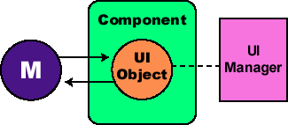

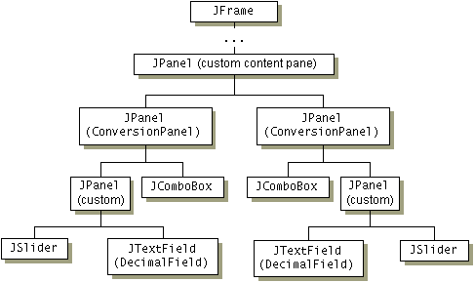

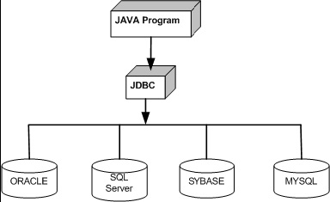

2.4 DATABASE STRUCTURE

* 1. The databases are used for almost all the activities in the system. There are total 6 tables used in the system, namely login (user login), Admin (Administrator login), Scrips (scrip details), Buy (Stock details which user buy), Sell (Stock details which users sell), ScripLists (list of stock name). All these six table work with each other to perform transactions. Thus all the tables are interrelated.

2.4.1**. Database tables designing**

.We have given the same name as that of the project that is Virtualstockmarket to

database used in this application. There will be 3 tables present in this database as given below.

1.Userinfo

2.bought

3.sold

1. **Database Table Designing**

**Userinfo Table**

|  |  |  |  |
| --- | --- | --- | --- |
| **Name** | **Key status** | **Data-type** | **Decription** |
| **Userno** |  | **Int not null** | **No. assigned to the User.** |
| **Username** |  | **Varchar(20)** | **Name of the User/client.** |
| **Userid** | **Primary key** | **Varchar(20)** | **Id of the User** |
| **Userpass** |  | **Varchar(20)** | **Password of the User** |
| **Balance** |  | **Int** | **Balance of the User.** |

**bought Table**

1

|  |  |  |  |
| --- | --- | --- | --- |
| **Name** | **Key status** | **Data-type** | **Decription** |
| **bno** | **Primary key** | **Int not null** | **No. assigned to the the bought transaction.** |
| **Userid** | **Foreign key** | **Varchar(20)** | **Id of the User** |
| **Sharename** |  | **Varchar(20)** | **Name of the share that is bought** |
| **bquantity** |  | **Varchar(20)** | **Quantity of the share that has been bought** |
| **bprice** |  | **Int** | **Price of the share that has been bought** |
| **totalbprice** |  |  | **Share price\* share quantity.** |

**sold Table**

|  |  |  |  |
| --- | --- | --- | --- |
| **Name** | **Key status** | **Data-type** | **Decription** |
| **sno** | **Primary key** | **Int not null** | **No. assigned to the the sold transaction.** |
| **Userid** | **Foreign key** | **Varchar(20)** | **Id of the User** |
| **Sharename** |  | **Varchar(20)** | **Name of the share that is sold** |
| **squantity** |  | **Varchar(20)** | **Quantity of the share that has been sold** |
| **sprice** |  | **Int** | **Price of the share that has been sold** |
| **totalsprice** |  |  | **Share price\* share quantity.** |

**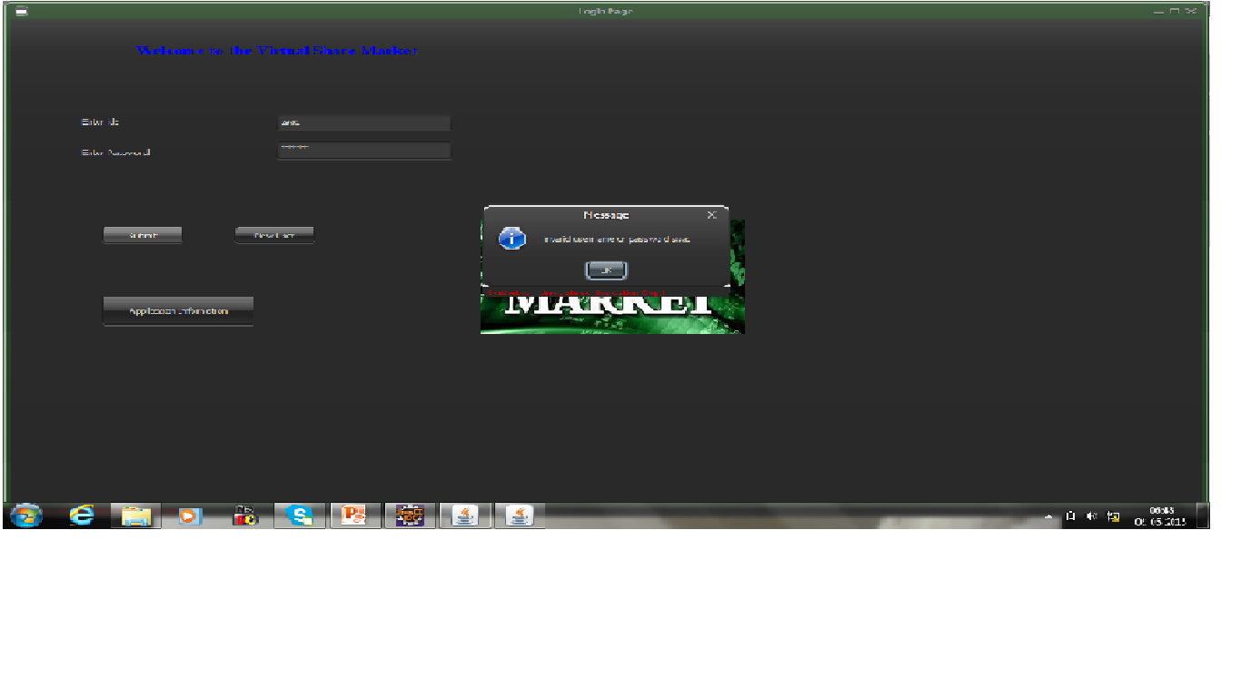2.4.2** Screen Shots

**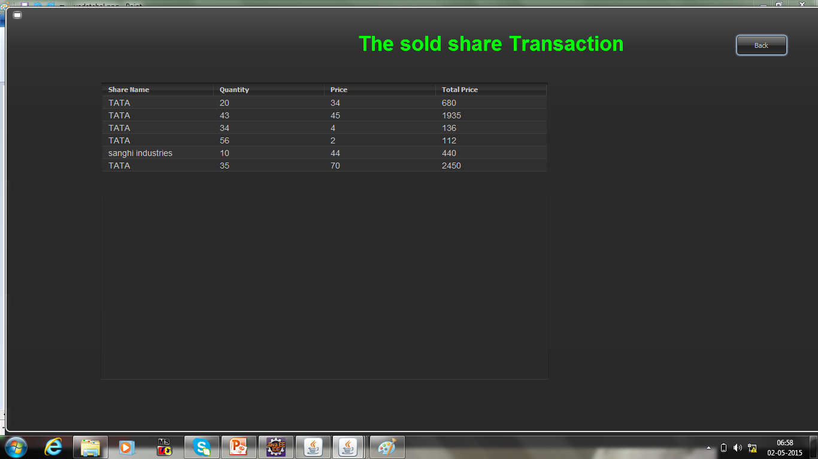**

**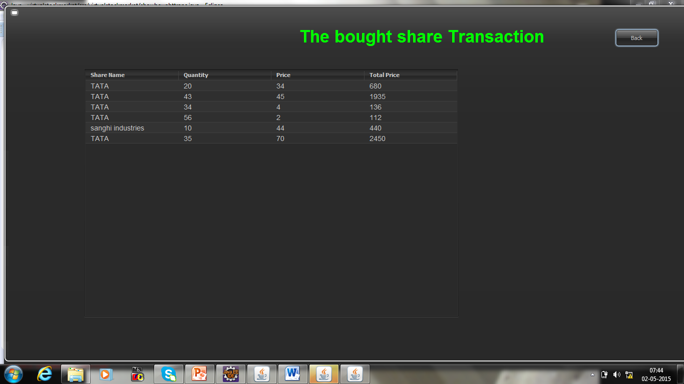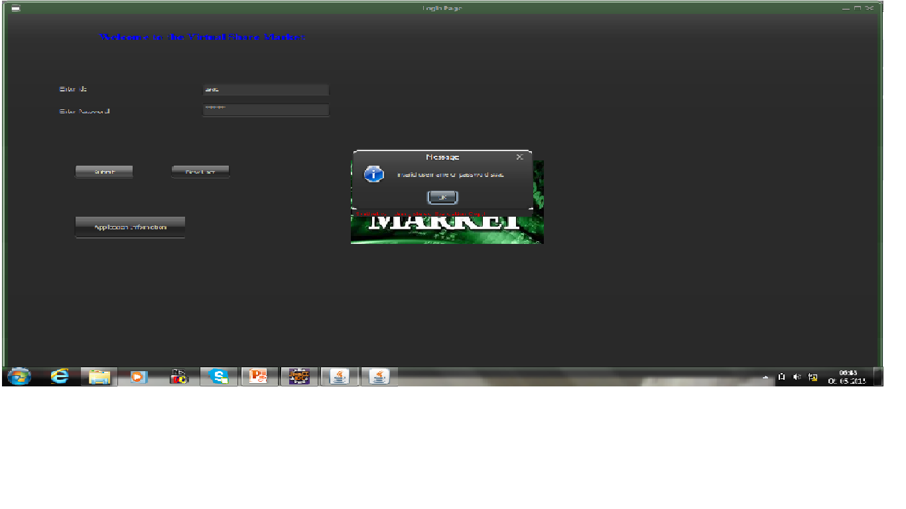**

**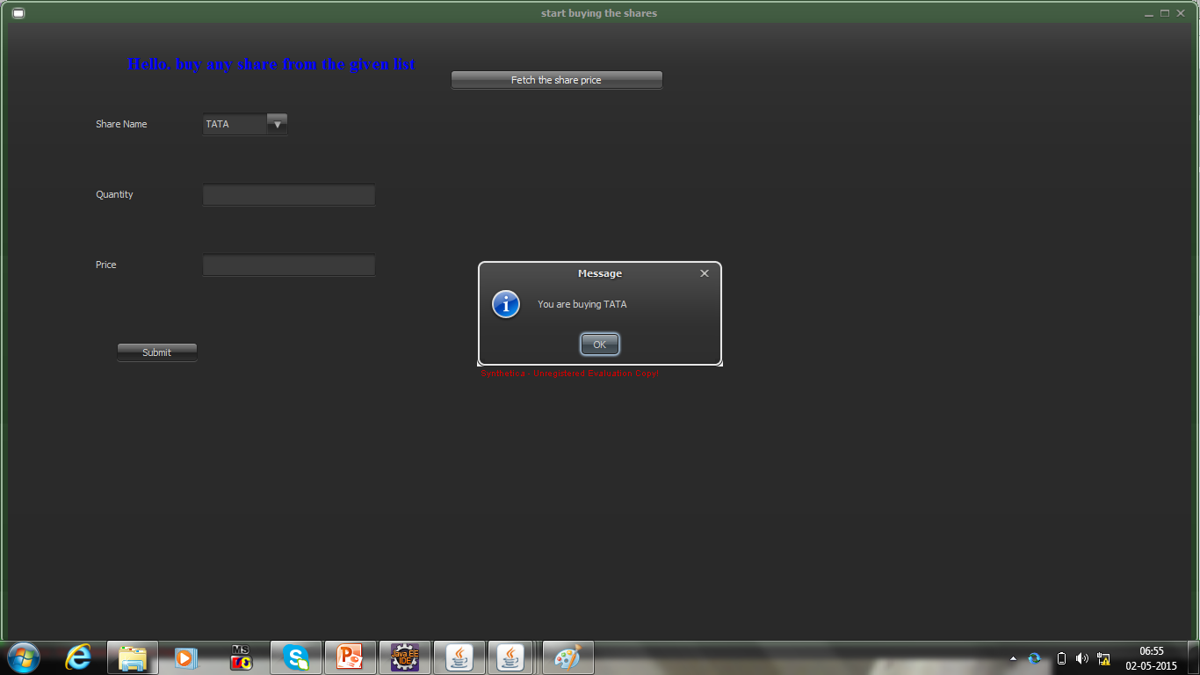**

**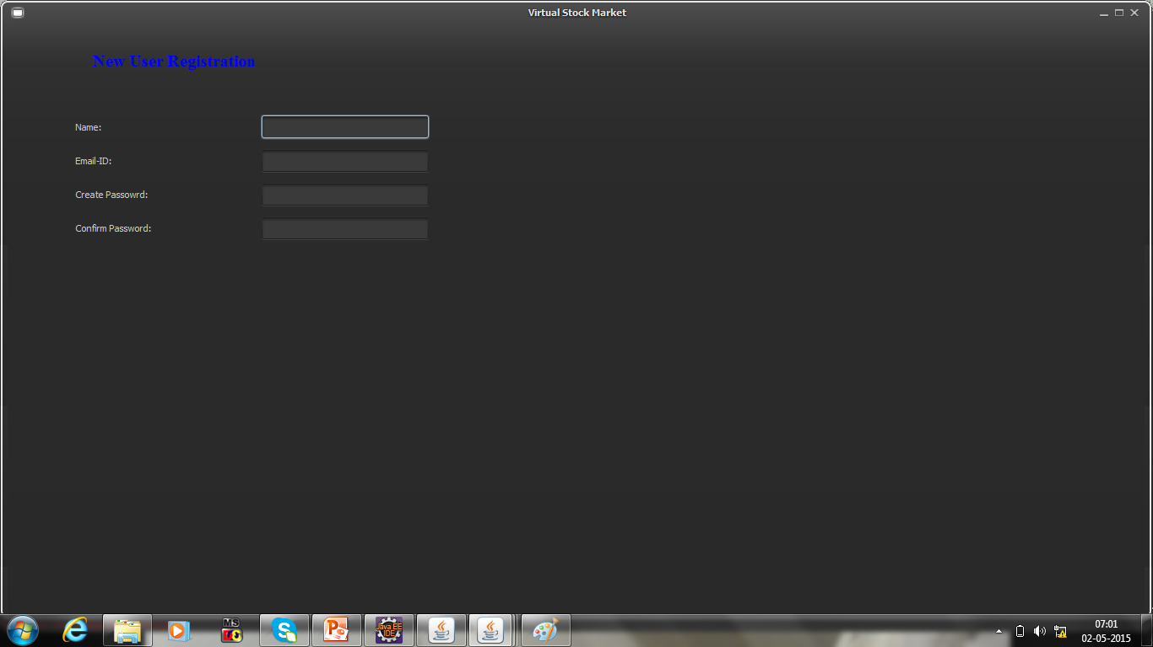**

**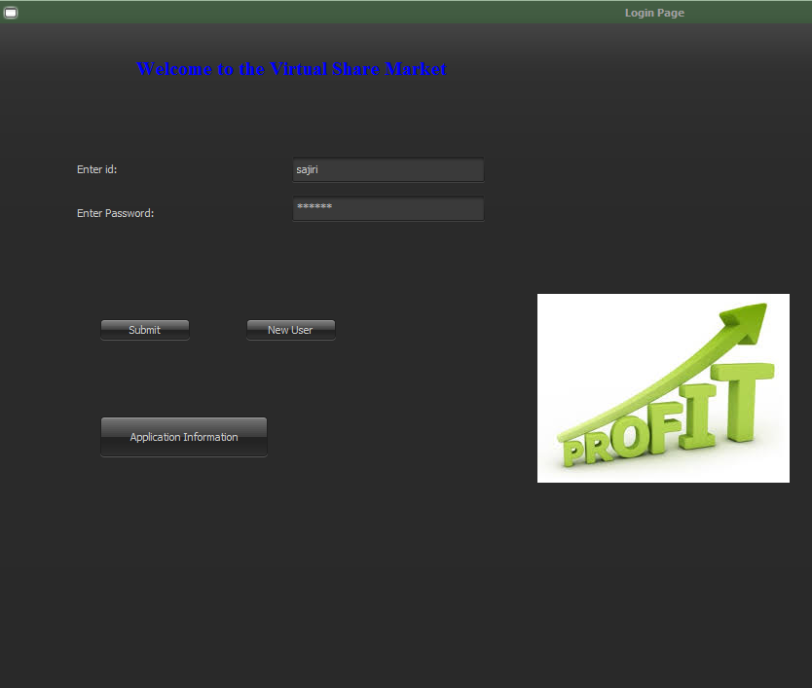**

**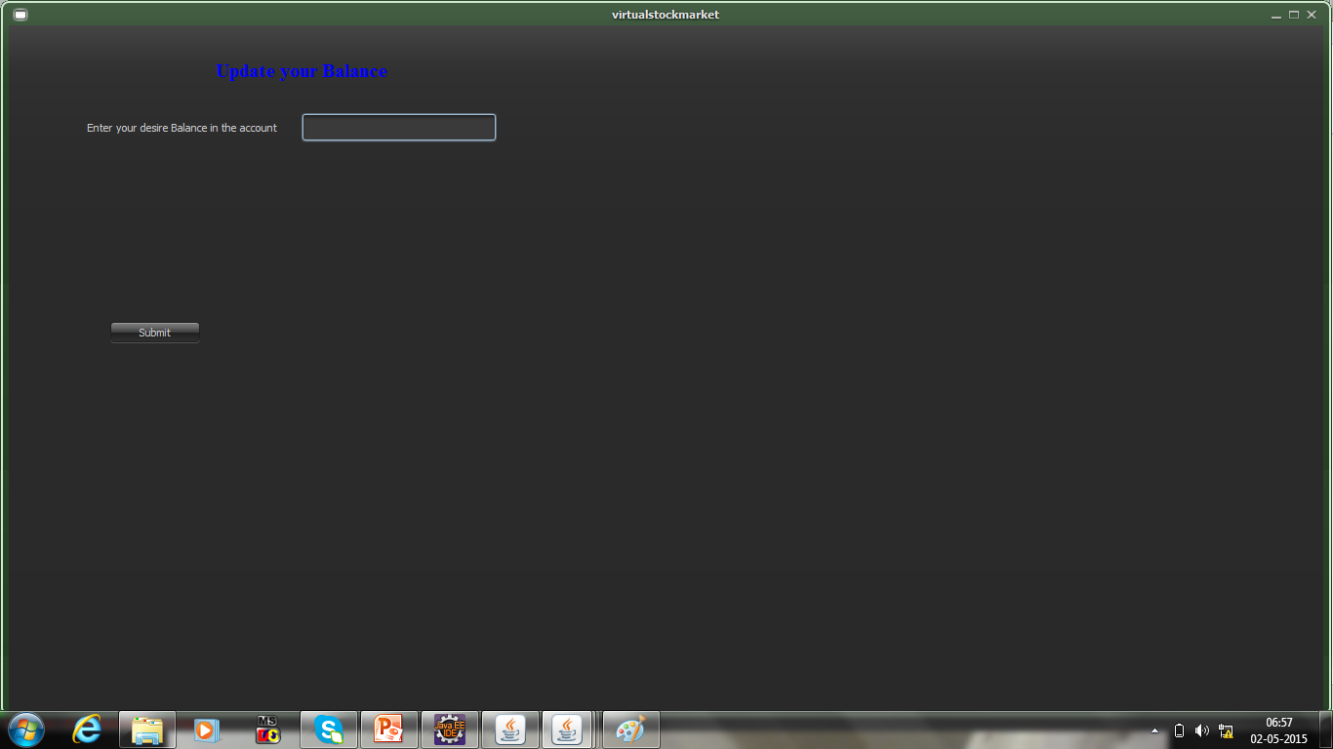**

**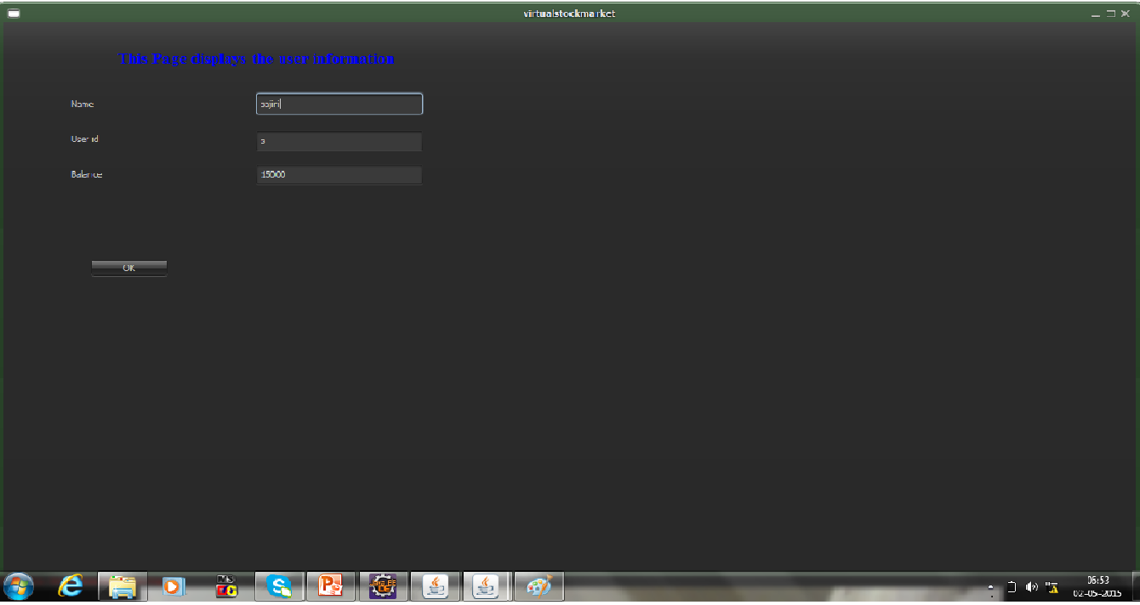**

**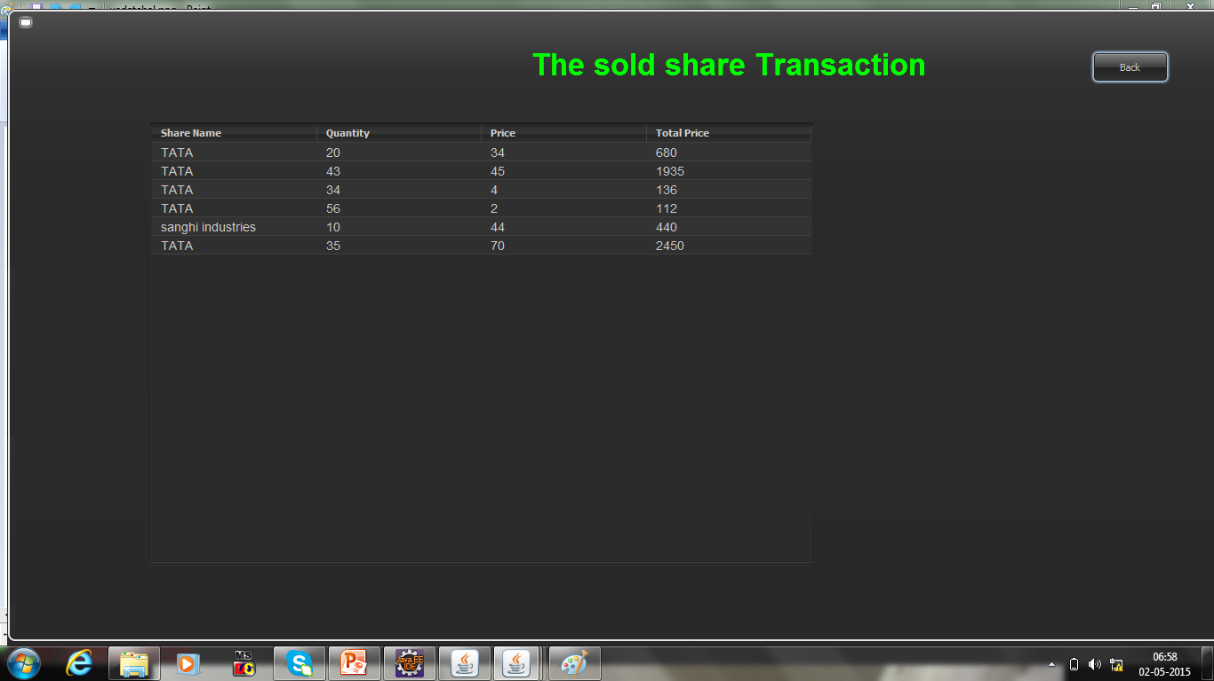**

2.5 TESTING

2

2.5.1 TYPES OF TESTING

2.5.1.1 UNIT TESTING

Unit Testing is done by testing the functionalities of all the classes. E.g class login is tested so that all its methods are executed.

2.5.1.2 Integration Testing

Use Case based testing is done by testing first independent classes(class Login, class newuser, class mainpage) and then dependent classes like(class buyshare, class sellshare)etc. All collaborating classes are tested together to perform clustered testing.

2.5.1.3 **System Testing**

System testing is actually a series of different tests whose primary purpose is to fully exercise the computer-based system.

* Recovery Testing: It is a system that forces the software to fail in a variety of ways and verifies that the recovery is properly performed.
* Security Testing: It attempts to verify that protection mechanisms built into a system will in fact protect it from improper penetration. The system’s security must of course be tested from in vulnerability form frontal attack.
* Stress Testing: It executes a system in a manner that demands resources in abnormal quantity and volume.

2.5.2 TEST CASES

2.5.2.1 TEST CASE FOR LOGIN

|  |  |  |  |  |
| --- | --- | --- | --- | --- |
| Test id | Test Case | Expected Result | Actual Result | Pass/Fail |
| 1. | User/Admin Enters login info. | System should check if details are entered properly and check whether the password entered is valid, open the next appropriate window. | As Expected. | Pass |
| 2. | User/Admin Enters login info. | System should check if details are entered properly and check whether the password entered is not valid | As Expected. | Pass |

2.5.2.2 TEST CASE FOR LOGOUT.

|  |  |  |  |  |
| --- | --- | --- | --- | --- |
| Test id | Test Case | Expected Result | Actual Result | Pass/Fail |
| 1. | User/Admin clicks sign-out. | System displays appropriate screen and logs out of the system. | As Expected. | Pass |

2.5.2.3 TEST CASE FOR BUY

|  |  |  |  |  |
| --- | --- | --- | --- | --- |
| Test id | Test Case | Expected Result | Actual Result | Pass/Fail |
| 1. | User buys n quantity of shares at price p. | If n\*p> user limit then display error message | Error message displayed. | Pass |
| 2. | User buys n quantity of shares at price p. | If n\*p> user limit then perform transaction update database and display successful message. | Successful message displayed. | Pass |

3. LIMITATIONS OF THE PROJECT

In real time system, we have 3 basic types of transactions which include buy, sell and shortsell. In case of shortsell a trader can sell the stocks before buying. But he has to follow some rules. After trader shortsell the stock he has to buy the same quantity of the stock within the fixed time period (maybe 2 days).

In our case we can not include the shortsell option since this is a standalone application. User related information will be stored on the same machine. If the user does not log in within 2 days he won’t be able to buy the stock in given time period. And if he logs in after 3 days we won’t be having the stock market history available to perform the transaction.

Thus we cannot include the shortsell option in the proposed system even if it is one of the basic operations in the Stock Market.

4. FUTURE ENHANCEMENTS

The scope can be the proposed system is limited to only India. It includes the NSE(National Stock Exchange). It can be enhanced to global stock market.

The system can be enhanced to the system which will contain all the operations in the stock market like

* Shortsell
* Buy with limit price
* Sell with limit price

The system can also provide tools to study the stock market such as graph.

5. BIBLIOGRAPHY

Ken Arnold and James Gosling (1998), The Java Programming Language, Second Edition, Addision-Wesley.

Gary Cornell and Cay S. Horstmann (1997),Core Java, Second edition, Sunsoft Press.

Peter Coad and Mark Mayfield (1996), Java Design: Building Better Apps and Applets, Yourdon Press.