R2: Geo Experiment Design
+40% paid-social test, 1-28 June 2026. Online retailer, 16 US states. Tooling: Meridian GeoX v1.0.1 (TBR) plus custom constraint screening.
Bottom line: PROCEED with treatment in Ohio, Pennsylvania and Missouri (16.0% of audited revenue, +$274,106 spend) against an 11-state BAU comparison pool. Estimated MDE is 1.3-1.8% of treated revenue against the 2.5% planning effect. WI+TN+KY is the fallback.

1. Raw data analysis
The workbook holds 2,260 daily rows (Jan 12 - May 31, 2026), 16 markets, an audience-overlap table and a 7-row operations calendar. Prices are USD. The outcome is finance net_revenue_usd; platform-attributed revenue is not used as an outcome. Table 1 lists what was wrong and what I did.
Issue | What I found | Decision | Effect on analysis
Duplicate rows | 20 exact duplicates appended at the end of the sheet (2,260 rows vs 16 states x 140 days = 2,240). | Dropped; panel is now complete with no missing state-days. | Prevents double-counted revenue and a distorted pre-period fit.
State labels | 40 rows use lower-case or padded codes (e.g. "nv", " CA"), giving 32 labels for 16 states. | Trimmed and upper-cased to 16 geos. | Without this GeoX would treat one state as two geos.
Georgia revenue | 4 days (Apr 13-16) show revenue 0 and orders 0 with revenue_feed_complete = 0 (the documented export incident); a further 8 days in February have blank revenue (not in the calendar). | Treated all 12 as missing. Filled 8 as orders x local AOV, 4 as same-weekday median. Spend and platform data untouched. | 12 of 2,240 rows (0.5%). GA only enters as a comparison state; dropping GA moves the MDE from 1.32% to 1.38%.
Nevada anomalies | 3 negative spend values (-$1,850 to -$1,950; credits, which the spend definition excludes), 2 negative order counts, and 27 revenue days more than 25% off a 15-day rolling median (no other state has any). | Spend set to NV median, orders to absolute value, revenue kept. | NV is small (1.3% of revenue) but noisy. Kept in pool, stress-tested: dropping it moves MDE 1.32% to 1.53%.
Audit reconciliation | Cleaned May 4-31 revenue equals audited_last_28d_revenue_usd exactly in all 16 states (ratio 1.000). Total $46,177,710. | Audited totals used for the 12-25% share rule; daily data accepted for May. | Confirms the last 28 days, which GeoX uses to size effects, are clean.
Spend vs BAU plan | Median daily spend is within 0.4% of planned BAU in every state, with almost no day-to-day variation. | BAU plan accepted as credible. | Good for cost maths; but history contains no spend experiments, so response to spend cannot be learned from it.
Table 1. Data preparation log.
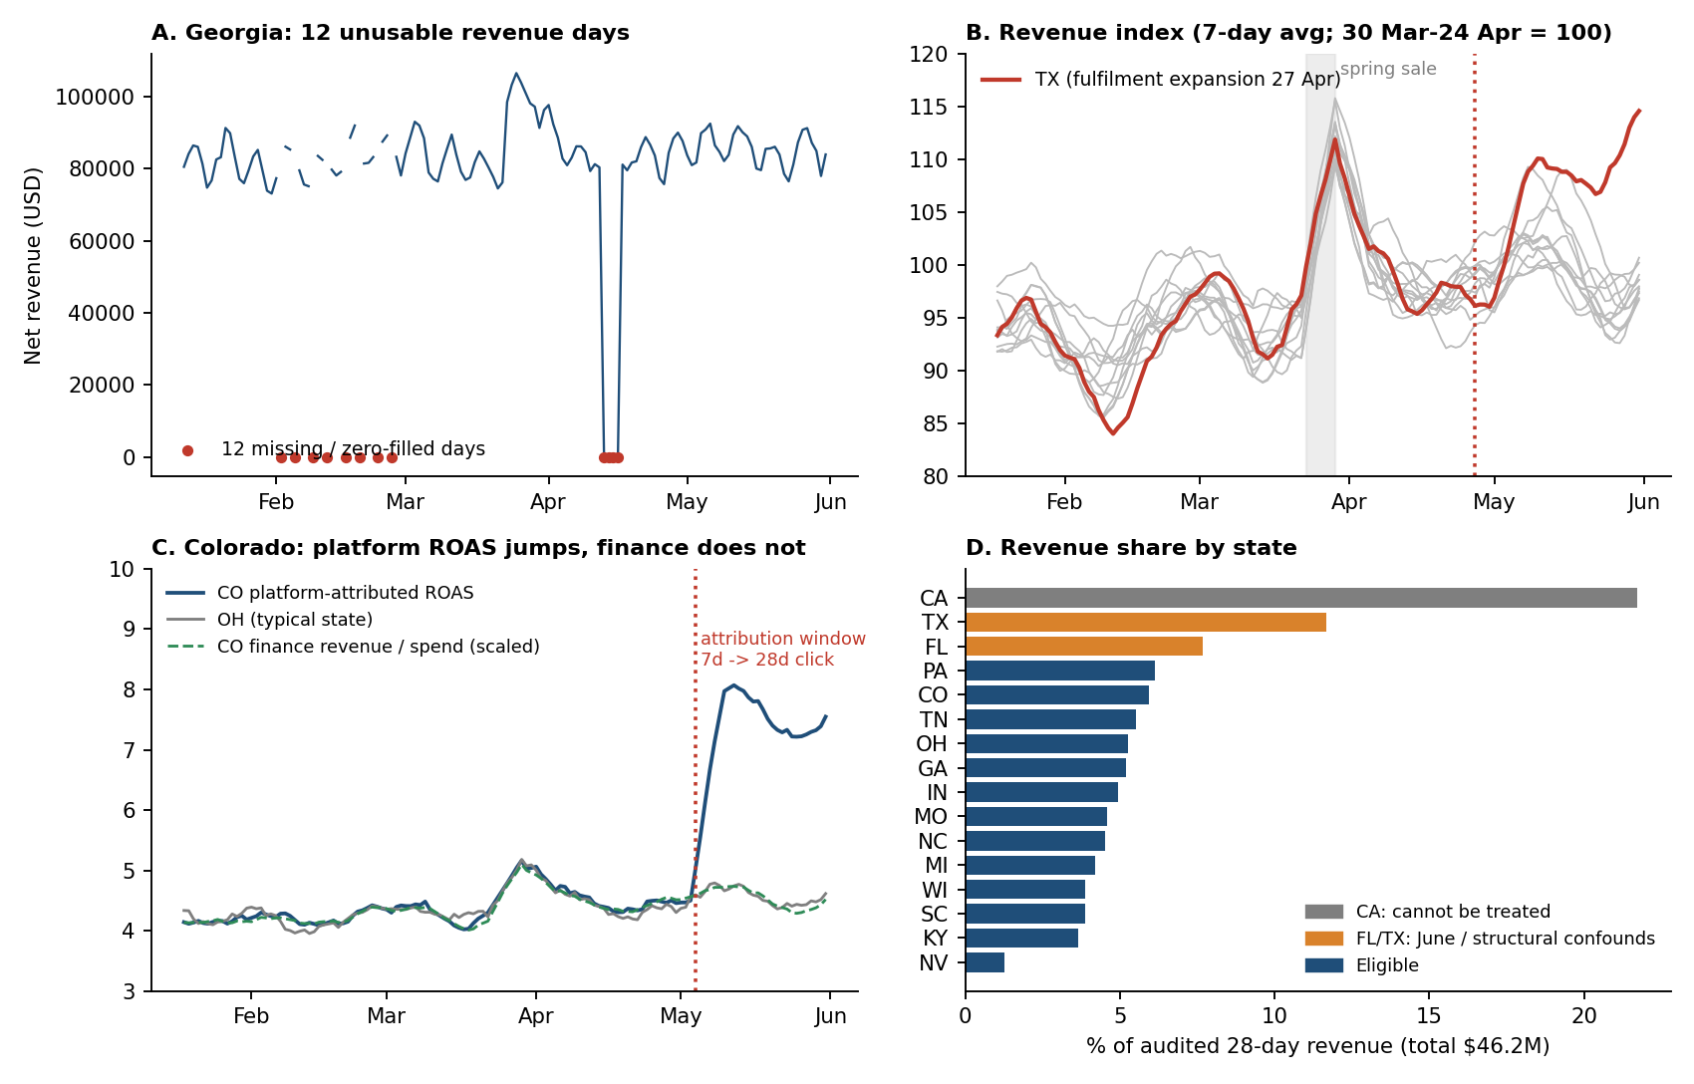
Figure 1. State-level patterns that matter. A: GA gap. B: seven-day revenue index; TX (red) leaves the pack after its 27 Apr fulfilment expansion, while the others move together and all spike in the 23-29 Mar national sale. C: CO platform ROAS jumps from about 4.4 to 7.6 on 4 May while finance revenue per dollar is flat, so the change is a reporting artefact. D: revenue concentration.
What this means for the experiment.
- States move together. Weekly seasonality (Tue/Wed about 13% above Sat) and the spring sale are shared, which is what makes a control-based counterfactual work. June 1-28 is exactly four Monday-Sunday weeks, so the test window is weekday-balanced.
- Size is skewed. CA (21.7%) cannot be treated. TX (11.7%) and FL (7.7%) are the largest treatable markets but both carry June or structural confounds (TX post-expansion drift; FL 20% online discount and email push, 8-21 Jun, cannot be cancelled), so neither should be treated nor used as a comparison state.
- Finance revenue is roughly $10.6-11.0 per paid-social dollar in every state (TX 12.0), against platform-attributed ROAS of about 4.5. Only finance revenue is comparable across states and dates.

2. Hypothesis definition and clarity
Hypothesis (H1). From 1 to 28 June 2026, raising daily paid-social spend by 40% above planned BAU in Ohio, Pennsylvania and Missouri (an extra $9,790 per day, $274,106 in total) raises the combined daily total finance net revenue of those three states by at least the 2.5% planning effect (about $185k on a $7.39M baseline), relative to what the same three states would have earned under BAU spend.
Null (H0): the lift is zero. Comparison: a TBR counterfactual built from daily average revenue of 11 BAU states (CA, CO, GA, IN, KY, MI, NC, NV, SC, TN, WI), fitted on 140 days of pre-test history. Test: two-sided, alpha 0.10, target power 80%. Existing advertising continues everywhere. Orders and AOV are diagnostics only.
Evidence that would support H1:
- The 90% interval for percentage lift excludes zero, and the estimate and interval are consistent with the 2.5% planning effect. If the upper bound falls below 2.5%, the planning effect is not met even if some lift exists.
- Treated spend rises about 40% every day, and comparison-state spend stays within about 2% of BAU. Otherwise the dose or the comparison was not as designed.
- Pre-registered placebo and A/A checks (Section 3) show no pre-existing gap, and the lift appears from week 1 rather than in one outlier day.
What stays uncertain: (i) profit, since the target is revenue and an iROAS of 0.67 would be net revenue per dollar, not margin; (ii) persistence after June 28 (no cooldown in the window); (iii) shape of the response, because only one dose (+40%) is tested; (iv) transfer to CA, TX or FL; (v) June-specific seasonality, since there is no prior-year data; and (vi) leakage across borders, since overlap below 1% is not necessarily zero.

3. Experiment design

3.1 How the design was chosen
I first ran GeoX run_design (HEAVY_UP, TBR, +40% budget, 28 days). Its stratified search returned a single design, KY+PA+TN+WI, which needs $330,146 and breaks the $300k cap; random assignment returned no design that passed the A/A test. GeoX does not enforce a dollar cap, delivery groups, overlap or calendar conflicts, so I enumerated every 2-4 state treatment set under your rules and scored each with GeoX's TBR routines. Sets were removed if outside 12-25% of audited revenue, above $300k, or infringing can_increase_spend, delivery groups, or fewer than four comparison states. CA, FL and TX were excluded from treatment (contract, promotion, structural break), and FL and TX from the comparison pool. If a treated state has an overlap partner outside the treatment group, that partner is dropped from the pool. 277 designs were feasible; 126 (45%) could not detect 2.5%, so screening matters.
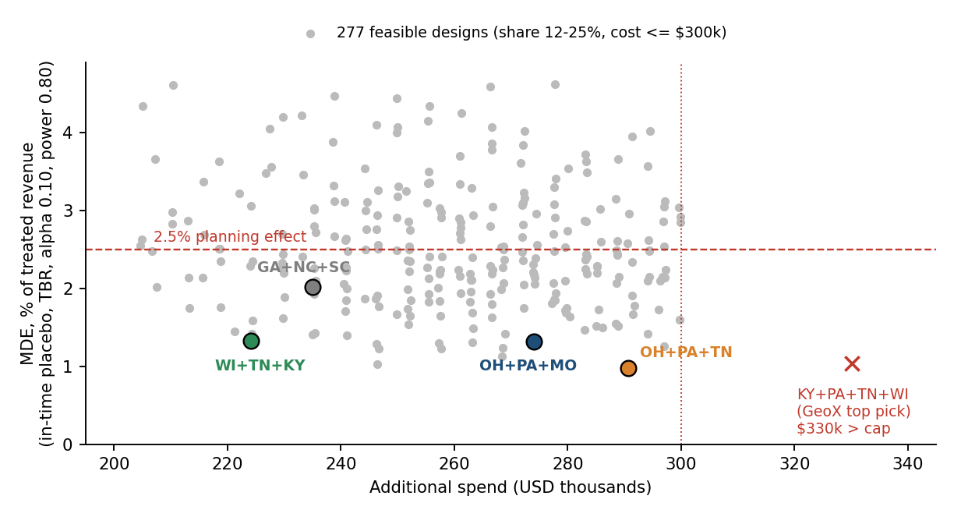
Figure 2. All 277 feasible designs: cost vs MDE. The shortlist and GeoX's unconstrained top pick are marked.

3.2 Shortlist and alternatives
Design | Share | Extra spend | Pool | MDE placebo / GeoX | R² / A-A p (GeoX) | Verdict
D1 OH+PA+MO | 16.0% | $274.1k | 11 | 1.32% / 1.44% | 0.90 / 0.55 | Selected. No treated-control overlap; least sensitive to pool changes (worst 1.77%).
D2 WI+TN+KY | 13.0% | $224.2k | 11 | 1.33% / 1.77% | 0.89 / 1.00 | Fallback. Cheaper, cleaner A/A, but more sensitive to pool (2.06% if TX added) and share near floor.
D6 OH+PA+TN | 16.9% | $290.7k | 10 | 0.98% / 1.36% | 0.88 / 0.92 | Lowest MDE, but 97% of cap and KY dropped from pool (TN-KY 4% overlap). Extra 0.3 pt not needed.
D4 GA+NC+SC | 13.6% | $235.0k | 11 | 2.02% / 1.70% | 0.73 / 0.15 | Honours shared NC/SC group, but GA has imputed days, weakest fit, only 95% power at 2.5%.
D5 KY+PA+TN+WI (GeoX top) | 19.2% | $330.1k | 9 | 1.04% / 1.86% | 0.92 / 0.52 | Rejected: breaks $300k cap; OH (3% overlap with PA) would sit in the control pool.
Table 2. D1 = OH, PA, MO. Pool = number of BAU comparison states. Only one 2-state design is feasible (PA+CO, MDE 2.5%, PA-OH leakage) and was rejected.

3.3 Constraint check for the selected design
Constraint | Result for D1 (OH, PA, MO)
2-4 treatment states | 3 states. Pass.
12-25% of audited revenue (16-state denominator, $46,177,710) | OH $2.43M + PA $2.84M + MO $2.12M = $7,390,586 = 16.0%. Pass.
Additional spend <= $300,000 | 0.40 x 28 days x $24,473.79 BAU per day = $274,106 (91.4% of cap, $25.9k headroom). Pass.
can_increase_spend | OH, PA and MO are all 1. CA (0) is untreated. Pass.
Delivery groups | OH, PA and MO are single-state groups. NC and SC are both untreated, so the shared buying group gets one BAU policy. Pass.
Comparison pool >= 4, all BAU | 11 states: CA, CO, GA, IN, KY, MI, NC, NV, SC, TN, WI. Pass.
Calendar | No OH/PA/MO events in June. FL (promotion) and TX (expansion) kept out of the pool. CA contract equals BAU. National sale does not repeat. CO attribution change affects platform metrics only. Pass.
Audience overlap | OH-PA (3%) sit together in treatment; MI-IN (2%), TN-KY (4%) and NC-SC (23%) sit together in the pool; MO has no listed overlap. No treated-control pair reaches 1%. Pass.
Table 3. Operating constraints.

3.4 Decision-relevant metrics
Metric | What it measures | How obtained / set | Value (D1) | If it changed
MDE (relative) | Smallest true lift detectable at alpha 0.10 (two-sided), 80% power. | (a) GeoX design-aware: std of TBR effects across all 277 feasible masks x (1.645+0.842) / treated baseline. (b) Design-specific: 38 leave-out 28-day placebo windows in the history. | 1.44% (GeoX); 1.32% (placebo); worst stress test 1.77% | Above 2.5%: revise (more spend, states or duration) or postpone.
Power at 2.5% | Chance an injected +2.5% clears the decision threshold. | Injected 2.5% into each placebo window, tested against 1.645 x SE. | 100%; 97% if TX is added | Below 80%: revise.
Out-of-sample R² | How well controls track treated revenue. | GeoX get_r2: train first 84 days, validate on next 28. | 0.90 (0.95 in-sample) | Below 0.80 (GeoX default floor): change the pool.
A/A p and bias | Whether the model invents a lift when none exists. | GeoX A/A p-value; mean placebo error; GeoX analyze pseudo-test on 4-31 May. | p 0.55; bias +0.09 pt (placebo), +0.35 pt (pseudo-test) | Bias near 0.5 pt or more: widen interval, prefer D2.
Treated revenue share | Whether the test sits within 12-25%. | Audited 28-day revenue, all 16 states in denominator. | 16.0% | Outside 12-25%: design invalid.
Extra spend | Budget consumed. | 0.40 x 28 x sum of BAU daily spend. | $274,106 | A BAU plan up more than 9.4% breaches the cap: cut the uplift or switch to D2.
iROAS thresholds | Net revenue per extra dollar the test can see. | Required = 2.5% x $7.39M / $274k. Detectable = MDE x $7.39M / $274k. | Required 0.67; detectable 0.39 | If leadership expects marginal return below about 0.4, the test cannot show it.
Overlap leakage | Contamination of the comparison. | Overlap table; drop any pool state overlapping a treated state. | 0 treated-control pairs at or above 1% | A new pair at 1-2% or more: drop that state from the pool.
Table 4. Metrics that drive the recommendation.

3.5 GeoX evidence
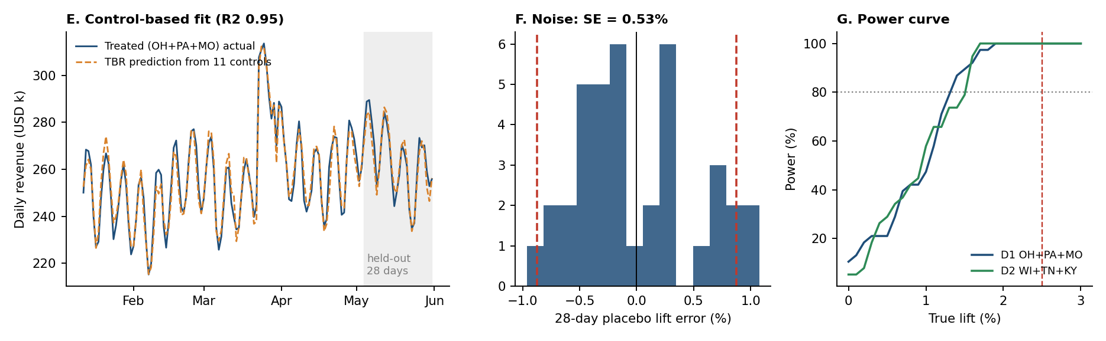
Figure 3. E: TBR fit for D1 (held-out 28 days shaded). F: 28-day placebo errors (SE 0.53%; dashed = 90% threshold). G: power curve, reaching 80% near 1.3-1.5% lift.
Stress tests (D1 MDE): base 1.32%; without CA 1.42%; without GA 1.38%; without NV 1.53%; without CO 1.54%; excluding the spring-sale week 1.38%; adding TX 1.77%; adding TX and FL 1.76%; alpha 0.05 raises the base to 1.49%. All stay below 2.5% with at least 97% power. GeoX analyze pseudo-test on 4-31 May: with no lift injected, D1 returned +0.35%; an injected +2.5% came back as +2.86% and +1.5% as +1.85%. D2 returned 0.00%, 2.50% and 1.50%. The confidence-interval and p-value fields from this GeoX version returned degenerate values (identical bounds, constant p), so I rely on point estimates and my placebo intervals for these checks.

3.6 Key settings
Setting | Value
Tool / version | meridian-geox 1.0.1 (GeoX). GeoLift (R) could not be installed in this environment and was not run; see Risk 5.
Experiment type / method | ExperimentType.HEAVY_UP, budget_pct 0.40; Methodology.TBR; 1 cell; two-sided
KPI / grain | Cleaned net_revenue_usd, state x day; spend = paid_social_spend_usd
Duration / alpha / power | 28 days (1-28 Jun 2026) / 0.10 / 0.80
Design search | STRATIFIED_SAMPLING, seed 42, n_candidates 200,000, n_ranked 2,000, min_r2 0.5, max_conversions_percent 0.25, excluded FL and TX, CA forced into control, outlier-date exclusion on
Final assignment | Hand-selected after constraint enumeration (Section 3.1). Data split: 84 days train, 28 validation, 28 estimation
Placebo settings | Leave-one-window-out, 28-day windows every 3 days (38 windows), non-negative slope OLS as in GeoX TBR
Data prep | Table 1: dedupe, label normalisation, GA imputation, NV spend and order repair
Table 5. Settings.

3.7 Recommendation
Proceed, with the constrained design rather than GeoX's raw top pick. Treat OH, PA and MO with +40% daily paid-social spend for 1-28 June, keep the other 13 states at BAU, and compare against the 11-state pool with FL and TX excluded. D1 meets every rule, spends $274,106, and has an estimated MDE of 1.3-1.8% against a 2.5% planning effect, so a 2.5% lift would very likely be detected. This is a planning result, not a promised lift.
Conditions: (1) freeze the analysis specification and the pool before launch; (2) re-run the A/A check on data through 31 May and stop if out-of-sample R² falls below 0.80; (3) confirm BAU plans have not risen by more than 9.4%; (4) monitor daily treated spend at +40% and control spend within 2% of BAU; (5) cross-check the final estimate in GeoLift (R). Switch to D2 (WI+TN+KY, $224k) if a control-state change appears or the D1 A/A bias grows. Postpone only if the audited May totals are restated or the MDE rises above 2.5%.

4. Risks
Ordered by how much each could change the conclusion.
Risk | How it could affect the conclusion | Evidence I would check | Practical response
1. Comparison-state contamination (FL promo 8-21 Jun, TX drift, unlisted events) | Control revenue rises for reasons unrelated to spend; the lift is understated or reversed. Adding TX and FL raises MDE to 1.76% and bias to +0.4 pt. | Daily control-vs-forecast residuals; weekly check of the calendar; TX and FL trends vs the pool. | Keep FL and TX out of the pool; drop any state with a new event; fall back to D2.
2. Effect smaller than 2.5%, or saturating | A null result would not show that paid social is worthless; the dose may be too small or subject to diminishing returns. Required iROAS of 0.67 sits between the detectable 0.39 and the 4.5 platform ROAS. | Weekly lift path; treated spend delivered; interval upper bound vs 2.5%. | Report iROAS with interval; if inconclusive, plan a second dose or longer run instead of pooling.
3. Cross-border spillover | Ads reach treated-state users living or shopping in control states (or the reverse), shrinking the measured lift. Pairs below 1% overlap are not necessarily zero. | Overlap by pair; revenue in border states vs the rest of the pool. | Re-estimate without MI, IN, KY and TN (controls bordering OH or MO); MDE only rises to 1.57%, so a shift above 0.5 pt would signal spillover.
4. Data integrity in-flight | A GA-style export failure returns zeros that look like a sales collapse; duplicate or mislabeled rows repeat the problems in Table 1. | revenue_feed_complete daily; row counts of 16 x days; label check; reconcile to audited totals. | Treat incomplete days as missing, never zero; freeze the pipeline; reconcile weekly.
5. Optimistic design-time precision | MDE comes from 140 smooth synthetic days with no June history; overlapping placebo windows understate noise; D1 A/A bias is +0.35 pt in GeoX pseudo-test; GeoX CIs were degenerate; GeoLift was not run. | A/A on data to 31 May; leave-one-state-out; GeoLift augmented synthetic control on the same data. | Add 0.5 pt margin to the MDE; state interval honestly; use D2 if bias persists.
6. Execution fidelity | If spend is not raised about 40% every day (pacing, auction limits, learning phase) the effect is diluted; a BAU plan up more than 9.4% breaches the cap. CA must stay BAU; NC and SC must move together. | Daily spend vs plan by state; billing vs media plan; NC/SC instructions. | Set daily caps by state; alert at +/-5%; agree an approval route before any mid-test changes.
7. Window and lag | 28 days with no cooldown may miss delayed purchases; refunds after the window reduce net revenue later; CO-style attribution changes distort platform reports. | Revenue in the two weeks after 28 Jun; refund rate by cohort; only finance revenue in the readout. | Extend readout two weeks with spend back at BAU; re-pull refund-adjusted revenue; ignore platform revenue.
Table 6. Risk register.

References
- Meta. GeoLift. https://github.com/facebookincubator/GeoLift
- Google. Meridian GeoX: introduction to design. https://developers.google.com/meridian/geox/intro-to-design
- Google. meridian-geox (v1.0.1, used here). https://github.com/google/meridian-geox

