

Sri Lanka Institute of Information Technology

**Reliability of Twitter**

**Final Report**

Software Architecture Case Study 2017



Project ID: **DSN-QRL-GR2**

Submitted by:

**1. IT15068774 – A.P.I.R. Jayathilaka**

**2. IT14084614 – D.A. Polwattage**

**3. IT14098888 – S.C.G Liyanage**

**4. IT14104640 – S.R. Rajapakse**

**5. IT15029928 – A.M.A.S. Dias**

Submitted to:

…………………………..

Mr. Chathura R De Silva

21-05-2017

## Executive Summary <overview of the whole report>

<reliability twitter>

<history>

<usage of twitter in each fields>

<findings

Identify the problems found in the case. Each analysis of a problem should be supported by facts given in the case together with the relevant theory and course concepts. Here, it is important to search for the underlying problems for example: cross-cultural conflict may be only a symptom of the underlying problem of inadequate policies and practices within the company. • This section is often divided into sub-sections, one for each problem. >

<recommendations

Choose which of the alternative solutions should be adopted • Briefly justify your choice explaining how it will solve the major problem/s • This should be written in a forceful style as this section is intended to be persuasive • Here integration of theory and coursework is appropriate >

<conclusion

Sum up the main points from the findings and discussion >

* the topic area of the report
* the report's primary aim/s
* state what was achieved (key finding)
* a summary of your approach
* significant findings
* a summary of the report's recommendations

Outline the purpose of the case study • Describe the field of research – this is usually an overview of the company • Outline the issues and findings of the case study without the specific details • Identify the theory that will be used. • Here, the reader should be able to get a clear picture of the essential contents of the study. • Note any assumptions made (you may not have all the information you’d like so some assumptions may be necessary eg: “It has been assumed that…”, “Assuming that it takes half an hour to read one document…”)

**Table of Contents**

**List of Figures**

**List of Acronyms and Abbreviations**

|  |  |
| --- | --- |
| **Acronyms / Abbreviations** | **Meaning** |
| CSI | Crime Scene Investigation |
| FIFA | Fédération Internationale de Football Association |
| IBM | International Business Machines Corporation – American multinational technology company |
| NBA | National Basketball Association |
| Odeo | Odeo is a digital media company developing tools to support podcasting services. |
| permalink | A permanent static hyperlink to a particular web page or entry in a blog. |
| RSS | A standardized system for the distribution of content from an online publisher to Internet users.  "creating an RSS feed that others can subscribe to" |
| SXSW | South by Southwest |
| Yandex | Russian multinational technology company specializing in Internet-related services and products |
|  |  |
|  |  |
|  |  |

**Introduction**

**History of Twitter Reliability**

Twitter is an online social media platform where every user can build some reliable opinions. This was created in March of 2006 by Jack Dorsey, Noah Glass, Biz Stone and Evan Williams. [14]  They first created a prototype to simulate their idea which indicates a good feature for creating a quality product.

Figure 1.0:- First Tweet

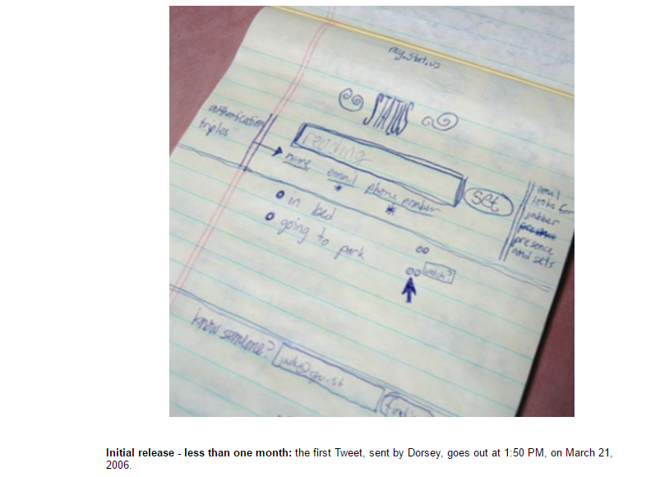

Figure 1.0 represents the ideation of first Twitter prototype that was used as an internal service for Odeo employees. For using such a service to a company like Odeo there should be a hidden solid background of Twitter. This is initially named as “Twttr” during a period of 2005 to 2006 as in the following image. [42]



Figure 1.1:- Twttr 2005-2006 prototype

Twttr is founded on February in 2006 and launched as twttr.com to all the private accounts on March 2006 and this was available to public on July 2006. [44] Therefore we can assume that there was an experimental era for twitter reliability from March to July in that same year. In order to make available Twttr accounts to public definitely there should be high reliable features which everyone can trust. On October 2006, it was rebranded as Twitter.com. [46]



Figure 1.2:- Twitter 2006–2010

Some people expected Twitter to work with larger ecosystem. As an example in September of 2006, RSS feeds and permalinks of tweets indicated users’ familiarity in blogging [45] which can be inherited from experience in tweeting. So these facts prove that there’s something believable figure of Twitter from the very beginning of this innovation.

Twitter reached its first tipping point at SXSW conference in March of 2007 while increasing 20,000 daily messages to 60,000 daily messages. [44] Such a massive 40,000 enhancements for average number of daily messages shows how this was become popular among the users within a short time period. In April of 2007, Twitter got incorporatedas a standalone company [44] which is an example for another milestone of their reliable evolution. This was introduced a mobile site, blocking capability feature and @replies column on May in 2007[44]  to expand their functionalities in a smart way. In June of 2007, Dell joined Twitter to corporate for business requirements [44] where we can predict Twitter was a reliable media even from that period. Your friends on Twitter were defined as followers from July 2007 onwards. And their updates were receiving to you all the time. [44] This facility would be a better opportunity to measure the reliability of your followers’ tweets. From August of 2007 onwards user could search people based on criteria such as location, name and more which can be called as ‘Twitter profile search goes live’. [44]  Introduction of tracking Twitter alias #Hashtags was happened in September 2007 as a development of earlier tracking feature. [44]  Such inventions might lead Twitter to be appeared in CSI on November in 2007 as a reliable source. Eventually it had 400,000 tweets posted per quarter in 2007. [14]

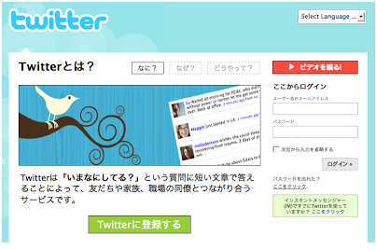Expanding of Twitter throughout the different countries was basically happened in 2008. In order to make more reliable among Japanese, Twitter launched their first non-English version in Japan on April 2008. [44]

Figure 1.3:- Twitter in Japan

And in November of 2008, Twitter could get the attraction for reporting the terrorist attacks in Mumbai. [1] This was played a major role in presidential election of President Barack Obama on November in 2008. [40] That maybe another reason for him to believe Twitter and became the 3rd top most follower of it. [52]

Twitter also encountered some reliability downtimes in the history. For an example on January 5 in 2009, due to a dictionary attack Twitter administrator’s password was guessed correctly and 33 high-profile Twitter accounts were compromised with drug related and sexually explicit tweets. [47] So on June 11 in 2009, Twitter had to launch the beta version of their ‘Verified Accounts’ which was letting famous people to announce their Twitter account name. [47]

Even though above mentioned kind of things happened twitter was still reliable among the users during that same year in 2009. A school shooting was taken place on March in Winnenden. But students were tweeted the scene of the killings which indicates how much Germans used it normally and how much they were relying on this social media even at the death bed. [45] And Twitter was the first news supplier in this incident. [53]



Figure 1.4:- Twitter 2010–2012

When moving to 2010 earthquake in Chile which occurred on Saturday, February 27, at 03:34:14 local time; Twitter couldn’t be a reliable source. It was started to tweet critical information such as missing people, deceased people, tsunami alerts and other emerging topics in the hours and days after the earthquake. [54] But there’s a relief to say that all the telecommunications including Internet had intermittent in Chile for the first 48 hours. So we can assume that Twitter users might not use any media often during such an inconsistent period.

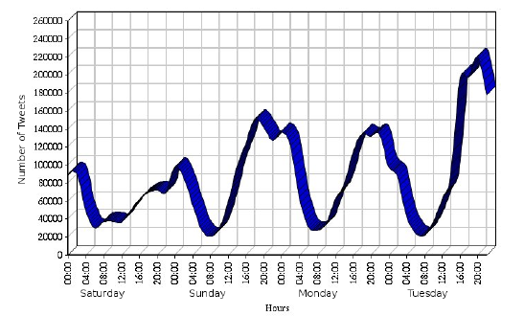

Figure 1.5:- Twitter Activities

Other reason for accepting twitter was unreliable in that incident is to discriminate what were the rumours and what were the confirmed news. Even though that was not their software fault that was totally the matter of reliability of tweets, since they were disseminated through twitter also my opinion is Twitter should be responsible there. According to Figure 1.5, tweets were increasing after few days roughly which was not a good sign for reliability of Twitter.

But there were more facts to prove Twitter didn’t get unreliable even in 2010. As examples in FIFA World Cup, 2940 tweets were posted per second in the 30 second period of time and 3085 tweets were tweeted per second in NBA Finals which both of events were happened on June. [47]

Back in 2011 establishing of some official football club accounts on Twitter was happened. [45] And launching of Twitter follow button, photo sharing service, link shortening service was occurred in the same year. [44] Those facts could contribute Twitter to reach its’ 100 million active users logging in at least once a month [14] while conserving their reliability quality for a long time.

Twitter made a partnership with Russian search engine called Yandex in 2012. Within a short period Yandex could find the value of it because of its real time news feeds. [43] As below in Figure 1.6, Twitter changed their logo again and still (2017) that is remaining same.

It has reported that 140 million active users and 340 million daily tweets were tweeted by the time of March 2012. [1] Due to such kind of enhancement of the Twitter reliability, Nielsen and Twitter entered a multi-year agreement in December 2012 to produce social TV ratings which is called as the Nielsen Twitter TV Rating. [14] It was founded that there were more than 200 million active users with 400 million daily tweets when Twitter reached its seventh birthday. [34] It was included as one of the top ten most visited websites in the world in 2013. [14]

Figure 1.6:- Twitter 2012 -present

As reliability downtimes happened in almost all the years, in 2013 also it was revealed that at least 5% accounts on Twitter are fraudulent. The reason behind that was the Twitterbots which is a computer program. It can tweet, retweet and follow other accounts automatically. [14]

While other companies started cooperating with Twitter, it also commenced to build partnership with others. So in 2014, it was announced a new connection with IBM in order to improve business goals and customer interactions. [14] We can predict that making a partnership with IBM would be another turning point in their evolution of reliability.

When stepping forward to another year in 2015, Twitter could privilege for another innovative feature called TweetDeck. [43] It allows people to share team accounts. Interesting part of there is no need to share the passwords among even the group members which could preserve the security aspects. Since it protects the security, reliability also getting increased with this new function.

In last year, Twitter had more than 319 million active users per month. And also it could prove that it is the largest media for breaking news when 40 million election related tweets were sent on the US presidential election. [14] So there is no second word of how the reliability is being improved in 2016.

**Reliability definition by Twitter**

**Actions taken for improving reliability**

**When increasing reliability how other quality attributes can get affected and vice versa of it.**

**compare twitter with facebook**

**Conclusion**

**Reference List**

**Appendices**