**Bug Tracking Tool**

**Jira**

**Introduction to tool: -** Jira is a defect tracking/project management tool by Atlassian, Inc., the current version is 6 which is platform independent.

**Download and configuration details: -**

* Creating a trial account

1. Go to <https://www.atlassian.com/software/jira/try>
2. Select a package

Enter the details as follows,

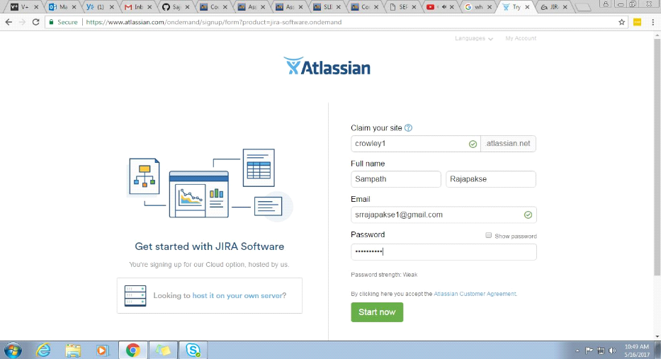

Figure 3.0 – Creation of Jira Account

**Usage of Tool: -**

Software project development teams, help desk systems, leave request systems, QA teams widely used for bug tracking, tracking project level issues- like documentation completion and for tracking environmental issues. A working knowledge of this tool is highly desirable across the industry.

* Basics about JIRA:

JIRA in its entirety is based on 3 concepts.

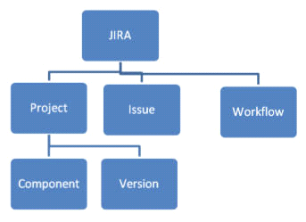

Figure 3.1 – Jira Basics

1. Issue: Every task, bug, enhancement request; basically anything to be created and tracked via JIRA is considered an Issue.

2. Project: a collection of issues

3. Workflow: A workflow is simply the series of steps an issue goes through starting from creation to completion.

Say the issue first gets created, goes to being worked on and when complete gets closed. The work flow in this case is:

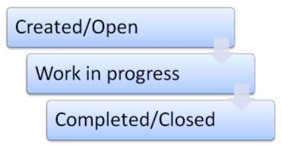

Figure 3.2 – Jira WorkFlow

**Strengths: -**

* Flexible - JIRA started out as being a bug tracking system. It has become a general purpose issue/task tracking solution. You can use it to track any "tasks".
* Customizable - Every aspect of the system can be customized through configuration (not custom development). It does add a bit complexity to the JIRA admin, but it is still a better trade off than writing code.
* Workflow – JIRA has a robust and customizable workflow. Workflow can be designed graphically.
* Linking: You can link different tasks. For example, TASK-123 is depended on TASK-256. you can be aware of the dependency among the tasks.
* Sub-Task: A complex task can be divided to smaller sub-tasks so that it is more manageable and can be assigned to different people.

**Weaknesses: -**

* Hard to setup- JIRA is a large, complicated piece of software that started as a bug tracker and evolved into much, much more.
* Difficult to use- JIRA’s UI is not exactly user friendly, which is, once again, an outcome of being a feature-heavy one-size-fits-all solution. For many usage scenarios you’ll require plugins, which add to the overall UI clutter. JIRA requires time to learn and use effectively

**User Reviews of the tool: -**

* *“Jira has limited support for other phases of agile like retros, retro actions, demo feedback etc. which are also essential part of agile development”*-Gaurav Raman-Scrum Master/System Developer at H&M(Consultant).
* *“JIRA isn't one of the easiest tools, but it is more comprehensive than others - that's why it's that popular. Especially when it's integrated with time tracking software - TimeCamp seems to be a perfect solution*.”- Aleksandra Rybacka-Copywriter, Content Designer, Social Media Specialist / Hackyourlife.pl.

**Snapshots of tool usage using selected code samples:-**

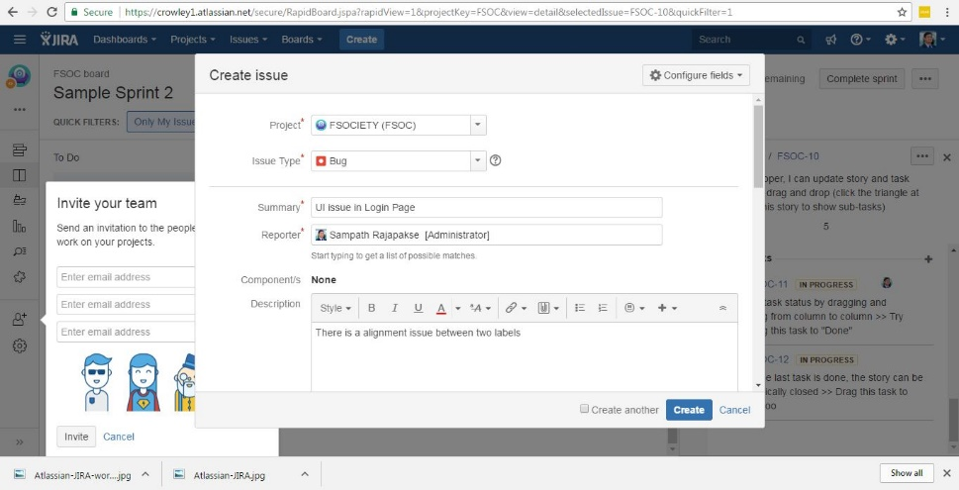

Figure 3.3 – Creation of an issue.

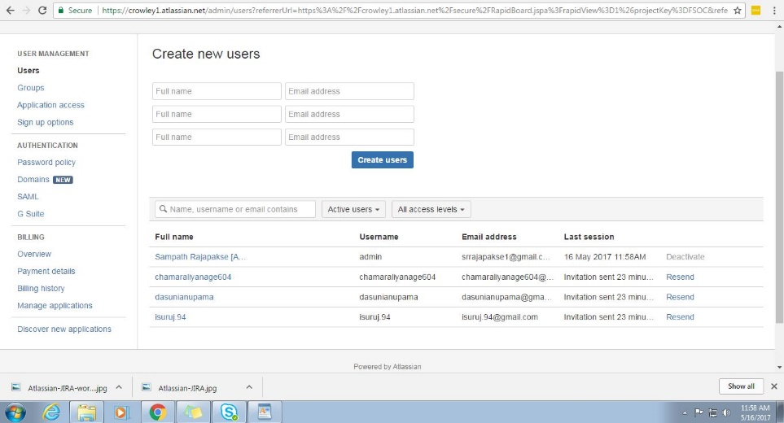

Figure 3.4 – Adding users to projects.

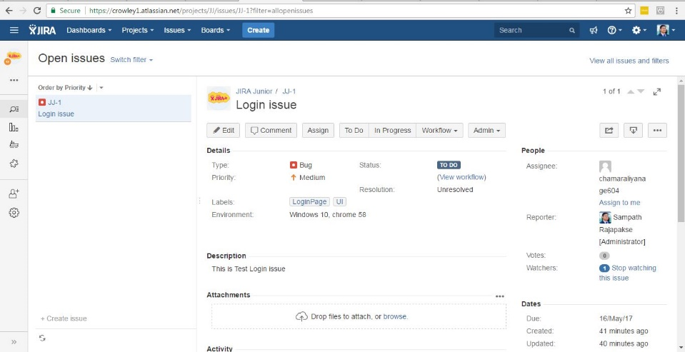

Figure 3.5 – Issue after creation.

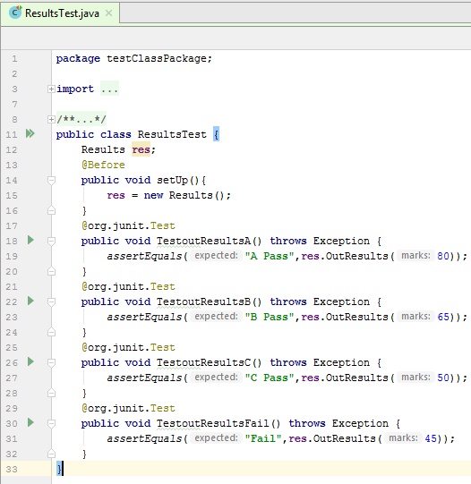**Outcome of the tool: -**

* Can track issues(bugs) in the development project.
* Can generate various software development related reports and charts (Burn down, Sprint reports).
* Helps in the development phase from start to finish.

**References**

Guo, Charles. "The Advantages Of JIRA". *linkedin*. N.p., 2016. Web. 20 May 2017.

Pracuch, Piotr. "5 Reasons NOT To Choose Atlassian JIRA For Agile Projects". *linkedin*. N.p., 2015. Web. 20 May 2017.