**Introduction to tool: -**

**Download and configuration details:-**

**Usage of Tool:-**

**Strengths: -**

**Weaknesses: -**

**User Reviews of the tool: -**

**Snapshots of tool usage using selected code samples:-**

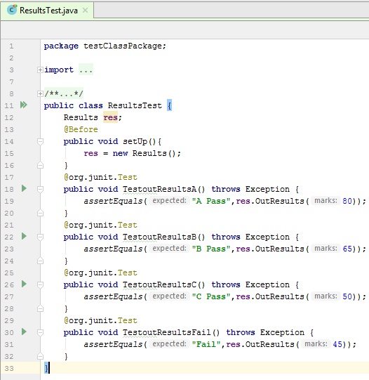**Outcome of the tool:-**