**Introduction to tool**: - Kiuwan is a static code analysis tool for code quality management which is offered as software as a service (SaaS) product. [11th URL]

**Download and configuration details: -** Need to visit: - [12th URL]

Basically, two download options

1. Free trial: - If it is for non-business purpose, have to go with the Github free repo which can be used as a free open source software. For scanning our code base, it should be in the same Github account.
2. Local analyser

**Usage of Tool: -** [9th URL]

* CIOs need this to make strategic decisions to improve software development.
* ForQA managersand engineers who need actual state of applications under development.
* CSOs to tackle security from the application perspective.
* Project managers can know the health of the projects from a technical perspective.
* Application architects can discover structural flaws early in the development process.
* Developers want this to develop the best software possible and learn as much as possible in the process.

**Strengths and weaknesses**: -

* It has the right information to the right stakeholder in the IT department. [9th URL]
* Supports for all major programming languages like Java, C/C++, JavaScript, PHP, C#, .NET, VB, Objective-C, Cobol, SQL, etc. [11th URL]

**User Reviews of the tool**: - [4th URL]

**Snapshots of tool usage using selected code samples:-**

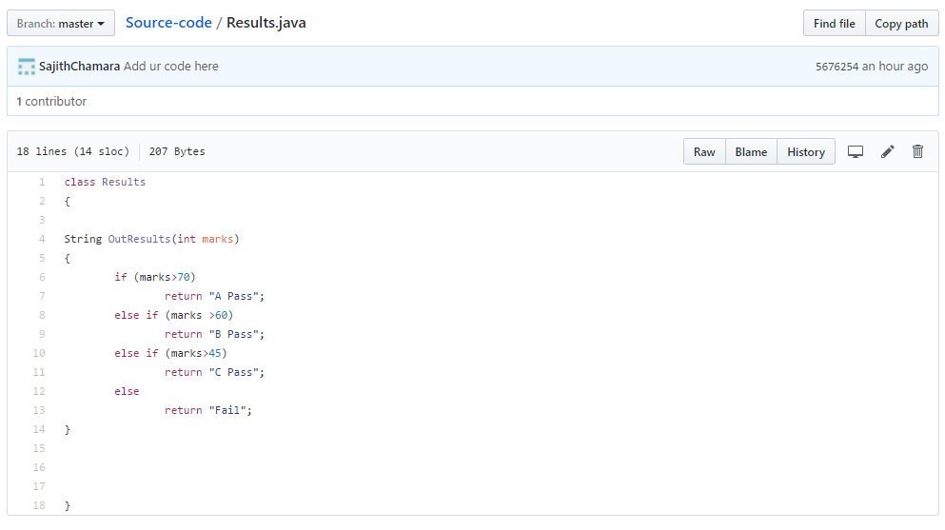

Figure 1:- Results.java in Github

**Outcome of the tool: -**

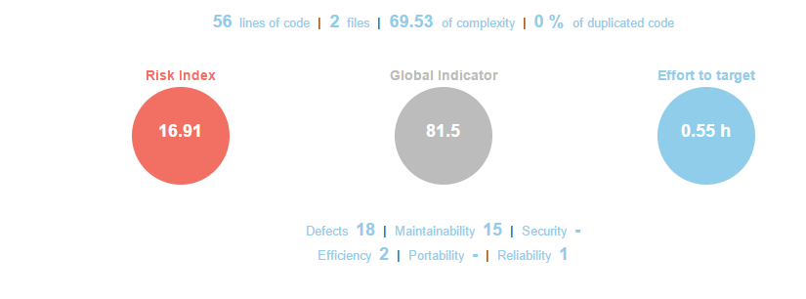

Figure 2:- Kiuwan report