

**Sri Lanka Institute of Information Technology**

**Group Assignment**

Software Engineering Process & Quality Management (SE 3010)

Year 03 Semester 01 – 2017

Submitted by:

1. IT 14098888 - S.C.G. Liyanage
2. IT 14084614 - D.A. Polwattage
3. IT 14104640 - S.R. Rajapakse
4. IT 15068774 - A.P.I.R. Jayathilaka

Submitted to:

…………………………..

Mr. Indraka Udayakumara / Mr. Saman Gunawardena

20-05-2017

**Introduction to tool: -** Jacoco is a structural code coverage tool to generate a report for how much percentage of java code is covered by implemented test methods.

**Download and configuration details:-**

Download from [1] or mention the URL in the root pom.xml to download through internet. Build the java project with test classes, using maven or ant. Then render the index.html page which is in the <YourProjectName>\target\site\jacoco to see the generated report.

**Usage of Tool:-**Developers are massively used in maven projects to see the code coverage level.

**Strengths: -** Easy to use and view a clear report.

**Weaknesses: -** Up to now only supported to java projects which built using maven or ant.

**User Reviews of the tool: -** [2]

**Snapshots of tool usage using selected code samples:-**

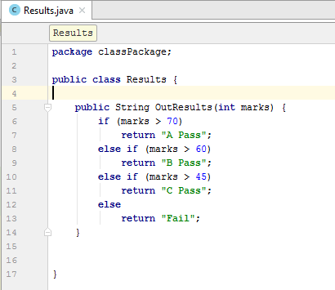

Figure 1:- Results.java

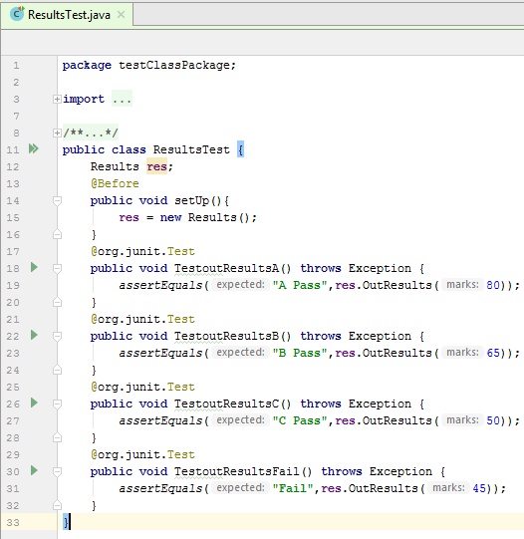

Figure 2:- ResultsTest.java

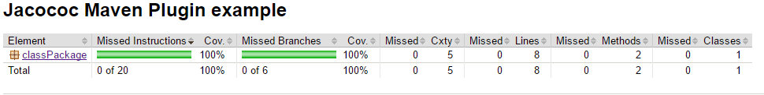**Outcome of the tool:-**

Figure 3:- JaCoCo Report

**References**

**[1]** [**http://www.eclemma.org/jacoco/**](http://www.eclemma.org/jacoco/)

**[2]** [**https://blog.tier1app.com/2015/09/07/which-code-coverage-tool-to-choose/**](https://blog.tier1app.com/2015/09/07/which-code-coverage-tool-to-choose/)