**TRUSTWORTHY MANET ROUTING ESTAODV IMPLEMENTATION USING DEEP REINFORCEMENT LEARNING**

Sajith Chamara Gunawardene Liyanage

IT14098888

Degree of Bachelor of Science Special (Honors) in Information Technology

Department of Software Engineering

Sri Lanka Institute of Information Technology

Sri Lanka

October 2018

**TRUSTWORTHY MANET ROUTING ESTAODV IMPLEMENTATION USING DEEP REINFORCEMENT LEARNING**

Sajith Chamara Gunawardene Liyanage

IT14098888

Dissertation submitted in partial fulfillment of the requirements for the degree of Bachelor of Science Special (Honors) in Information Technology

Department of Software Engineering

Sri Lanka Institute of Information Technology

Sri Lanka

October 2018

# DECLARATION

“I declare that this is my own work and this dissertation” does not incorporate without acknowledgement any material previously submitted for a Degree or Diploma in any other University or institute of higher learning and to the best of my knowledge and belief it does not contain any material previously published or written by another person except where the acknowledgement is made in the text.

Also, I hereby grant to Sri Lanka Institute of Information Technology the non-exclusive right to reproduce and distribute my dissertation, in whole or in part in print, electronic or other medium. I retain the right to use this content in whole or part in future works (such as articles or books).

**Author:**

|  |  |  |  |
| --- | --- | --- | --- |
| Name | Registration No | Signature | Date |
| Liyanage S.C.G. | IT14098888 |  |  |

The above candidate has carried out research for the B.Sc. Dissertation under my supervision.

**Supervisor:**

|  |  |  |
| --- | --- | --- |
| Name | Signature | Date |
| Mr. Prabath Lakmal Rupasinghe |  |  |

# Abstract

A collection of nodes which have the ability to move randomly within a wireless network is called a mobile ad hoc network (MANET). MANET plays a major role in wireless communication technology. Data transferring within the network has two considerable facts, reliability and security. Ensuring security in a mobile ad hoc network is a major concern due to the unpredictable motions and behaviors of network nodes.

In a wireless mobile network, it is possible for a large number of data packets to transmit among nodes within a small period of time. Therefore, it is possible that some nodes might not behave as we expect. It can eventually cause to a considerable amount of data packet drops. It shows that the existing security mechanisms have failed to distinguish between trustworthy and malicious nodes. In order to further categorize malicious nodes, spiral model has introduced. It is capable of distinguishing pure malicious and collaborative malicious nodes. Usually, the nodes select the shortest path; but sometimes it may not be the reliable route to transfer data. Therefore, Reinforcement Learning (RL) component has proposed to predict the trustworthy routes.

Keywords— MANET, Spiral model, RL component

# ACKNOWLEDGEMENT

I would like to express my special thanks of gratitude to our project supervisor, Mr. Prabath Lakmal Rupasinghe for his patient guidance, and useful critique of our research work. And I would be grateful to the corporation given by Ms. Chamira Nawarathna to make the research project for a successful one. Their willingness to give their time so generously has been very much valuable. Especially mentioning the moral support and the continuous guidance by providing important feedback enabled us to complete our work successfully. I would also like to thank our lecturer-in-charge, Mr. Jayantha Amararachchi for constantly providing us with the guidance and assistance to carry out the research successfully. Also, I would like to thank my parents and friends who supported and encouraged me throughout the research project.

# TABLE OF CONTENTS

DECLARATION iii

Abstract iv

ACKNOWLEDGEMENT v

TABLE OF CONTENTS vi

LIST OF TABLES vii

LIST OF FIGURES vii

LIST OF ABBREVIATIONS vii

1. INTRODUCTION 1

**1.1.** **Introduction** 1

**1.2. Literature Survey** 2

**1.2.1.** **Authentication using trust to detect misbehaving nodes in mobile ad Hoc networks using Q-Learning [1]** 2

**1.2.2.** **Information theoretic framework of trust modeling and evaluation for ad hoc networks [2]** 3

**1.2.3.** **Different ways to achieve trust in MANET [3]** 4

2. METHODOLOGY 6

**2.1.** **Spiral Model** 6

**2.1.1.** **Collaborative malicious node discovery process** 6

**2.1.2.** **Penalty phase** 8

**2.2.** **Deep Reinforcement Learning Model** 9

3. RESULTS AND DISCUSSION 11

**3.1.** **Results** 11

**3.1.1.** **Spiral model** 11

**3.1.2.** **Deep Reinforcement Learning Model** 13

REFERENCES 15

# LIST OF TABLES

Table 1.1: Backup Table 6

# LIST OF FIGURES

Figure 1.1: Sample Network Diagram with 3 Network Nodes 3

Figure 2.1: Flow Chart for the Spiral Model 7

Figure 2.2: System Diagram 10

# LIST OF ABBREVIATIONS

|  |  |
| --- | --- |
| **Abbreviation** | **Description** |
|  |  |
| AODV | Ad hoc On Demand Distance Vector |
| DQN | Deep Q Network |
| GRE | Generalized Reputation Evidence |
| MANET | Mobile Ad hoc Network |
| NFC | Near Field Communication |
| REP | Recommendation Exchange Protocol |
| RL | Reinforcement Learning |
| TL | Trust Level |
| TRR | Trust Recommendation Request |

# INTRODUCTION

## **Introduction**

Wireless communication is a communication mode which does not use physical wires to connect between two or more devices to transfer data. It uses electromagnetic waves to transfer signals. Depending on the wave frequencies, network coverage area will be changed. It can occur network connectivity issues for some regions. Generally, there are more advantages of using wireless networks. Cost is low since it does not require any physical infrastructure to maintain. Most of the times flexibility and accessibility of a wireless network is high regardless of the location. Some of the popular wireless technologies are WiFi, Bluetooth, NFC (Near-field communication) and satellite services. Routing protocols specify how routers should communicate with each other in the network with aid of such technologies. In a mobile ad hoc network, ad hoc routing protocol is used for this purpose.

Due to the mobility feature of network nodes in MANET, security issues could arise at any time. Simply the packets might be dropped due to some unpredictable conditions. Therefore, the regular transmission process of the network can be interrupted. Existing cryptographic techniques like public/private key encryption and other security mechanisms such as packet filters, firewalls cannot always identify the trustworthy nodes to communicate. In public/private key encryption, anyone can encrypt a message using public key of the receiver. As diverse to all the above-mentioned methods, defining a trust-based schema on top of AODV to detect each one hop (directly connected) neighbor nodes will solve this issue up to a considerable level.

Trustworthiness of nodes in ad hoc network will be evaluated by global trust value which is a combination of direct trust and indirect trust values. Direct trust is the trust which builds with the experience among directly connected nodes and when a node takes recommendations regarding a particular node from other neighbor nodes, simply it can be considered as taking the indirect trust. Based on the global trust value nodes will be categorized as trustworthy, partially trustworthy, selfish and malicious nodes. There malicious category can further divide into pure malicious and collaborative malicious through the **Spiral model** which will be reviewed ahead in this documentation. Next step is to determine the best route path in the ad hoc network using **Reinforcement learning (RL) model.** Before step into that model since system has already categorized network nodes as mentioned in above we could expect some performance wise efficient in the system.

## **1.2. Literature Survey**

### **Authentication using trust to detect misbehaving nodes in mobile ad Hoc networks using Q-Learning [1]**

Authentication which is the key factor to be considered in MANET can be categorized into two sections called pre-authentication and post-authentication. As the name denotes pre-authentication is initial network deployment and post-authentication is mechanism to detect nodes in the network over a period of time. According to S.Sivagurunathan, K.Prathapchandran and A.Thirumavalavan, trust can be defined as “*the reliability, timeliness, and integrity of message delivery to a node’s intended next hop*” [1].

Nodes in ad hoc network will eventually be categorized into three sections such as trustworthy, partially trusted and untrusted; based entirely on their direct trust. So, it is unwise to come to conclusions based only on their direct trust value. There could also exist indirect aspects throughout the network which might affect the trust between nodes. In that case, apart from the direct trust, an indirect trust value which would consider such indirect factors should be calculated. Afterwards, a global trust value can be defined based on the average value of both direct and indirect trust values and that global trust can be used for rewarding system within the network.

### **Information theoretic framework of trust modeling and evaluation for ad hoc networks [2]**

It is preferred to consider the recommendation values from other nodes to fulfill the requirement of calculating indirect trust. Yan Lindsay Sun, Wei Yu, Zhu Han and K.J. Ray Liu have proposed an information theoretic framework as a solution. According to them, trust is a “*measure of uncertainty with its value represented by entropy”* [2].

This is a better approach than the 1.2.1 solution to detect misbehaviors of nodes because it defines a combination of two trust models named ‘entropy-based model’ and ‘probability-based model’. Under entropy-based model they have come up with an equation to calculate TABC which is same as the indirect trust between node A and C.

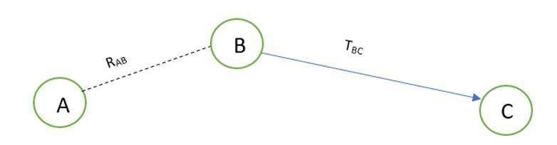

Figure 1.1: Sample Network Diagram with 3 Network Nodes

RAB is the recommendation value from node A to B and TBC is the trust value from node B to C. Probability-based model will calculate the multipath trust propagation and concatenation using probability equations. Probability values for the trust relationship can be converted into trust values using entropy-based equations. In order to calculate indirect trust, it is required to request recommendations from other nodes. A new control packet has introduced as TRR (Trust Recommendation Request) to get the trust value of a particular node by requesting from the other neighbor nodes.

TABC = RABTBC

According to the Figure 1.1, if node A wants to know the indirect trust value of node C, node A can send a TRR message to node B by requesting for the trust value of node C.  That trust value is only available in node B’s trust table. Finally, TABC can be evaluated as in the above equation. Based on that trust value they are attempting to detect malicious nodes.

One drawback of this solution is that malicious nodes can collaboratively provide wrong recommendations for other nodes. Therefore, a mechanism should be required to detect collaborative malicious nodes. By analyzing this past history of network node interactions, we came up with a solution to categorize nodes into levels based on the global trust which can be utilized to identify the malicious nodes. Network nodes can be trustworthy, partially trustworthy, selfish, pure malicious or collaborative malicious nodes.

### **Different ways to achieve trust in MANET [3]**

Nodes in MANET can move randomly without any centralized structure or any time pattern. Due to this self-configuration and self-optimization characteristics, such networks can be called as self-organized networks [1]. It is difficult to provide security for such dynamic environments than traditional networks. Ad hoc networks like MANET are vulnerable to various attacks due to this dynamic and distributed behaviors of nodes. This can lead to many IoT device failure with resource constrained environments. Therefore, there should be mechanisms which allow a node to measure the reliability and security of other nodes. Then trustworthy nodes can avoid dealing with malicious nodes. As a result, it can improve both network performance and security aspects.

As revealed in 1.2.1, only the direct trust is calculated to evaluate the trustworthiness of nodes. That will cause problems in capturing indirect behaviors of network nodes that brings harm. There is no way to prove complete trustworthiness is only depend on direct interactions among each node in the network. There might have chances of getting high accuracy for trust values by getting recommendations from other network nodes. At the same time could not come to a better decision only depending on indirect trust value. That will arise the requirement of calculating the average value of direct trust value and indirect trust value when taking a better conclusion on trustworthiness of nodes. On the other hand, definition for trust among the network nodes is similar to trust among human beings. Direct trust is the trust which builds with the experience among each other. When someone has suspects about that trust, going to take recommendations from others is the indirect trust. Therefore, measuring both direct trust and indirect trust is a vital factor.

According to 1.2.2, they do not consider about collaborative behaviors of malicious nodes. Sometimes group of malicious nodes provide wrong recommendations to make a node in their team as more trustworthy. Eventually it also contributes to a considerable amount of packet drops. Then there should be categories of malicious nodes such as pure malicious and collaborative malicious. Pure malicious nodes will misbehave individually, while collaborative malicious nodes misbehaving as a team in the network. Therefore, it is important to distinguish the type of malicious nodes.

# METHODOLOGY

## **Spiral Model**

As the advanced categorizing of the malicious nodes, we have to go to the spiral model where we have the collaborative malicious node discovery process. In spiral model mainly, there are three different phases.

Table 1.1: Backup Table

|  |  |  |  |
| --- | --- | --- | --- |
| Neighbor node | Trust Value | Time duration/ Backup time | Analyzed results |
|  |  |  |  |

### **Collaborative malicious node discovery process**

This is the phase where will do the advanced categorization for the malicious nodes and identify the collaborative malicious nodes by analyzing the dynamic behavior of the nodes. Only using one record it cannot predict a collaborative malicious behavior, and it has to have more historical records or trust records. For this purpose, mainly, will maintain a backup table as in Table 1.1, where it stores the recent records of the trust table and each entry on the backup table is associated with a timeout. Initially, it has predetermined range for the trust with high trust value (HT) and low trust value (LT) and using the backup table records and current trust record it can compare the values against the time. For a given time period it can analyze the trust values, and after getting the analyzed report or plot, it can check for outliers within the given range HT – LT. If it contains any outliers or there are any sudden dynamic changes of the trust values it can suspect as a collaborative malicious node. Otherwise, it can be a pure malicious node without any dynamic changing behavior. The range can be changed according to the 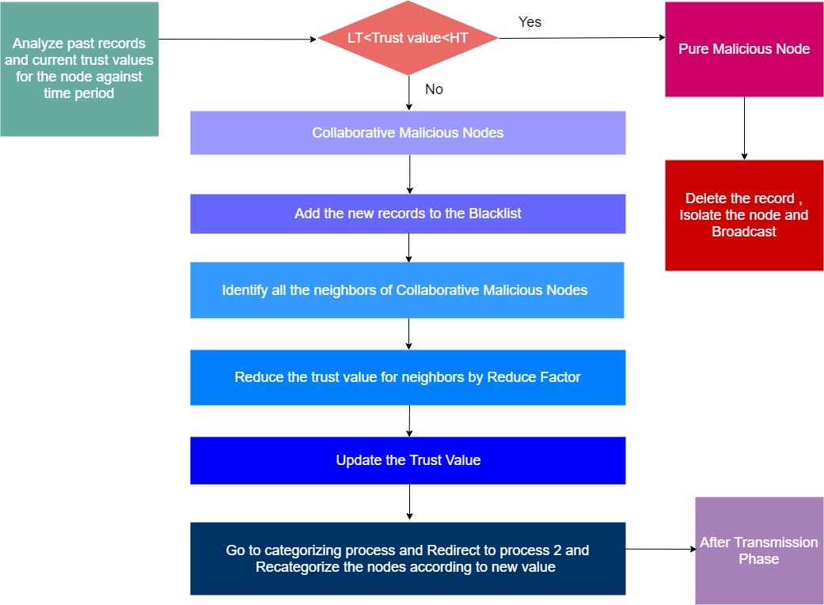user specification.

Figure 2.1: Flow Chart for the Spiral Model

The procedure for the algorithm in Figure 2.1 is as follows.

**Procedure:** collaborative malicious node discovery Algorithm (Spiral model)

1: Get highest trust value and lowest trust value for the node for a given time range and marked them as value boundary for outliers

2: Then compare current trust value is in between the range or not.

3: If current trust value is in between the range, it's categorized as a pure malicious node.

4: Then it (the node who execute this) can delete that record from all of its tables and can broadcast message to aware others.

5: So that will terminate the pure malicious identified process.

6: If current trust value is not in between outliers it's categorized as collaborative malicious (CM) node.

7: Then it (the node who execute this) can edit its trust table blackList flag to true.

8: Identify all the neighbors of identified CM node and reduce their trust value since they have given the incorrect recommendations.

9: Broadcast to the other nodes

10: Go to the Identifying_trust_levels algorithm again.

### **Penalty phase**

Same as the trust level identification phase here also will reduce the trust value of the particular recommending node with the help of a reduction factor. Reduction factor will be calculated based on the maturity level or the reputation of the node. Immediately after the trust reduction, old trust value in the trust table should be updated with the newly calculated value. According to the updated trust value, the particular neighbor nodes should be redirected to the trust level identification phase in order to re-categorize their trust levels. The pseudocode for this algorithm is as follows.

BEGIN

p_M =passed-in malicious node

IF trust value is not an outlier

THEN

Delete from trust table

Send Broadcast to delete node

ELSE

Mark node as blacklist in trust table

FOR each node which recommended p_M DO

Calculate reduce factor

Recalculate indirect trust

Update global trust

END FOR

Broadcast neighbors about p_M node

GOTO Identifying_trust_levels

END IF

END

## **Deep Reinforcement Learning Model**

Reinforcement Learning (RL) model is trained to achieve a particular goal through the optimal path. It will assign a positive reward for correct action and negative reward for incorrect action. RL model can predict more accurate result without utilizing more historical data of the relevant scenario. As for the agent in RL model, will be using a DQN (Deep Q Network). DQN is a network which consists of state changing operations where an agent will monitor the actions and assign rewards for accurate actions and assign penalty points for inaccurate actions.

Figure 2.2: System Diagram

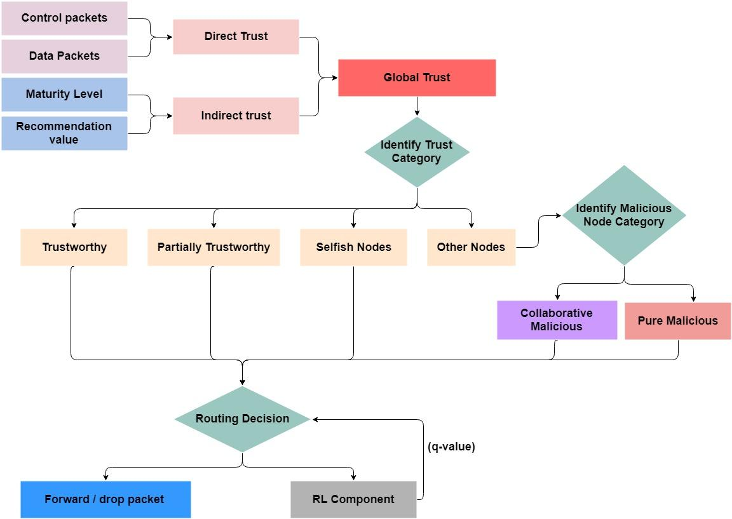As in the Figure 2.2, global trust value will be inputted to RL component. Then it will generate a q-value based on defined rewards. This q-value can determine the most trustworthy path to forward packets. If the q-value is high then it will consider as the more trustworthy route and if q-value holds a law value then it will be an untrustworthy route. Here, will assign performance metrics as the state and predict actions according to it by the DQN agent.

# RESULTS AND DISCUSSION

## **Results**

### **Spiral model**

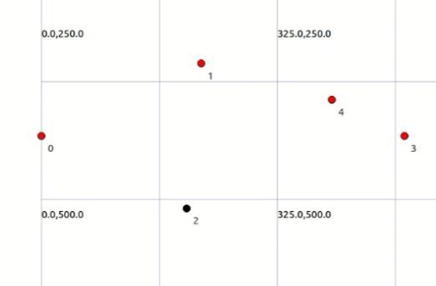

Figure 3.1: Sample Network Topology

Will take a topology of five network nodes including one **malicious node - 10.0.0.3** (black color node in Figure 3.1). Total simulation time is 100 seconds and will calculate trust values in each 10,40 and 90 seconds. There the goal is to identify the category of malicious node through spiral model.

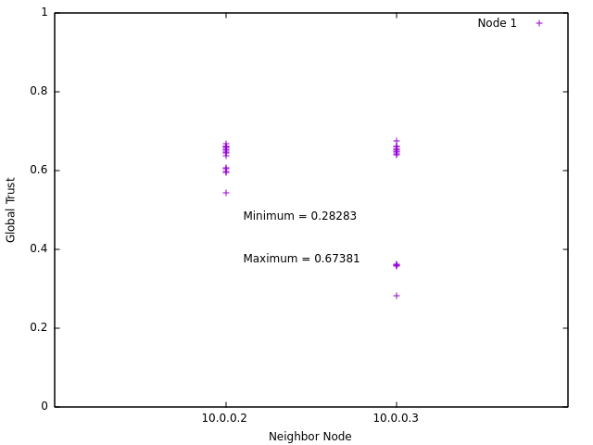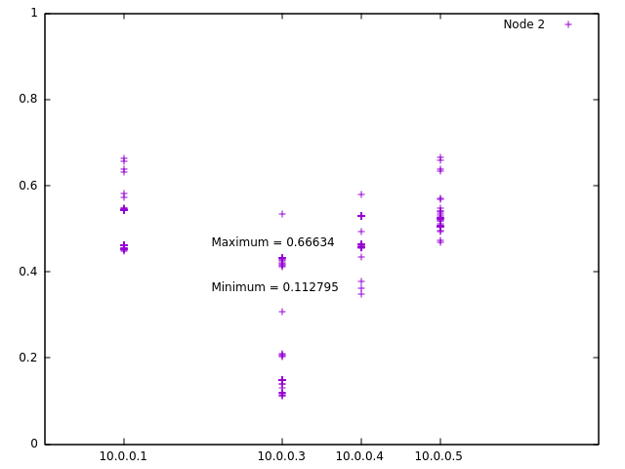

Figure 3.3: Backup Table Data for Node 2

Figure 3.2: Backup Table Data for Node 1

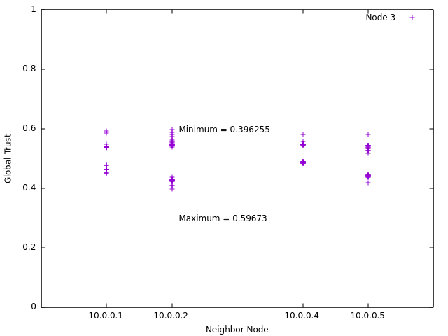

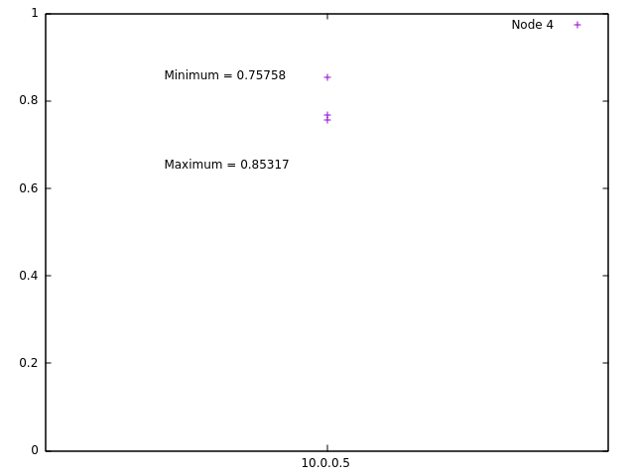

Figure 3.4: Backup Table Data for Node 3

Figure 3.5: Backup Table Data for Node 4

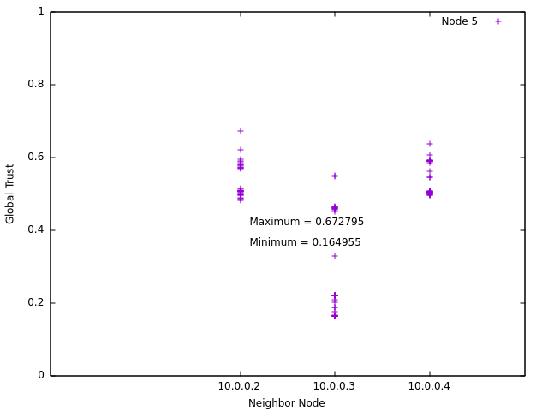

Figure 3.6: Backup Table Data for Node 5

Figure 3.2- Figure 3.6 represent the plotted backup table data for all the nodes in above defined network. Each diagram consists of minimum and maximum global trust value (outliers) of each neighbor node. Based on those outliers, it could identify that 10.0.0.3 is a pure malicious node.

### **Deep Reinforcement Learning Model**

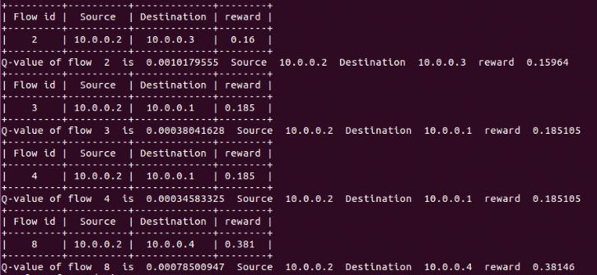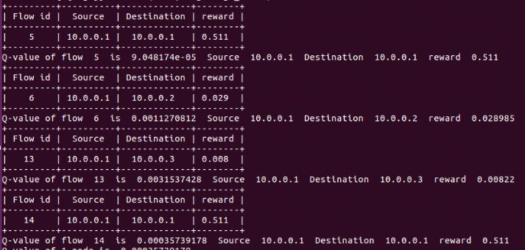In order to measure the trustworthiness of routes will analyze result of a flow wise approach which was generated by the flow monitor in ns-3 simulator. Following images represent q-values of each flow node by node separately.

Figure 3.8: Q-values for Flows in Node 2

Figure 3.7: Q-values for Flows in Node 1

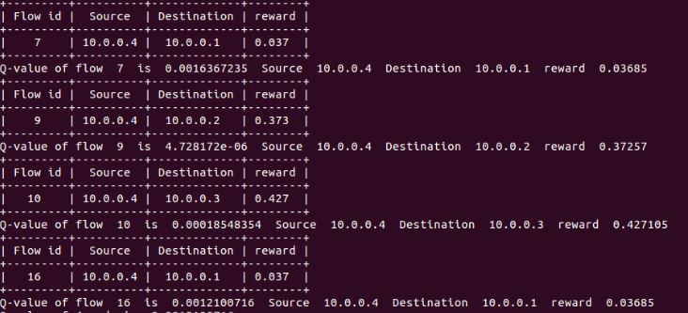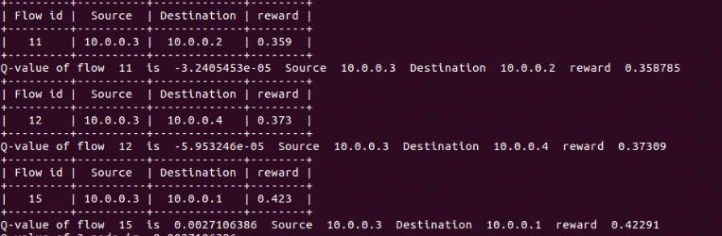

Figure 4.0: Q-values for Flows in Node 4

Figure 3.9: Q-values for Flows in Node 3

# REFERENCES

[1] S. S, P. K, and T. A, “Authentication Using Trust to Detect Misbehaving Nodes in Mobile Ad hoc Networks Using Q-Learning,” *Int. J. Netw. Secur. Its Appl.*, vol. 8, no. 3, pp. 47–64, 2016.

[2]     K. J. R. Liu, “Information theoretic framework of trust modeling and evaluation for ad hoc networks,” *IEEE J. Sel. Areas Commun.*, vol. 24, no. 2, pp. 305–317, 2006.

[3]       R. Dalal, “Different Ways to Achieve Trust in MANET,” *Int. J. AdHoc Netw. Syst.*, vol. 2, no. 2, pp. 53–64, 2012.

[4]       C. Fountas, “Swarm Intelligence: The Ant Paradigm,” Springer, Berlin, Heidelberg, 2010, pp. 137–157.

[5]     P. Velloso, R. Laufer, D. De O. Cunha, O. C. Duarte, and G. Pujolle, “Trust management in mobile ad hoc networks using a scalable maturity-based model,” *IEEE Trans. Netw. Serv. Manag.*, vol. 7, no. 3, pp. 172–185, 2010.

[6]    T. Farid and A. Prahladachar, “Secure Routing with AODV Protocol for Mobile Ad Hoc Networks.”

[7] S. Subramanian and B. Ramachandran, “QOS Assestion in MANET Routing based on Trusted AODV,” Int. J. Ad hoc, Sens. Ubiquitous Comput., vol. 3, no. 3, pp. 135–143, 2012.

[8]   J. S. S.Uma, “Human Interaction Pattern Mining Using Enhanced Artificial Bee Colony Algorithm S.,” *Int. J. Innov. Res. Comput. Commun. Eng.*, vol. 3, no. 10, pp. 10131–10138, 2015.

[9] R. K. Bar, J. K. Mandal, and M. M. Singh, “QoS of MANet Through Trust based AODV Routing Protocol by Exclusion of Black Hole Attack,” *Procedia Technol.*, vol. 10, pp. 530–537, 2013.

[10]   Y. Yoo and D. P. Agrawal, “Why does it pay to be selfish in a MANET?,” *IEEE Wirel. Commun.*, vol. 13, no. 6, pp. 87–97, 2006.

[11] R. Neogy, C. Chowdhury, and S. Neogy, “Reliability of mobile agents for reliable service discovery protocol in MANET,” *arXiv Prepr. arXiv1111.1865*, vol. 3, no. 5, pp. 229–243, 2011