PROJECT REPORT

Customer Churn Analysis
Advanced Data Visualization and Storytelling with Python

Executive Summary
This project focuses on advanced data visualization and storytelling using a customer churn dataset containing 10,000 customer records and 16 variables. The work extends the data-cleaning and exploratory-analysis foundation into a visual analysis workflow designed to communicate patterns clearly to a non-technical audience.
The analysis uses Python in Visual Studio Code, with Pandas and NumPy for data handling and calculations, and Matplotlib and Seaborn for visualization. The objective is to describe the existing data and compare churn rates across meaningful customer groups.
The overall churn rate is 22.60% (2,260 of 10,000 customers). Several visual comparisons show substantial differences between groups. Month-to-month customers have a 30.65% churn rate compared with 9.59% for two-year customers. Customers with 5 or more complaints have a 51.26% churn rate compared with 15.31% among customers with no complaints. Low-satisfaction customers show a 57.14% churn rate, while the 49+ month tenure group shows 10.84%. A combined view of month-to-month customers with 0–12 months of tenure reaches approximately 52.87%.
These findings demonstrate how carefully selected charts and numerical annotations can turn a large customer table into a coherent visual story. The results are descriptive associations only and should not be interpreted as proof that any individual factor causes churn.

1. Introduction
Customer churn refers to customers who stop using a service. A raw dataset can contain many columns and thousands of records, but tables alone can make it difficult to recognize meaningful patterns. Data visualization provides a way to transform these records into comparisons that are easier to interpret.
This assignment focuses on the visualization and storytelling stage of a data-analysis workflow. After checking and cleaning the dataset, customer groups were created for variables such as tenure, complaints, support calls, monthly charges and last-login recency. Churn rates were then calculated for these groups and represented using charts.

1.1 Objectives
- Inspect and validate the customer churn dataset before visualization.
- Perform descriptive exploratory analysis using Python.
- Create meaningful customer groups for visual comparison.
- Calculate churn rates for important categorical and grouped numerical variables.
- Use Matplotlib and Seaborn to create clear and readable visualizations.
- Add exact values and percentages where they strengthen interpretation.
- Combine variables to demonstrate more advanced visual storytelling.
- Explain findings using evidence from the charts rather than unsupported assumptions.
- Document limitations of descriptive visual analysis.

1.2 Scope
The scope is limited to data cleaning, exploratory analysis, visualization and storytelling. No machine-learning model, prediction, risk classification, forecasting or automated business recommendation is included in this Week 2 work.

2. Dataset Description
The dataset contains 10,000 customer records and 16 columns. It includes demographic information, service characteristics, billing-related measures, customer-support indicators, engagement measures, satisfaction and churn status.
Variable | Description
Customer_ID | Unique customer identifier
Gender | Customer gender category
Age | Customer age
Tenure_Months | Length of customer relationship in months
Contract_Type | Month-to-month, one-year or two-year contract
Payment_Method | Customer payment method
Monthly_Charges | Monthly customer charge
Total_Charges | Total accumulated charges
Internet_Service | Internet service category
Tech_Support | Technology support status
Streaming_Service | Streaming service status
Number_of_Complaints | Number of recorded complaints
Support_Calls | Number of support calls
Last_Login_Days | Days since the customer's last login
Satisfaction_Score | Customer satisfaction score
Churn | Churn status used for descriptive comparisons

2.1 Dataset Summary
Metric | Result
Total records | 10,000
Total columns | 16
No Churn | 7,740 (77.40%)
Churn | 2,260 (22.60%)
Overall churn rate | 22.60%
Final missing values after cleaning | 0

The Churn column is used as the main analysis variable for descriptive comparisons. It is not treated as a machine-learning target in this project because no predictive model is being developed.

3. Data Cleaning and Preprocessing
Visualization is only useful when the underlying data is reasonably consistent. The dataset was therefore inspected before creating charts. The cleaning stage focused on missing values, duplicates, data types, numerical ranges and the consistency of categorical values.

3.1 Cleaning Checks
- Checked the number of rows and columns.
- Inspected data types and column names.
- Calculated missing-value counts and percentages.
- Checked for duplicate rows.
- Reviewed descriptive statistics and numerical ranges.
- Inspected the distribution of the Churn column.
- Standardised or handled values where required before visualization.

3.2 Missing Values
Before cleaning, missing values were identified in Payment_Method (0.5%), Total_Charges (1.0%) and Satisfaction_Score (1.0%). These issues were handled during preprocessing so that the final analysis dataframe contained 10,000 rows and 16 columns with no remaining missing values.

3.3 Analysis Groups
Grouped variables were created to make numerical measures easier to compare visually. Tenure was grouped into 0–12, 13–24, 25–48 and 49+ months. Complaints were grouped into None, 1–2, 3–4 and 5+. Support calls were grouped into None, 1–2, 3–5 and 6+. Similar categories were created for monthly charges and last-login recency.
These groups are analytical categories created for visualization. They simplify continuous or count-based measurements into interpretable segments, but the chosen boundaries can influence the visual pattern.

4. Exploratory Data Analysis
Descriptive statistics were used to understand the central tendencies of important numerical variables before comparing churn rates.
Variable | Mean
Age | 38.39 years
Tenure_Months | 36.70 months
Monthly_Charges | 82.76
Total_Charges | 3042.20
Number_of_Complaints | 1.30
Support_Calls | 2.20
Last_Login_Days | 13.27 days
Satisfaction_Score | 6.75

The overall churn distribution provides the baseline for every subsequent chart: 22.60% of customers churned, while 77.40% did not. Therefore, a group with a churn rate substantially above 22.60% can be described as having a higher observed churn rate than the overall dataset.

5. Customer Churn Distribution
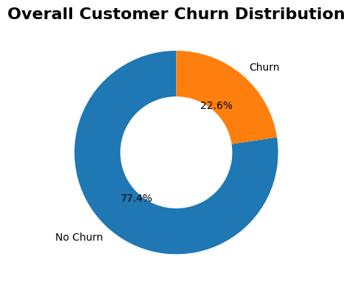
Figure 1. Overall customer churn distribution.
The dataset contains 7,740 customers who did not churn and 2,260 customers who churned. This corresponds to an overall churn rate of 22.60%. The figure establishes the baseline against which all subgroup churn rates are compared.
Analytical insight: the churned group represents more than one-fifth of the dataset. This makes subgroup comparisons useful because the analysis can identify where observed churn rates are substantially higher or lower than the 22.60% baseline.

6. Churn Rate by Contract Type
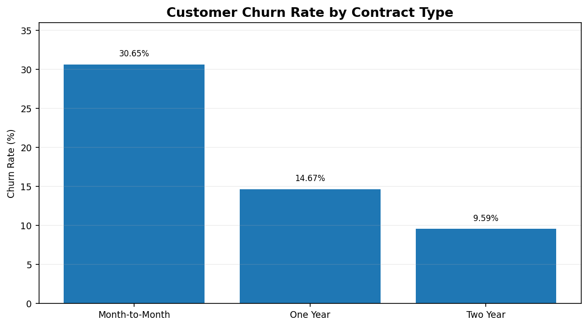
Figure 2. Churn rate by contract type.
Contract Type | Customers | Churned | Churn Rate
Month-to-Month | 5,596 | 1,715 | 30.65%
One Year | 2,413 | 354 | 14.67%
Two Year | 1,991 | 191 | 9.59%

Analytical insight: month-to-month customers have a 30.65% churn rate, which is 21.06 percentage points higher than the 9.59% observed for two-year customers. The month-to-month rate is also about 3.2 times the two-year rate. This is one of the clearest differences in the descriptive analysis.
Storytelling point: the chart moves from a relatively high churn rate for short-term contracts toward a lower observed rate for longer contracts. This is an association in the dataset, not evidence that contract length alone causes churn.

7. Churn Rate by Tenure
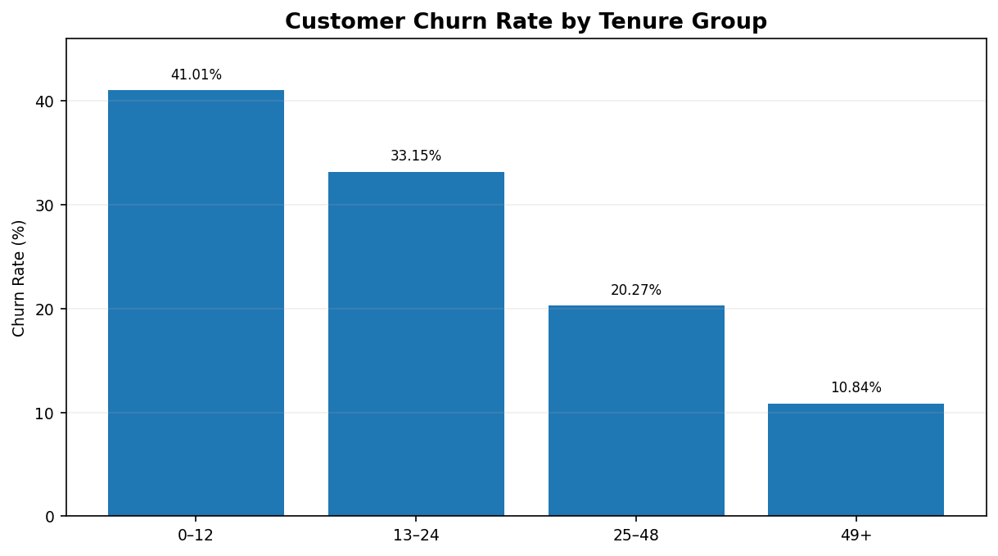
Figure 3. Churn rate across tenure groups.
Tenure Group | Churn Rate
0–12 | 41.01%
13–24 | 33.15%
25–48 | 20.27%
49+ | 10.84%

Analytical insight: customers with 0–12 months of tenure have a 41.01% churn rate, while the 49+ month group has 10.84%. The difference is 30.17 percentage points. The visual shows a consistent downward pattern across the four tenure groups.
Storytelling point: the first year is visually distinct from the longest-tenure group. This suggests that customer tenure is an important dimension for further descriptive investigation.

8. Churn Rate by Number of Complaints
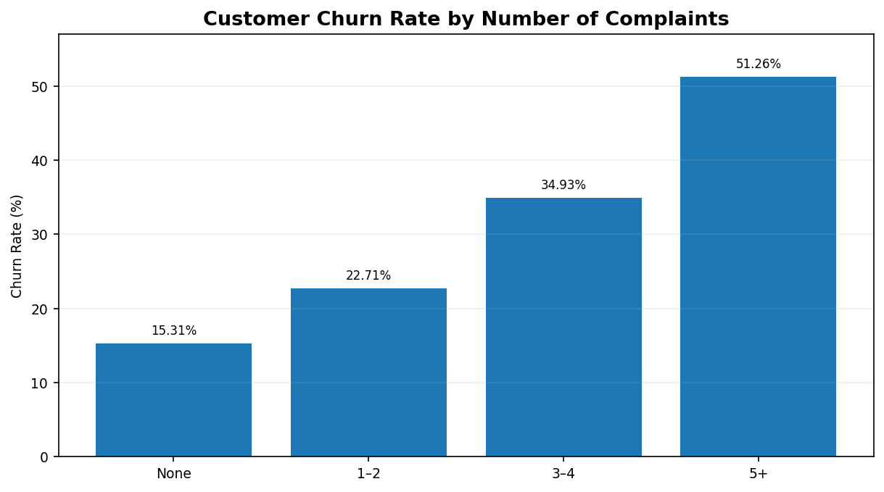
Figure 4. Churn rate by complaint group.
Complaint Group | Churn Rate
None | 15.31%
1–2 | 22.71%
3–4 | 34.93%
5+ | 51.26%

Analytical insight: churn rises from 15.31% among customers with no complaints to 51.26% among customers with 5 or more complaints. That is a 35.95 percentage-point difference. The 5+ complaint group has a churn rate more than three times the no-complaint group.
Storytelling point: the increasing bars create a strong visual progression. However, the chart does not establish whether complaints cause churn; complaints and churn may both be related to other customer experiences.

9. Churn Rate by Satisfaction Level
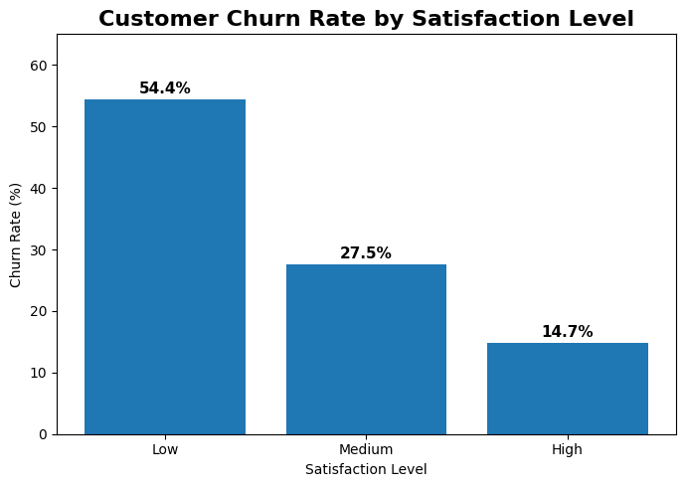
Figure 5. Churn rate by satisfaction level.
Satisfaction Level | Churn Rate
Low | 54.4%
Medium | 27.5%
High | 14.7%

Analytical insight: the low-satisfaction group has an observed churn rate of 54.4%, compared with 14.7% for the high-satisfaction group. The difference is 39.7 percentage points. The low-satisfaction rate is approximately 3.4 times the high-satisfaction rate.
Storytelling point: satisfaction produces one of the largest observed gaps in this analysis. Because this is descriptive analysis, the result should be presented as an association rather than a causal conclusion.

10. Churn Rate by Last-Login Recency

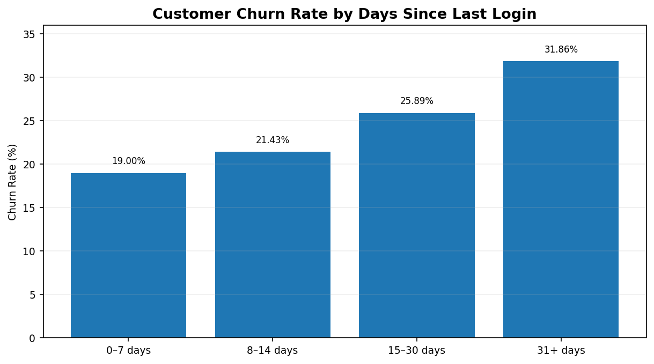
Figure 9. Churn rate by days since last login.
Last Login Group | Churn Rate
0–7 days | 19.00%
8–14 days | 21.43%
15–30 days | 25.89%
31+ days | 31.86%

Analytical insight: churn increases from 19.00% among customers who logged in within the last 7 days to 31.86% among customers whose last login was 31 or more days ago. The difference is 12.86 percentage points.
Storytelling point: the visual suggests a consistent upward pattern as login recency decreases. This is an observational pattern and should not be interpreted as a causal effect.

11. Churn Rate by Support Calls
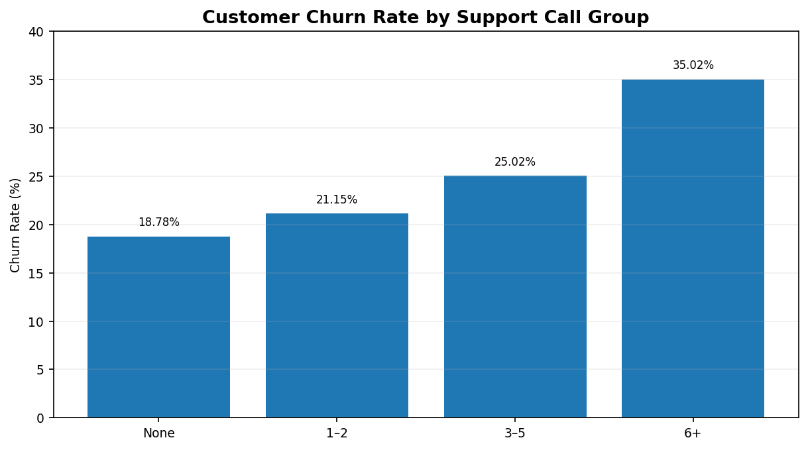
Figure 6. Churn rate by support-call group.
Support Call Group | Churn Rate
None | 18.78%
1–2 | 21.15%
3–5 | 25.02%
6+ | 35.02%

Analytical insight: churn increases from 18.78% for customers with no support calls to 35.02% for customers with 6 or more calls. This represents a 16.24 percentage-point difference. The pattern becomes progressively higher as the support-call group increases.
Storytelling point: support-call frequency is useful as an engagement/service-interaction measure. It should not be interpreted as evidence that support calls themselves cause customers to churn.

12. Churn Rate by Monthly Charges
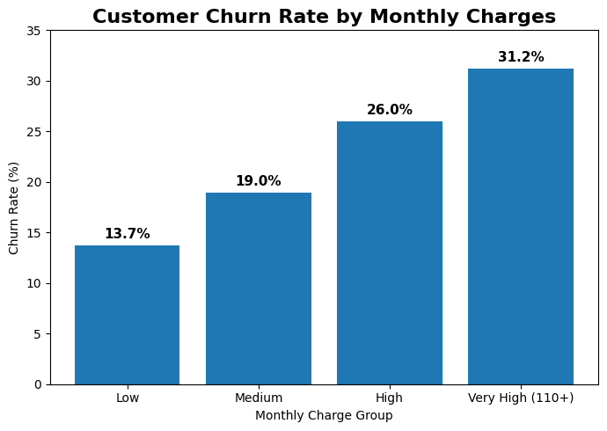
Figure 7. Churn rate by monthly-charge group.
Monthly Charge Group | Churn Rate
Low | 13.71%
Medium | 19.00%
High | 26.04%
Very High | 31.21%

Analytical insight: churn increases from 13.71 in the low monthly-charge group to 31.21% in the very-high group. The difference is 17.51 percentage points. The two higher groups are above the overall 22.60% churn baseline.
Storytelling point: the upward visual pattern makes the relationship easy to communicate, while the exact percentages prevent the story from relying only on visual height.

13. Churn Rate by Internet Service
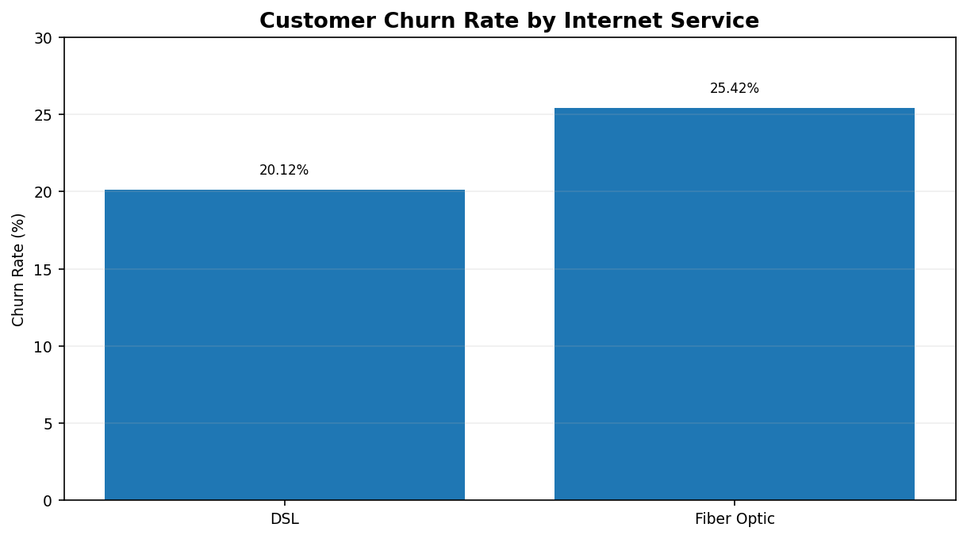
Figure 8. Churn rate by internet service.
Internet Service | Customers | Churned | Churn Rate
DSL | 3,733 | 751 | 20.12%
Fiber Optic | 4,760 | 1,210 | 25.42%

Analytical insight: Fiber Optic customers have a 25.42% churn rate compared with 20.12% for DSL customers, a difference of 5.30 percentage points. The Fiber Optic rate is also above the overall 22.60% baseline, whereas DSL is below it.
Storytelling point: this difference is smaller than the gaps observed for satisfaction, complaints or tenure. This illustrates why visual storytelling should consider both the direction and magnitude of differences.

14. Combined Analysis: Contract Type and Tenure
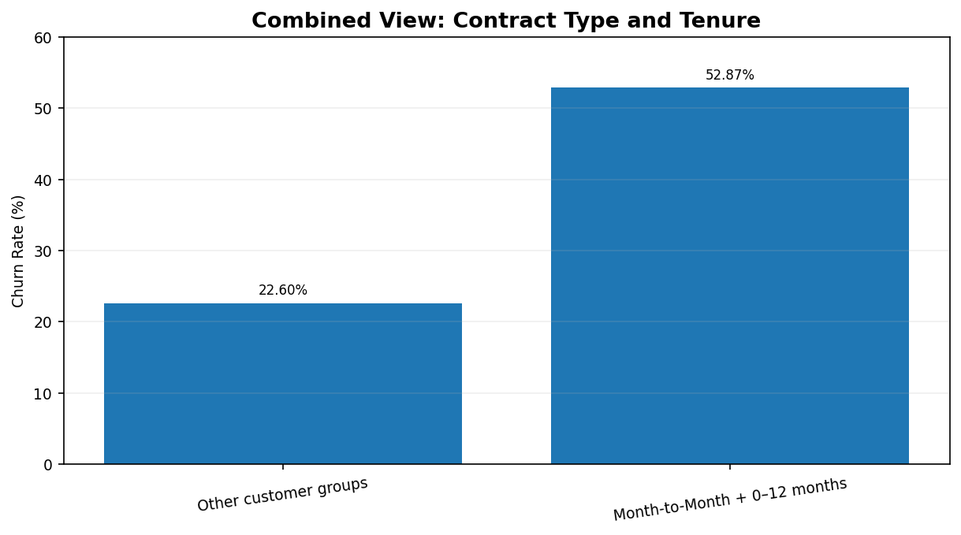
Figure 10. Combined visual comparison highlighting the strongest segment observed.
Single-variable charts are useful for identifying broad patterns, but combining variables can reveal stronger segments. In the analysis, the Month-to-Month + 0–12 months segment has an observed churn rate of approximately 52.87%. This is 30.27 percentage points above the overall 22.60% baseline.
Analytical insight: the combined segment demonstrates why two-dimensional analysis can provide more specific context than looking at contract type or tenure separately. It does not mean that every customer in this segment will churn, nor does it establish that either variable causes churn.
Storytelling point: the overall story becomes more specific when the analysis moves from a general baseline, to individual dimensions, and finally to a combined segment.

15. Visual Storytelling
The charts were interpreted as a connected narrative rather than as isolated figures. The storytelling sequence begins with the overall churn baseline and then moves through the variables that show the clearest differences.
Stage | Evidence | Storytelling Role
Baseline | 22.60% overall churn | Establishes the reference point
Contract | 30.65% month-to-month | Shows a clear contract-level difference
Tenure | 41.01% at 0–12 months | Highlights early-tenure churn
Complaints | 51.32% at 5+ | Shows a strong complaint-group difference
Satisfaction | 54.41% low satisfaction | Shows the largest single-group rate
Support | 35.02% at 6+ | Adds service-interaction context
Charges | 31.21% very high | Adds a financial/usage dimension
Internet | 25.42% Fiber Optic | Shows a smaller service-type difference
Last Login | 31.86% at 31+ days | Adds engagement context
Combined | 52.87% M2M + 0–12 months | Demonstrates multi-variable storytelling

The numerical evidence is intentionally included alongside charts. This prevents the report from relying only on visual impressions and makes comparisons such as 57.14% versus 18.63% or 41.01% versus 10.84% explicit.

16. Key Analytical Findings
Analysis Area | Key Evidence | Difference / Comparison
Overall churn | 22.60% | 2,260 of 10,000 customers
Contract type | 30.65% M2M vs 9.59% two-year | 21.06 percentage points
Tenure | 41.01% at 0–12 vs 10.84% at 49+ | 30.17 percentage points
Complaints | 51.26% at 5+ vs 15.31% none | 35.95 percentage points
Satisfaction | 57.14% low vs 18.63% high | 38.51 percentage points
Support calls | 35.02% at 6+ vs 18.78% none | 16.24 percentage points
Monthly charges | 31.21% very high vs 11.56% low | 19.65 percentage points
Internet service | 25.42% Fiber vs 20.12% DSL | 5.30 percentage points
Last login | 31.86% at 31+ vs 19.00% at 0–7 | 12.86 percentage points
Combined segment | 52.87% M2M + 0–12 | 30.27 points above baseline

The strongest observed single-group churn rate is 57.14% for low satisfaction, followed by 51.26% for customers with 5+ complaints. The strongest combined segment shown is Month-to-Month customers with 0–12 months of tenure at approximately 52.87%. These figures are descriptive and should be interpreted in the context of the full dataset.

17. Limitations and Considerations
A strong visualization report should explain not only what the charts show, but also what they cannot prove. The following limitations are important when interpreting this project.
- Descriptive analysis only: The project summarizes existing observations and does not estimate future churn or individual customer risk.
- Association is not causation: A higher churn rate within a group does not prove that the grouping variable caused customers to churn.
- Confounding variables: Contract type, tenure, charges, services, complaints and satisfaction may be related to one another. A single-variable chart cannot isolate their individual effects.
- Group boundaries affect results: Categories such as 0–12 months or 5+ complaints are analytical choices. Different cut-offs could produce somewhat different visual patterns.
- Aggregated rates hide variation: A group-level churn rate does not show the full distribution within that group or explain why individual customers behaved differently.
- Sample-size context matters: A percentage should ideally be interpreted together with the number of customers represented by that category, especially for smaller groups.
- Missing-value treatment can affect results: Cleaning decisions may influence summary statistics and charts. The final dataset contains no remaining missing values, but the treatment used should always be documented.
- No statistical significance testing: The project uses descriptive percentages and visual comparisons; it does not formally test whether observed group differences are statistically significant.
- No predictive validation: There is no train/test split, model evaluation, probability calibration or prediction performance assessment because machine learning is outside the scope.
- No causal or longitudinal analysis: The dataset does not establish whether changes in satisfaction, complaints, support calls or login activity occurred before churn in a way that would support causal interpretation.
- Visualization limitations: Charts simplify complex data. Axis ranges, grouping choices and chart types can influence how large a difference appears, so exact values are included where possible.
- Dataset-specific conclusions: The findings describe this dataset and should not automatically be generalized to all telecom customers or other companies without additional evidence.
These limitations do not reduce the usefulness of the project. Instead, they define the appropriate level of interpretation: the charts identify patterns and differences that are suitable for further investigation.

18. Conclusion
This project demonstrated how Python can be used to move from a cleaned customer dataset to advanced visualization and data storytelling. The analysis established a 22.60% overall churn baseline and then compared churn rates across contract type, tenure, complaints, satisfaction, support calls, monthly charges, internet service and last-login recency.
The visual analysis identified several substantial differences. Month-to-month customers had a 30.65% churn rate compared with 9.59% for two-year customers. The 0–12 month tenure group had a 41.01% rate compared with 10.84% for 49+ months. Customers with 5 or more complaints had a 51.26% rate, while the low-satisfaction group had the highest observed single-group rate at 57.14%. The combined Month-to-Month + 0–12 months segment reached approximately 52.87%.
The project also demonstrates an important principle of data storytelling: a chart becomes more informative when it is supported by exact values, comparisons to a baseline, clear interpretation and appropriate limitations. The analysis remains descriptive and does not claim causation, prediction or future outcomes.

Appendix A. Python Implementation
The analysis was developed and executed in Visual Studio Code (VS Code). The following excerpts represent the main stages of the implementation.

A.1 Import Libraries and Load Data
import pandas as pd
import numpy as np
import matplotlib.pyplot as plt
import seaborn as sns
df = pd.read_csv("customer_churn_data.csv")
print("Dataset Shape:", df.shape)
print(df.head())
print(df.dtypes)
print(df.info())

A.2 Data Quality Checks
print(df.isnull().sum())
print((df.isnull().sum() / len(df) * 100).round(2))
print("Duplicates:", df.duplicated().sum())
print(df.describe())
print(df["Churn"].value_counts())
print(df["Churn"].value_counts(normalize=True) * 100)

A.3 Create Analytical Groups
df["Tenure_Group"] = pd.cut(
df["Tenure_Months"],
bins=[0, 12, 24, 48, float("inf")],
labels=["0–12", "13–24", "25–48", "49+"]
)
df["Complaint_Group"] = pd.cut(
df["Number_of_Complaints"],
bins=[-1, 0, 2, 4, float("inf")],
labels=["None", "1–2", "3–4", "5+"]
)
df["Support_Call_Group"] = pd.cut(
df["Support_Calls"],
bins=[-1, 0, 2, 5, float("inf")],
labels=["None", "1–2", "3–5", "6+"]
)

A.4 Calculate Churn Rates
contract_churn = (
df.groupby("Contract_Type")["Churn"]
.mean()
.mul(100)
.reset_index()
)
tenure_churn = (
df.groupby("Tenure_Group", observed=False)["Churn"]
.mean()
.mul(100)
.reset_index()
)
complaint_churn = (
df.groupby("Complaint_Group", observed=False)["Churn"]
.mean()
.mul(100)
.reset_index()
)

A.5 Example Visualization
plt.figure(figsize=(8, 5))
sns.barplot(
data=contract_churn,
x="Contract_Type",
y="Churn"
)
plt.title("Customer Churn Rate by Contract Type")
plt.xlabel("Contract Type")
plt.ylabel("Churn Rate (%)")
plt.tight_layout()
plt.show()

Appendix B. Workflow Summary
Stage | Work Completed
1. Data Loading | Loaded customer churn CSV in VS Code using Pandas
2. Data Inspection | Checked shape, columns, data types and sample records
3. Data Cleaning | Checked and handled missing values, duplicates and consistency
4. EDA | Calculated descriptive statistics and churn distribution
5. Group Creation | Created meaningful tenure, complaint, support, charge and login groups
6. Aggregation | Calculated churn rates for each analytical group
7. Visualization | Created bar charts using Matplotlib and Seaborn
8. Storytelling | Compared groups using exact values and baseline differences
9. Combined Analysis | Examined contract type together with tenure
10. Documentation | Recorded insights, limitations and reproducibility information

Tools used: Python, Pandas, NumPy, Matplotlib, Seaborn and Visual Studio Code. No machine-learning model, prediction, risk score or forecasting component was used in this Week 2 assignment.

References
- Pandas documentation — https://pandas.pydata.org/docs/
- NumPy documentation — https://numpy.org/doc/
- Matplotlib documentation — https://matplotlib.org/stable/
- Seaborn documentation — https://seaborn.pydata.org/

