TELCO CUSTOMER CHURN
Data Acquisition, Cleaning and Exploratory Data Analysis

Executive Summary
This project demonstrates a data-preparation workflow using the Telco Customer Churn dataset. The supplied CSV contains 7,043 customer records and 21 original variables covering customer demographics, services, contract/payment details, charges and churn status. Text fields were trimmed, TotalCharges was converted to numeric, and 11 blank values were investigated. 11 of these records had zero tenure and were assigned zero total charges under the stated business assumption. After cleaning, the dataframe has 0 missing values. The overall churn rate is 26.54%.

1. Introduction
Customer churn occurs when a customer stops using a service. Analysing churn patterns can help a business identify customer groups for further retention research. This assignment simulates a standard data-science workflow: acquiring a public dataset, inspecting its structure, cleaning data, exploring distributions and relationships, and documenting findings.

1.1 Objectives
- Load and inspect a publicly available dataset.
- Identify and address missing or incorrectly typed values.
- Check duplicates, category consistency and numerical ranges.
- Use summary statistics and visualisations to explore churn patterns.
- Document cleaning decisions, findings, limitations and future work.

2. Dataset Description and Acquisition
Dataset: Telco Customer Churn. File: WA_Fn-UseC_-Telco-Customer-Churn.csv. The dataset includes customer identifiers, demographic indicators, subscribed services, contract/payment details, monthly and total charges, and a Churn label. The analysis uses the supplied local CSV.
Public dataset reference: Kaggle, Telco Customer Churn — https://www.kaggle.com/datasets/blastchar/telco-customer-churn

2.1 Loading and inspecting the data
import pandas as pd
import numpy as np
import matplotlib.pyplot as plt
file_path = "WA_Fn-UseC_-Telco-Customer-Churn.csv"
df = pd.read_csv(file_path)
print(df.head())
print(df.shape)
print(df.info())
print(df.isnull().sum())
Initial inspection found 7,043 records and 21 original columns. Churn is the target variable with values Yes and No. customerID is an identifier rather than a continuous measurement.

3. Initial Inspection
Check | Result | Meaning
Dataset size | 7,043 rows × 21 original columns | Suitable for descriptive analysis.
Target | Churn (Yes/No) | Used for subgroup comparisons.
Exact duplicate rows | 0 | No exact duplicate rows found.
Unique customer IDs | 7043 | IDs are unique.
TotalCharges | 11 blanks after numeric conversion | Column needed type correction and investigation.

4. Data Cleaning and Preprocessing
Cleaning decisions were based on the meaning of each field. Valid records were retained, monetary values were converted to numeric, and meaningful service categories such as 'No internet service' were not treated as missing values.

4.1 Trim text values
for column in df.select_dtypes(include="object").columns:
df[column] = df[column].str.strip()
Rationale: leading or trailing spaces can cause values such as 'Yes' and ' Yes' to be treated as different categories. Trimming standardises labels without changing their meaning.

4.2 Convert TotalCharges to numeric
df["TotalCharges"] = pd.to_numeric(
df["TotalCharges"], errors="coerce"
)
missing_total = df[df["TotalCharges"].isna()]
print(missing_total[
["customerID", "tenure", "MonthlyCharges", "TotalCharges"]
])
Rationale: TotalCharges represents money and should be numeric for summaries and charts. Conversion exposed 11 blank values. Inspection showed 11 of these had tenure equal to zero.

4.3 Handle the blank TotalCharges values
mask = df["TotalCharges"].isna() & (df["tenure"] == 0)
df.loc[mask, "TotalCharges"] = 0.0
Rationale: zero is consistent with the interpretation that a customer with zero tenure has not accumulated total charges. This is a business-rule assumption and should be checked against the dataset documentation or billing rules; it is not a universal rule.

4.4 Check duplicates and customer IDs
print("Duplicate rows:", df.duplicated().sum())
print("Unique customer IDs:", df["customerID"].nunique())
Result: 0 exact duplicate rows and 7,043 unique IDs. No rows were removed for duplication because none were found.

4.5 Create analysis variables
df["ChurnBinary"] = df["Churn"].map(
{"No": 0, "Yes": 1}
).astype("int8")
df["SeniorCitizenLabel"] = df["SeniorCitizen"].map(
{0: "No", 1: "Yes"}
)
Rationale: ChurnBinary is useful for numerical summaries and correlations; SeniorCitizenLabel is easier to read in charts. Original variables are retained.

4.6 Validate the cleaned data
print("Final shape:", df.shape)
print("Missing values:", df.isna().sum().sum())
print("Duplicate rows:", df.duplicated().sum())
print(df.dtypes)
After adding two analysis columns, the dataset has 7,043 rows and 23 columns, 0 missing values and 0 duplicate rows. MonthlyCharges and TotalCharges are numeric. No customer rows were removed.

5. Exploratory Data Analysis
EDA uses summary statistics and visualisations to describe the data and identify relationships worth further investigation.
Metric | Result
Total customers | 7,043
Customers who churned | 1,869
Customers who stayed | 5,174
Overall churn rate | 26.54%
Average tenure | 32.37 months
Average monthly charges | $64.76
Average total charges | $2279.73

5.1 Customer churn distribution
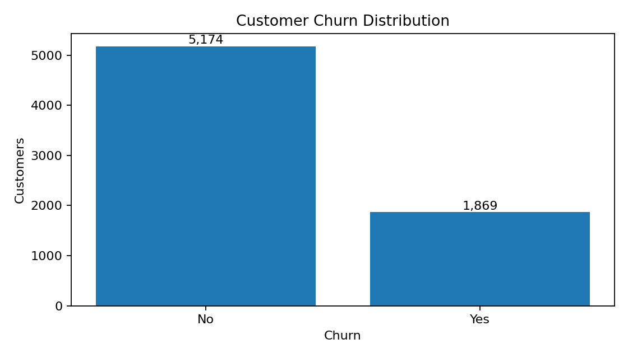
Figure 1. Number of customers by churn status.
1,869 customers churned and 5,174 did not. The overall churn rate is 26.54%, so churn is a meaningful segment for further investigation.

5.2 Customer tenure distribution
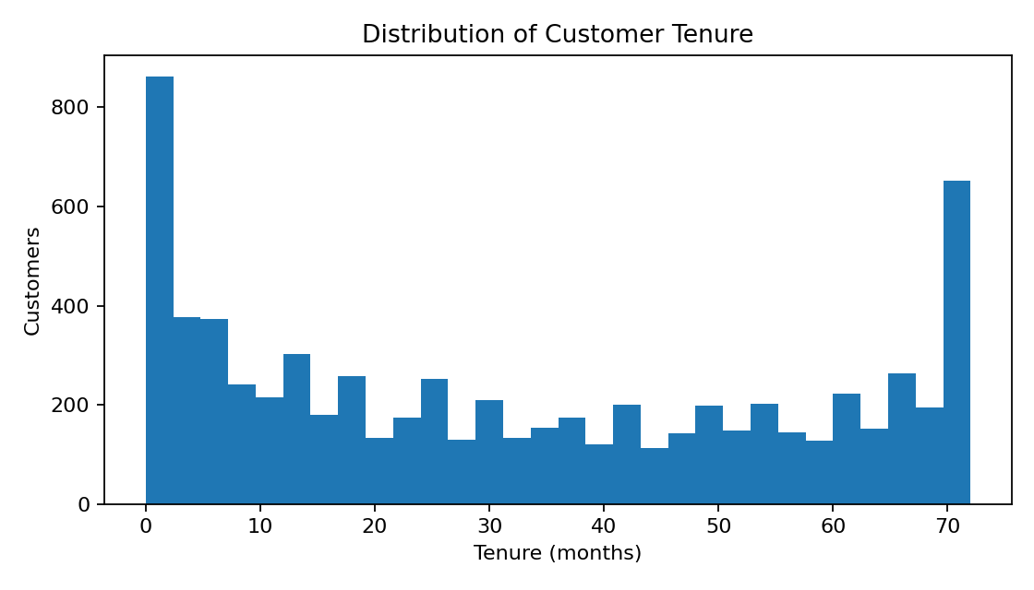
Figure 2. Distribution of customer tenure in months.
Tenure ranges from new customers to customers with several years of service. There are concentrations at low tenure and toward the long-tenure end. Tenure is worth exploring alongside churn.

5.3 Monthly charges by churn status
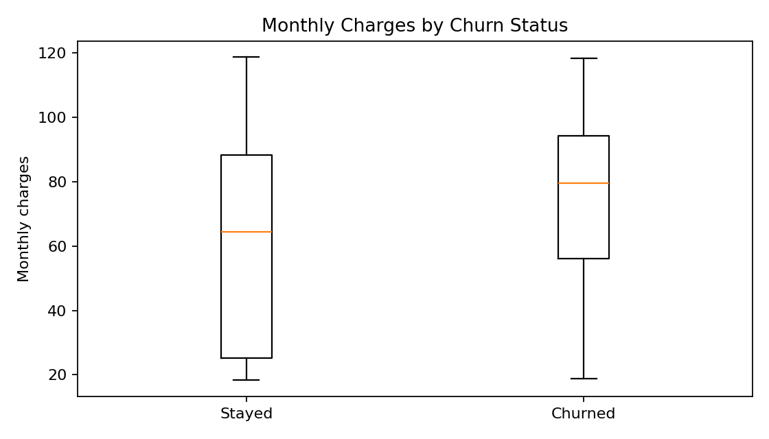
Figure 3. Monthly charges for customers who stayed and churned.
The median monthly charge is higher for churned customers than for retained customers in this dataset. The distributions overlap, so monthly charges alone do not distinguish every customer. This is an association, not evidence of causation.

5.4 Churn rate by contract type
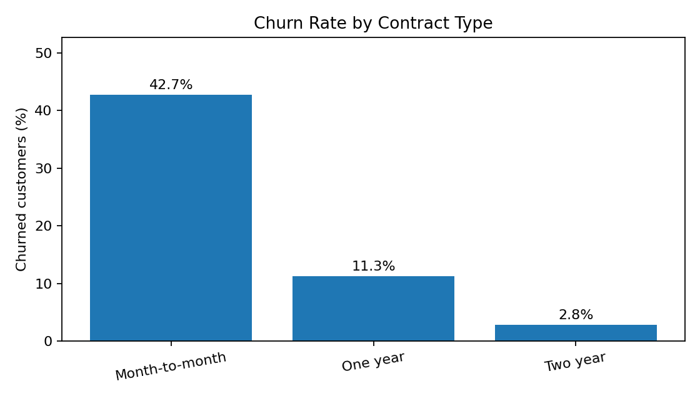
Figure 4. Percentage of customers who churned within each contract type.
Churn rates are 42.71% for month-to-month, 11.27% for one-year, and 2.83% for two-year contracts. The difference is substantial, but this descriptive result does not establish causation.

5.5 Correlation matrix
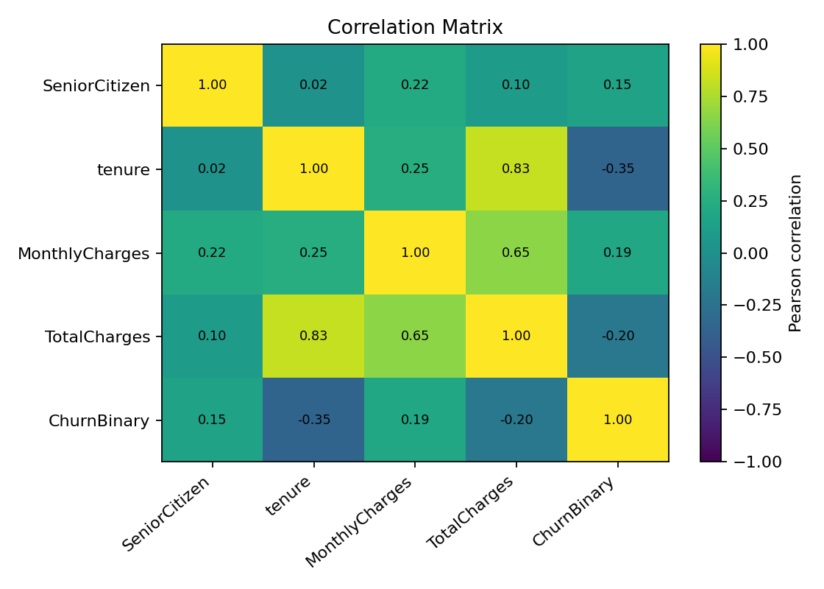
Figure 5. Pearson correlations for selected numerical variables.
Tenure has a negative correlation with ChurnBinary (r = -0.35); MonthlyCharges has a positive correlation (r = 0.19). Tenure and TotalCharges are strongly positively correlated (r = 0.83), which is plausible because charges accumulate over time. Correlation does not establish cause and effect.

5.6 Churn rate by internet service
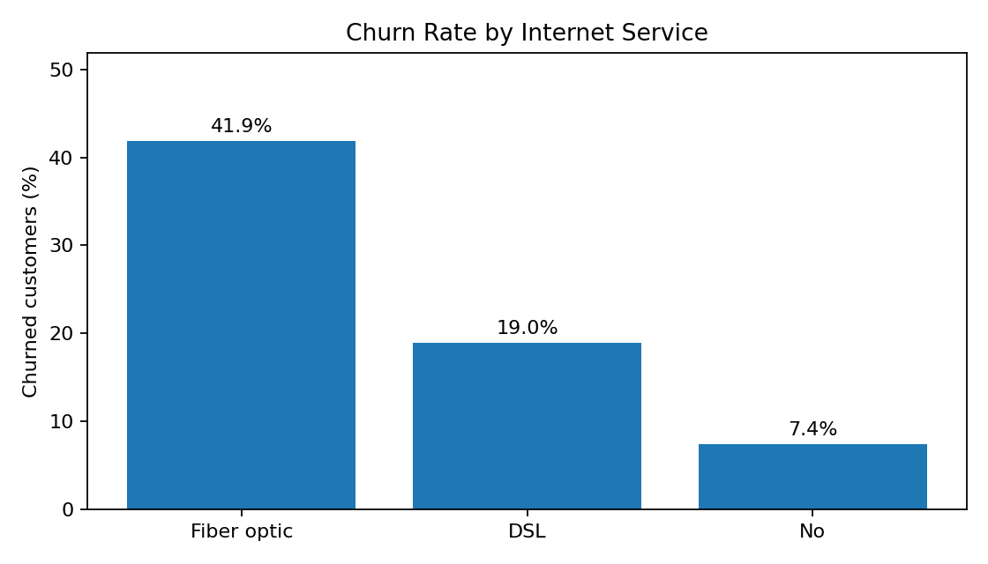
Figure 6. Churn rate by internet service category.
Churn rates differ across internet service categories. Service type may be related to other factors, such as price, contract type or support options, so these variables should be examined together in future analysis.

6. Key Findings
- The overall churn rate is 26.54% (1,869 of 7,043 customers).
- Month-to-month customers have a churn rate of 42.71%, compared with 11.27% for one-year and 2.83% for two-year contracts.
- Tenure is negatively associated with churn in the selected correlation analysis (r = -0.35).
- MonthlyCharges has a modest positive correlation with churn (r = 0.19).
- Tenure and TotalCharges are strongly positively correlated (r = 0.83).
- These are descriptive associations and do not prove that a factor causes churn.

7. Limitations and Further Analysis
- The analysis is observational and descriptive; it does not establish causation.
- The zero value assigned to TotalCharges for zero-tenure records is a business-rule assumption and should be verified against the dataset documentation or billing process.
- Pearson correlation captures linear association only and is not a complete churn model.
- customerID is an identifier and should not be treated as a predictive numerical feature.
- Further analysis could compare churn rates by payment method, online security, tech support, dependents, partner status and paperless billing.
- A future project could build and evaluate a churn classification model; this is beyond the core Week 1 cleaning and EDA scope.

8. Conclusion
This project demonstrated data acquisition, inspection, cleaning and exploratory analysis using a telecom customer dataset. The main preprocessing issue was the text-typed TotalCharges column, which was converted to numeric and checked for blank values. Duplicate and identifier checks were performed, and analysis variables were added without removing valid customer records. EDA highlighted differences in churn by contract type, a negative association between tenure and churn, and differences in monthly charges across churn groups. These results provide a foundation for deeper customer-retention analysis.

Appendix A. Reproducibility
Run the notebook cells in order. Keep the CSV in the notebook's working directory or update file_path to its actual location. Regenerate figures from the cleaned dataframe so the submitted report matches the notebook.
# Save the cleaned dataframe using a new output filename
df.to_csv("telco_cleaned.csv", index=False)
# Calculate churn rate by contract
contract_churn = pd.crosstab(
df["Contract"], df["Churn"], normalize="index"
) * 100
print(contract_churn["Yes"].round(2))

References
Kaggle. Telco Customer Churn dataset. https://www.kaggle.com/datasets/blastchar/telco-customer-churn
pandas documentation. https://pandas.pydata.org/docs/
Matplotlib documentation. https://matplotlib.org/stable/

