**CO2**

**Experiment No : 1**

**Aim :** Program to find the factorial of a number

**Program Code:**

import math

a=int(input("Enter a number : "))

f=math.factorial(a)

print(f)

**Output:**



**Experiment No : 2**

**Aim :** Program to find the factorial of a number

**Program Code:**

a=int(input("enter limit : "))

f1=0

f2=1

print(f1)

print(f2)

i=2

while i<a:

    f3=f1 +f2

    f1=f2

    f2=f3

    i=i+1

    print(f3)

**Output:**

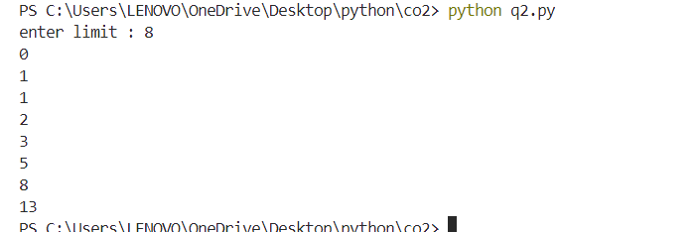

**Experiment No : 3**

**Aim :** Find the sum of all items in a list

**Program Code:**

sum=0

for i in l:

    sum=sum+i

print(sum)'''

l=[1,2,5,6,9,4]

print(l)

sum=sum(l)

print('sum =',sum)

**Output:**

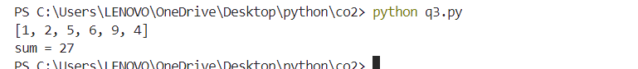

**Experiment No : 4**

**Aim :** Generate a list of four digit numbers in a given range with all

their digits even and the number is a perfect square.

**Program Code:**

l=[]

for i in range(32,100):

    sqr=i*i

    if 1000<=sqr<=9999 and all(int(n)%2==0 for n in str(sqr)):

                l.append(sqr)

print(l)

**Output:**

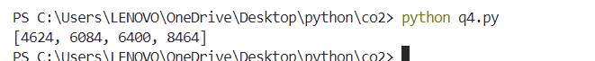

**Experiment No : 5**

**Aim :** Display the given pyramid with step number accepted from

user.

Eg: N=4

1

2 4

369

4 8 12 16

**Program Code:**

a=int(input("Enter number of rows : "))

for i in range(1,a):

    for j in range(1,i+1):

        s=i*j

        print(s,end=" ")

    print("\n")

**Output:**

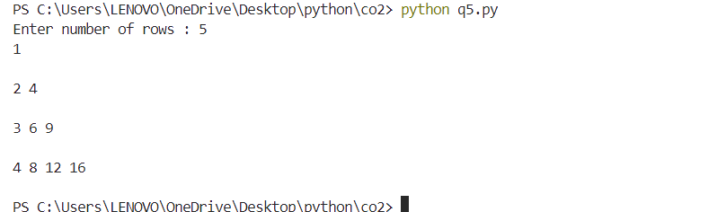

**Experiment No : 6**

**Aim :** Count the number of characters (character frequency) in a

string.

**Program Code:**

str=input("Enter a string : ")

lst=set()

for char in str:

    if char not in lst:

        print(f"'{char}' appears {str.count(char)} times")

        lst.add(char)

**Output:**

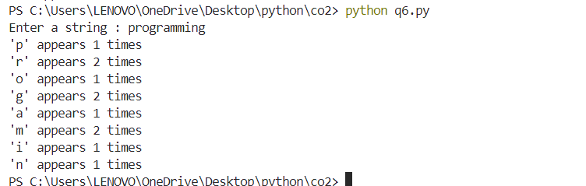

**Experiment No : 7**

**Aim :** Add 'ing' at the end of a given string. If it already ends with

'ing', then add 'ly'

**Program Code:**

str=input("Enter a string : ")

if str.endswith("ing"):

    str=str+"ly"

else:

    str=str+"ing"

print(str)

**Output:**

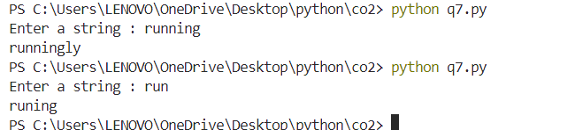

**Experiment No : 8**

**Aim :** Accept a list of words and return length of longest word.

**Program Code:**

words = ["apple", "banana", "cherry", "blueberry"]

max_length = 0

for word in words:

    length = 0

    for char in word:

        length += 1

    if length > max_length:

        max_length = length

print("Length of the longest word:", max_length)

**Output:**

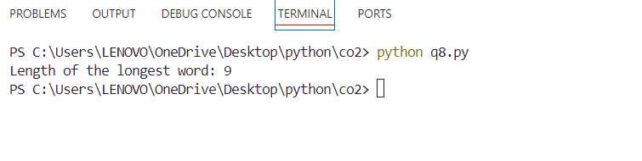

**Experiment No : 9**

**Aim :** Construct following pattern using nested loop

**Program Code:**

for i in range(0,5):

    for j in range(0,i+1):

        print("*",end=" ")

    print("\n")

for i in range(5,0,-1):

    for j in range(0,i-1):

        print("*",end=" ")

    print("\n")

**Output:**

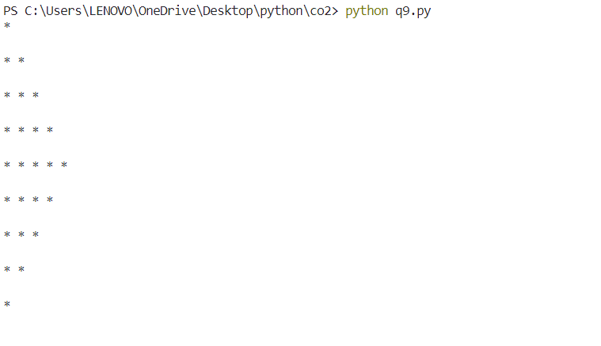

**Experiment No : 10**

**Aim :** Generate all factors of a number.

**Program code:**

x=int(input("Enter a number : "))

for i in range(1,x+1):

   if(x%i==0):

      print(i)

**Output:**

