**LET’S PREVENT - COVID-19**

-**Sreya Sajith (VII-B)**

Now a days, we hearken a lot about ‘Novel Coronavirus Disease’ or COVID-19. Though it started in China, it had spread across 200+ countries and as on 31st March 2020, 799,723 people are affected in the world and 38,721 people have lost their life. In India, 32 people died and 1250+ people are affected.

The virus is spread mainly from person-to-person through respiratory droplets produced when an infected person coughs or sneezes. As the count is increasing day by day, we should practice below preventive measures to reduce this epidemic.

**SOCIAL DISTANCING:**

Social distancing is a measure taken to prevent the spread of this disease by maintaining a physical distance between people and reducing the number of times people come into close contact with each other

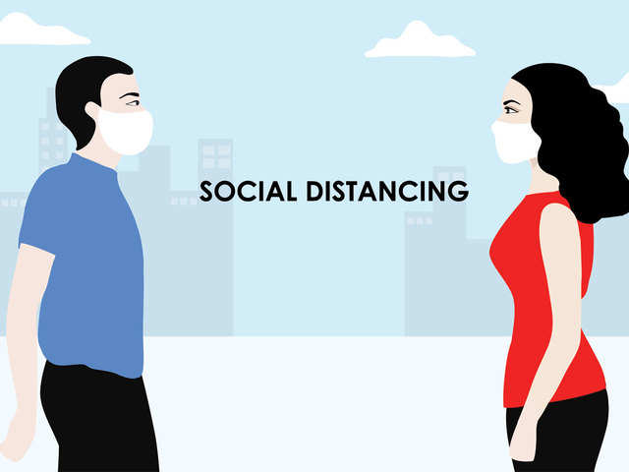

Few of the interventions are below:

* + - Closure of all educational establishments, gyms, museums, cultural and social centers, swimming pools and theatres.
    - Encourage organizations to allow employees to work from home wherever feasible.
    - Keep planned functions to a limited gathering, postpone all non-essential social and cultural gatherings
    - All commercial activities must keep a distance of one meter between customers.
    - Non-essential travel should be avoided.
    - Shaking hands and hugging to be avoided.

**HYGIENE**

|  |
| --- |
| * + Wash your hands with soap or sanitizer for at least 20 seconds especially after you have been in a public place, or after blowing your nose, coughing, or sneezing.   + Avoid touching eyes, nose, and mouth with unwashed hands.   + Cover mouth and nose with mask while going out. |

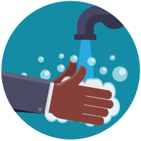

On 24 March 2020, Prime Minister [Narendra Modi](https://en.wikipedia.org/wiki/Narendra_Modi) ordered a nationwide [lockdown](https://en.wikipedia.org/wiki/Lockdown) for 21 days in India as a preventive measure. Let’s participate in this initiative and **STOP** the spread of **COVID-19**!!!

