Time VS SORTING ALGORITHM

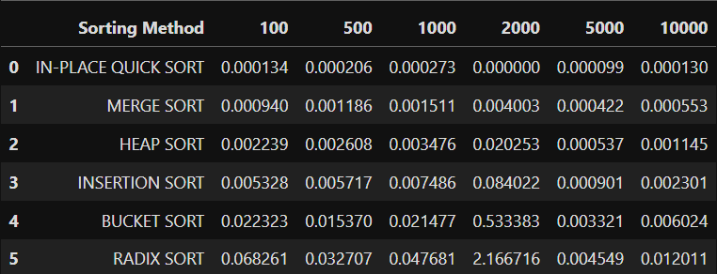

**INPUT VS TIME**

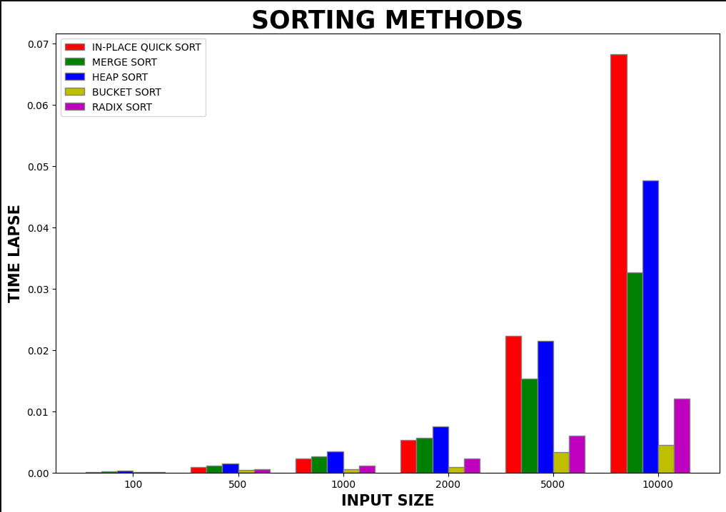

**SWAPS VS SORTING ALGORITHM**

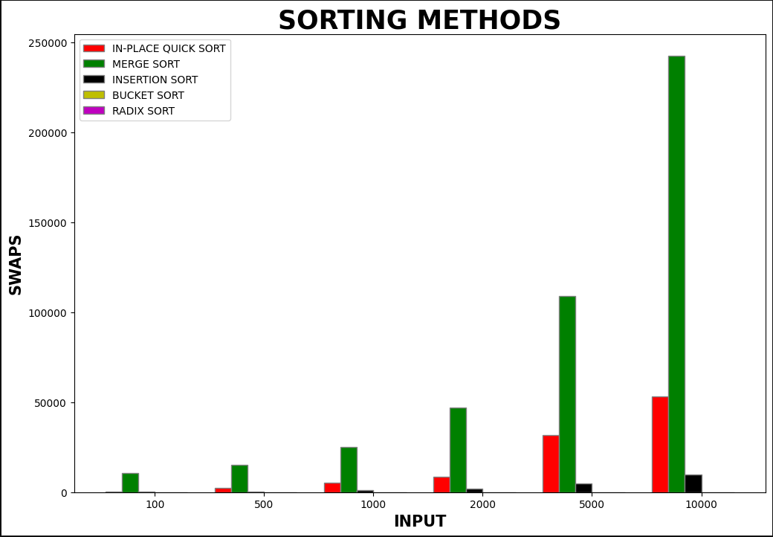

**COMPARISION VS SORTING ALGORITHM**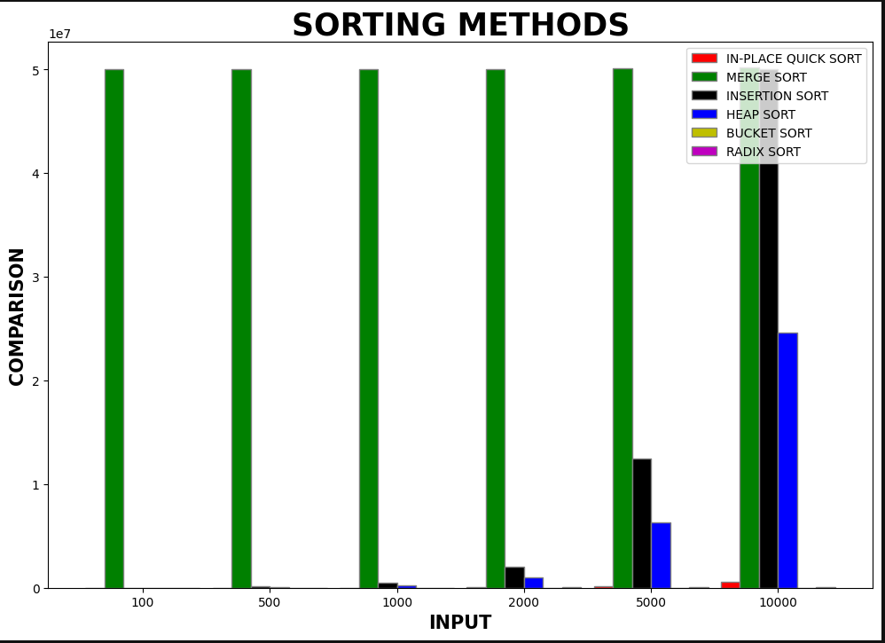

**GRAPHS ARE PLOTTED FOR ALL SORTING ALGORITHMS**

**REFER .IPYNB FILE**

**REFERENCE:**

[**https://matplotlib.org/stable/index.html**](https://matplotlib.org/stable/index.html)

**https://geeksforgeeks.org/**