**OUTPUT:**

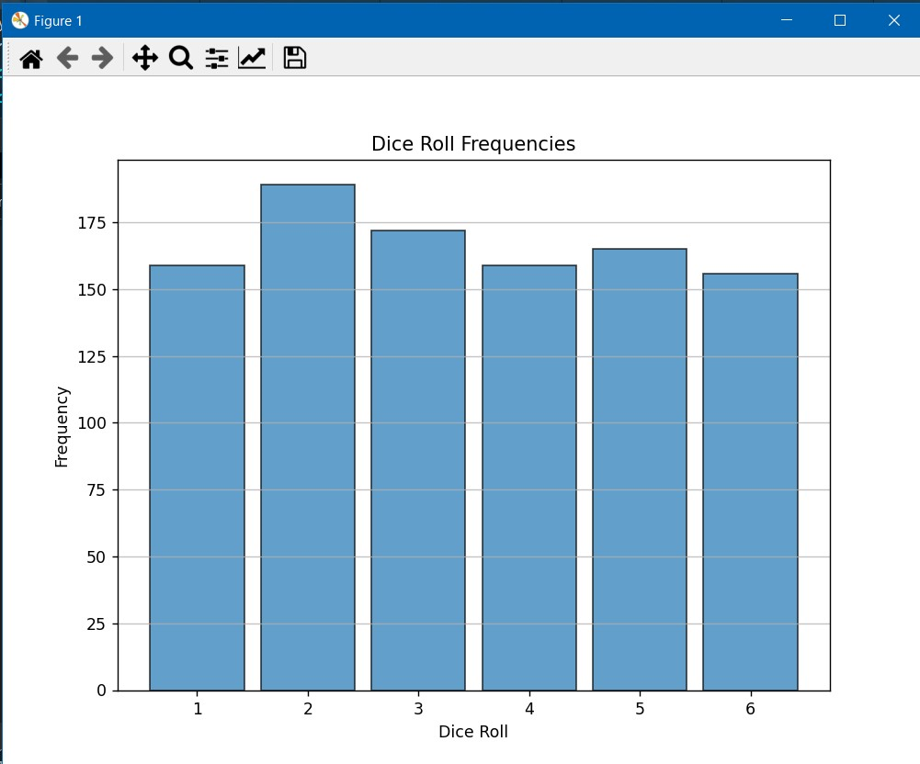

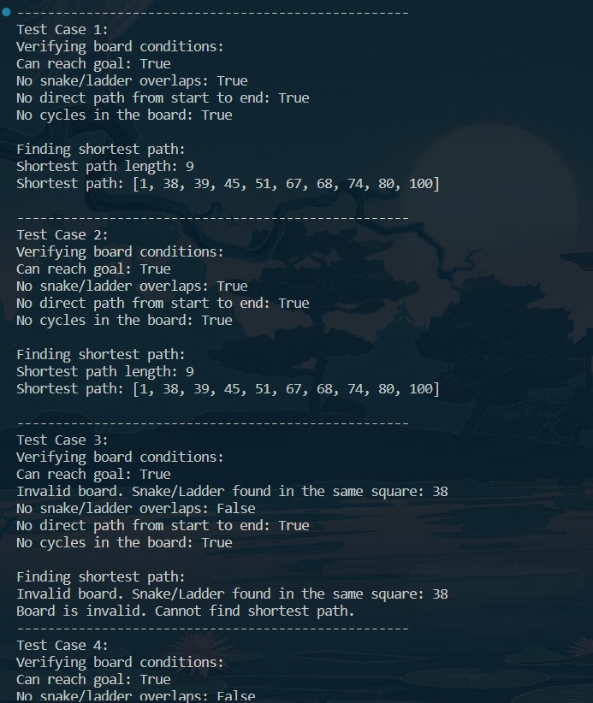

Complexity Analysis:

- The complexity for creating the graph is O(n²) because we iterate through each square.

- The complexity for BFS-based tasks is O(n + m), where n is the number of vertices (squares) and m is the number of edges (snakes and ladders).

- The topological sort-based cycle detection task also has a complexity of O(n + m).

- The shortest path task using BFS has a complexity of O(n + m).

REFERENCE:

https://www.geeksforgeeks.org/