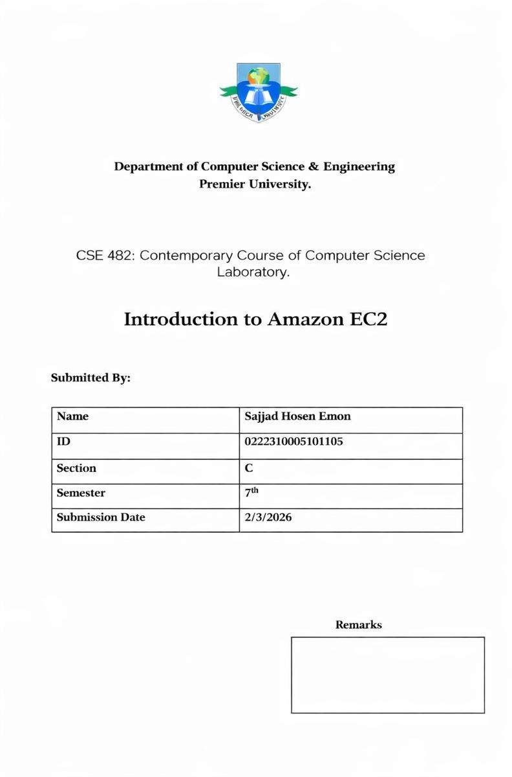

Lab 3: Introduction to Amazon EC2 Objective
The objective of this lab is to understand the basic functionality of Amazon EC2 and learn how to launch, configure, and manage a virtual server in a cloud environment. It provides hands-on experience in selecting an instance type, configuring network and security settings, enabling protection features, and automating web server installation using user data. The lab also helps develop skills in monitoring instance performance and scaling resources by modifying the instance type and storage. Overall, it builds foundational knowledge required for managing secure and efficient cloud infrastructure.

Scenario
In this lab, you take on the role of a cloud engineer responsible for setting up a basic web server for an organization using AWS. The goal is to deploy a secure and reliable server that can host a webpage accessible from the internet.

To accomplish this, an EC2 instance is launched and configured with the necessary network and security settings. An Apache web server is automatically installed using a user data script so that the server can immediately begin hosting content. After deployment, the instance is monitored to ensure it is functioning properly.

Since cloud environments must adapt to changing demands, the server is later scaled by upgrading the instance type and increasing storage capacity. Protection features are also tested to prevent accidental stopping or termination of the server. This lab reflects practical cloud operations where engineers must ensure availability, security, and scalability while maintaining full control over computing resources.
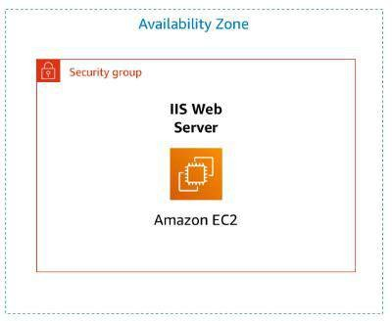

Working Procedure
Step 1: Starting the Lab and Accessing AWS Console
- Clicked Start Lab and waited until the AWS indicator turned green.
- Opened the AWS link to access the AWS Management Console in a new browser tab.
- Arranged the console and lab instructions side by side for easier navigation.

Step 2: Launching the EC2 Instance
- Navigated to Services → Compute → EC2.
- Verified that the region was set to N. Virginia (us-east-1).
- Clicked Launch Instance to begin creating the virtual server.
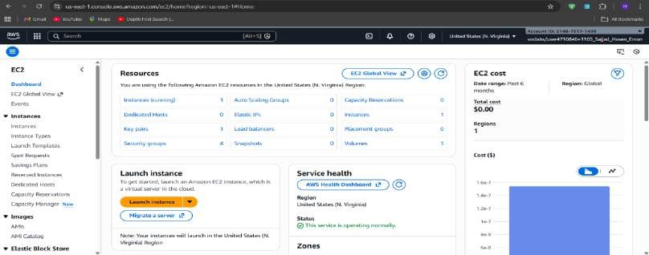

- Entered the instance name 'Web Server'.

Step 3: Selecting AMI, Instance Type, and Key Pair
- Selected the default Amazon Linux 2023 AMI from the Quick Start list.
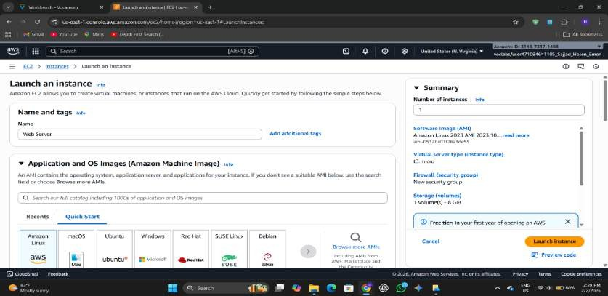

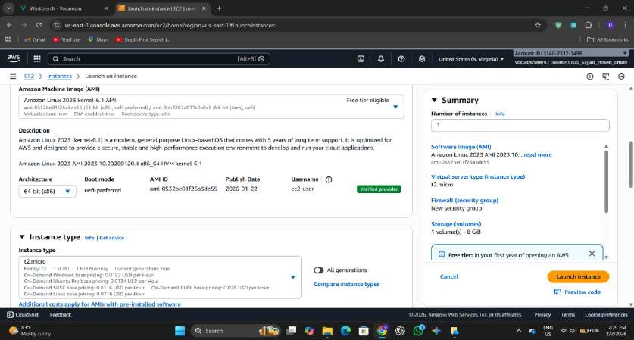
- Chose t2.micro as the instance type.

- Selected the 'vockey' key pair for secure login authentication.

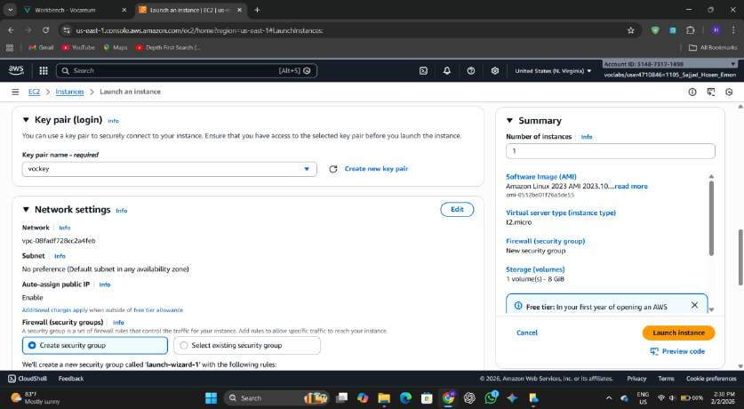

Step 4: Configuring Network and Security Group
- Edited Network Settings and selected the preconfigured Lab VPC.
- Kept PublicSubnet1 so the instance would receive a public IP address.

- Created a security group named 'Web Server security group' with the description 'Security group for my web server'.
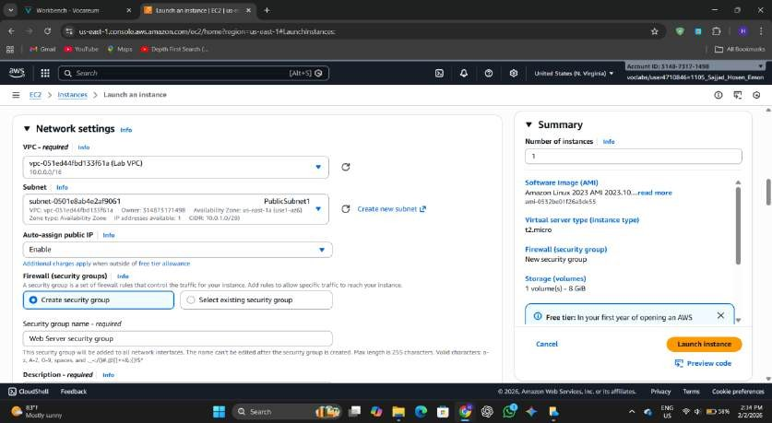

- Removed the existing inbound rule to block unnecessary traffic.

Step 5: Configuring Storage
- Kept the default 8 GiB Elastic Block Store (EBS) volume as the root disk for the instance.
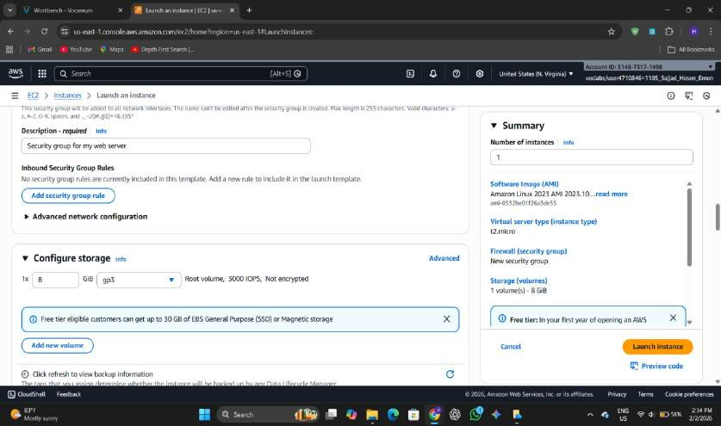

Step 6: Enabling Termination Protection and Adding User Data

- Expanded Advanced Details and enabled termination protection to prevent accidental deletion.
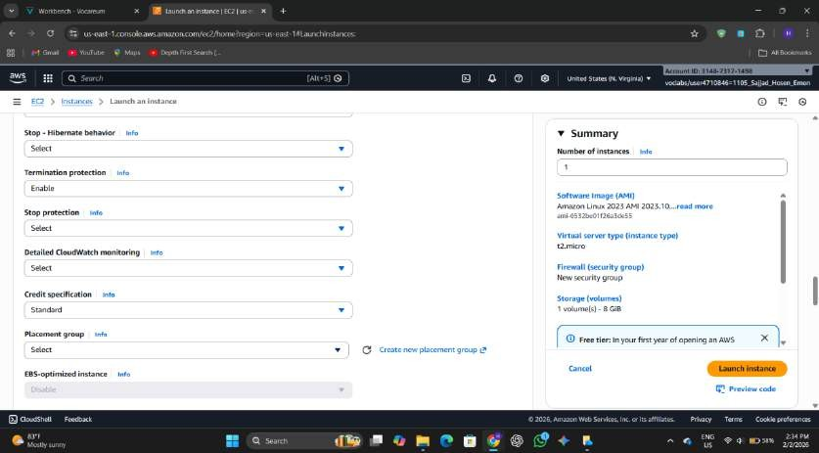

- Added the provided user data script to automatically install Apache, start the service, enable auto- start on boot, and create a simple HTML webpage.
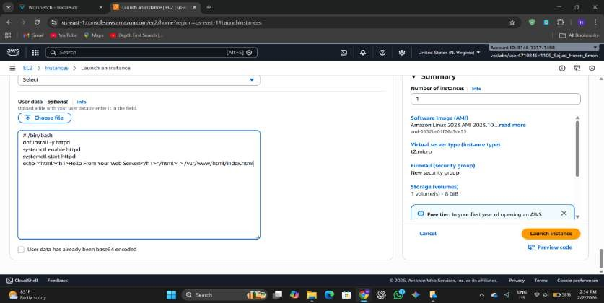

Step 7: Launching and Verifying the Instance
- Clicked Launch Instance and viewed the success message.

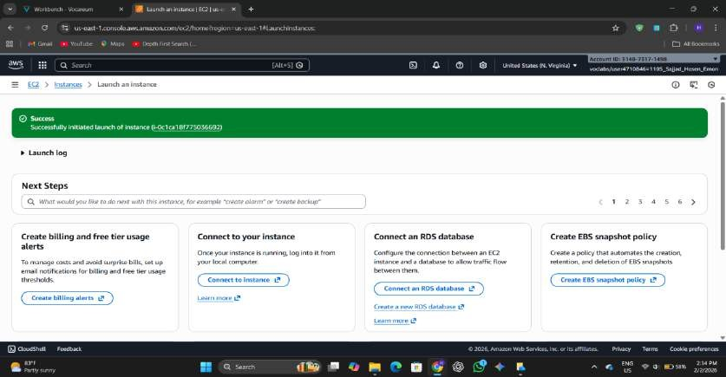

- Opened the Instances page and selected the Web Server instance.
- Observed the instance state change from Pending to Running.
- Confirmed that both status checks showed 2/2 checks passed.
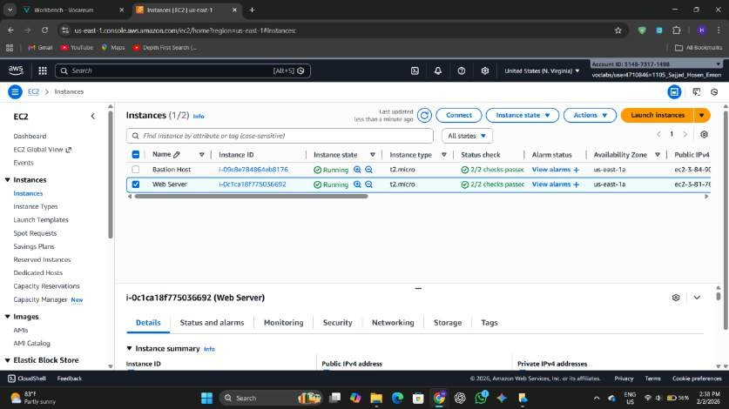

Step 8: Monitoring the Instance
- Opened the Status Checks tab to verify system and instance reachability.
- Viewed the Monitoring tab to analyze CloudWatch metrics.

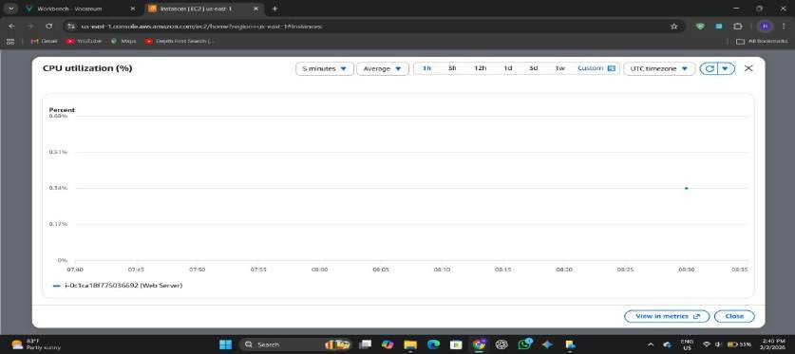

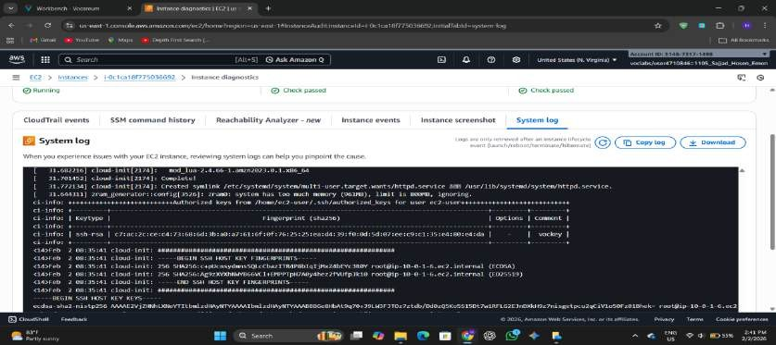
- Retrieved the System Log to confirm that the HTTP package was installed from the user data script
- Captured the Instance Screenshot to view the console display for troubleshooting.
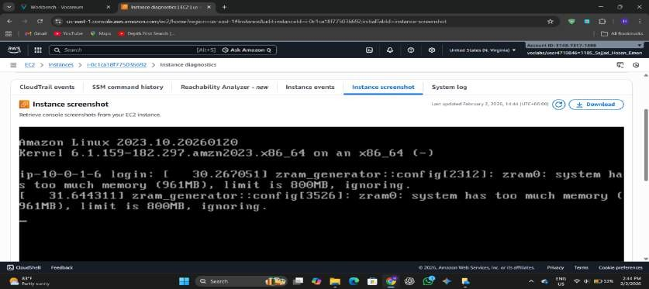

Step 9: Updating Security Group and Accessing the Web Server
- Copied the Public IPv4 address from the Details tab.
- Pasted the IP address into a browser and observed that the webpage was not accessible due to blocked HTTP traffic.
- Navigated to Security Groups and selected 'Web Server security group
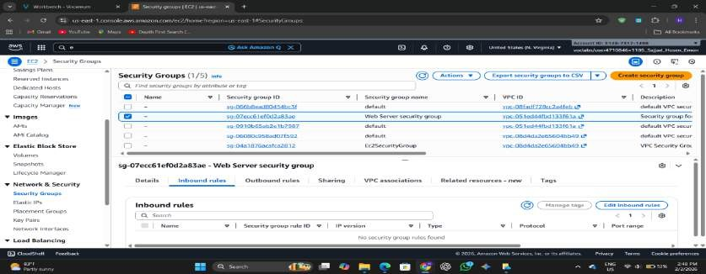
- Edited inbound rules and added a new rule allowing HTTP (Port 80) from Anywhere-IPv4.
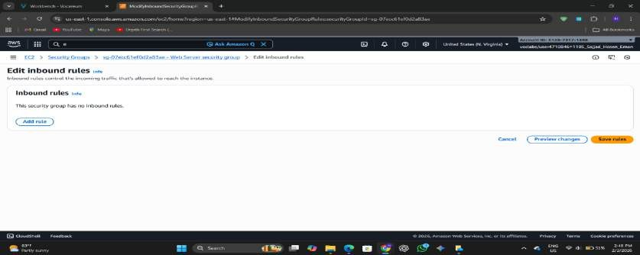
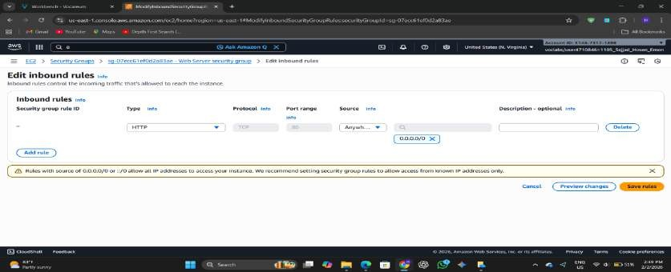

- Saved the rules and refreshed the browser.
- Verified that the webpage displayed 'Hello From Your Web Server!'.
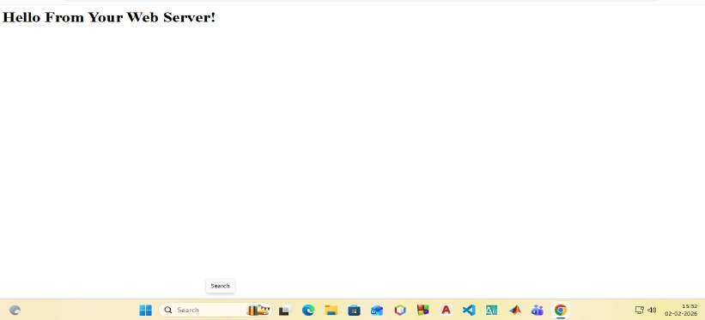

Step 10: Stopping the Instance for Resizing
- Selected the Web Server instance and chose Instance State → Stop Instance.
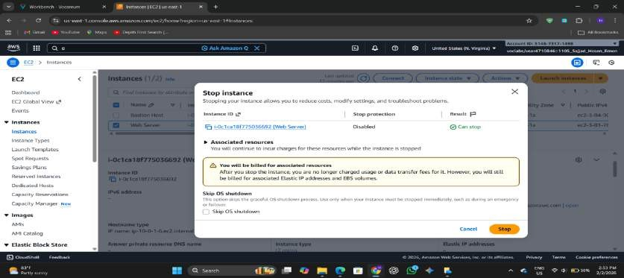

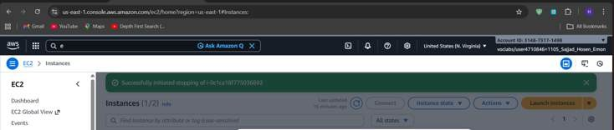
- Confirmed the stop action and waited until the instance state displayed Stopped.

Step 11: Changing Instance Type and Enabling Stop Protection

- Opened Actions → Instance Settings → Change instance type.
- Upgraded the instance from t2.micro to t2.small to increase memory.
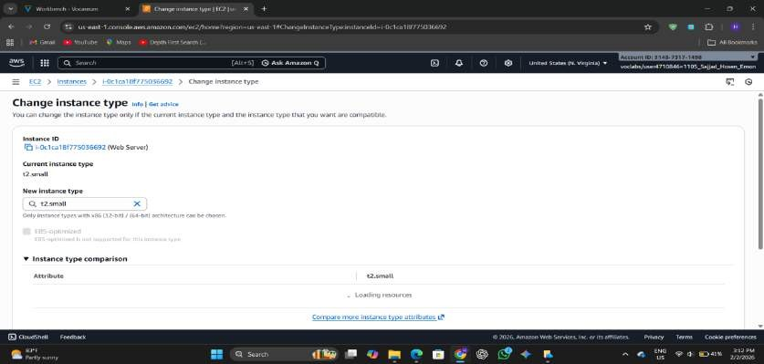

- Enabled stop protection to prevent accidental shutdown.
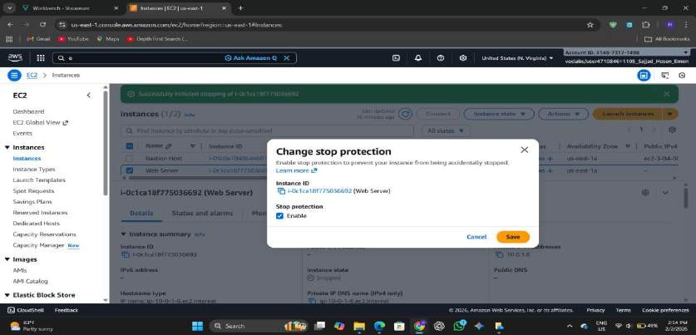

Step 12: Modifying the EBS Volume

- Navigated to the Storage tab and selected the attached volume.
- Clicked Modify Volume and increased the disk size from 8 GiB to 10 GiB.

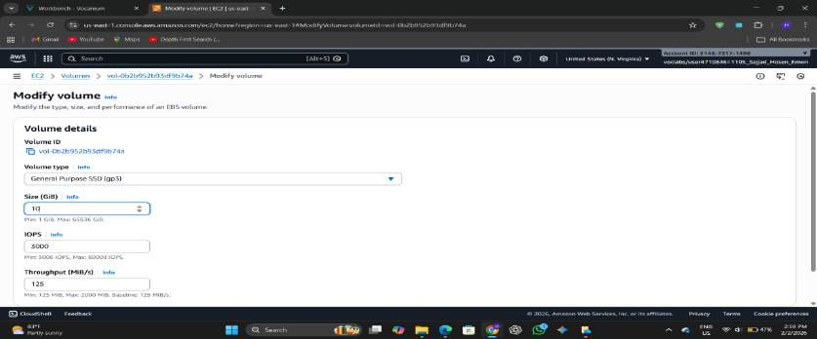
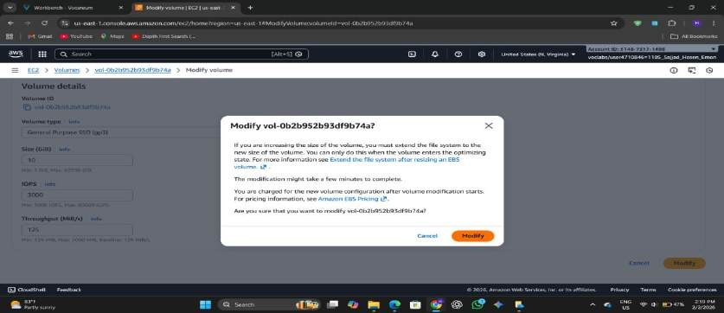
- Confirmed the modification.

Step 13: Restarting the Instance
- Returned to the Instances page and clicked Start Instance.
- Verified that the instance restarted successfully with upgraded resources.
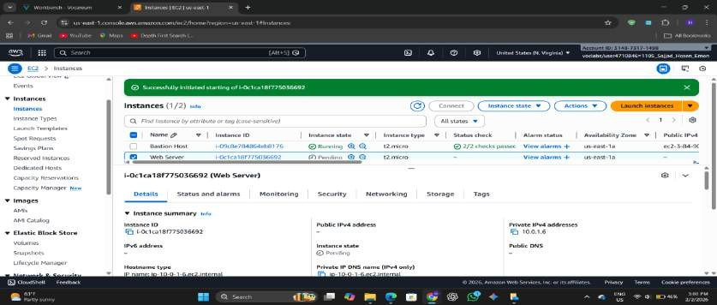

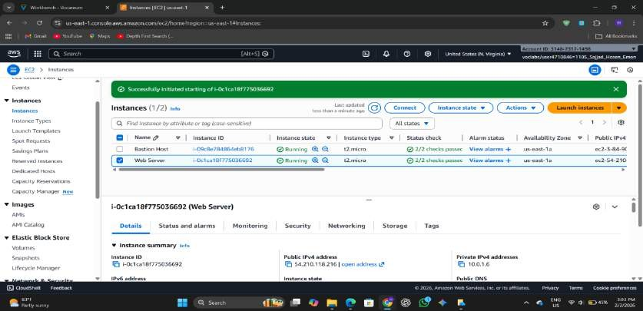

Step 14: Exploring EC2 Service Limits

- Searched for Service Quotas from the AWS console.
- Selected Amazon Elastic Compute Cloud (EC2).
- Searched for 'running on-demand' quotas and reviewed the limits for instances in the region.
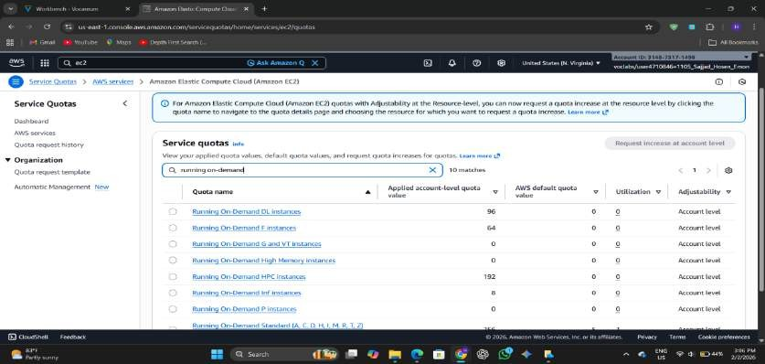

Step 15: Testing Stop Protection

- Attempted to stop the instance while stop protection was enabled and received an error message.
- Opened Instance Settings and disabled stop protection.

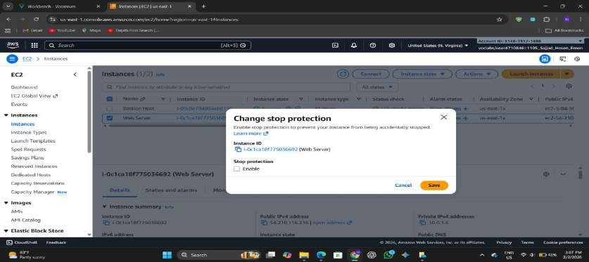
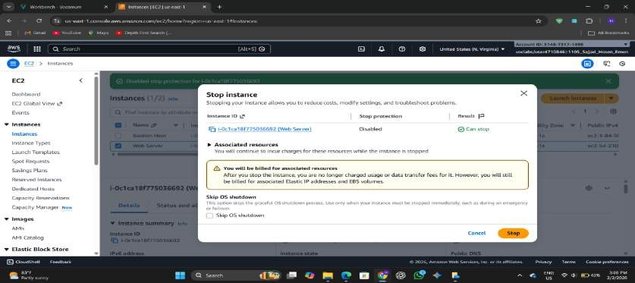
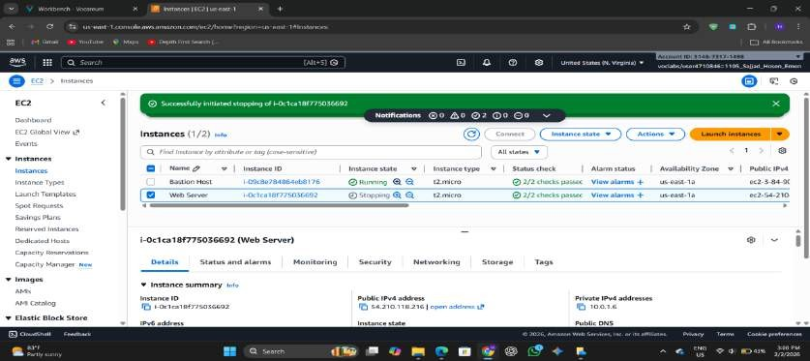
- Stopped the instance successfully afterward.

Step 16: Submitting and Ending the Lab
- Clicked Submit to record the lab progress and viewed the grading panel.

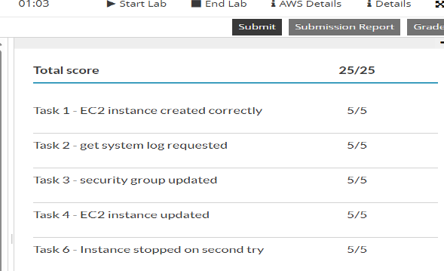

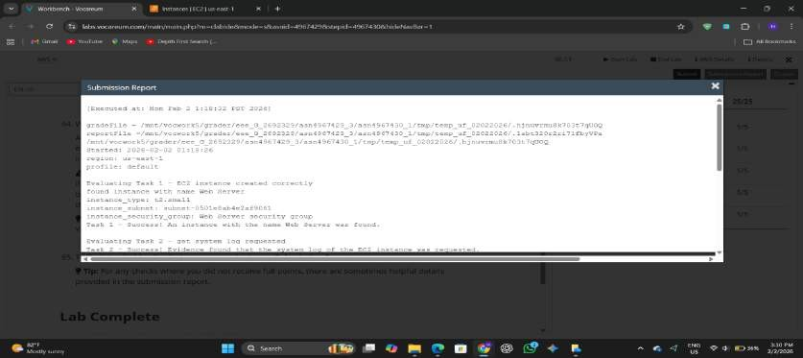
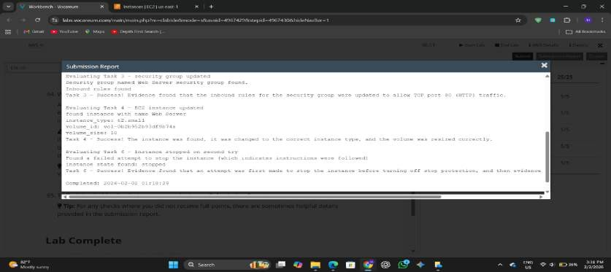
- Reviewed the submission report for feedback.
- Clicked End Lab and confirmed to close the session.

Conclusion
This lab provided practical experience in launching, configuring, and managing a virtual server using Amazon EC2. It covered essential tasks such as setting up security groups, enabling protection features, monitoring instance health, and automating web server installation. The lab also demonstrated how cloud resources can be scaled by modifying the instance type and storage based on requirements. Overall, it helped build a strong foundation in cloud computing and improved understanding of secure and efficient infrastructure management using AWS.

