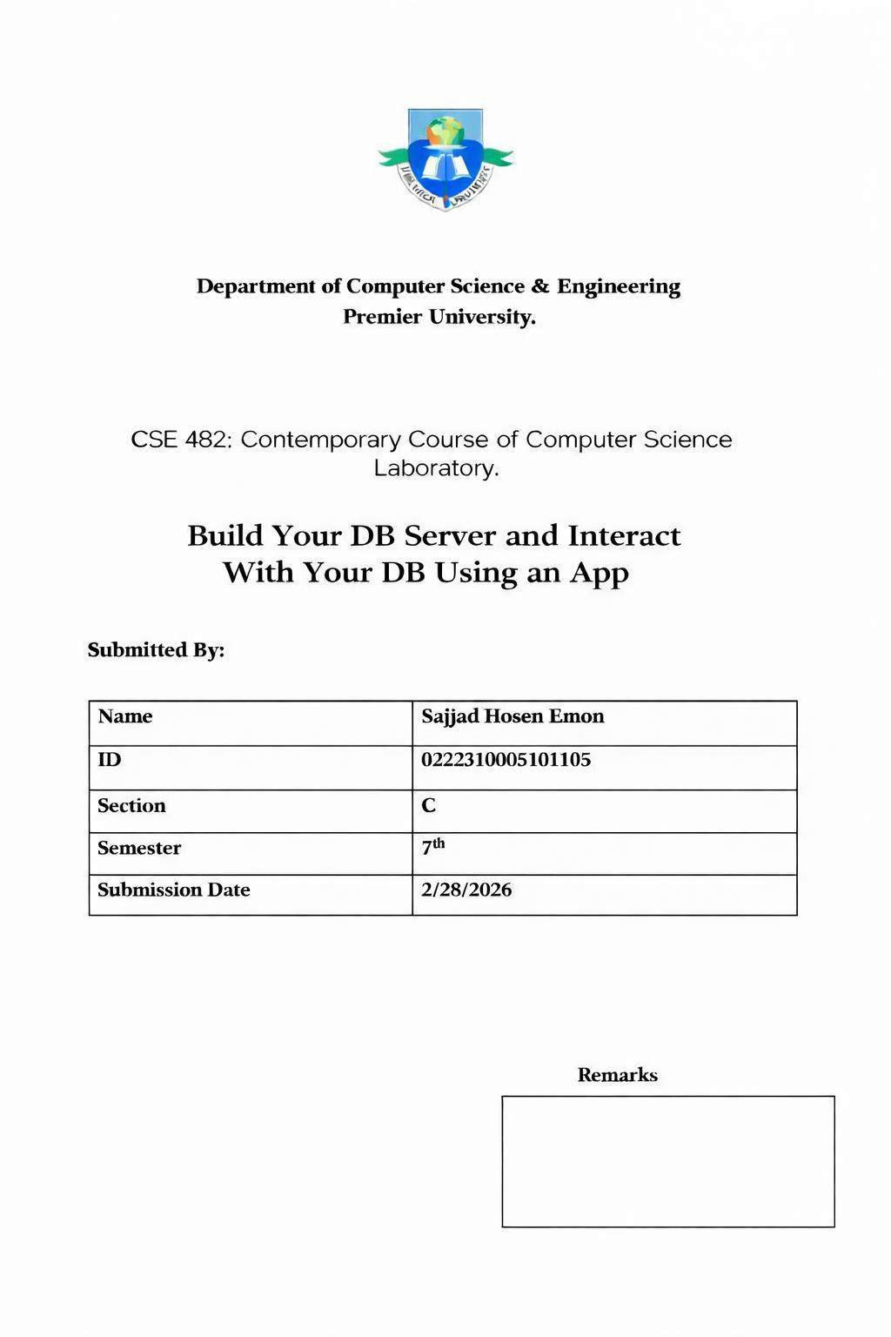

Lab Report

Lab 5: Build Your DB Server and Interact With Your DB Using an App
- Objective
The objective of this lab is to understand how to deploy and manage a relational database in the cloud using Amazon Web Services (AWS). In this lab, a highly available database instance is launched using Amazon Relational Database Service (Amazon RDS), and secure communication between a web server and database server is established. The lab demonstrates how to configure security groups, subnet groups, and Multi-AZ deployment to ensure high availability and data durability. It also provides practical experience in connecting a web application running on Amazon EC2 to an RDS database and performing database operations through an application interface.

Scenario
At the beginning of the lab, a Lab VPC and a web server instance were already provided, but no database was available for storing application data. The task was to create a secure and highly available relational database inside the same VPC and connect it with the web application. To achieve this, a database security group was created to allow controlled access from the web server. A DB subnet group was configured across multiple Availability Zones to support Multi-AZ deployment. Then, a MySQL database instance was launched using Amazon RDS. Finally, the web application was configured with the database endpoint and credentials to perform CRUD operations, verifying successful integration between the application and the database.
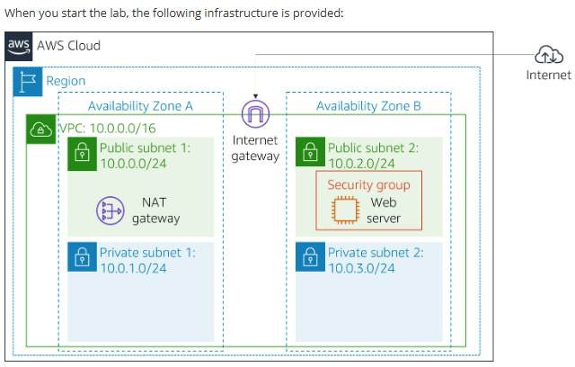

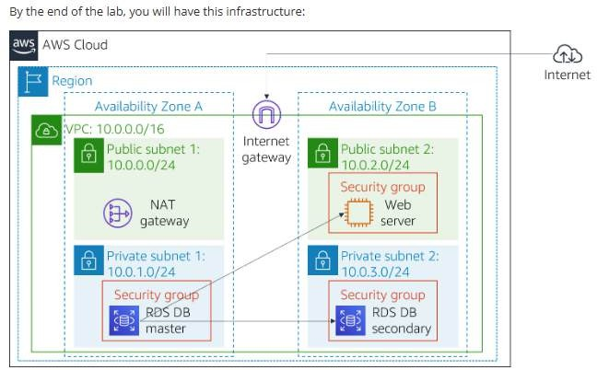

Working Procedure

Task 1: Create Security Group

  - Open AWS Console and go to VPC service.
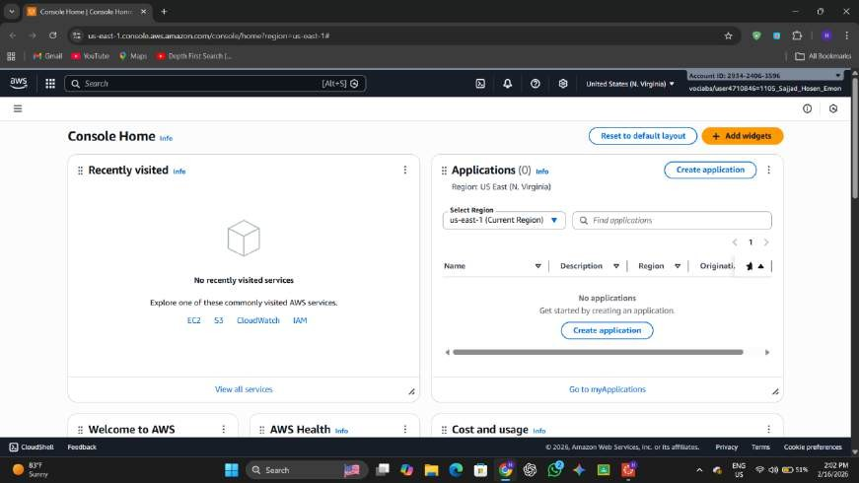
  - Click Security Groups and choose Create Security Group.

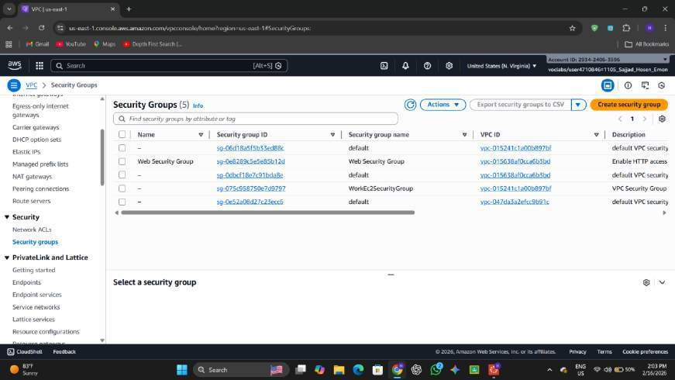
  - Enter DB Security Group as name and select Lab VPC.
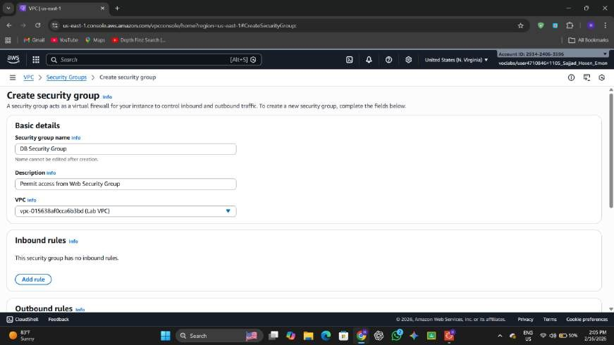
  - Add inbound rule for MySQL/Aurora (Port 3306).
  - Select Web Security Group as the source.
  - Click Create Security Group.

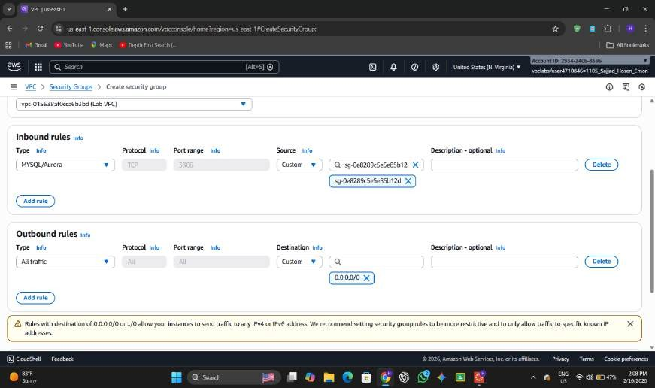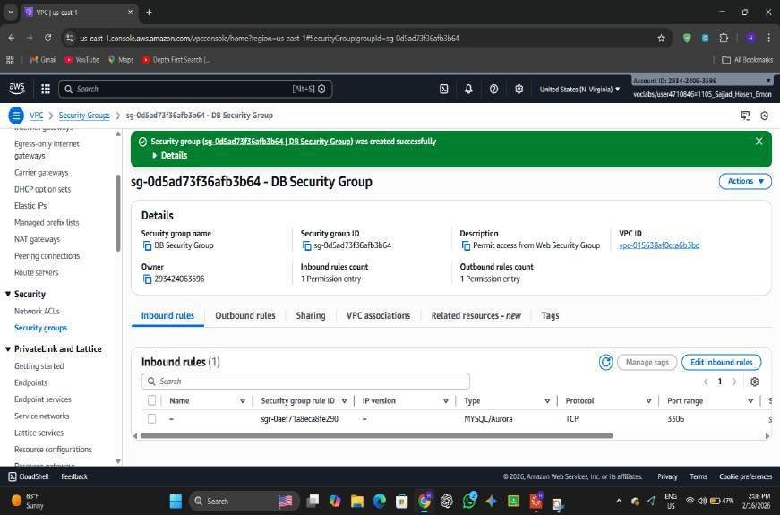

Task 2: Create DB Subnet Group
- Open RDS service from AWS Console.

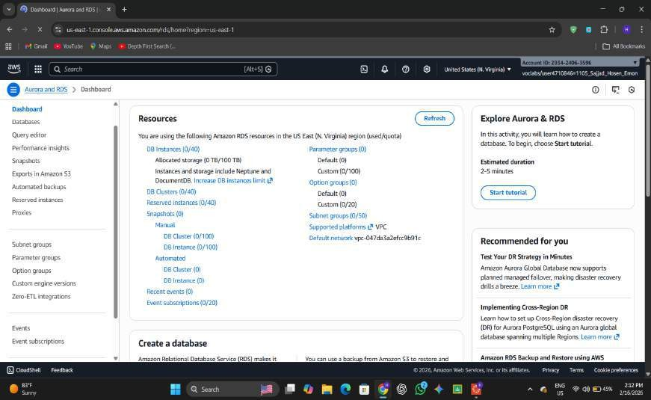
- Click Subnet Groups and choose Create DB Subnet Group.
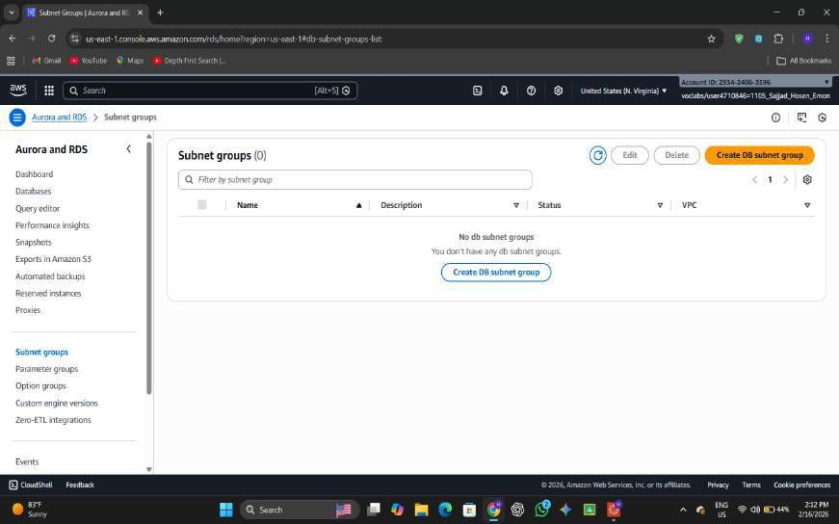
- Enter DB-Subnet-Group as name and select Lab VPC.

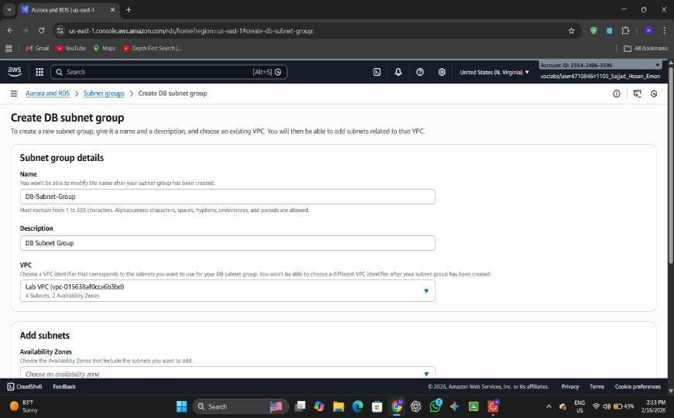
- Select Availability Zones us-east-1a and us-east-1b.
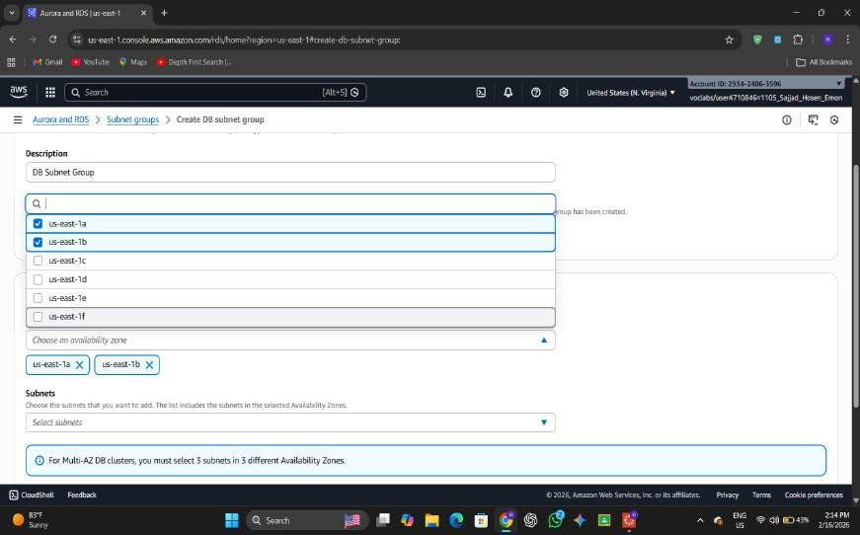
- Add subnets 10.0.1.0/24 and 10.0.3.0/24.

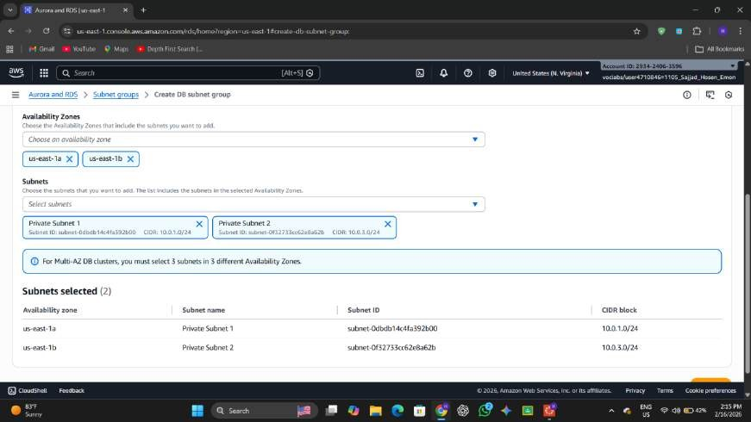
- Click Create.
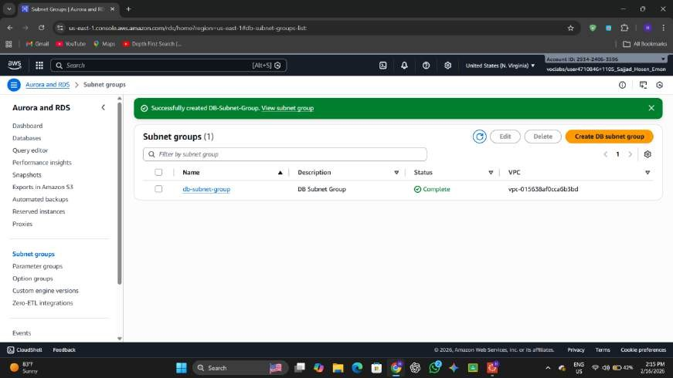

Task 3: Create RDS DB Instance

- Go to Databases in RDS and click Create Database.

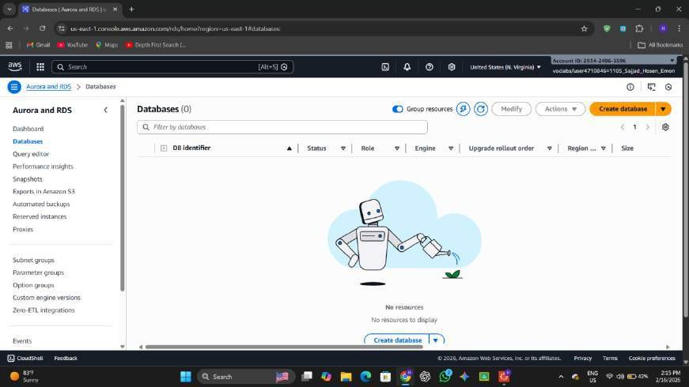
- Select MySQL engine and choose Dev/Test template.

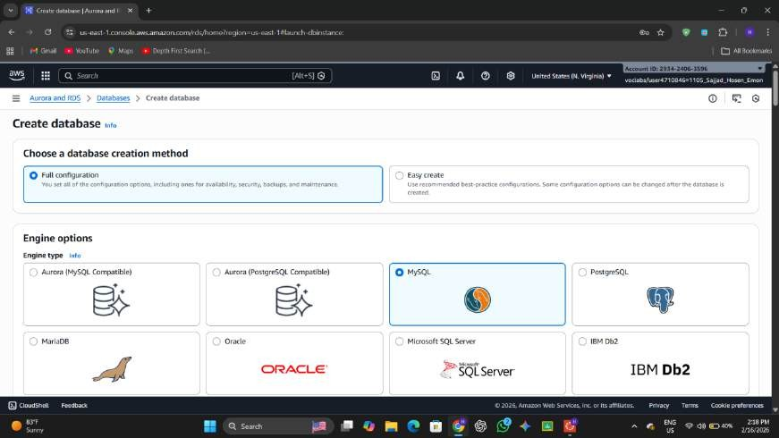

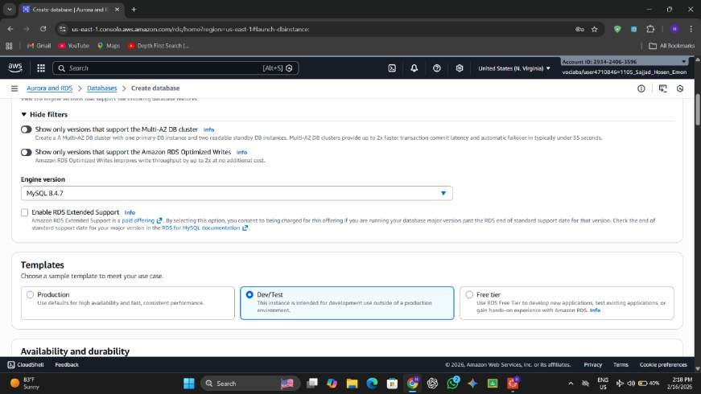
- Enable Multi-AZ deployment option.
- Set DB identifier as lab-db.
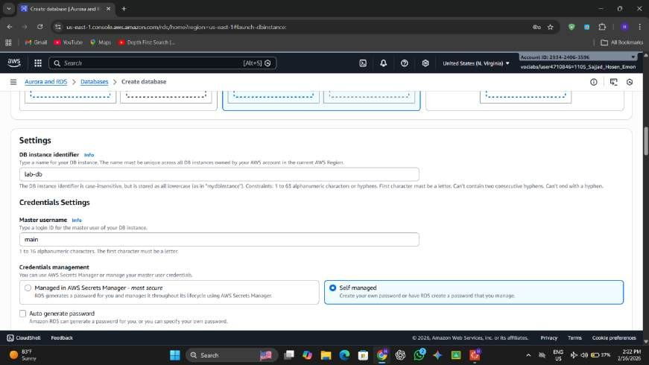
- Enter username main and password lab-password.

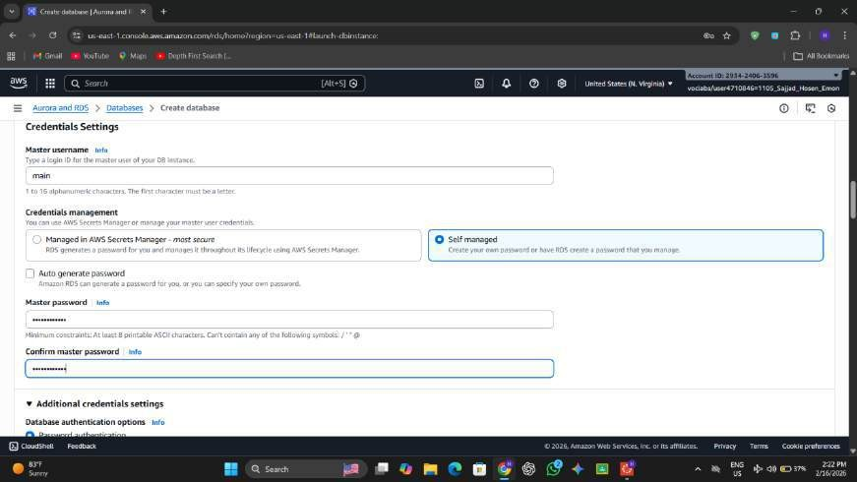
- Choose db.t3.micro instance class.
- Set storage type as General Purpose SSD (20 GB).
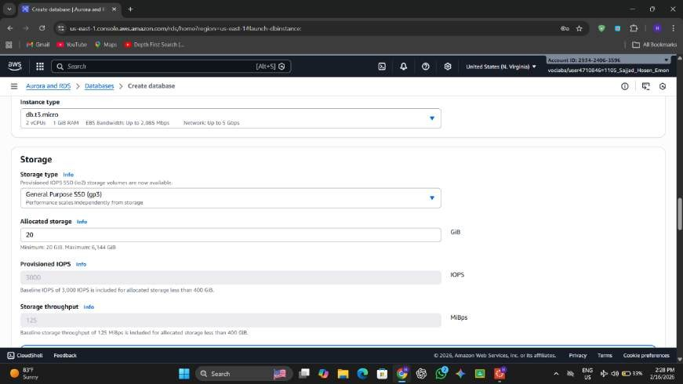
- Select Lab VPC and attach DB Security Group.

- Enter initial database name as lab.
- Disable automatic backups, encryption, and enhanced monitoring.
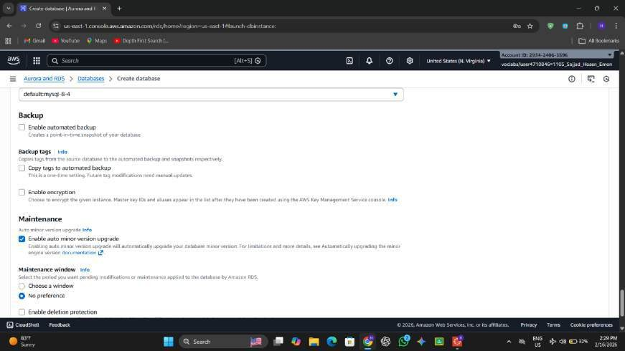
- Click Create Database and wait until status becomes Available.
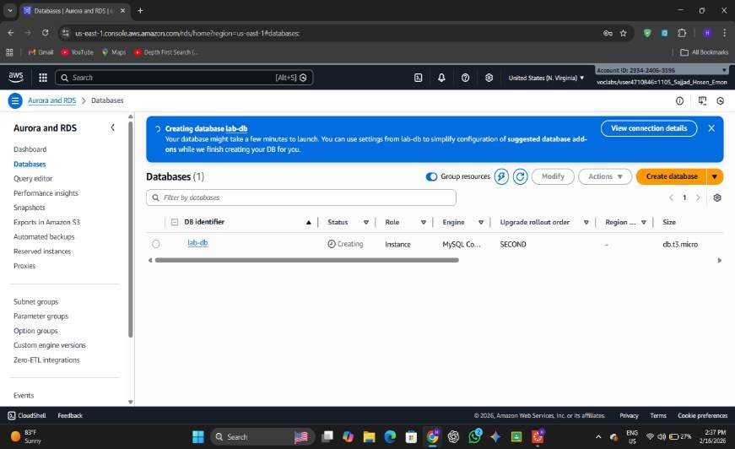

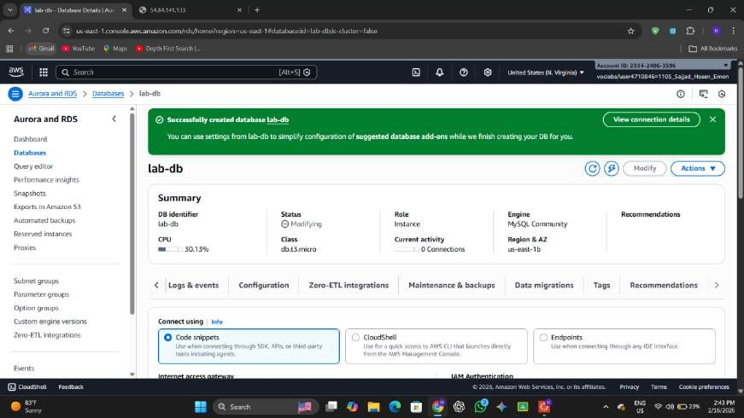
- Copy the Endpoint from Connectivity & Security section.
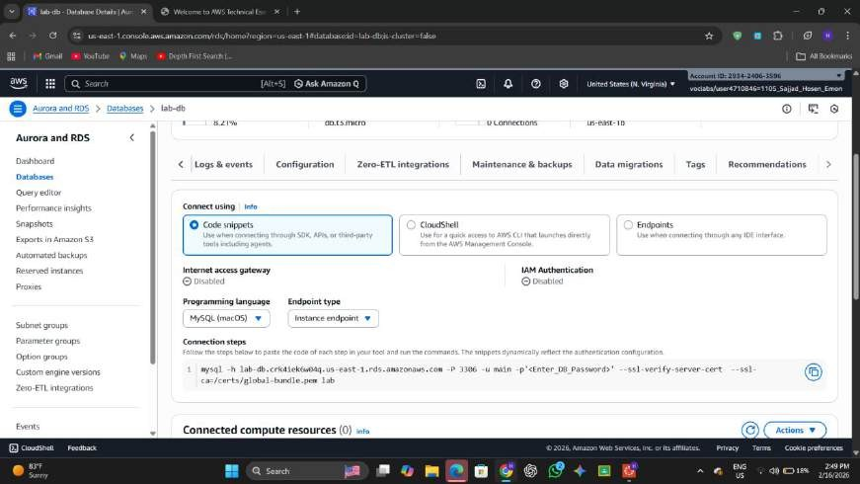

Task 4: Connect Web Application to Database
  - Copy Web Server Public IP from AWS Details.

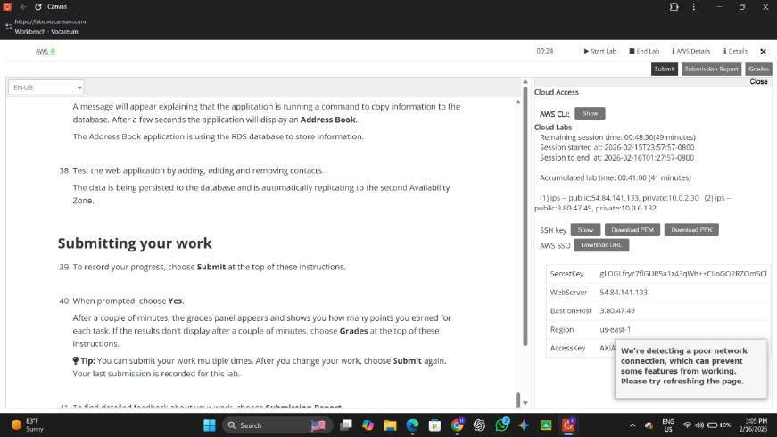
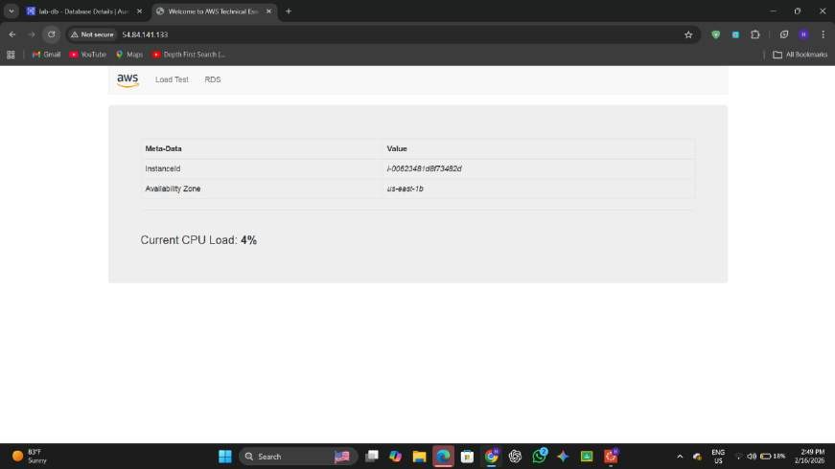
  - Open the IP address in a web browser.
  - Click the RDS link on the application page.
  - Enter the RDS Endpoint in Endpoint field.
  - Enter database name lab.
  - Enter username main and password lab-password.

  - Click Submit to connect the database.
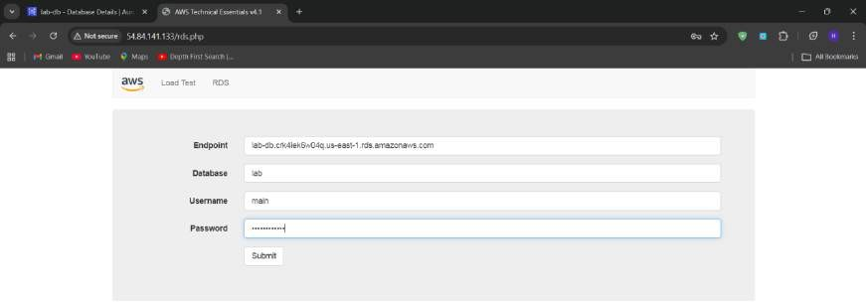

  - Add, edit, and delete contacts to test database interaction.
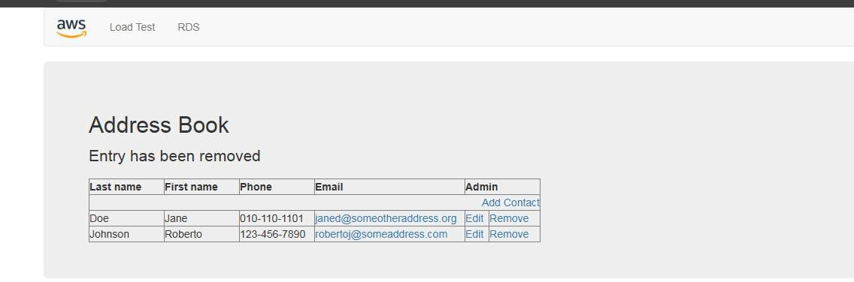
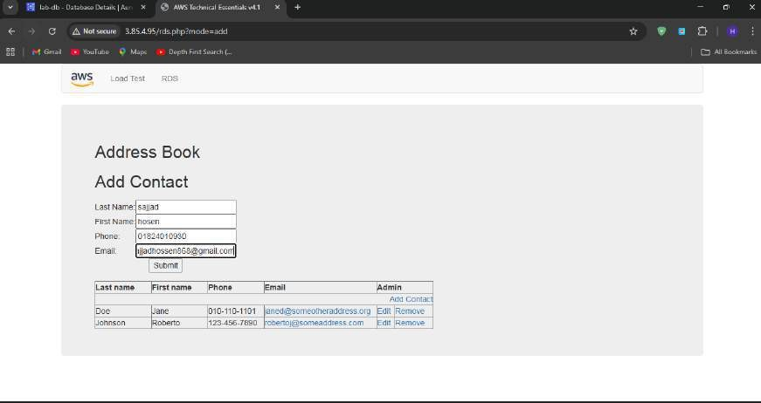

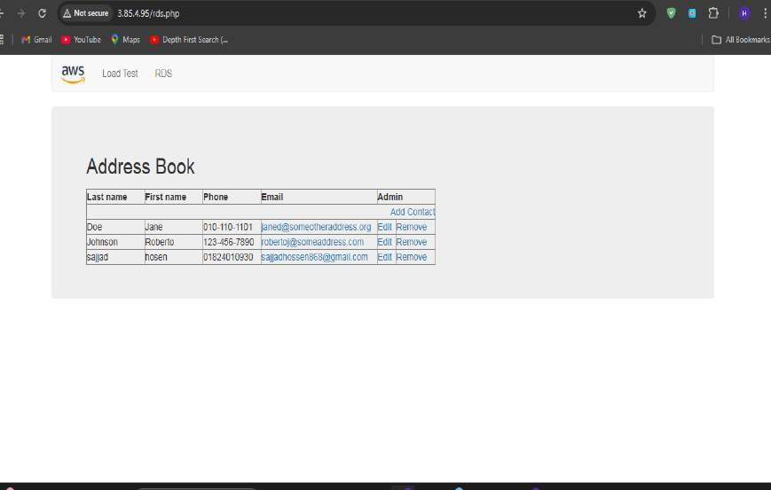
When load Current CPU Load 100%
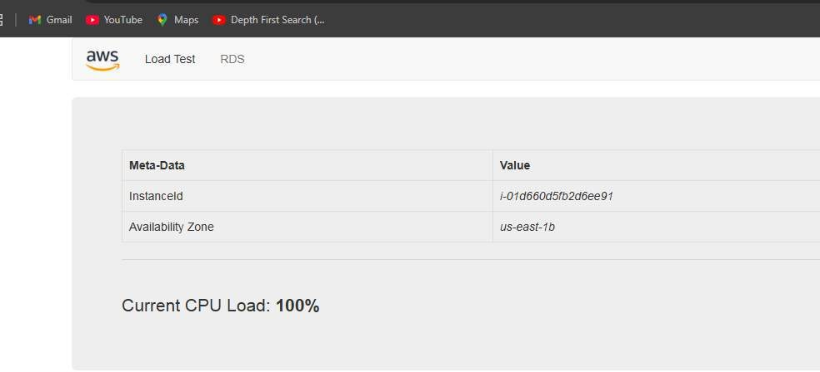

  - Total Score
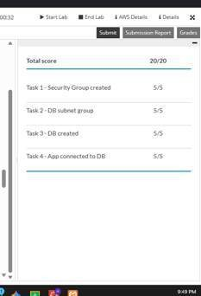
  - Report Submission:
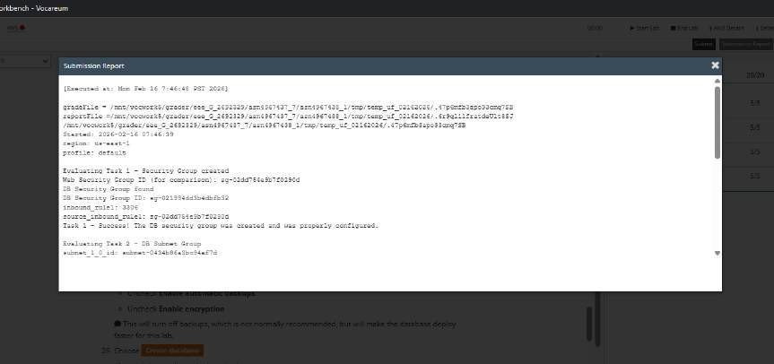

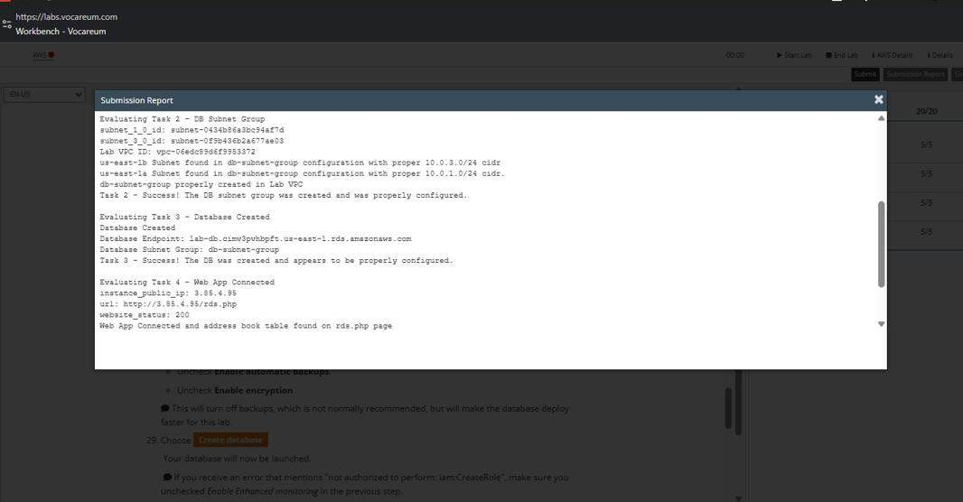

Conclusion
In this lab, a secure and highly available MySQL database was successfully deployed using Amazon RDS. Proper networking and security configurations were implemented to allow controlled communication between the EC2 web server and the database. The Multi-AZ deployment ensured high availability and data replication across Availability Zones. Finally, the web application was connected to the database, and CRUD operations were performed successfully, demonstrating real- world cloud-based application and database integration.

