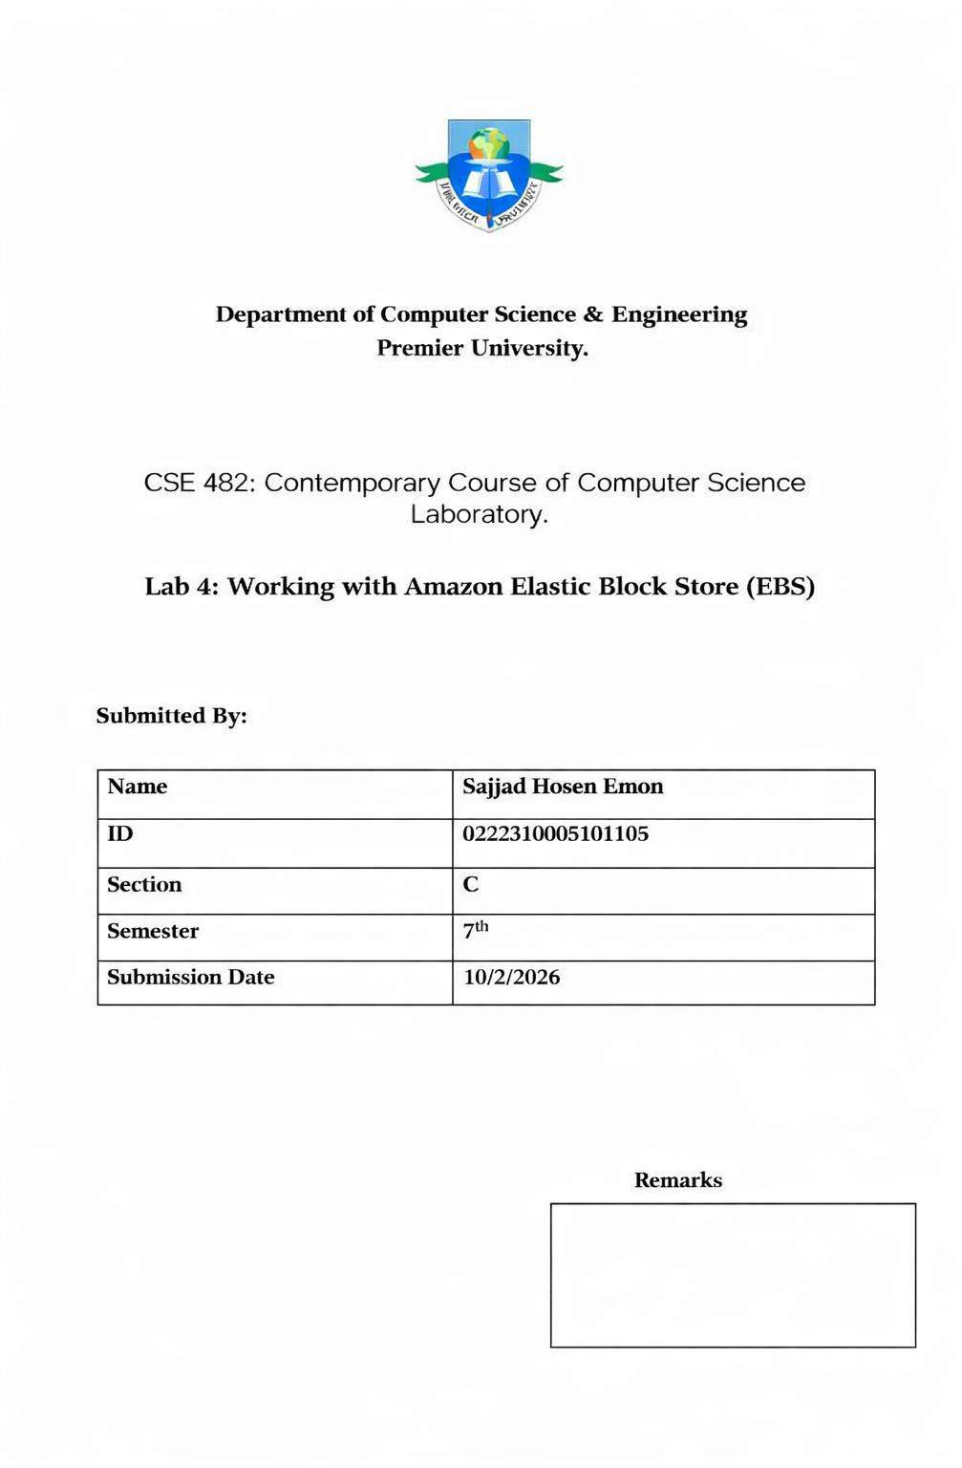

Lab 4: Working with Amazon Elastic Block Store (EBS)

Objective
The objective of this lab is to develop practical knowledge about Amazon Elastic Block Store (EBS) by creating a storage volume, attaching it to an Amazon EC2 instance, configuring a file system, and performing data backup using snapshots. This lab also demonstrates how data can be restored from a snapshot to ensure storage reliability and persistence in a cloud computing environment.

Scenario
Amazon Elastic Block Store (EBS) is a block-level storage service designed for use with Amazon EC2 instances. It provides persistent storage that remains available even after an instance is stopped. In this lab, a running EC2 instance requires additional storage. Therefore, a new EBS volume is created and attached to the instance. After formatting and mounting the volume, data is written to it. A snapshot is then created to back up the stored data. Finally, the snapshot is used to create a new volume, which is attached and mounted to verify that the data has been successfully restored.

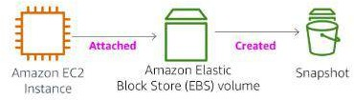

Working Procedure

- Logged in to the AWS Management Console and opened the EC2 Dashboard.
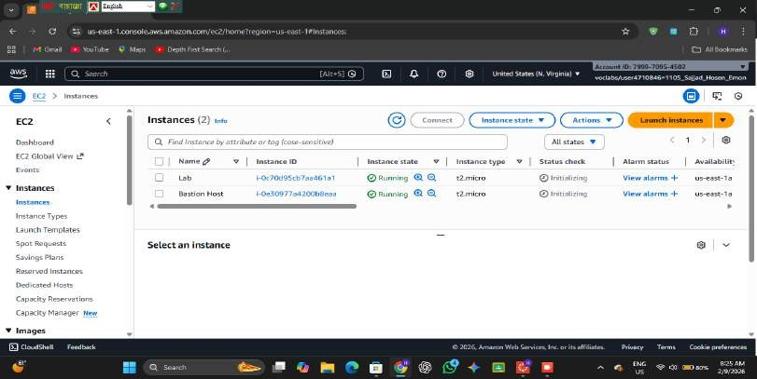

- Navigated to the Volumes section and selected Create Volume.
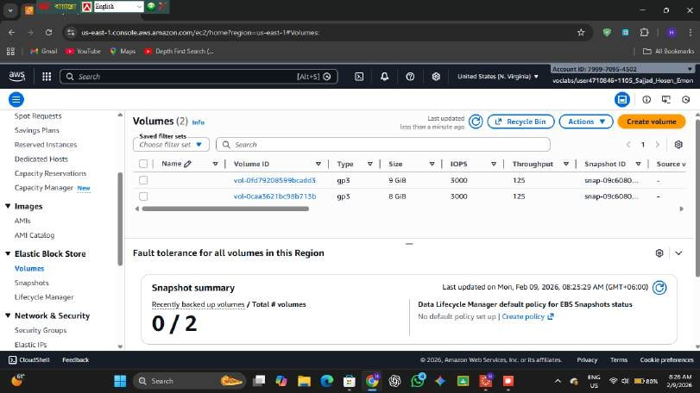

- Selected General Purpose SSD (gp2) as the volume type.
- Set the volume size to 1 GiB.
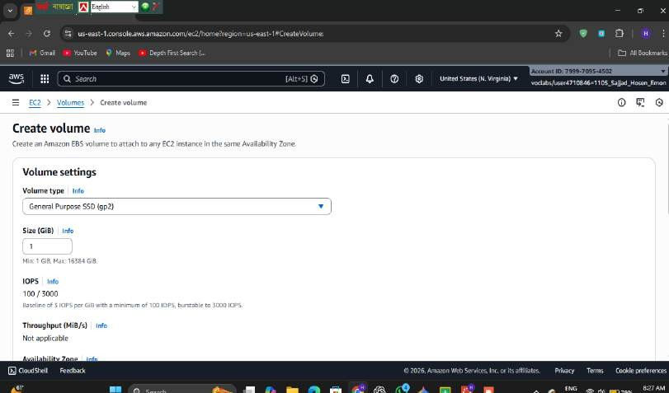

- Chose the same Availability Zone as the running EC2 instance.
- Added a tag with the name My Volume for identification.

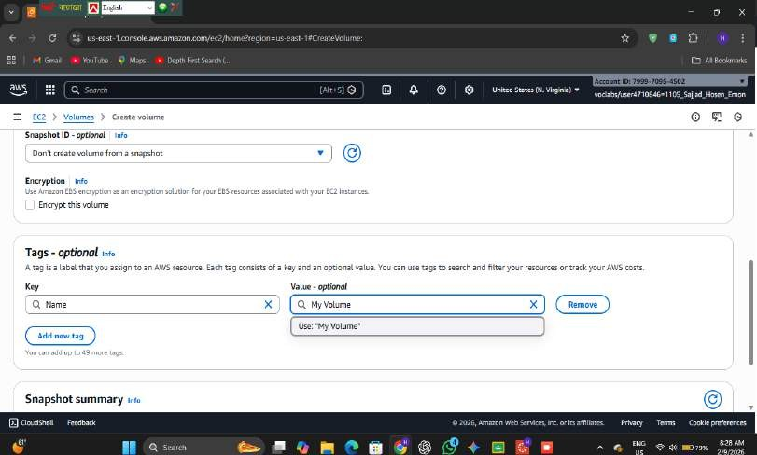

- Created the volume and waited until its status became Available.
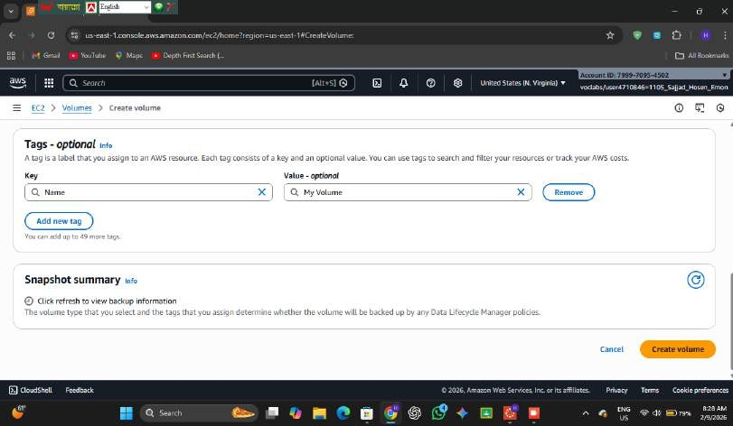

- Selected the newly created volume and clicked Attach Volume.

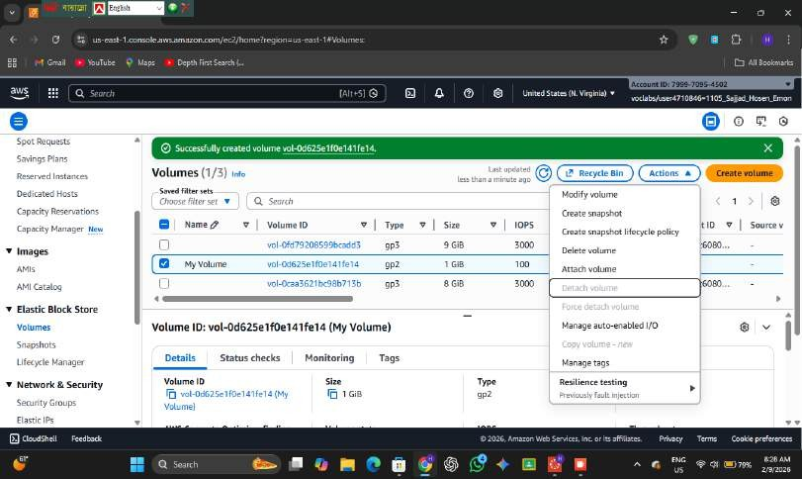

- Chose the Lab EC2 instance and assigned the device name /dev/sdf.
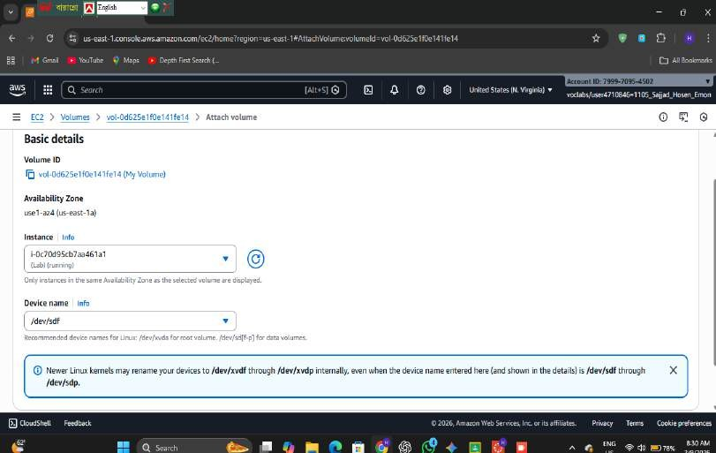

- Attached the volume successfully and confirmed the status changed to In-use.

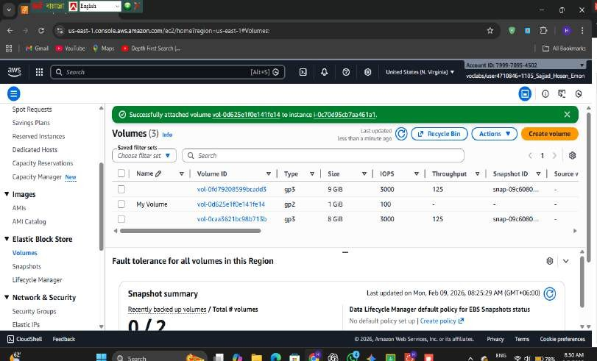

- Opened the Instances section and connected to the EC2 instance using EC2 Instance Connect.
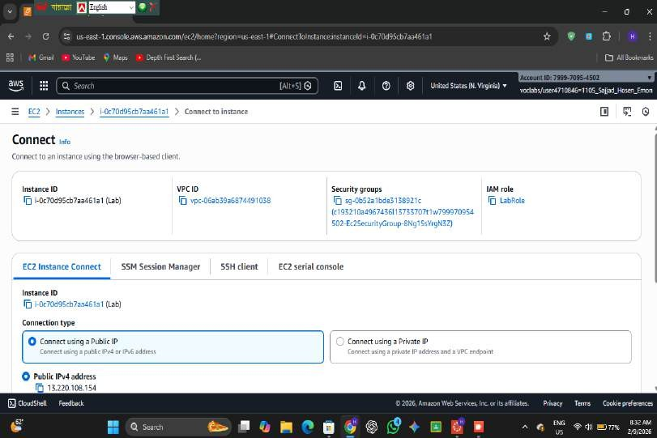

- Checked the available storage using the df -h command.

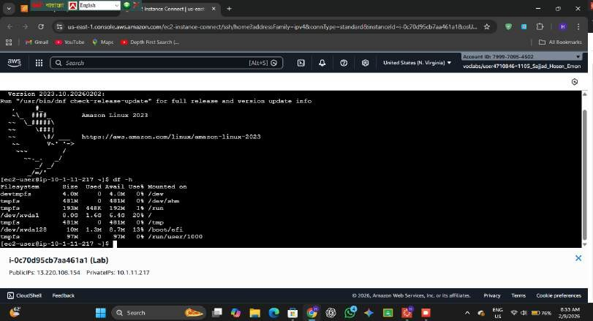

- Created a file system on the new volume using sudo mkfs -t ext3 /dev/sdf.
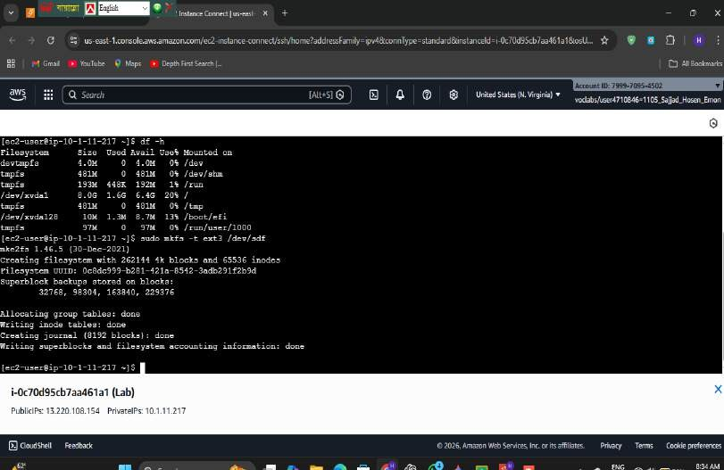

- Created a directory /mnt/data-store to use as a mount point.
- Mounted the volume to the directory using sudo mount /dev/sdf /mnt/data-store.
- Updated the /etc/fstab file to enable automatic mounting after reboot.
- Created a text file inside the mounted volume to store data.

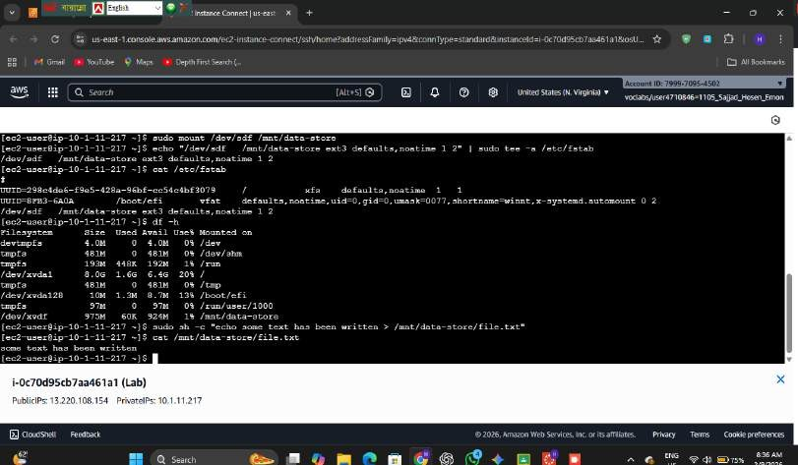

- Verified the file to confirm that data was written successfully.
- • Returned to the EC2 console and selected the previously created volume My Volume.
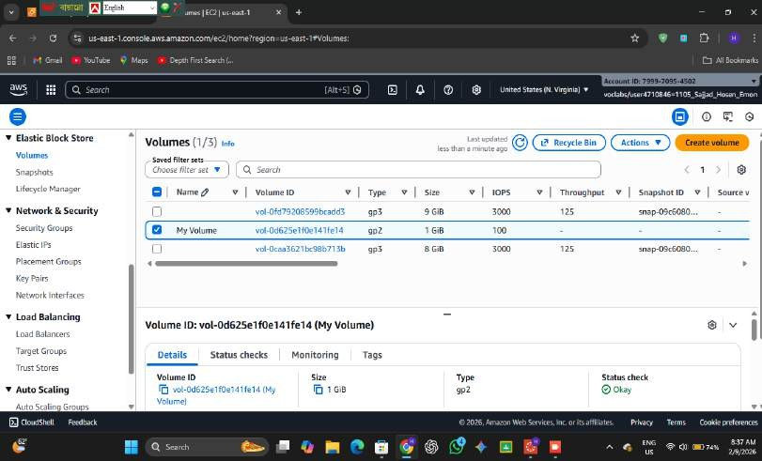

- • Clicked on Actions → Create Snapshot to create a backup of the volume.

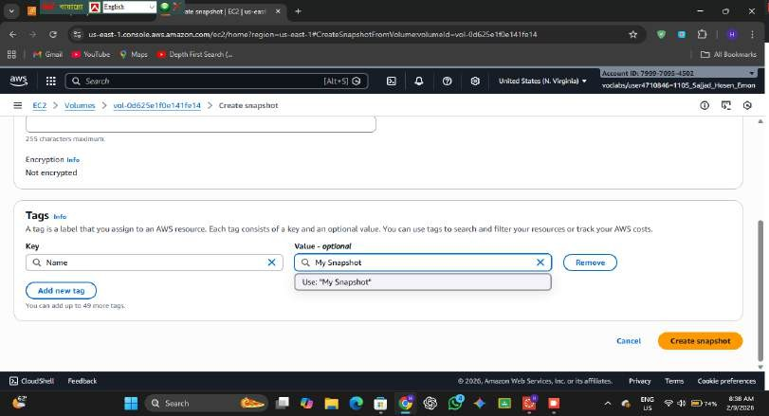

- • Provided the snapshot name My Snapshot for easy identification.
- • Initiated the snapshot creation process and waited until the status changed from Pending to
Completed.
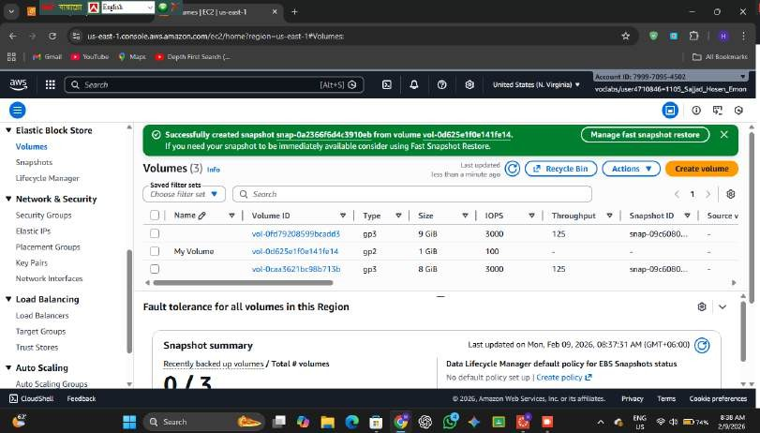

- • After the snapshot was created, connected back to the EC2 instance terminal.
- • Deleted the previously created file from the original volume to simulate data loss.
- • Verified that the file was successfully deleted from the directory.

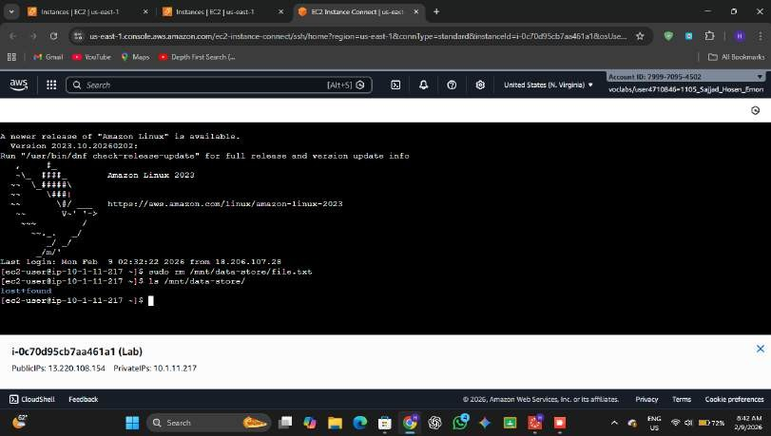

- • Navigated to the Snapshots section in the EC2 console.
- • Selected My Snapshot and clicked Create Volume from Snapshot.
- • Chose the same Availability Zone as the EC2 instance to ensure compatibility.
- • Entered the name Restored Volume for the new volume.
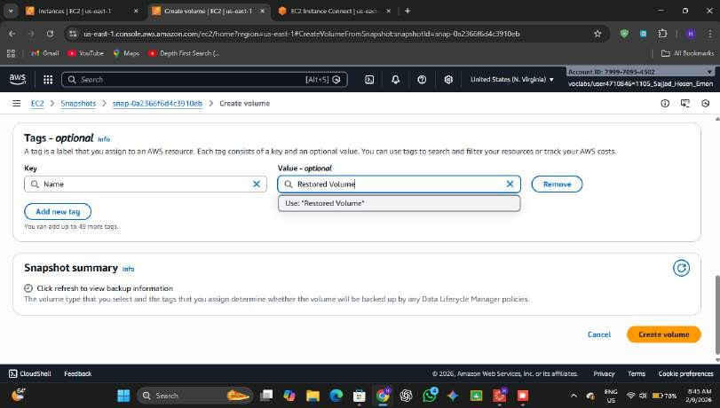

- • Created the new volume from the snapshot.

- • Selected the restored volume and clicked Attach Volume.
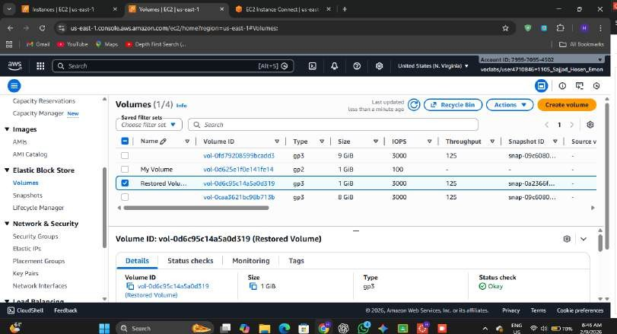

- • Chose the Lab EC2 instance and assigned the device name /dev/sdg.
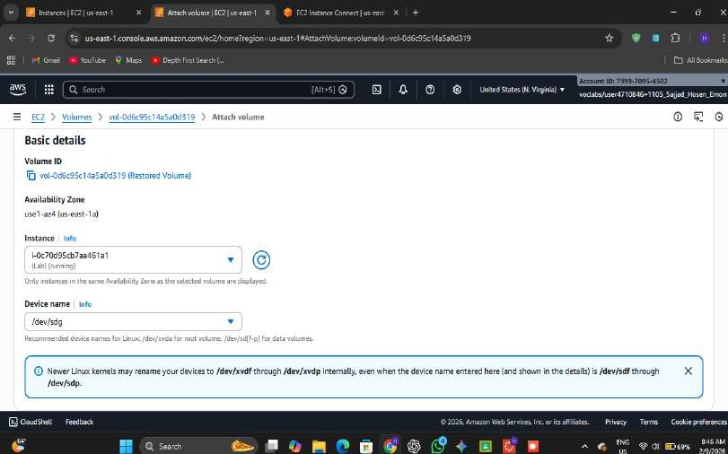

- • Confirmed that the restored volume status changed to In-use.

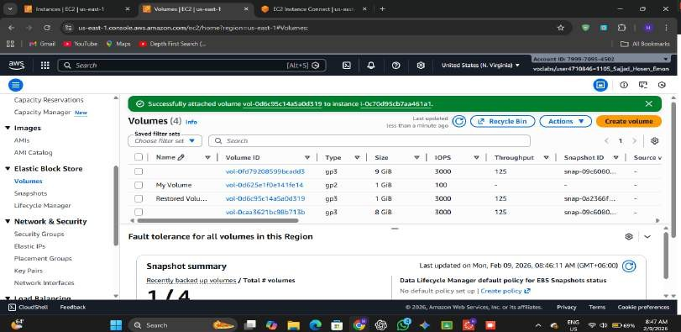

- • Opened the EC2 terminal again to configure the restored storage.
- • Created a new directory /mnt/data-store2 to serve as the mount point.
- • Mounted the restored volume using the command sudo mount /dev/sdg /mnt/data- store2.
- • Listed the files in the mounted directory to verify the restoration process.
- • Confirmed that file.txt was recovered successfully, proving that the snapshot restoration worked correctly.
- Created a new directory /mnt/data-store2 for mounting the restored volume.
- Mounted the restored volume using sudo mount /dev/sdg /mnt/data-store2.
- Checked the directory and verified that the previously stored file was successfully recovered.
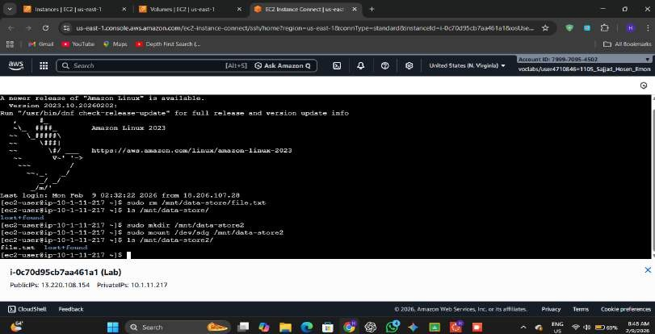

- Submission report:
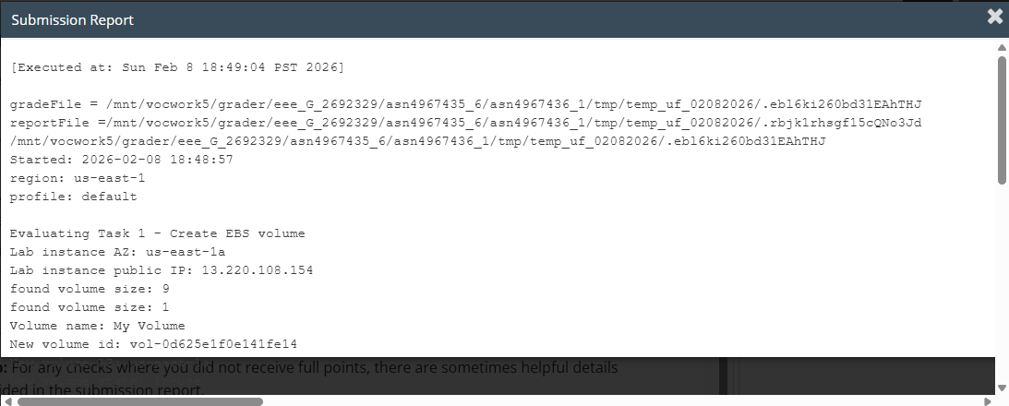
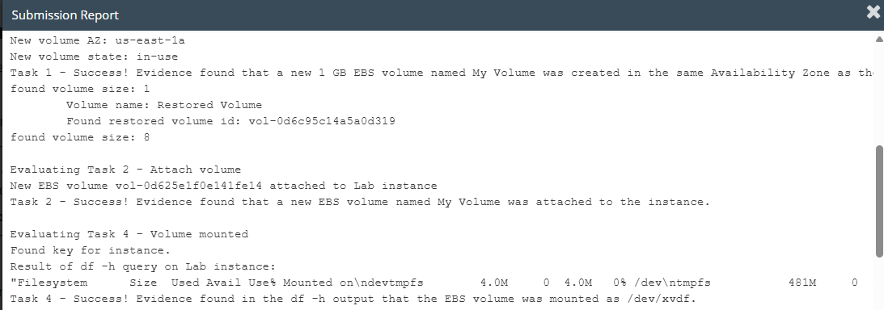
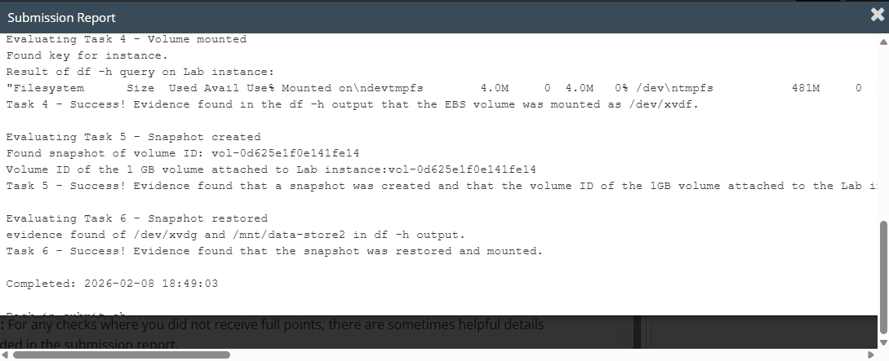

- Total score
- 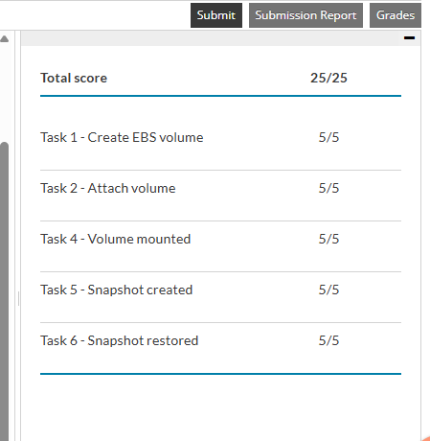

Conclusion
In this lab, Amazon EBS was used to create persistent storage for an EC2 instance. The volume was successfully attached, formatted, and mounted for data storage. A snapshot was created to ensure backup, and the data was restored by creating a new volume from the snapshot. This lab highlighted the importance of Amazon EBS in providing reliable, scalable, and durable storage solutions in cloud computing.

