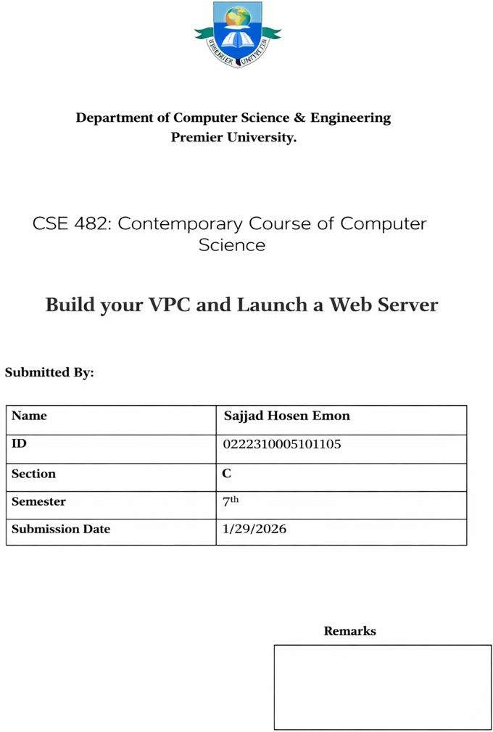

Objectives
The primary objectives of this laboratory session were:

- To create a Virtual Private Cloud (VPC) within Amazon Web Services (AWS) to establish a private and secure network.
- To configure subnets, route tables, and security groups to control and secure network traffic.
- To launch a web server inside this private network.
- To verify that the web server is accessible from the public internet.

Scenario
Imagine you are working as a cloud engineer.
Your job is to build a private network where everything is isolated and protected.
Inside this private area, you need to run one web server that people on the internet can visit.

This practice is similar to how real companies launch their websites or apps in a secure cloud setup instead of putting everything directly on the open internet.
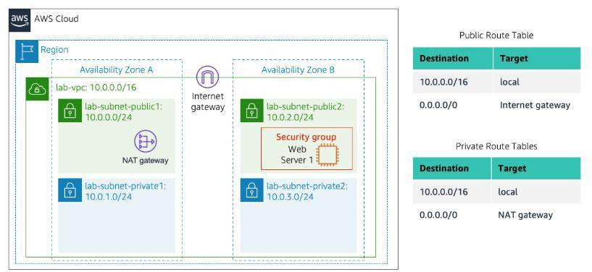

Work Procedure
- Open the AWS Academy Vocareum lab.
- Make sure your temporary AWS login is active.
- Check the region at the top right and set it to N. Virginia (us-east-1).
- Go to VPC service and choose Create VPC → select VPC and more.
- Keep auto name on but change the name from project to lab.
- Keep the main network range as 10.0.0.0/16.
- Use only 1 Availability Zone.
- Keep 1 public subnet and 1 private subnet.
- Open the subnet CIDR settings and change:
  - Public subnet to 10.0.0.0/24
  - Private subnet to 10.0.1.0/24

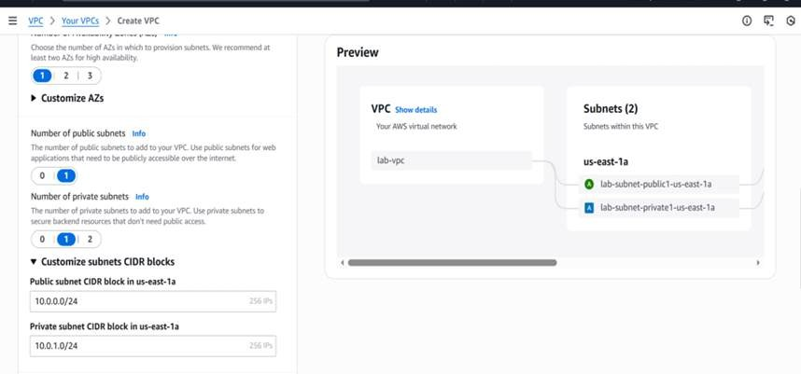
- Set NAT Gateway to 1 in one AZ.
- Keep VPC endpoints as None.
- Leave DNS options enabled.
- Click Create VPC and wait, then open the VPC page.
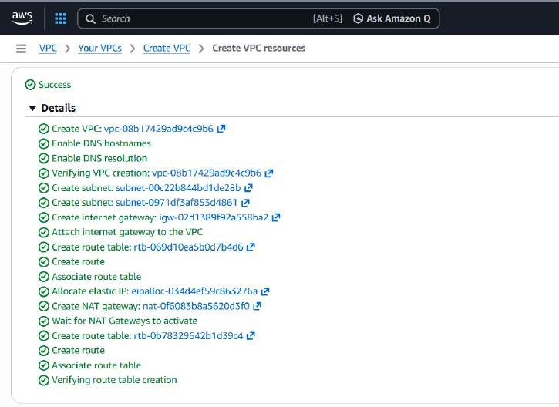

Create extra subnets

- Once it is complete, choose View VPC.
- Then go to subnet in left menu

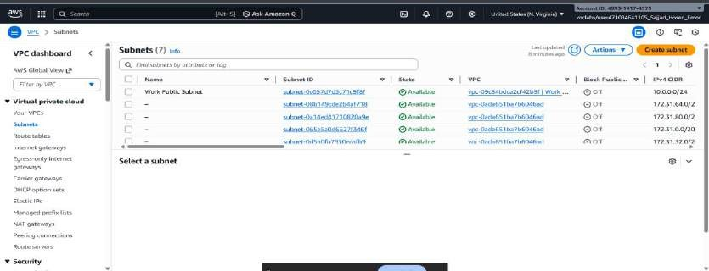
- Go to Subnets → Create subnet.
- Select lab-vpc.
- Create a second public subnet:

- Name: lab-subnet-public2
- AZ: second zone (like us-east-1b)
- CIDR: 10.0.2.0/24
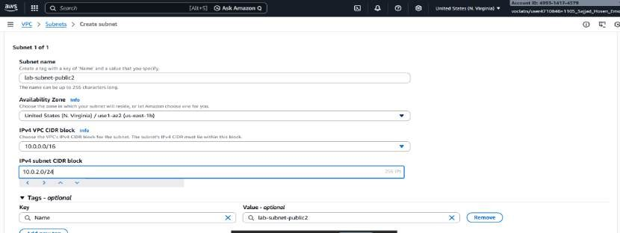
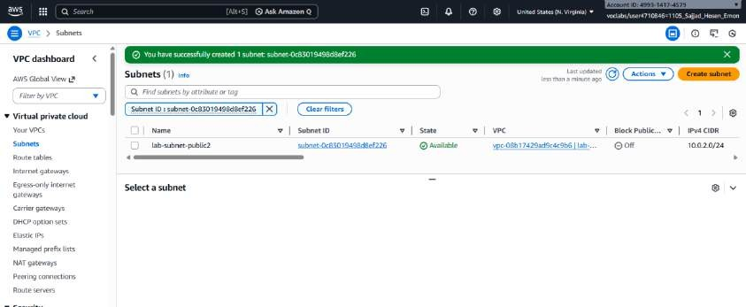

- Create another subnet again for private use:

  - Name: lab-subnet-private2
  - AZ: second zone
  - CIDR: 10.0.3.0/24
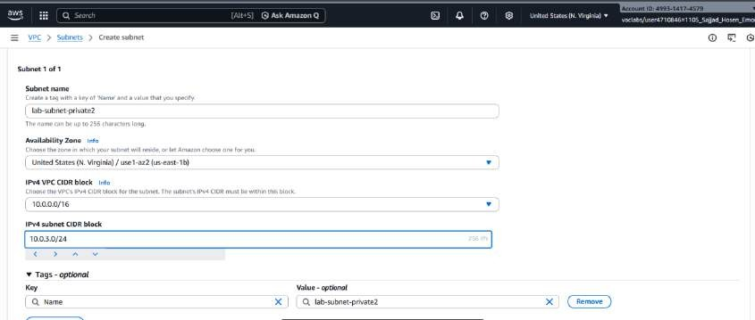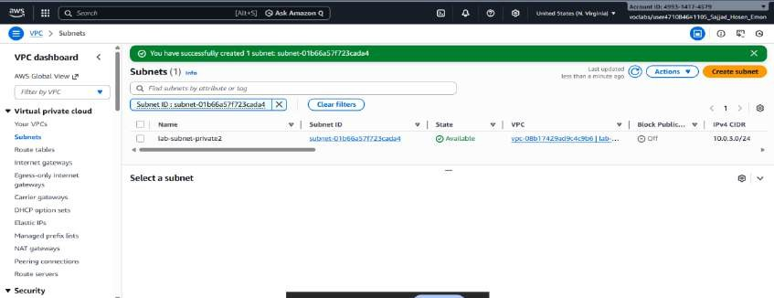

Update route tables
- Open Route tables.
- Select the private route table and add both private subnets to it.
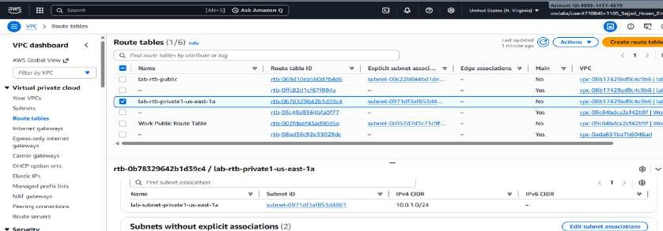

- Select the public route table and add both public subnets to it.
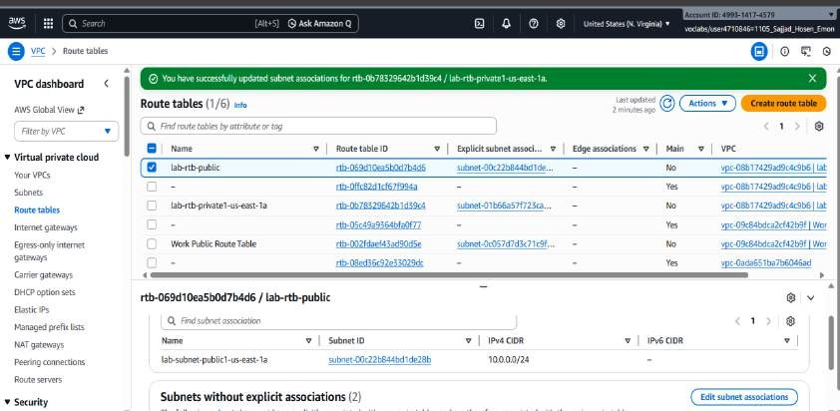

This makes public subnets able to talk to the internet.

Create a security group for the web server
- Create new Security Group:

  - Name: Web Security Group
  - Description: allow web access
  - Choose lab-vpc
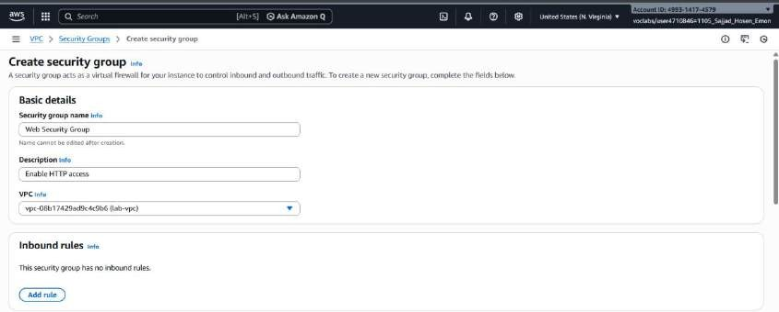

- Add inbound rule:

  - Type: HTTP
  - Source: Anywhere (IPv4)

- Create the security group.
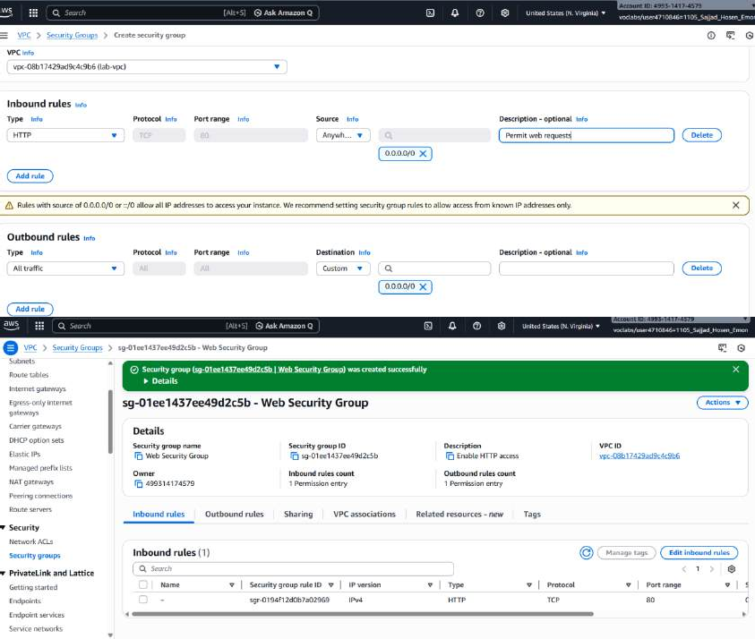

Launch the web server

- Open EC2 service and click Launch instance.
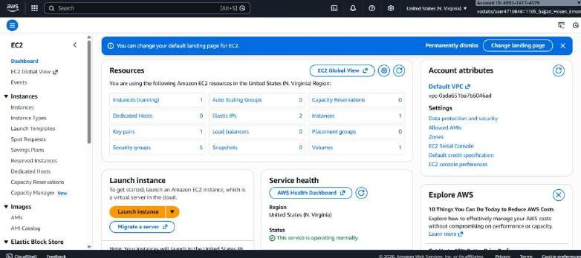

- Name it Web Server 1.
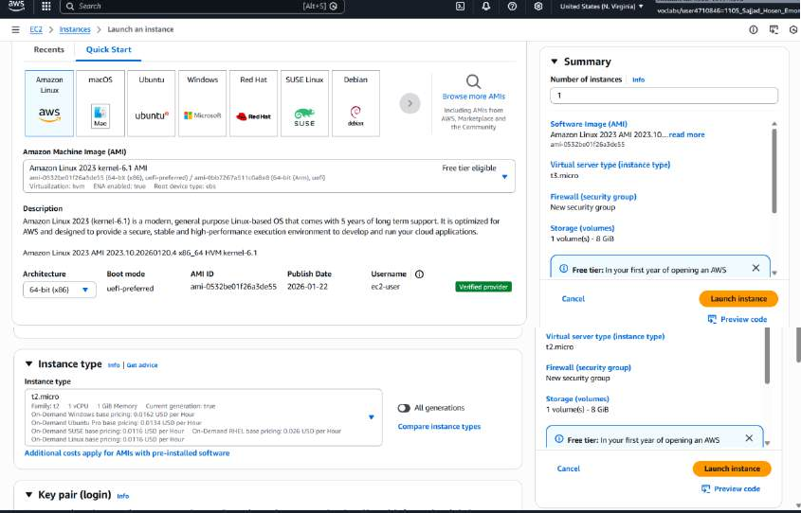
- Use default Amazon Linux image and t2.micro type.
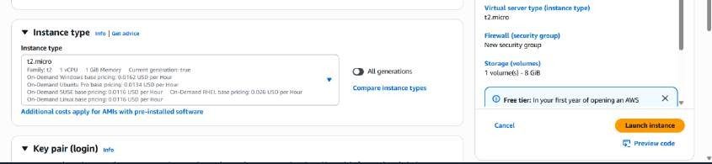

- Choose the provided key pair vockey.
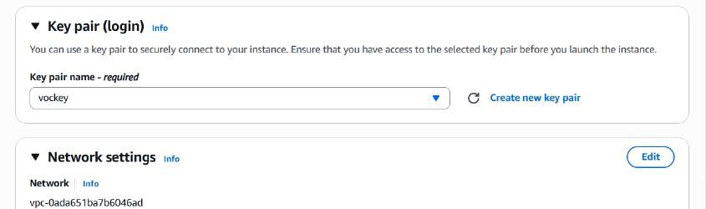

- Select Exacting security group
- Network settings:

  - VPC: lab-vpc
  - Subnet: lab-subnet-public2
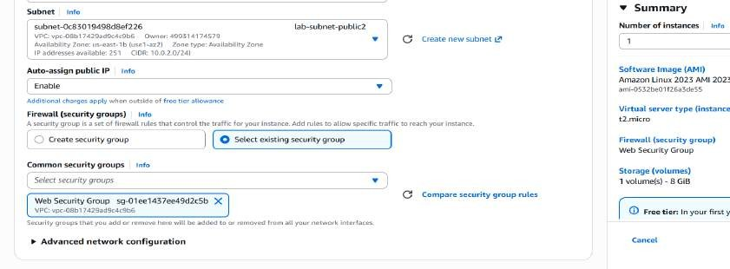
  - Enable auto public IP
  - Use existing security group: Web Security Group

29. Launch the instance and wait until status checks are 2/2 passed.
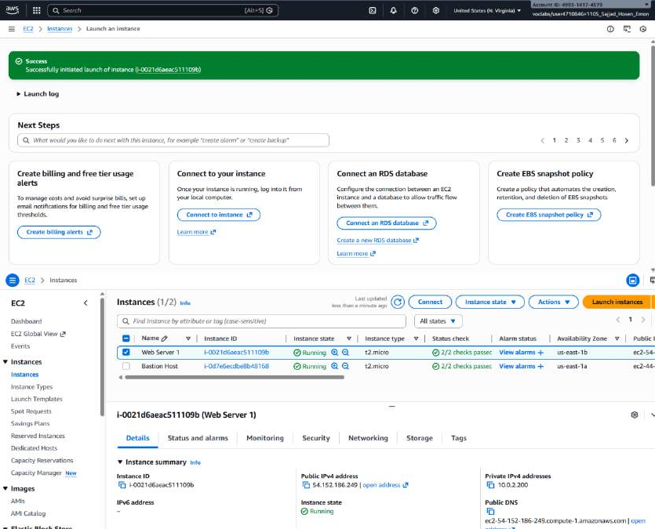

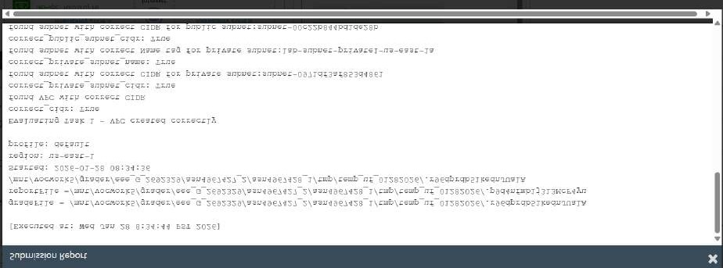
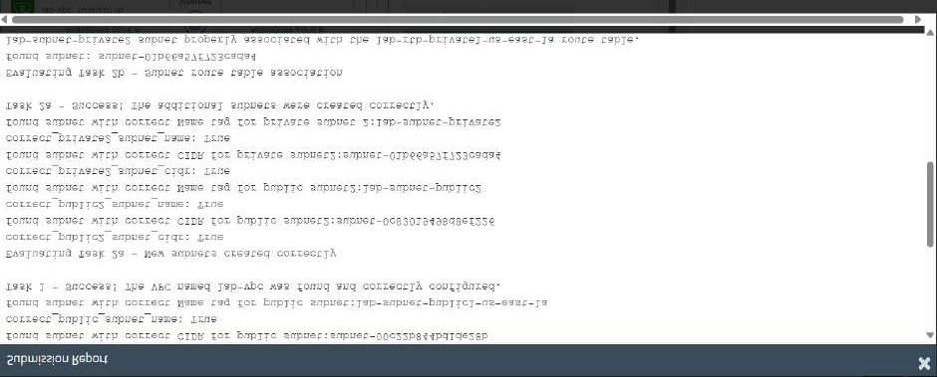
Test the server

- Open the instance details.
- Copy the Public IPv4 DNS.
- Paste it in your browser.
- If the page opens, the web server is working and publicly reachable.
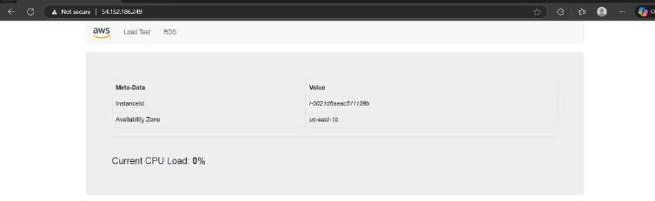

- Finally, submit the lab and view the report.

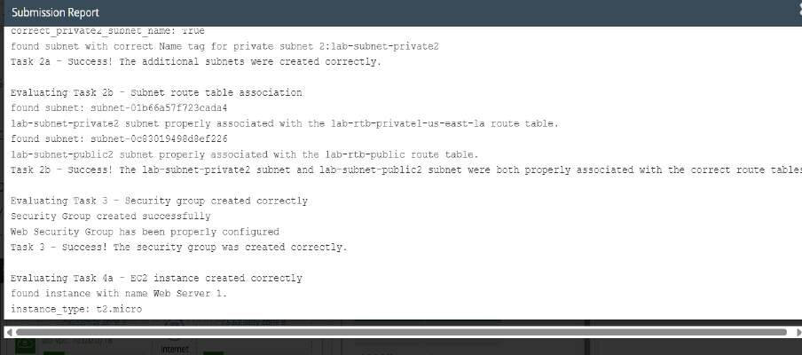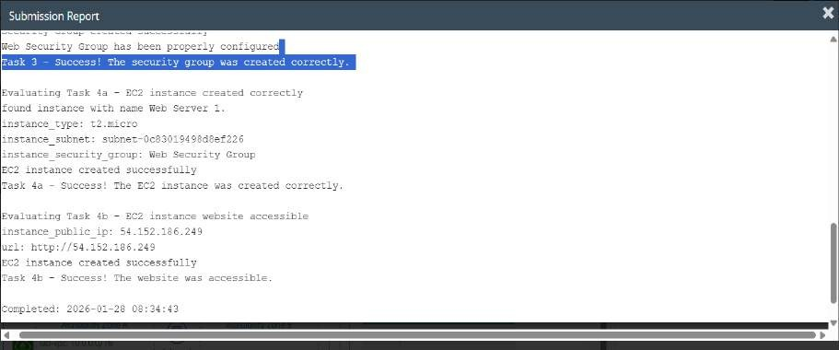
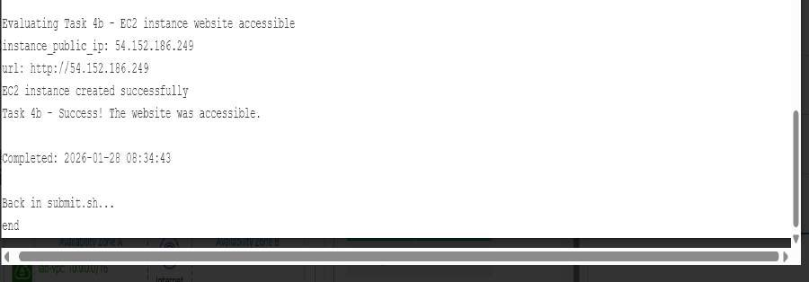

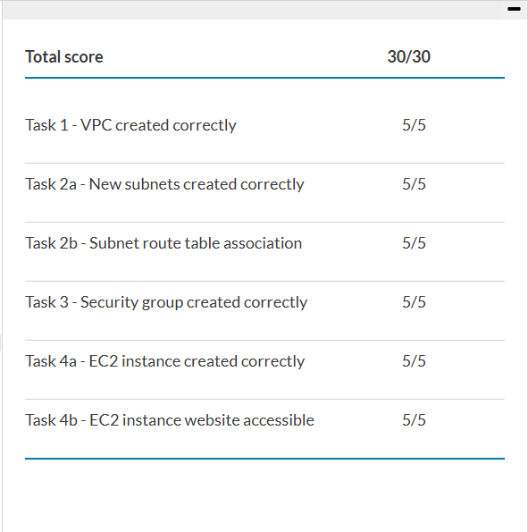
- Grade:

Conclusion
  - A private cloud network was created successfully.
  - Networking rules were set so public and private areas stay organized and secure.
  - A web server was launched inside the public subnet and connected to the internet.
  - This exercise shows the basic but important skills needed to deploy real applications safely in the cloud.

