Configuring and Verifying Single-Area OSPF Routing
Cisco Packet Tracer Lab Report
Course: Computer Networking / Cybersecurity Program
Prepared by: Sajjad
Southeast University, Dhaka

1. Objective
The objective of this lab is to design, address, and configure a small three-router network in Cisco Packet Tracer, and to implement single-area OSPF (Open Shortest Path First) as the dynamic routing protocol. The lab further verifies OSPF neighbor adjacency, checks the link-state database, tests end-to-end reachability between hosts on different LANs, and observes OSPF's convergence behavior when a link fails.

1.1 Tools Used
- Cisco Packet Tracer
- Three Cisco routers (R1, R2, R3) with Gigabit Ethernet and Serial interfaces
- Switches and end-device PCs on each LAN segment
- Command-line (CLI) configuration via router console

2. Network Topology and IP Addressing
The network consists of three routers connected in a partial-mesh arrangement: R1 connects to R2 and R3 over separate Gigabit Ethernet links, while R2 and R3 are connected to each other over a serial WAN link. Each router also serves a local LAN with a switch and a PC. The topology and the address plan assigned to each segment are shown below.
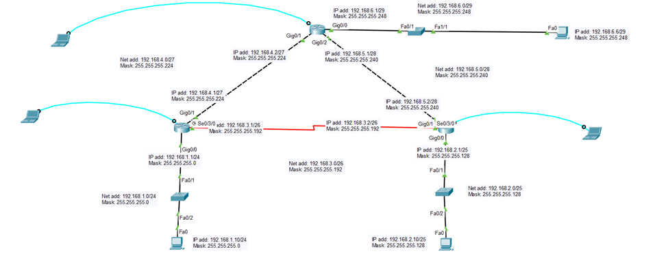
Figure 1 – Logical topology showing all routers, links, subnets, and connected end devices.

2.1 Subnetting Plan
A single major network, 192.168.0.0, was subnetted using VLSM (Variable Length Subnet Masking) to efficiently address each link and LAN according to the number of hosts required.
Segment | Network Address | Subnet Mask | CIDR | Location
LAN A | 192.168.1.0 | 255.255.255.0 | /24 | R2 Gig0/0 (PC0 LAN)
LAN B | 192.168.2.0 | 255.255.255.128 | /25 | R3 Gig0/0 (PC2 LAN)
WAN Link (R2–R3) | 192.168.3.0 | 255.255.255.192 | /26 | R2 Se0/3/0 – R3 Se0/3/0
Link (R1–R2) | 192.168.4.0 | 255.255.255.224 | /27 | R1 Gig0/1 – R2 Gig0/1
Link (R1–R3) | 192.168.5.0 | 255.255.255.240 | /28 | R1 Gig0/2 – R3 Gig0/1
LAN C | 192.168.6.0 | 255.255.255.248 | /29 | R1 Gig0/0 (PC1 LAN)

2.2 Router Interface Addressing
Router | Interface | IP Address | Subnet Mask
R1 | Gig0/0 | 192.168.6.1 | 255.255.255.248
R1 | Gig0/1 | 192.168.4.2 | 255.255.255.224
R1 | Gig0/2 | 192.168.5.1 | 255.255.255.240
R2 | Gig0/0 | 192.168.1.1 | 255.255.255.0
R2 | Gig0/1 | 192.168.4.1 | 255.255.255.224
R2 | Se0/3/0 | 192.168.3.1 | 255.255.255.192
R3 | Gig0/0 | 192.168.2.1 | 255.255.255.128
R3 | Gig0/1 | 192.168.5.2 | 255.255.255.240
R3 | Se0/3/0 | 192.168.3.2 | 255.255.255.192

3. Basic Router Configuration
Each router was given a hostname and its interfaces were configured with the IP addresses and subnet masks from the plan above, then brought up with the no shutdown command. The configurations were saved to NVRAM using write (wr).

3.1 Router R1
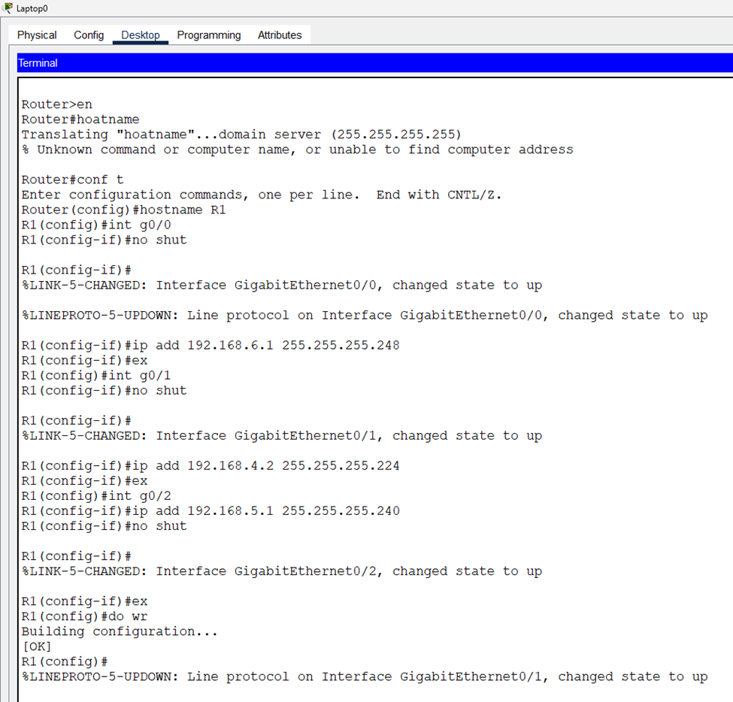
Figure 2 – Hostname and interface configuration on R1 (Gig0/0, Gig0/1, Gig0/2).

3.2 Router R2
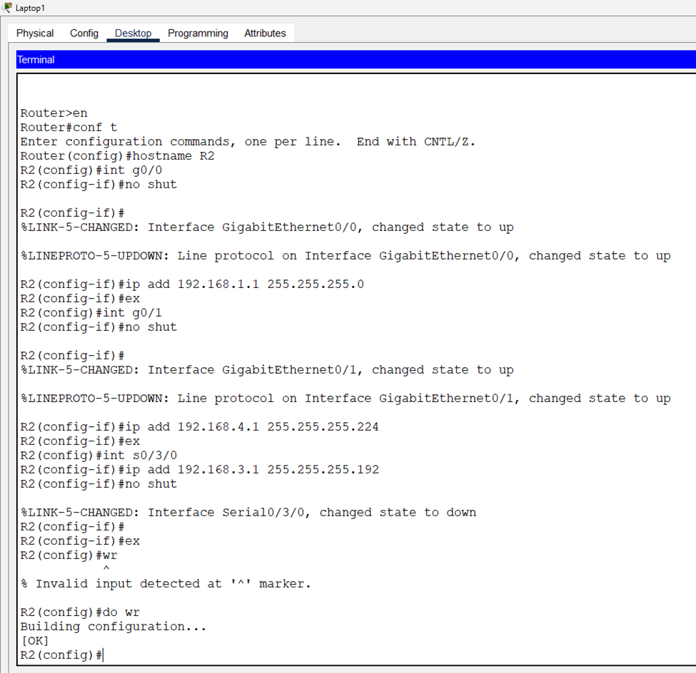
Figure 3 – Hostname and interface configuration on R2 (Gig0/0, Gig0/1, Se0/3/0).

3.3 Router R3
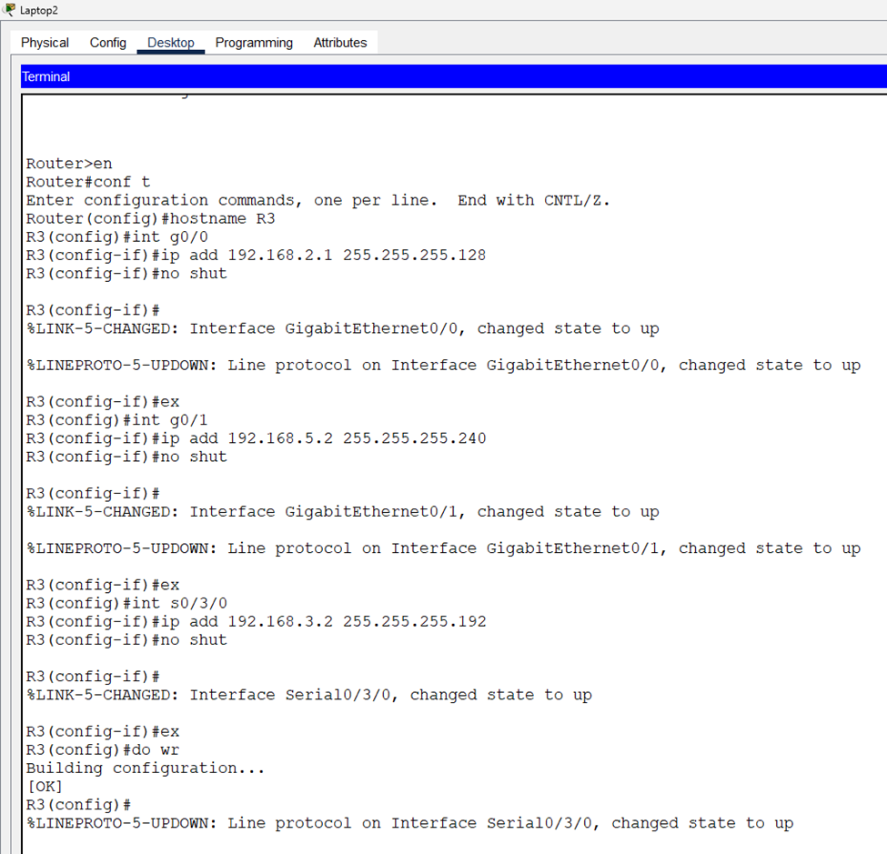
Figure 4 – Hostname and interface configuration on R3 (Gig0/0, Gig0/1, Se0/3/0).

4. OSPF Configuration
Single-area OSPF (Process ID 1, Area 0) was enabled on all three routers. Each router was assigned a unique router-id, and every directly connected network was advertised using the network command with the appropriate wildcard mask.
Router | Router ID | Networks Advertised (network / wildcard, area)
R1 | 1.1.1.1 | 192.168.6.0 0.0.0.7 a0 | 192.168.4.0 0.0.0.31 a0 | 192.168.5.0 0.0.0.15 a0
R2 | 2.2.2.2 | 192.168.4.0 0.0.0.31 a0 | 192.168.3.0 0.0.0.63 a0 | 192.168.1.0 0.0.0.255 a0
R3 | 3.3.3.3 | 192.168.5.0 0.0.0.15 a0 | 192.168.2.0 0.0.0.127 a0 | 192.168.3.0 0.0.0.63 a0

4.1 OSPF on R1 (router-id 1.1.1.1)
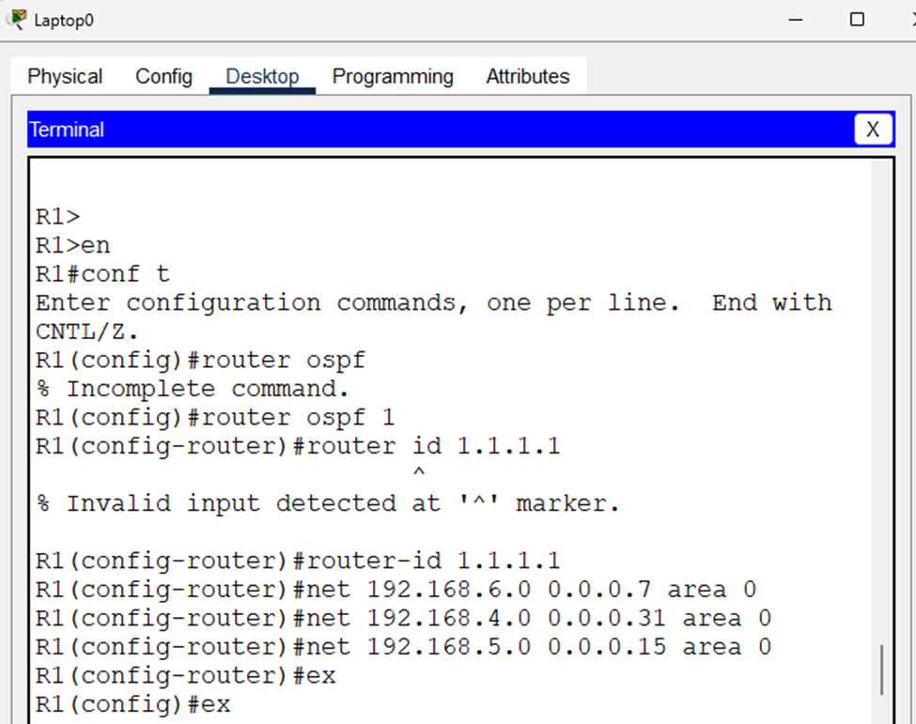
Figure 5 – OSPF process, router-id, and network statements configured on R1.

4.2 OSPF on R2 (router-id 2.2.2.2)
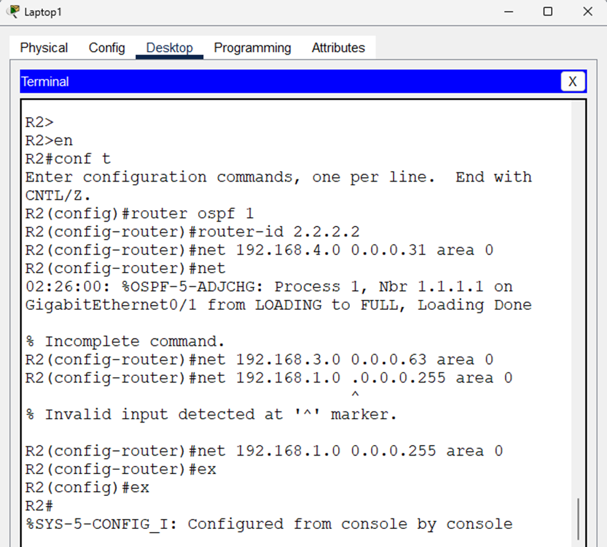
Figure 6 – OSPF configuration on R2. The adjacency message confirms R2 reached FULL state with neighbor 1.1.1.1 (R1) on GigabitEthernet0/1.

4.3 OSPF on R3 (router-id 3.3.3.3)
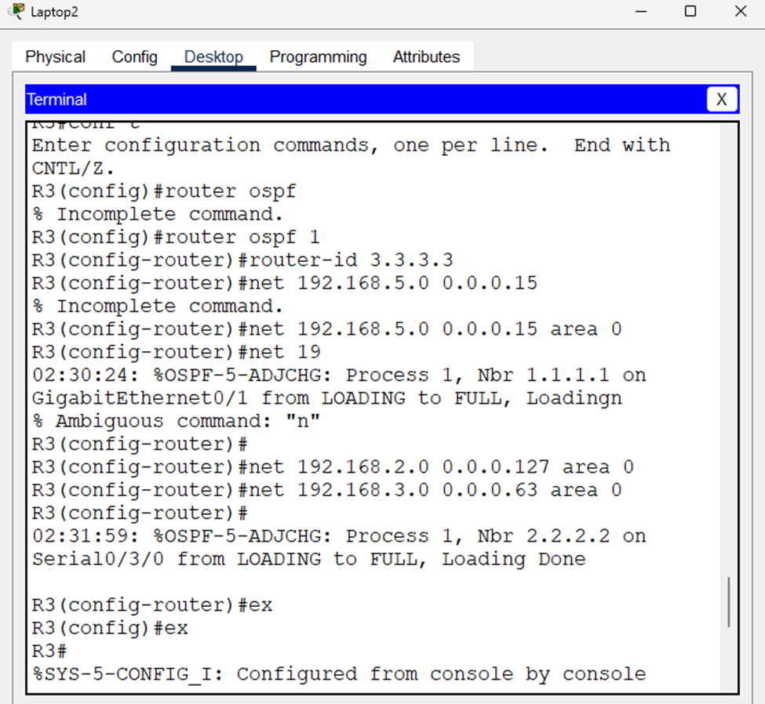
Figure 7 – OSPF configuration on R3. Adjacencies reach FULL state with neighbor 1.1.1.1 (R1) on GigabitEthernet0/1 and neighbor 2.2.2.2 (R2) on Serial0/3/0.

5. OSPF Verification
The command show ip ospf database was issued on each router to confirm that the link-state database is fully synchronized across the OSPF domain. All three routers list identical Router Link States for 1.1.1.1, 2.2.2.2, and 3.3.3.3, plus Net Link States for the two multi-access (Ethernet) segments 192.168.4.0/27 and 192.168.5.0/28, on which R1 is the elected Designated Router (DR). Matching sequence numbers and checksums across all routers confirm the database has converged.

5.1 R1 — show ip ospf database
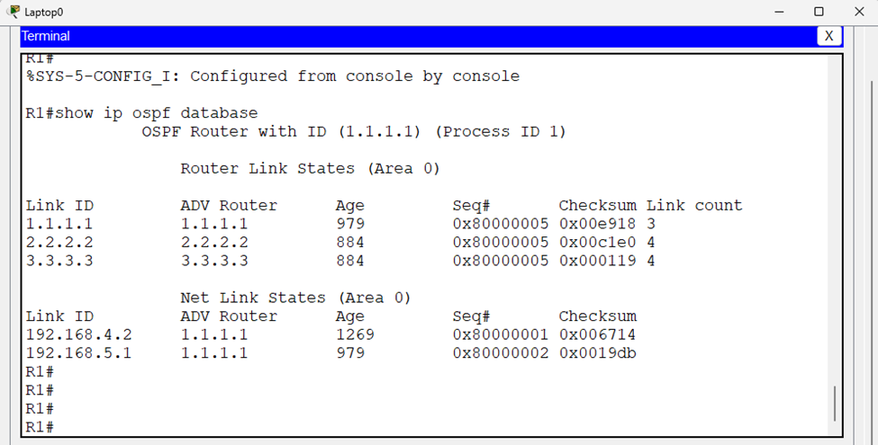
Figure 8 – Link-state database as seen from R1.

5.2 R2 — show ip ospf database
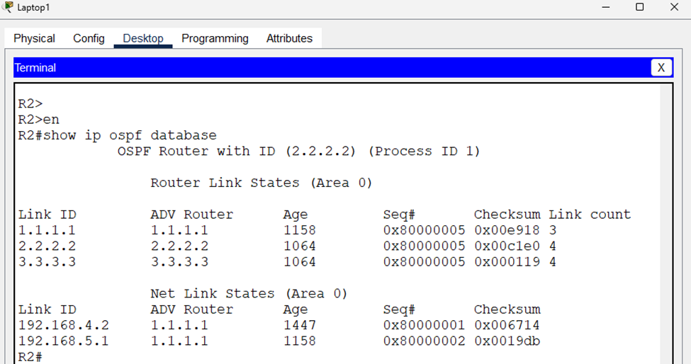
Figure 9 – Link-state database as seen from R2 (identical to R1, confirming synchronization).

5.3 R3 — show ip ospf database
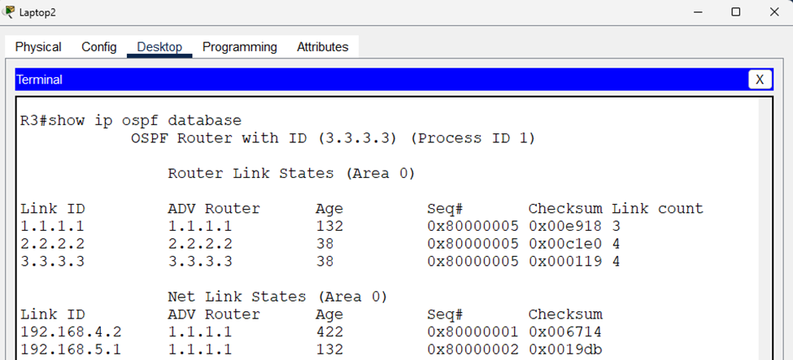
Figure 10 – Link-state database as seen from R3 (identical to R1 and R2).

6. End-to-End Connectivity Testing
With OSPF fully converged, reachability was tested from the PC on each LAN to the PCs on the other two LANs using ping. Successful replies with TTL values below 128 confirm that traffic is being routed across multiple hops rather than switched locally.

6.1 Ping from PC0
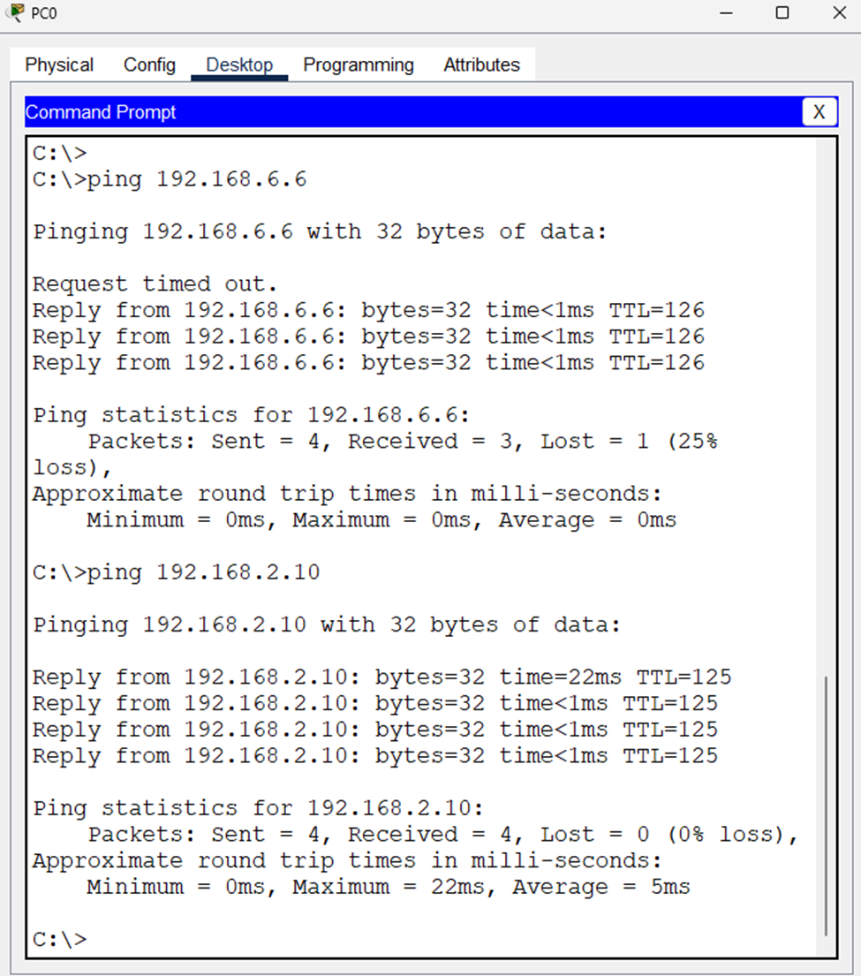
Figure 11 – PC0 pings 192.168.6.6 and 192.168.2.10. The first ping to 192.168.6.6 shows one timeout (normal ARP-resolution delay) followed by three successful replies (0% loss thereafter); the ping to 192.168.2.10 succeeds with 0% loss.

6.2 Ping from PC1
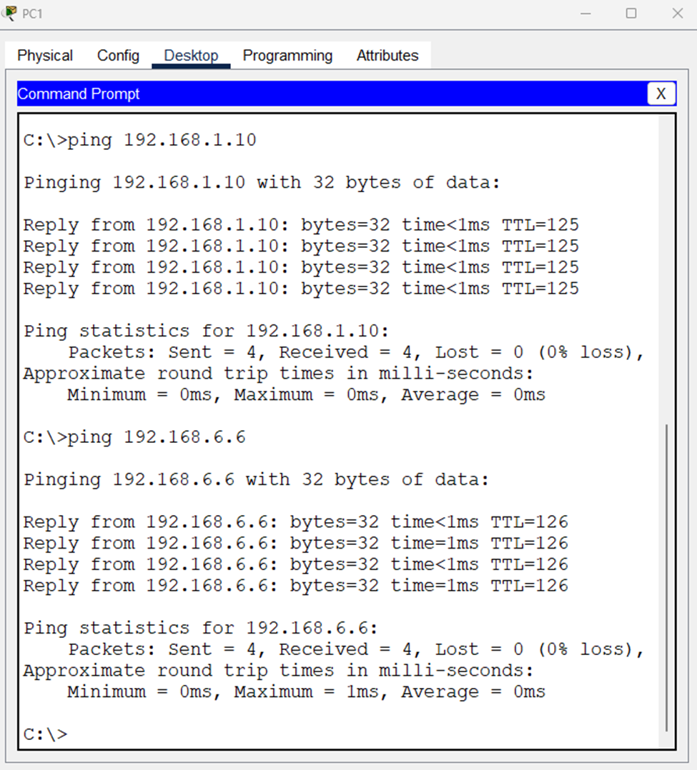
Figure 12 – PC1 successfully pings 192.168.1.10 and 192.168.6.6 with 0% packet loss on both, confirming full reachability.

6.3 Ping from PC2
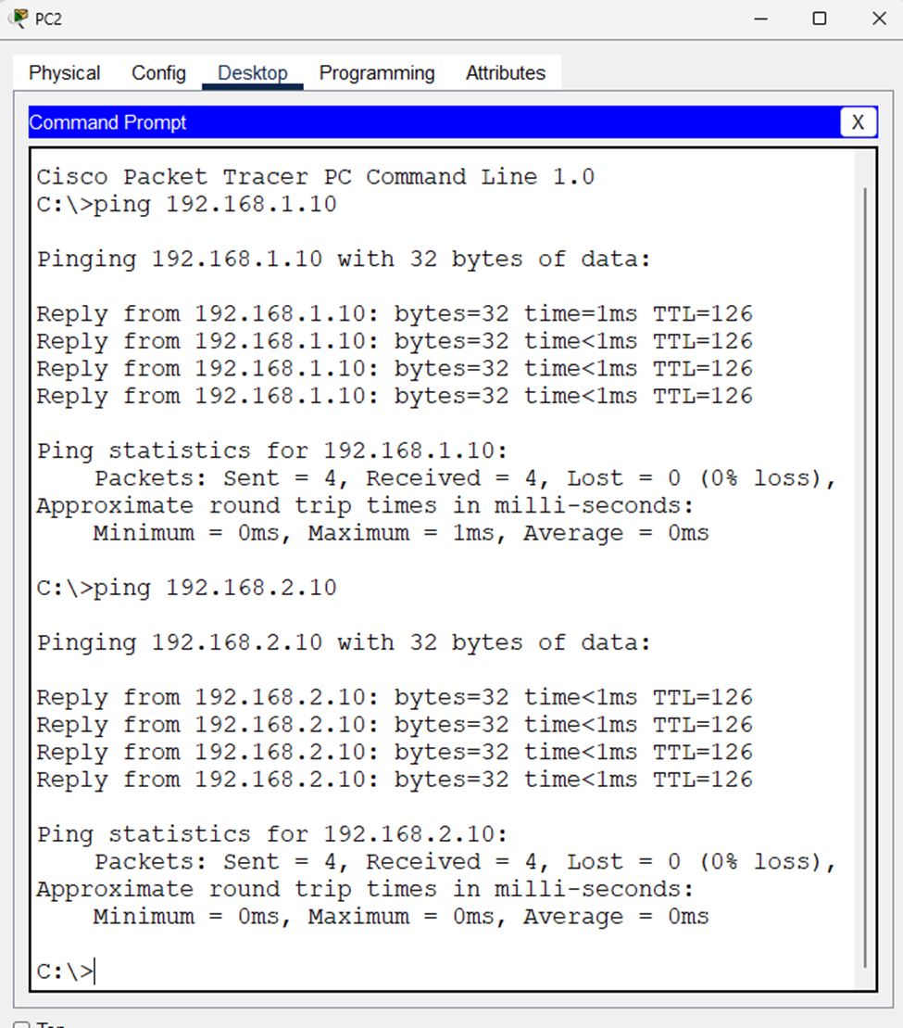
Figure 13 – PC2 successfully pings 192.168.1.10 and 192.168.2.10 with 0% packet loss on both.
All ping tests completed with 0% loss after the initial ARP resolution packet, confirming that OSPF successfully installed routes to every subnet in every routing table and that the network is fully reachable end to end.

7. Link Failure and Convergence Test
To test OSPF's fault tolerance, a continuous ping (ping -t) was started between two end hosts, and the serial cable connecting R2 and R3 was then disconnected and later reconnected while the ping continued to run. This simulates a WAN link failure and demonstrates OSPF's ability to detect the topology change, recalculate the shortest path using the SPF algorithm, and reconverge without a sustained loss of connectivity.

7.1 Continuous Ping During Link Down
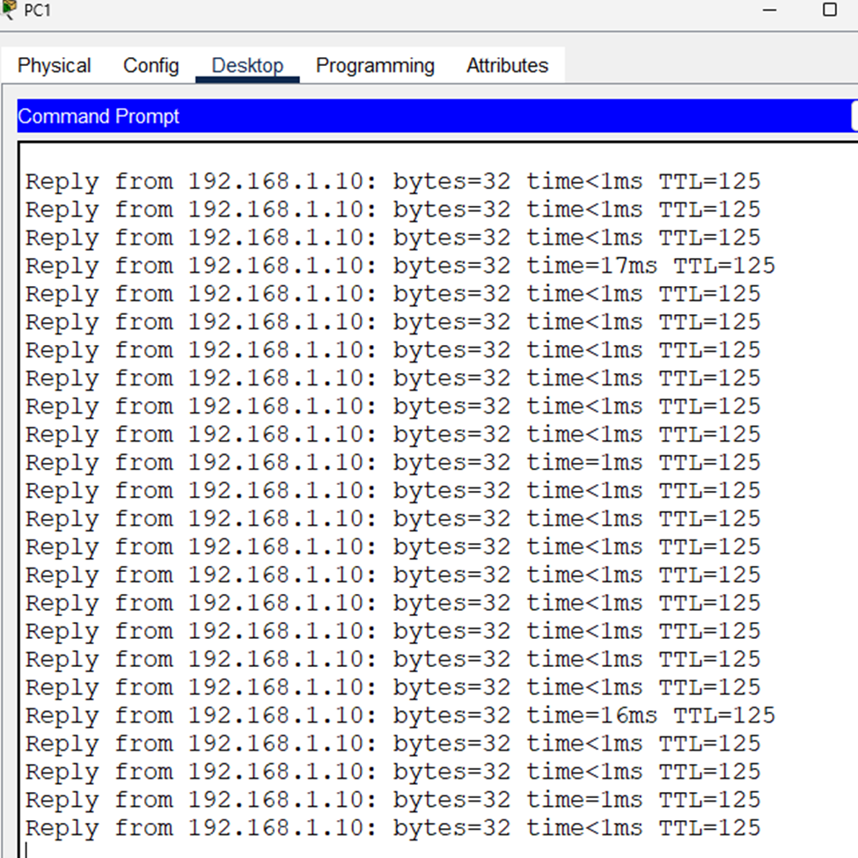
Figure 14 – Continuous ping while the R2–R3 serial link was shut down. All packets still receive replies; two brief latency spikes (17 ms and 16 ms) mark the moments OSPF recalculated routes, but no packets were dropped, showing the network remained reachable via the alternate path through R1.

7.2 Continuous Ping During Link Restoration
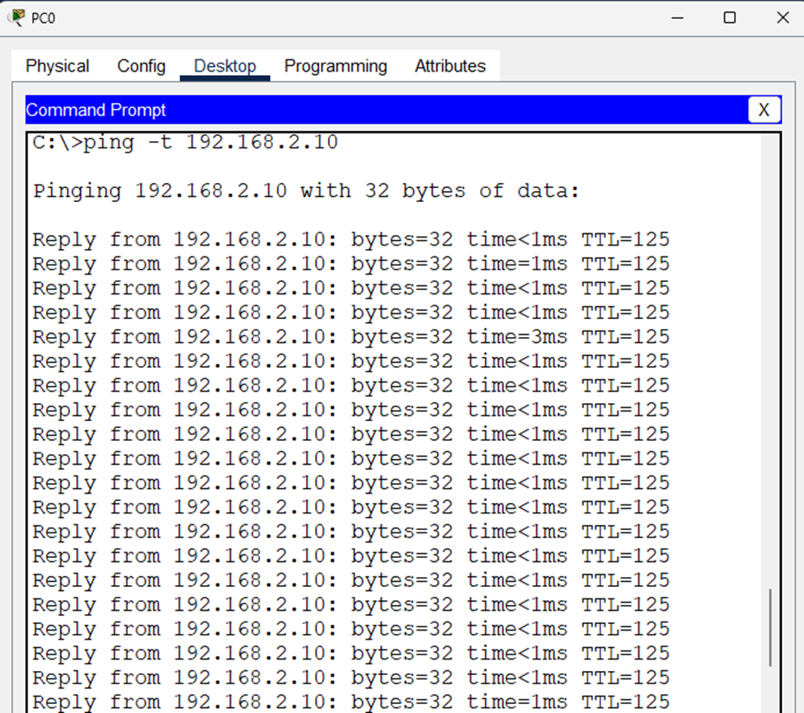
Figure 15 – Continuous ping while the R2–R3 serial link was brought back up. Replies continue uninterrupted with normal (sub-millisecond to a few-millisecond) round-trip times, confirming OSPF re-added the restored link into the topology without disrupting active traffic.
The test confirms that the redundant paths created by the mesh of R1–R2 and R1–R3 links, combined with OSPF's dynamic recalculation, allow the network to tolerate a single link failure with little to no impact on end-to-end connectivity.

8. Conclusion
This lab successfully demonstrated the design and configuration of a multi-router network using VLSM subnetting and single-area OSPF routing in Cisco Packet Tracer. All three routers formed full OSPF adjacencies, synchronized identical link-state databases, and correctly computed shortest paths to every subnet. End-to-end ping tests confirmed full reachability between all LAN segments, and the link-failure test confirmed that OSPF converges quickly enough to maintain connectivity when a link goes down, illustrating the resilience that dynamic routing protocols provide over static routing in networks with redundant paths.

8.1 Key Observations
- OSPF automatically discovered neighbors on all Ethernet and serial links once the matching networks were advertised in the correct area.
- Router IDs (1.1.1.1, 2.2.2.2, 3.3.3.3) were manually set to avoid ambiguity, since Packet Tracer routers had no loopback interfaces to derive them from automatically.
- R1 was elected Designated Router (DR) on both multi-access Ethernet segments (192.168.4.0/27 and 192.168.5.0/28), which is why only R1 originates the Net Link State entries for those segments.
- The network tolerated the failure of the R2–R3 serial link because R1 provided an alternate path to both routers, demonstrating the value of redundant topology design combined with a dynamic routing protocol.

