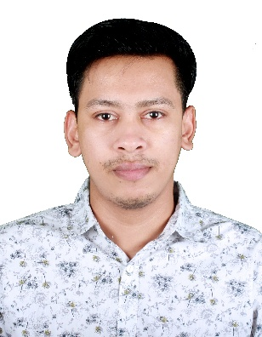**Sajjad Hossain**

**MERN Stack Developer**

01907488316

sajjadhossainX06@gmail.com

<https://github.com/Sajjad177>

<http://www.linkedin.com/in/sajjadsajjad>

**Career Objective**

A curious learner and excellent team player seeking a position in a growth-oriented company where I can use my skills to advantage of the company while having the scope to develop my own skills.

**Skills**

**Expertise:** HTML5, CSS3, Tailwind CSS, JavaScript, ES6, React JS, Redux Toolkit, REST API, React Router, Material UI, Firebase Authentication, JWT, Node.JS, MongoDB, Express JS, Mongoose, TypeScript, Next.JS, MySQL.

**Tools:** GitHub, VS Code, vercel, Postman.

**Experience**