**Introduction**

*This section provides an overview of the project; describing the problem, the objective and the intended approach.*

**Background**

*This section provides the theory and application of the project. In short it provides the information needed to understand various concepts in the project.*

**Literature Review**

*This section provides a literature review of the existing approaches so far employed to solve the same problem.*

**Proposed Project Design**

*This section discusses the* ***proposed*** *design and its various building blocks.*

**Project breakdown**

*This section discusses the milestones reached in course of implementation of the proposed project design. It also shows the tentative timeline of the milestones.*

**Milestones Achieved**

*This section is the core of the progress report. It discusses the details regarding the techniques, methodology, tools, etc. employed in the milestones achieved so far. It also discusses preliminary results wherever applicable.*

**References**

*This section provides a numbered list, in standard format, of all the references cited in the progress report. Some examples of the standard reference format are as follows:*

1. D. Christopher and M. Spiros, “Using Program Transformation to Secure C Programs Against Buffer Overflows”, *10th IEEE Working Conference on Reverse Engineering, Victoria, B.C., Canada,* November 13 - 17, 2003.
2. E. Barrantes, D. Ackley, S. Forrest, T. Palmer, D. Stefanovic and D. Zovi, “Randomized Instruction Set Emulation to Disrupt Binary Code Injection Attacks,” *In Proceedings of the 10th ACM Conference on Computer and Communication Security,* October 2003.
3. Andrew Wright, “On Sapphire and Type-Safe Languages”, *Proceedings, Texas Workshop on Security of Information Systems, Texas A&M University,* April 2 2003.
4. T. K. Tsai and S. Navjot, “Libsafe: Protecting Critical Elements of Stacks”, White Paper <http://www.research.avayalabs.com/project/libsafe>, August 29, 2001.
5. J. M. Mendel, “Uncertain Rule-Based Fuzzy Logic Systems”, *Prentice-Hall, Upper Saddle River, NJ 07458*, 2001.

# Introduction

The brain is the most important and complex organ of the human body. It controls and coordinates all the actions and reactions that we make. It is challenging for learners such as college students or medical students to understand it thoroughly using textual information. That’s why we are proposing a solution to develop a 3D mobile app for the human brain. We aim to describe the morphology, taxonomy, physiology, and anatomy of the human brain with 3D models using our app. It will not show the visualization of the process/working of neurons in the brain. In addition, we employ the agile methodology to design and develop our application because it provides faster development with the support of incremental changes. We will be using Unity 3D with C# for development. This application will help the students to envision the concept of the human brain with 3D visualization and better information design. Finally, users can realistically move and rotate the virtual 3D human brain in the app while viewing it from different angles and magnifications.

# Background

The Brain is the most important and complicated organ in the human body. It controls all of our activities, tasks, thoughts, memory, emotions, touch, motor skills, vision, breathing, temperature, hunger, actions, reactions, and everything that regulates our body. Together, the brain and spinal cord that extends from it make up the Central Nervous System, CNS. In addition, the brain sends and receives chemical and electrical signals throughout the body through neurons. Different signals control the different processes and your brain interprets each. So, it is really important for us to understand it.

The human brain is studied by considering its four perspectives: Taxonomy, Anatomy, Physiology, and Morphology. Taxonomy of human brain is the process of classifying it into further parts such as forebrain, the midbrain, and hind-brain. Anatomy of human brain is to describe the three main structures of brain such as cerebrum, cerebellum and brainstem. Then, Physiology is to deeply examine those parts of human brain and morphology defines the structural measures of brain such as volume and shape.

Our app will explain the human brain in the aforementioned perspectives. Our app will be 3D based app that contains the virtual human brain. It facilitates the users to learn the concepts of the brain, they can explore the definitions of parts of the brain by clicking them. Like, when a user touches the forebrain, a new text box will be generated which will contain the definition of the forebrain. Moreover, users can visualize the brain complexity of the human brain such as subparts of its main parts in 3D model easily. It will give users a positive experience without information overloading and they can understand the information more clearly. Finally, learning the human brain using textbooks is very difficult for college students or beginners. They cannot understand the structure of humans by reading the words only. It is not sufficient for them to read the textual information.

It is a fact that students frequently run into difficulties when studying the human brain, especially college students or beginners. First, it is challenging for them to develop an understanding of the human brain from the perspectives of morphology, anatomy, physiology, and taxonomy. They get confused between the different terms. Second, it is also taught in educational institutions using different text books which mostly does not have a better visualizations of brain structure. They also throw huge overload of information to learners which gets difficult for learners to grasp. Third, there is also a lack of 2D/3D desktop/mobile applications available for understanding the human brain from the aforementioned perspectives. It demands higher cognitive effort from learners because these systems and applications mostly have poor user experiences and improper information design. Therefore, we are proposing the solution to this major problem. It is discussed in next section.

# Literature Review

We have reviewed many real-world existing 3D applications for learning the human brain. They do have some amazing features, but also lack some features such as information design, content, etc. Some of them are given below:

## 3D Human Brain

3D Human Brain [1] is an android/windows application that contains 3D models of the human brain which you can easily use for visualization. However, it does not describe any of the four perspectives taxonomy, anatomy, physiology, or morphology.



## Brain Pro

Brain Pro [2] is a mac edition 3D app that has wonderful features for the anatomical perspectives of the brain. Following are some of its main features:

1. Allows sectioned views and custom label
2. 360-degreedegree rotation and slice
3. View, Edit, and Add pins with notes
4. Layers, Map and Transparency

Some of its limitations are:

1. It does not describe other characteristics such as taxonomy, physiology, and morphology
2. It is only available for MAC.

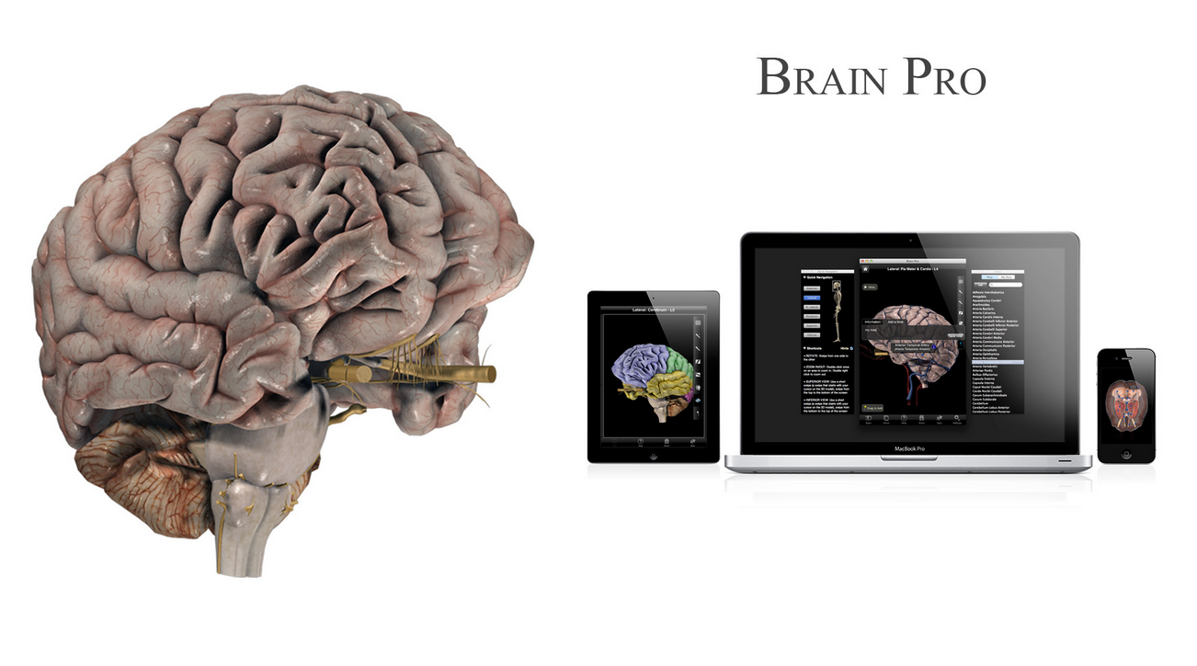

1. It is not free

## 3D Brain

3D Brain [3] is an interactive 3D app designed for mobile devices. It is freely available and contains 29 individual maps showing different structures of the human brain. It focuses on the anatomy and physiology of the human brain. There are some issues with this app:

1. It is developed for older versions of android
2. It does not describe the morphology and taxonomy of human brain
3. It needs to have access on internal media files

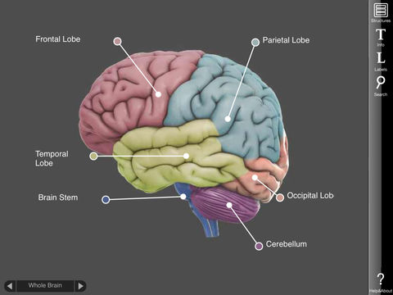

## 

## Bio Digital Human – 3D Anatomy

Bio Digital Human – 3D Anatomy [4] is a premium app available at android play store and focuses on anatomy of human body. Some of its main features are:

1. Interactive 3D visualization
2. Scalable Content Creation and Management
3. Highly customizable visualizations
4. Easy to integrate into any Digital platform

However, it also has many issues:

1. It is general anatomy tutorial, not specific to human brain.
2. It does not focus to taxonomy, morphology, and physiology.
3. It is not freely available.

## Brain Tutor 3D

Brain Tutor [5] is a 3D mobile application available in the android play store. It visualizes the anatomy and physiology of the human brain. It uses the brain models developed by MRI scans. However, there are some issues existing in this app:

1. It is developed for older versions of Android.
2. It is freemium.
3. It does not have a visualization for morphology and taxonomy.
4. Its information is not so user-friendly.

# Proposed Project Design

Our project's primary goal is to develop a 3D mobile application. This project is important because we will be using the most recent tools and technologies, which will keep us aware of the IT industries. The users will also profit because they will be able to learn in new and innovative ways as most students in our area still apply outdated textbooks for their education. We have also discussed the existing problems in studying the human brain. Further we have reviewed some major apps which does not fully provide the solution to our problem. Therefore, it is really important to work on this and provide a better solution that answers these issues and provide a solution to the problem.

# References

1. [3D Human Brain, AXON](https://apkcombo.com/3d-human-brain/axon.apps.humanbrain3d/)
2. [BRAIN PRO](https://3d4medical.com/apps/brain-pro)
3. [3D Brain, Educational App Store](https://www.educationalappstore.com/app/3d-brain)
4. [Bio Digital Human – 3D Anatomy](https://www.biodigital.com/)
5. [Brain Tutor 3D](https://www.brainvoyager.com/Mobile/BrainTutor3D_iOS.html)