

Final Year Project

Brain Unpacked – 3D

Project Code: 19F_09

Group Members

Mohammad Hasnain (023-19-0034)

Sajjad Ali (023-19-0100)

Mujeeb Ahmed (023-19-0001)

Supervised By:

Dr. Ahsanullah Abro

Table of Contents

Abstract 3

Introduction and Background 3

Problem Identification 4

Proposed Solution 4

Objectives 4

Literature Review 5

3D Human Brain 5

Brain Pro 5

3D Brain 6

Bio Digital Human – 3D Anatomy 6

Brain Tutor 3D 7

Project Rationale 8

Scope of the Project 8

Methodology 9

Development Methodology 9

Expected Results 10

Work Division 11

Proposed Project Timeline 12

Gantt chart 12

References 13

# Abstract

The brain is the most important and complex organ of the human body. It controls and coordinates all the actions and reactions that we make. It is challenging for learners such as college students or medical students to understand it thoroughly using textual information. That’s why we are proposing a solution to develop a 3D mobile app for the human brain. We aim to describe the morphology, taxonomy, physiology, and anatomy of the human brain with 3D models using our app. It will not show the visualization of the process/working of neurons in the brain. In addition, we employ the agile methodology to design and develop our application because it provides faster development with the support of incremental changes. We will be using Unity 3D with C# for development. This application will help the students to envision the concept of the human brain with 3D visualization and better information design. Finally, users can realistically move and rotate the virtual 3D human brain in the app while viewing it from different angles and magnifications.

**Keywords: Human Brain, 3D Application, Unity 3D, C#,**

# Introduction and Background

The Brain is the most important and complicated organ in the human body. It controls all of our activities, tasks, thoughts, memory, emotions, touch, motor skills, vision, breathing, temperature, hunger, actions, reactions, and everything that regulates our body. Together, the brain and spinal cord that extends from it make up the Central Nervous System, CNS. In addition, the brain sends and receives chemical and electrical signals throughout the body through neurons. Different signals control the different processes and your brain interprets each. So, it is really important for us to understand it.

The human brain is studied by considering its four perspectives: Taxonomy, Anatomy, Physiology, and Morphology. Taxonomy of human brain is the process of classifying it into further parts such as forebrain, the midbrain, and hind-brain. Anatomy of human brain is to describe the three main structures of brain such as cerebrum, cerebellum and brainstem. Then, Physiology is to deeply examine those parts of human brain and morphology defines the structural measures of brain such as volume and shape.

Our app will explain the human brain in the aforementioned perspectives. Our app will be 3D based app that contains the virtual human brain. It facilitates the users to learn the concepts of the brain, they can explore the definitions of parts of the brain by clicking them. Like, when a user touches the forebrain, a new text box will be generated which will contain the definition of the forebrain. Moreover, users can visualize the brain complexity of the human brain such as subparts of its main parts in 3D model easily. It will give users a positive experience without information overloading and they can understand the information more clearly. Finally, learning the human brain using textbooks is very difficult for college students or beginners. They cannot understand the structure of humans by reading the words only. It is not sufficient for them to read the textual information.

# Problem Identification

It is a fact that students frequently run into difficulties when studying the human brain, especially college students or beginners. First, it is challenging for them to develop an understanding of the human brain from the perspectives of morphology, anatomy, physiology, and taxonomy. They get confused between the different terms. Second, it is also taught in educational institutions using different text books which mostly does not have a better visualizations of brain structure. They also throw huge overload of information to learners which gets difficult for learners to grasp. Third, there is also a lack of 2D/3D desktop/mobile applications available for understanding the human brain from the aforementioned perspectives. It demands higher cognitive effort from learners because these systems and applications mostly have poor user experiences and improper information design. Therefore, we are proposing the solution to this major problem. It is discussed in next section.

# Proposed Solution

By considering the above-mentioned problem, we have chosen the project to develop a 3D mobile application for understanding the human brain. It will specifically focus on the following study perspectives of the human brain:

1. Morphology
2. Anatomy
3. Taxonomy, and
4. Physiology

There will be 3D Brain models with data tags attached. As a result, learners will find it easier to grasp the concepts of the human brain with our app. They can rotate the models to view at any angle and can also see their details by clicking the detailed section icon.

# Objectives

Considering the problem faced by learners to study the human brain from the morphology, taxonomy, anatomy, and physiology perspectives, information overload in text books design, lack of 2D/3D applications with a better UI and information design, our objective is to design and create a 3D mobile application with a user-friendly UI that will address the above issues and improve the user performance.

# Literature Review

We have reviewed many real-world existing 3D applications for learning the human brain. They do have some amazing features, but also lack some features such as information design, content, etc. Some of them are given below:

## 3D Human Brain

3D Human Brain [1] is an android/windows application that contains 3D models of the human brain which you can easily use for visualization. However, it does not describe any of the four perspectives taxonomy, anatomy, physiology, or morphology.



## Brain Pro

Brain Pro [2] is a mac edition 3D app that has wonderful features for the anatomical perspectives of the brain. Following are some of its main features:

1. Allows sectioned views and custom label
2. 360-degreedegree rotation and slice
3. View, Edit, and Add pins with notes
4. Layers, Map and Transparency

Some of its limitations are:

1. It does not describe other characteristics such as taxonomy, physiology, and morphology
2. It is only available for MAC.

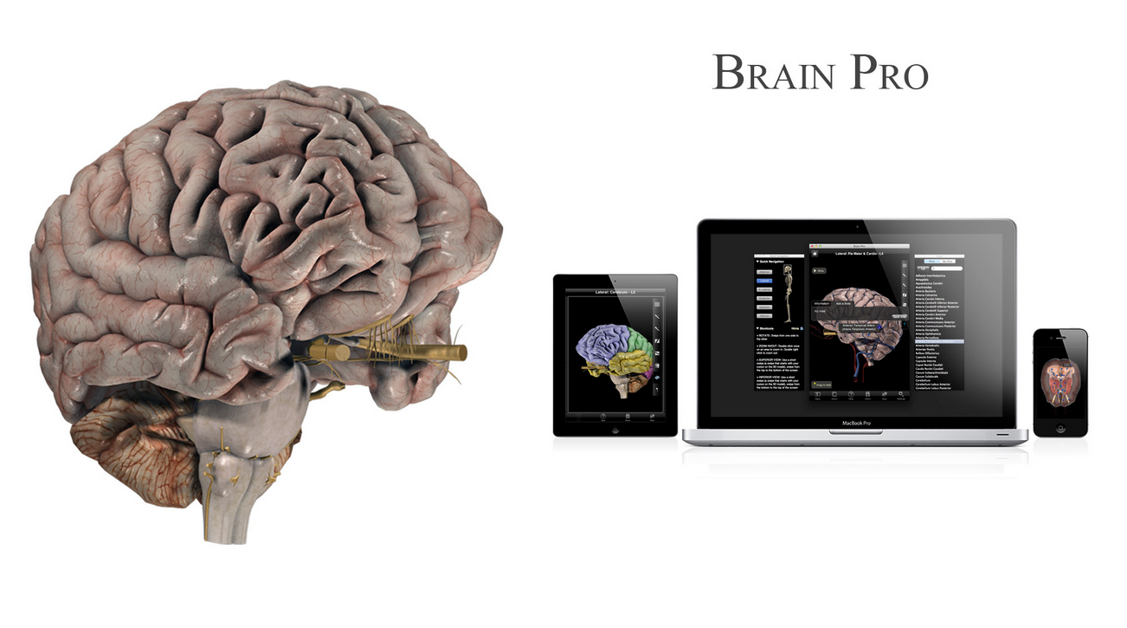

1. It is not free

## 3D Brain

3D Brain [3] is an interactive 3D app designed for mobile devices. It is freely available and contains 29 individual maps showing different structures of the human brain. It focuses on the anatomy and physiology of the human brain. There are some issues with this app:

1. It is developed for older versions of android
2. It does not describe the morphology and taxonomy of human brain
3. It needs to have access on internal media files

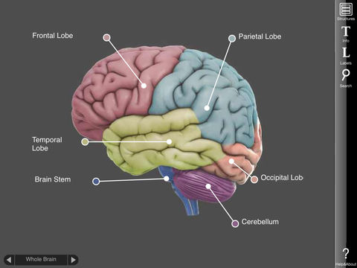

## Bio Digital Human – 3D Anatomy

Bio Digital Human – 3D Anatomy [4] is a premium app available at android play store and focuses on anatomy of human body. Some of its main features are:

1. Interactive 3D visualization
2. Scalable Content Creation and Management
3. Highly customizable visualizations
4. Easy to integrate into any Digital platform

However, it also has many issues:

1. It is general anatomy tutorial, not specific to human brain.
2. It does not focus to taxonomy, morphology, and physiology.
3. It is not freely available.

## Brain Tutor 3D

Brain Tutor [5] is a 3D mobile application available in the android play store. It visualizes the anatomy and physiology of the human brain. It uses the brain models developed by MRI scans. However, there are some issues existing in this app:

1. It is developed for older versions of Android.
2. It is freemium.
3. It does not have a visualization for morphology and taxonomy.
4. Its information is not so user-friendly.

# Project Rationale

Our project's primary goal is to develop a 3D mobile application. This project is important because we will be using the most recent tools and technologies, which will keep us aware of the IT industries. The users will also profit because they will be able to learn in new and innovative ways as most students in our area still apply outdated textbooks for their education. We have also discussed the existing problems in studying the human brain. Further we have reviewed some major apps which does not fully provide the solution to our problem. Therefore, it is really important to work on this and provide a better solution that answers these issues and provide a solution to the problem.

# Scope of the Project

There are many things that can be added in the project. First, it may include the basic introduction of human brain and their different functions. Second, it may include some portion of psychological perspectives of human brain and their theories. Third, it may include the working of neurons and their visualization. Fourth, it may also include the study of the human brain from the taxonomy, anatomy, physiology, and morphology perspectives. However, we just focus on the first and fourth parts: The basic introduction, its functions, and studying from four perspectives. We will not be touching the other two.

# Methodology

The agile methodology would be used for both design and development. We would specifically adhere to the agile practices of Extreme Programming (XP). It offers various advantages, including faster project development timelines, cost and schedule control, flexibility, and high-quality projects. Additionally, we'll be using Unity 3D to create 3D designs and mobile application. The language that we will be using is C#.

## Development Methodology

Our project's development methodology would be agile, as shown in Figure. Agile is a software development technique based on iterative development. The agile approach focuses on continual planning, requirement collecting, learning, improvement, evolutionary development, and fast delivery of the project. It encourages changes that can be welcomed again and again.

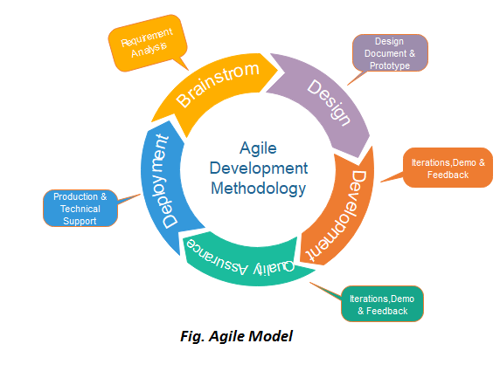

**The following are four values of agile methodology:**

1. Requirements gathering
2. Design the requirements
3. Construction/ iteration
4. Testing/ Quality assurance
5. Deployment
6. Feedback

**Procedure:**

1. **Requirements gathering:**

In this phase, we will define the requirements and explain what exactly features should be in our application, and plan the time and effort needed to build the project. Based on this information.

1. **Design the requirements:**

When you have identified the project, work with stakeholders to define requirements. We can use the user flow diagram or the high-level UML diagram to show the work of new features and show how it will apply to your existing system.

1. **Construction/ iteration:**

When the team defines the requirements, the work begins. We will start working on the Design and development of our project, which aims to deploy a working product. The product will undergo various stages of improvement, so it includes simple, minimal functionality.

1. **Testing:**

In this phase, we will do system testing and examine the Quality Assurance of the application’s performance and look for the bug.

1. **Deployment:**

In this phase, the team issues a product for the user's work environment.

1. **Feedback:**

After releasing the product, the last step is feedback. In this, we will receive feedback about the product and works through the feedback.

This is all about the mythology we are going to use to complete our project.

# Expected Results

Students will understand the concepts of the brain efficiently with the use of this application. They can also master the taxonomy, morphology, physiology, and anatomy of the brain through improved memory design with recognition and recall. Additionally, users can realistically move and rotate the virtual 3D human brain in the app while viewing from different angles and magnifications. Due to the fact that recognition is significantly quicker than recall in memory, it gives users a superior memory design.

# Work Division

The future tasks of requirement gathering, requirement analysis, design, development, implementation, and testing are illustrated in the following table:

|  |  |  |  |
| --- | --- | --- | --- |
| Works to do | Muhammad Hasnain | Sajjad Ali | Mujeeb Ahmed |
| Requirement Gathering Phase | | | |
| Design Survey |  |  |  |
| Design Interview |  |  |  |
| Analysis of Requirement |  |  |  |
| Devise Problem Identified |  |  |  |
| Development Phase | | | |
| Functional Requirements |  |  |  |
| Non Functional Requirements |  |  |  |
| UML Diagram |  |  |  |
| Flow Chart |  |  |  |
| Design and Implementation Phase | | | |
| Design 3D Models of Human Brain |  |  |  |
| Design of Application |  |  |  |

# Proposed Project Timeline

The timeline of our project is shown in the following Gantt chart

## Gantt chart

|  |  |  |  |  |  |  |  |  |  |
| --- | --- | --- | --- | --- | --- | --- | --- | --- | --- |
| **Activity** | **2022** | | **2023** | | | | | | |
| **Nov** | **Dec** | **Jan** | **Feb** | **March** | **April** | **May** | **June** | **July** |
| **Proposal** |  |  |  |  |  |  |  |  |  |
| **System Requirement** |  |  |  |  |  |  |  |  |  |
| **System Design** |  |  |  |  |  |  |  |  |  |
| **System Development** |  |  |  |  |  |  |  |  |  |
| **System  Integration** |  |  |  |  |  |  |  |  |  |
| **System  Testing** |  |  |  |  |  |  |  |  |  |
| **System  Deployment** |  |  |  |  |  |  |  |  |  |

# References

1. [3D Human Brain, AXON](https://apkcombo.com/3d-human-brain/axon.apps.humanbrain3d/)
2. [BRAIN PRO](https://3d4medical.com/apps/brain-pro)
3. [3D Brain, Educational App Store](https://www.educationalappstore.com/app/3d-brain)
4. [Bio Digital Human – 3D Anatomy](https://www.biodigital.com/)
5. [Brain Tutor 3D](https://www.brainvoyager.com/Mobile/BrainTutor3D_iOS.html)
6. [Development Methodology](https://www.javatpoint.com/software-engineering-agile-model)