

### CSC-325: Web Engineering

### Semester VI (CS, SE) Section (A, B) (Spring 2022)

### Course Instructor(s): Riaz Ali Soomro

### Sajjad Ali

### 023-19-0100

### BSCS VI B

### Sukkur IBA University

<!DOCTYPE html>

<html lang="en">

<head>

<meta charset="UTF-8">

<title>Title</title>

<link href="https://cdn.jsdelivr.net/npm/bootstrap@5.1.3/dist/css/bootstrap.min.css" rel="stylesheet" integrity="sha384-1BmE4kWBq78iYhFldvKuhfTAU6auU8tT94WrHftjDbrCEXSU1oBoqyl2QvZ6jIW3" crossorigin="anonymous">

<link rel="stylesheet" href="style01.css">

</head>

<body>

<div class="container">

<div class="row">

<div class="col-4 first">

<nav>

<ul>

<li><a href="#">Home</a></li>

<li><a href="#">Profile</a></li>

<li><a href="#">Messages</a></li>

</ul>

</nav>

</div>

<div class="col-8 second">

<h1>Hello World!</h1>

<p>Lorem ipsum dolor sit amet, consectetur adipisicing elit. Accusamus architecto blanditiis dolore ex harum nisi perferendis quaerat quisquam sunt? Consequuntur?</p>

</div>

</div>

</div>

<script src="https://cdn.jsdelivr.net/npm/bootstrap@5.1.3/dist/js/bootstrap.bundle.min.js" integrity="sha384-ka7Sk0Gln4gmtz2MlQnikT1wXgYsOg+OMhuP+IlRH9sENBO0LRn5q+8nbTov4+1p" crossorigin="anonymous"></script>

</body>

</html>

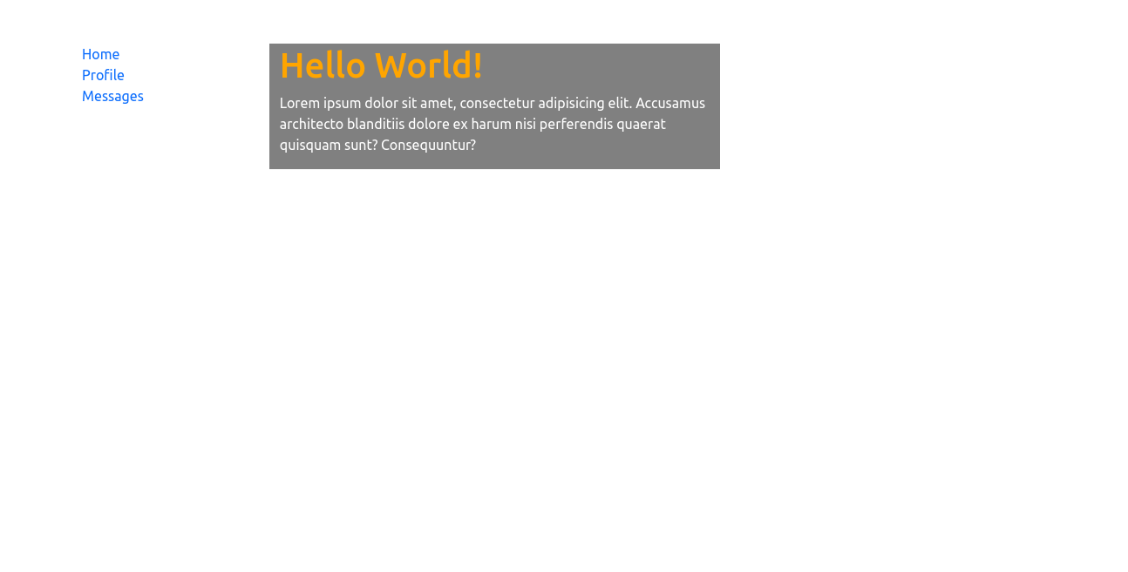

2.

<!DOCTYPE html>

<html lang="en">

<head>

<meta charset="UTF-8">

<title>Title</title>

<link rel="stylesheet" href="style02.css">

<link rel="stylesheet" href="https://cdn.jsdelivr.net/npm/bootstrap@4.1.3/dist/css/bootstrap.min.css" integrity="sha384-MCw98/SFnGE8fJT3GXwEOngsV7Zt27NXFoaoApmYm81iuXoPkFOJwJ8ERdknLPMO" crossorigin="anonymous">

<style>

.callout{

border-left: 2px solid blue;

padding-left: 7px;

}

</style>

</head>

<body>

<div class="container">

<div class="row">

<div class="col-3 " >

<div style="background: grey">

<h3>Favourite <br> Languages</h3>

<ul>

<li>ECMAScript</li>

<li>Python</li>

<li>TypeScript</li>

</ul>

</div>

</div>

<div class="col-9">

<h1>Hello Bootstrap!</h1>

<div>

<div class="callout">

Lorem ipsum dolor sit amet, consectetur adipisicing elit. Ad at hic impedit itaque magnam nulla officiis placeat, provident quas, quod saepe sed totam voluptate. Et libero nihil quia tempora voluptas.

</div>

</div>

<br>

<p>Lorem ipsum dolor sit amet, consectetur adipisicing elit. Ab adipisci asperiores atque commodi consectetur dolorum ea et excepturi fuga harum iste iure magnam nesciunt porro, quaerat quam quas repellat rerum sint vel vero vitae voluptates! Ab accusantium consequatur deserunt distinctio eum ex expedita facilis incidunt iste, itaque laboriosam libero nisi non officiis pariatur praesentium provident quae reiciendis reprehenderit sed similique suscipit totam veritatis. Amet beatae consectetur culpa cumque delectus dolor doloribus ea earum eligendi, enim est exercitationem fuga impedit inventore, ipsum magnam magni nihil odit provident quae quisquam reiciendis repellat soluta tempora tempore totam vero voluptates! Fuga iste magnam nemo.</p>

</div>

</div>

</div>

<script src="https://code.jquery.com/jquery-3.3.1.slim.min.js" integrity="sha384-q8i/X+965DzO0rT7abK41JStQIAqVgRVzpbzo5smXKp4YfRvH+8abtTE1Pi6jizo" crossorigin="anonymous"></script>

<script src="https://cdn.jsdelivr.net/npm/popper.js@1.14.3/dist/umd/popper.min.js" integrity="sha384-ZMP7rVo3mIykV+2+9J3UJ46jBk0WLaUAdn689aCwoqbBJiSnjAK/l8WvCWPIPm49" crossorigin="anonymous"></script>

<script src="https://cdn.jsdelivr.net/npm/bootstrap@4.1.3/dist/js/bootstrap.min.js" integrity="sha384-ChfqqxuZUCnJSK3+MXmPNIyE6ZbWh2IMqE241rYiqJxyMiZ6OW/JmZQ5stwEULTy" crossorigin="anonymous"></script>

<script src="https://cdn.jsdelivr.net/npm/bootstrap@5.1.3/dist/js/bootstrap.bundle.min.js" integrity="sha384-ka7Sk0Gln4gmtz2MlQnikT1wXgYsOg+OMhuP+IlRH9sENBO0LRn5q+8nbTov4+1p" crossorigin="anonymous"></script>

</body>

</html>

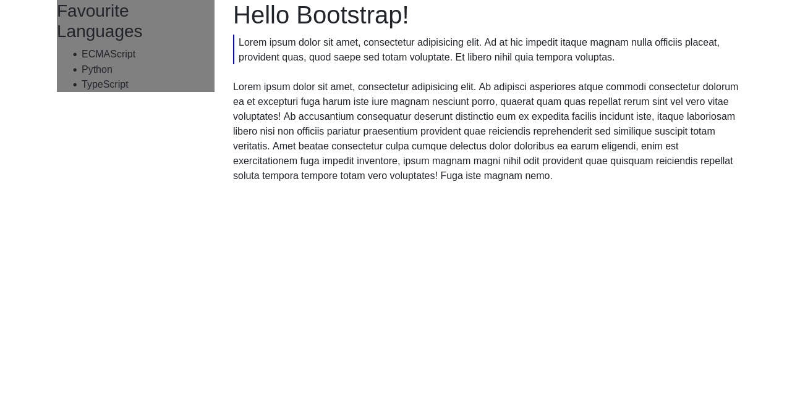

3.

<!DOCTYPE html>

<html lang="en">

<head>

<meta charset="UTF-8">

<title>Title</title>

<link href="https://cdn.jsdelivr.net/npm/bootstrap@5.1.3/dist/css/bootstrap.min.css" rel="stylesheet" integrity="sha384-1BmE4kWBq78iYhFldvKuhfTAU6auU8tT94WrHftjDbrCEXSU1oBoqyl2QvZ6jIW3" crossorigin="anonymous">

<link rel="stylesheet" href="style03.css">

</head>

<body>

<div class="container mt-5" >

<div class="row">

<div class="col">

<h3>Is hard to remember all the Bootstrap elements</h3>

<p>The rest seems easy because it was very well thought? Don't you agree?</p>

<button class="btn btn-success">Yes</button>

<button class="btn btn-danger">No</button>

</div>

<div class="col">

<svg xmlns="http://www.w3.org/2000/svg" style="display: none;">

<symbol id="info-fill" fill="currentColor" viewBox="0 0 16 16">

<path d="M8 16A8 8 0 1 0 8 0a8 8 0 0 0 0 16zm.93-9.412-1 4.705c-.07.34.029.533.304.533.194 0 .487-.07.686-.246l-.088.416c-.287.346-.92.598-1.465.598-.703 0-1.002-.422-.808-1.319l.738-3.468c.064-.293.006-.399-.287-.47l-.451-.081.082-.381 2.29-.287zM8 5.5a1 1 0 1 1 0-2 1 1 0 0 1 0 2z"/>

</symbol>

</svg>

<div class="alert alert-warning d-flex align-items-center" role="alert">

<svg class="bi flex-shrink-0 me-2" width="24" height="24" role="img" aria-label="Info:"><use xlink:href="#info-fill"/></svg>

<div>

An example alert with an icon

</div>

</div>

<table class="table table-striped">

<tr>

<th>Firstname</th>

<th>Lastname</th>

<th>Email</th>

</tr>

<tr>

<td>John</td>

<td>Doe</td>

<td>john@example.com</td>

</tr>

<tr>

<td>Mary</td>

<td>Moe</td>

<td>mary@example.com</td>

</tr>

<tr>

<td>July</td>

<td>Dooley</td>

<td>july@example.com</td>

</tr>

</table>

</div>

</div>

</div>

<script src="https://cdn.jsdelivr.net/npm/bootstrap@5.1.3/dist/js/bootstrap.bundle.min.js" integrity="sha384-ka7Sk0Gln4gmtz2MlQnikT1wXgYsOg+OMhuP+IlRH9sENBO0LRn5q+8nbTov4+1p" crossorigin="anonymous"></script>

</body>

</html>

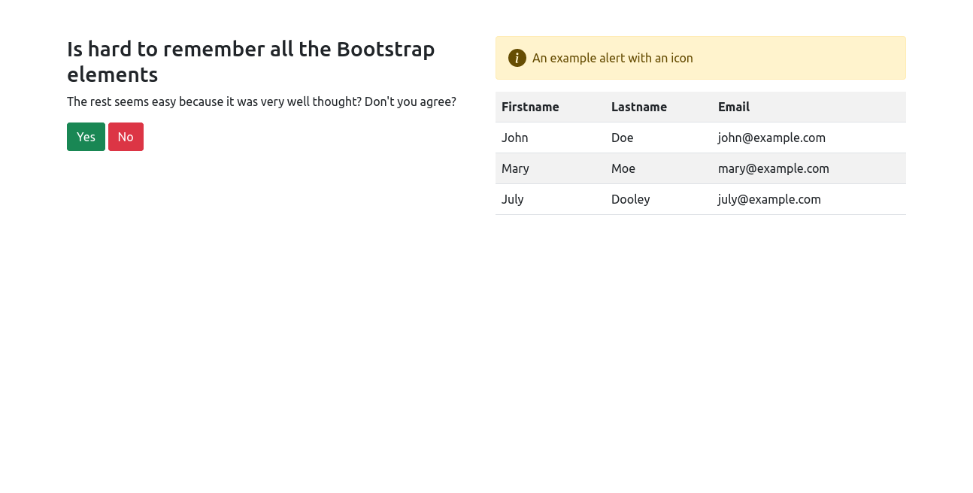

4.

<!DOCTYPE html>

<html lang="en">

<head>

<meta charset="UTF-8">

<title>Title</title>

<link href="https://cdn.jsdelivr.net/npm/bootstrap@5.1.3/dist/css/bootstrap.min.css" rel="stylesheet" integrity="sha384-1BmE4kWBq78iYhFldvKuhfTAU6auU8tT94WrHftjDbrCEXSU1oBoqyl2QvZ6jIW3" crossorigin="anonymous">

<link rel="stylesheet" href="style04.css">

</head>

<body>

<div class="container p-4" style="width: 40%; background: grey;">

<h2>Please Login</h2>

<form>

<!-- Email input -->

<div class="form-outline mb-4">

<input type="email" id="form2Example1" class="form-control" placeholder="Email Address"/>

</div>

<!-- Password input -->

<div class="form-outline mb-4">

<input type="password" id="form2Example2" class="form-control" placeholder="Password"/>

</div>

<!-- 2 column grid layout for inline styling -->

<div class="row mb-4">

<div class="col ">

<!-- Checkbox -->

<div class="form-check">

<input class="form-check-input" type="checkbox" value="" id="form2Example31" checked />

<label class="form-check-label" for="form2Example31"> Remember me </label>

</div>

</div>

</div>

<!-- Submit button -->

<div class="row-cols-1">

<button class="btn btn-primary btn-block">Login</button>

</div>

</form>

</div>

<script src="https://cdn.jsdelivr.net/npm/bootstrap@5.1.3/dist/js/bootstrap.bundle.min.js" integrity="sha384-ka7Sk0Gln4gmtz2MlQnikT1wXgYsOg+OMhuP+IlRH9sENBO0LRn5q+8nbTov4+1p" crossorigin="anonymous"></script>

</body>

</html>

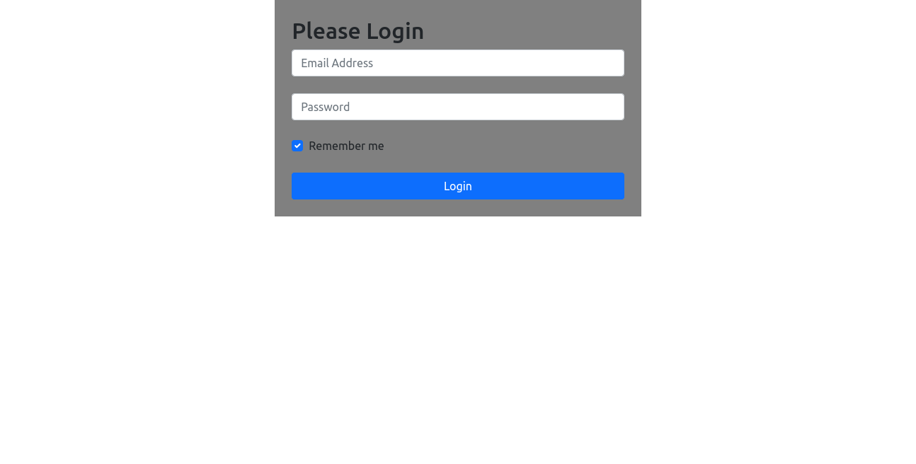

5.

<!DOCTYPE html>

<html lang="en">

<head>

<meta charset="UTF-8">

<title>Title</title>

<link href="https://cdn.jsdelivr.net/npm/bootstrap@5.1.3/dist/css/bootstrap.min.css" rel="stylesheet" integrity="sha384-1BmE4kWBq78iYhFldvKuhfTAU6auU8tT94WrHftjDbrCEXSU1oBoqyl2QvZ6jIW3" crossorigin="anonymous">

<link rel="stylesheet" href="style05.css">

</head>

<style>

.callout{

border-left: 2px solid;

padding-left: 7px;

}

ul{

text-align: start;

}

nav ul li{

/*border: 2px solid;*/

margin-left: -32px;

text-align: start;

list-style: none;

}

ul li a{

text-decoration: none;

padding: 5px 0;

}

ul li a:hover{

background: blue;

color: #fff;

padding: 5px;

border-radius: 3px;

}

</style>

<body>

<div class="container">

<div class="row">

<div class="col-4">

<h4>Some Favorites</h4>

<nav>

<ul style="">

<li><a href="#">Celery Root</a></li>

<li><a href="#">Spaghetti Squash</a></li>

<li><a href="#">Killer Mushrooms</a></li>

</ul>

</nav>

<input type="text" name="" id="">

<br>

<button class="btn btn-sm btn-primary mt-2">Search Recipes</button>

</div>

<div class="col-8">

<div class="alert alert-danger" role="alert">

Uh ho! Have you had your daily dose of veggies today??

</div>

<!-- HEADING-->

<h2>Wild and Wacky Vegetables</h2>

<div class="row d-flex " >

<div>

<div class="callout">Lorem ipsum dolor sit amet, consectetur adipisicing elit. Ab atque aut cupiditate debitis delectus, illum libero nihil numquam odit, quibusdam tenetur, ut voluptate. Dolores harum natus, nesciunt porro quaerat sequi.</div>

</div>

</div>

<h4 class="mt-3">Some Diseases</h4>

<!-- TABLE -->

<table class="table table-hover table-bordered">

<tr>

<th>Veggie</th>

<th>Disease</th>

</tr>

<tr class="table-active">

<td>Beets</td>

<td>Beeturia</td>

</tr>

<tr>

<td>Carrots</td>

<td>Carotenosis</td>

</tr>

</table>

<!-- IMAGE CARD GROUP-->

<div class="card-group">

<div class="card">

<img src="https://hips.hearstapps.com/hmg-prod.s3.amazonaws.com/images/beets-beet-juice-1522792239.jpg?crop=1.00xw:0.845xh;0,0.109xh&resize=980:*" class="card-img-top" alt="...">

<div class="card-body">

<h5 class="card-title">Beets</h5>

<p class="card-text">Careful not to get your hands dirty.</p>

</div>

</div>

<div class="card">

<img src="https://www.eatthis.com/wp-content/uploads/sites/4/2021/07/bunch-carrots.jpg?quality=82&strip=1&w=800" class="card-img-top" alt="...">

<div class="card-body">

<h5 class="card-title">Carrots</h5>

<p class="card-text">Not Sticks, can motivate.</p>

</div>

</div>

<div class="card">

<img src="https://media-cldnry.s-nbcnews.com/image/upload/t_fit-1240w,f_auto,q_auto:best/newscms/2020_06/3219151/how-to-make-roasted-asparagus-355-1200x800.jpg" class="card-img-top" alt="...">

<div class="card-body">

<h5 class="card-title">Asparagus</h5>

<p class="card-text">Spears, spears, spears</p>

</div>

</div>

</div>

<br>

<h3>Really informative info</h3>

<p>Lorem ipsum dolor sit amet, consectetur adipisicing elit. Adipisci alias consectetur deserunt quos repudiandae! Corporis itaque quo sapiente veritatis voluptates?</p>

<p>Lorem ipsum dolor sit amet, consectetur adipisicing elit. Consectetur deleniti earum impedit perspiciatis porro, provident quaerat quam quia sunt totam, veritatis voluptates? Dicta dignissimos eaque est eum exercitationem expedita explicabo, ipsa ipsum laboriosam nulla odit possimus qui sapiente similique ullam? Eveniet hic incidunt iure labore molestias nam quisquam ratione voluptas.</p>

</div>

</div>

</div>

<script src="https://cdn.jsdelivr.net/npm/bootstrap@5.1.3/dist/js/bootstrap.bundle.min.js" integrity="sha384-ka7Sk0Gln4gmtz2MlQnikT1wXgYsOg+OMhuP+IlRH9sENBO0LRn5q+8nbTov4+1p" crossorigin="anonymous"></script>

</body>

</html>

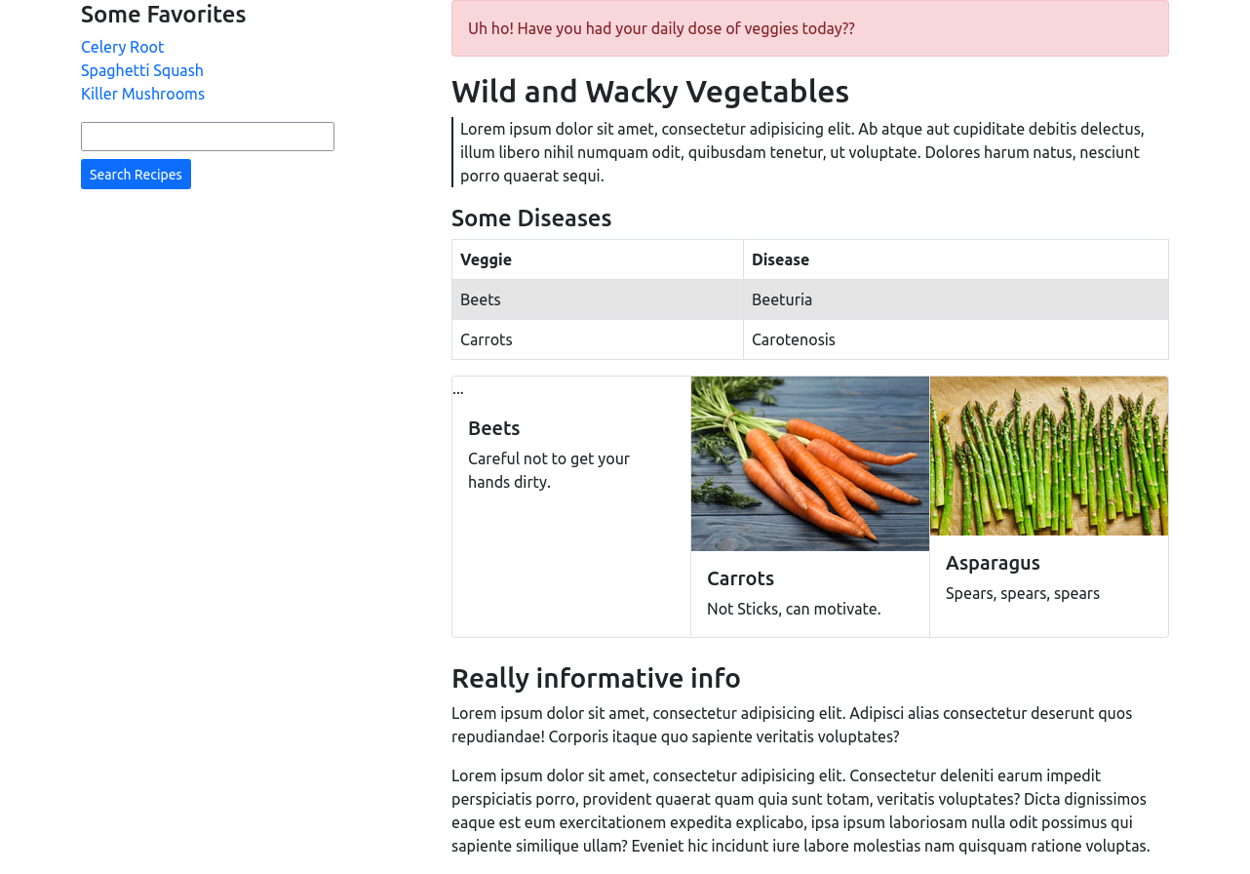

6.

<!DOCTYPE html>

<html lang="en">

<head>

<meta charset="UTF-8">

<title>Title</title>

<link href="https://cdn.jsdelivr.net/npm/bootstrap@5.1.3/dist/css/bootstrap.min.css" rel="stylesheet" integrity="sha384-1BmE4kWBq78iYhFldvKuhfTAU6auU8tT94WrHftjDbrCEXSU1oBoqyl2QvZ6jIW3" crossorigin="anonymous">

<link rel="stylesheet" href="style06.css">

</head>

<body>

<div class="container-fluid">

<div class="row">

<div class="col h-100">

<div class="card" style="border-radius: 15px;">

<div class="card-body p-5">

<h2 class="text-uppercase text-center mb-5">Create an account</h2>

<form>

<div class="form-outline mb-4">

<input type="text" id="form3Example1cg" class="form-control form-control-lg" placeholder="Full name"/>

</div>

<div class="form-outline mb-4">

<input type="email" id="form3Example3cg" class="form-control form-control-lg" placeholder="Email Address"/>

</div>

<div class="form-outline mb-4">

<input type="password" id="form3Example4cg" class="form-control form-control-lg" placeholder="Password"/>

</div>

<div class="form-outline mb-4">

<input type="password" id="form3Example4cdg" class="form-control form-control-lg" placeholder="Company Name"/>

</div>

<div class="form-check d-flex justify-content-center mb-5">

<input

class="form-check-input me-2"

type="checkbox"

value=""

id="form2Example3cg"

/>

<label class="form-check-label" for="">

I agree all statements in <a href="#!" class="text-body"><u>Terms of service</u></a>

</label>

</div>

<div class="d-flex justify-content-center row-cols-1">

<button type="button" class="btn btn-primary btn-block btn-block text-white">CREATE ACCOUNT</button>

</div>

<p class="text-center text-muted mt-5 mb-0">Have already an account? <a href="#!" class="fw-bold text-body"><u>Login here</u></a></p>

</form>

</div>

</div>

</div>

<div class="col">

<section class="vh-100 bg-image" style="background-image: url('https://images.unsplash.com/photo-1617472592135-72a181d04b27?crop=entropy&cs=tinysrgb&fit=crop&fm=jpg&h=800&ixid=MnwxfDB8MXxyYW5kb218MHx8bGFwdG9wLGNvZGV8fHx8fHwxNjQ5ODU1NzEy&ixlib=rb-1.2.1&q=80&utm_campaign=api-credit&utm_medium=referral&utm_source=unsplash_source&w=800');">

</section>

</div>

</div>

</div>

<script src="https://cdn.jsdelivr.net/npm/bootstrap@5.1.3/dist/js/bootstrap.bundle.min.js" integrity="sha384-ka7Sk0Gln4gmtz2MlQnikT1wXgYsOg+OMhuP+IlRH9sENBO0LRn5q+8nbTov4+1p" crossorigin="anonymous"></script>

</body>

</html>

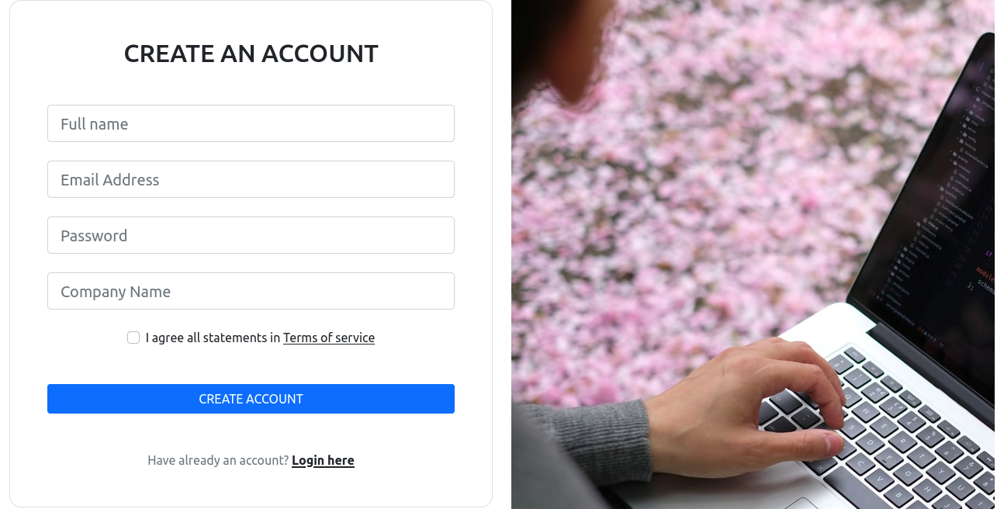

7.

<!DOCTYPE html>

<html lang="en">

<head>

<meta charset="UTF-8">

<title>Title</title>

<link href="https://cdn.jsdelivr.net/npm/bootstrap@5.1.3/dist/css/bootstrap.min.css" rel="stylesheet" integrity="sha384-1BmE4kWBq78iYhFldvKuhfTAU6auU8tT94WrHftjDbrCEXSU1oBoqyl2QvZ6jIW3" crossorigin="anonymous">

<link rel="stylesheet" href="style07.css">

</head>

<body>

<nav class="navbar navbar-expand-lg navbar-dark bg-dark">

<div class="container-fluid">

<a class="navbar-brand" href="#"></a>

<button class="navbar-toggler" type="button" data-bs-toggle="collapse" data-bs-target="#navbarSupportedContent" aria-controls="navbarSupportedContent" aria-expanded="false" aria-label="Toggle navigation">

<span class="navbar-toggler-icon"></span>

</button>

<div class="collapse navbar-collapse" id="navbarSupportedContent">

<ul class="navbar-nav me-auto mb-2 mb-lg-0">

<li class="nav-item">

<a class="nav-link active" aria-current="page" href="#">Home</a>

</li>

<li class="nav-item">

<a class="nav-link" href="#">Menu</a>

</li>

<li class="nav-item">

<a class="nav-link" href="#">Testimonials</a>

</li>

<li class="nav-item dropdown">

<a class="nav-link dropdown-toggle" href="#" id="navbarDropdown" role="button" data-bs-toggle="dropdown" aria-expanded="false">

About Us

</a>

<ul class="dropdown-menu" aria-labelledby="navbarDropdown">

<li><a class="dropdown-item" href="#">Action</a></li>

<li><a class="dropdown-item" href="#">Another action</a></li>

<li><hr class="dropdown-divider"></li>

<li><a class="dropdown-item" href="#">Something else here</a></li>

</ul>

</li>

</ul>

<form class="d-flex">

<input class="form-control me-2" type="search" placeholder="Search" aria-label="Search">

<button class="btn btn-light" type="submit">Search</button>

</form>

</div>

</div>

</nav>

<div class="container p-5" style="background: #8a0505">

<div class="row">

<div class="col">

<img src="https://i.insider.com/5ac2989210d6bb1b008b45eb?width=700&format=jpeg&auto=webp" class="card-img-top" alt="...">

</div>

<div class="col text-white">

<h3>Eat My Puhleeze</h3>

<p>Lorem ipsum dolor sit amet, consectetur adipisicing elit. Dolorem fugit iure molestiae rerum sed temporibus voluptatem! A asperiores consequuntur corporis culpa est quae quisquam quos repudiandae vel voluptatum! Accusamus, rerum?</p>

<div class="row-cols-1">

<button class="btn btn-warning btn-block">Order Now</button>

</div>

</div>

</div>

</div>

<div class="container p-4" style="background: #b0780e">

Lorem ipsum dolor sit amet, consectetur adipisicing elit. Ab at cupiditate distinctio dolores doloribus eligendi excepturi, facilis hic illo inventore ipsum magni minima modi natus necessitatibus nihil nulla possimus provident quae quaerat qui, quis ratione saepe soluta vel! Assumenda commodi cumque doloremque eaque ex fugit non provident quasi tenetur veritatis!

</div>

<div class="container ">

<div class="row">

<div class="col">

<img src="https://www.eatthis.com/wp-content/uploads/sites/4/2021/06/mcdonalds-2.jpg?quality=82&strip=1" class="card-img-top" alt="...">

</div>

<div class="col">Lorem ipsum dolor sit amet, consectetur adipisicing elit. Aliquam architecto aspernatur consequatur dolorem dolores earum enim eos ex facere, hic illo illum in itaque iusto labore laboriosam laborum magni molestiae, molestias nam natus provident ratione sapiente soluta suscipit vero voluptatibus!</div>

<div class="col">

<img src="https://www.eatthis.com/wp-content/uploads/sites/4/2021/06/mcdonalds-2.jpg?quality=82&strip=1" class="card-img-top" alt="...">

</div>

<div class="col">Lorem ipsum dolor sit amet, consectetur adipisicing elit. Ad aspernatur debitis ducimus enim eveniet id iste labore maiores natus neque non omnis possimus quibusdam quidem, quod, recusandae rerum similique sint soluta tenetur veniam voluptate voluptates! Doloribus nihil nostrum pariatur sint!</div>

</div>

</div>

<div class="container-fluid p-5" style="background: #b0780e">

<div class="row">

<div class="col-6">

<h5>About McDonalds</h5>

<p>Lorem ipsum dolor sit amet, consectetur adipisicing elit. Eligendi in iste, non porro sed tempora unde vero voluptatibus? A accusamus alias blanditiis commodi dolorem dolorum ea ex explicabo facere, fuga fugiat illo impedit ipsam itaque iusto laborum magnam modi molestias quasi similique sint sunt tenetur? Cupiditate deserunt doloremque quam reiciendis.</p>

</div>

<div class="col">

<h5>Meal Includes</h5>

<ul>

<li>burger</li>

<li>fries</li>

<li>hash browns</li>

<li>sausages</li>

<li>egg</li>

<li>hotcakes</li>

<li>syrup</li>

</ul>

</div>

<div class="col">

<h5>Contact Us</h5>

<ul>

<li>714-537-5350</li>

<li>11931 Euclid St.</li>

<li>Garder Grove, CA 92640</li>

<li>714-537-5250</li>

</ul>

</div>

</div>

</div>

<script src="https://cdn.jsdelivr.net/npm/bootstrap@5.1.3/dist/js/bootstrap.bundle.min.js" integrity="sha384-ka7Sk0Gln4gmtz2MlQnikT1wXgYsOg+OMhuP+IlRH9sENBO0LRn5q+8nbTov4+1p" crossorigin="anonymous"></script>

</body>

</html>

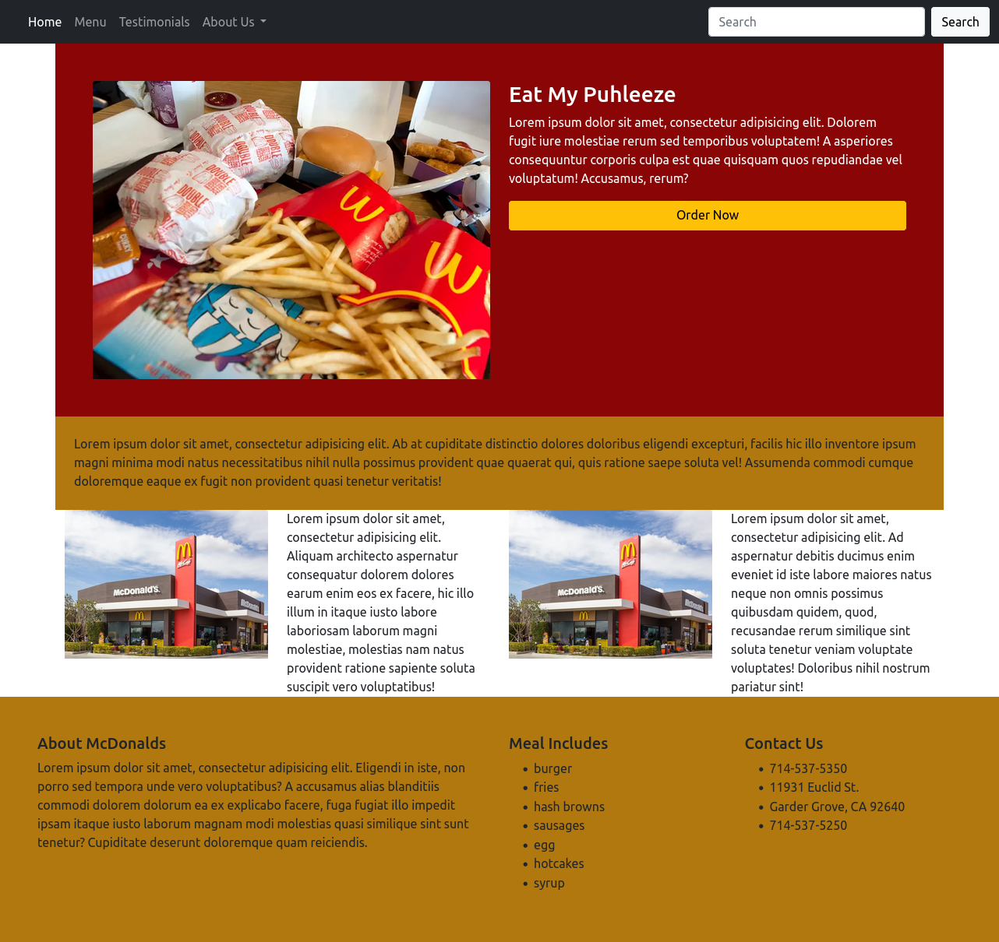

8.

//index.html

<!DOCTYPE html>

<html lang="en">

<head>

<meta charset="UTF-8">

<title>Title</title>

<link href="https://cdn.jsdelivr.net/npm/bootstrap@5.1.3/dist/css/bootstrap.min.css" rel="stylesheet" integrity="sha384-1BmE4kWBq78iYhFldvKuhfTAU6auU8tT94WrHftjDbrCEXSU1oBoqyl2QvZ6jIW3" crossorigin="anonymous">

</head>

<body>

<!--NAVBAR-->

<nav class="navbar navbar-expand-lg navbar-dark bg-dark">

<div class="container-fluid">

<a class="navbar-brand" href="#">Enterprise App</a>

<button class="navbar-toggler" type="button" data-bs-toggle="collapse" data-bs-target="#navbarSupportedContent" aria-controls="navbarSupportedContent" aria-expanded="false" aria-label="Toggle navigation">

<span class="navbar-toggler-icon"></span>

</button>

<div class="collapse navbar-collapse" id="navbarSupportedContent">

<ul class="navbar-nav me-auto mb-2 mb-lg-0">

<li class="nav-item">

<a class="nav-link active" aria-current="page" href="/">Home</a>

</li>

<li class="nav-item">

<a class="nav-link" href="about.html">About</a>

</li>

<li class="nav-item dropdown">

<a class="nav-link dropdown-toggle" href="#" id="navbarDropdown" role="button" data-bs-toggle="dropdown" aria-expanded="false">

Categories

</a>

<ul class="dropdown-menu" aria-labelledby="navbarDropdown">

<li><a class="dropdown-item" href="#">Action</a></li>

<li><a class="dropdown-item" href="#">Another action</a></li>

<li><hr class="dropdown-divider"></li>

<li><a class="dropdown-item" href="#">Something else here</a></li>

</ul>

</li>

<li class="nav-item">

<a class="nav-link" href="#"></a>

</li>

</ul>

<form class="d-flex">

<input class="form-control me-2" type="search" placeholder="Search" aria-label="Search">

<button class="btn btn-outline-success" type="submit">Search</button>

</form>

</div>

</div>

</nav>

<!--CARASOUL-->

<div id="carouselExampleIndicators" class="carousel slide" data-bs-ride="carousel">

<div class="carousel-indicators">

<button type="button" data-bs-target="#carouselExampleIndicators" data-bs-slide-to="0" class="active" aria-current="true" aria-label="Slide 1"></button>

<button type="button" data-bs-target="#carouselExampleIndicators" data-bs-slide-to="1" aria-label="Slide 2"></button>

<button type="button" data-bs-target="#carouselExampleIndicators" data-bs-slide-to="2" aria-label="Slide 3"></button>

</div>

<div class="carousel-inner">

<div class="carousel-item active">

<img src="https://source.unsplash.com/1400x400/?code,program,laptop" class="d-block w-100" alt="...">

</div>

<div class="carousel-item">

<img src="https://source.unsplash.com/1400x400/?program,laptop" class="d-block w-100" alt="...">

</div>

<div class="carousel-item">

<img src="https://source.unsplash.com/1400x400/?code,laptop" class="d-block w-100" alt="...">

</div>

</div>

<button class="carousel-control-prev" type="button" data-bs-target="#carouselExampleIndicators" data-bs-slide="prev">

<span class="carousel-control-prev-icon" aria-hidden="true"></span>

<span class="visually-hidden">Previous</span>

</button>

<button class="carousel-control-next" type="button" data-bs-target="#carouselExampleIndicators" data-bs-slide="next">

<span class="carousel-control-next-icon" aria-hidden="true"></span>

<span class="visually-hidden">Next</span>

</button>

</div>

<!--CONTENT-->

<div class="container text-center p-3">

<h2>Enterprise Application</h2>

<p>Some Bootstrap variants with different dividers.</p>

<p>Snippet by <a href="#">KD</a></p>

</div>

<!--BreadCrumb-->

<div class="container w-50 p-3 border shadow">

<nav aria-label="breadcrumb">

<ol class="breadcrumb">

<li class="breadcrumb-item"><a href="#">Home</a></li>

<li class="breadcrumb-item"><a href="#">Library</a></li>

<li class="breadcrumb-item active" aria-current="page">Data</li>

</ol>

</nav>

<h5>Default Bootstrap breadcrumb</h5>

<p>Lorem ipsum dolor sit amet, consectetur adipisicing elit. Accusamus, aspernatur ducimus excepturi labore libero nesciunt placeat quod tenetur. Accusamus aliquid atque blanditiis distinctio dolorem dolores est eveniet exercitationem itaque officia.</p>

</div>

<!--Image Card Group-->

<div class="container p-2 mt-5">

<div class="row">

<div class="col">

<div class="card" style="width: 18rem;">

<img src="https://source.unsplash.com/400x400/?code,program" class="card-img-top" alt="...">

<div class="card-body">

<h5 class="card-title">Card title</h5>

<p class="card-text">Some quick example text to build on the card title and make up the bulk of the card's content.</p>

<a href="#" class="btn btn-primary">Go somewhere</a>

</div>

</div>

</div>

<div class="col">

<div class="card" style="width: 18rem;">

<img src="https://source.unsplash.com/400x400/?code,laptop" class="card-img-top" alt="...">

<div class="card-body">

<h5 class="card-title">Card title</h5>

<p class="card-text">Some quick example text to build on the card title and make up the bulk of the card's content.</p>

<a href="#" class="btn btn-primary">Go somewhere</a>

</div>

</div>

</div>

<div class="col">

<div class="card" style="width: 18rem;">

<img src="https://source.unsplash.com/400x400/?code,program,laptop" class="card-img-top" alt="...">

<div class="card-body">

<h5 class="card-title">Card title</h5>

<p class="card-text">Some quick example text to build on the card title and make up the bulk of the card's content.</p>

<a href="#" class="btn btn-primary">Go somewhere</a>

</div>

</div>

</div>

<div class="col">

<div class="card" style="width: 18rem;">

<img src="https://source.unsplash.com/400x400/?program,laptop" class="card-img-top" alt="...">

<div class="card-body">

<h5 class="card-title">Card title</h5>

<p class="card-text">Some quick example text to build on the card title and make up the bulk of the card's content.</p>

<a href="#" class="btn btn-primary">Go somewhere</a>

</div>

</div>

</div>

</div>

</div>

<script src="https://cdn.jsdelivr.net/npm/bootstrap@5.1.3/dist/js/bootstrap.bundle.min.js" integrity="sha384-ka7Sk0Gln4gmtz2MlQnikT1wXgYsOg+OMhuP+IlRH9sENBO0LRn5q+8nbTov4+1p" crossorigin="anonymous"></script>

</body>

</html>

//about.html

<!DOCTYPE html>

<html lang="en">

<head>

<meta charset="UTF-8">

<title>Title</title>

<link href="https://cdn.jsdelivr.net/npm/bootstrap@5.1.3/dist/css/bootstrap.min.css" rel="stylesheet" integrity="sha384-1BmE4kWBq78iYhFldvKuhfTAU6auU8tT94WrHftjDbrCEXSU1oBoqyl2QvZ6jIW3" crossorigin="anonymous">

</head>

<body>

<!--NAVBAR-->

<nav class="navbar navbar-expand-lg navbar-dark bg-dark">

<div class="container-fluid">

<a class="navbar-brand" href="#">Enterprise App</a>

<button class="navbar-toggler" type="button" data-bs-toggle="collapse" data-bs-target="#navbarSupportedContent" aria-controls="navbarSupportedContent" aria-expanded="false" aria-label="Toggle navigation">

<span class="navbar-toggler-icon"></span>

</button>

<div class="collapse navbar-collapse" id="navbarSupportedContent">

<ul class="navbar-nav me-auto mb-2 mb-lg-0">

<li class="nav-item">

<a class="nav-link active" aria-current="page" href="index.html">Home</a>

</li>

<li class="nav-item">

<a class="nav-link" href="#">About</a>

</li>

<li class="nav-item dropdown">

<a class="nav-link dropdown-toggle" href="#" id="navbarDropdown" role="button" data-bs-toggle="dropdown" aria-expanded="false">

Categories

</a>

<ul class="dropdown-menu" aria-labelledby="navbarDropdown">

<li><a class="dropdown-item" href="#">Action</a></li>

<li><a class="dropdown-item" href="#">Another action</a></li>

<li><hr class="dropdown-divider"></li>

<li><a class="dropdown-item" href="#">Something else here</a></li>

</ul>

</li>

<li class="nav-item">

<a class="nav-link" href="#"></a>

</li>

</ul>

<form class="d-flex">

<input class="form-control me-2" type="search" placeholder="Search" aria-label="Search">

<button class="btn btn-outline-success" type="submit">Search</button>

</form>

</div>

</div>

</nav>

<div class="container">

<div class="row">

<div class="row g-0 border rounded overflow-hidden flex-md-row mb-4 shadow-sm h-md-250 position-relative">

<div class="col p-4 d-flex flex-column position-static">

<h5 class="mb-0">It all started with KD's Idea</h5>

<p class="card-text mb-auto">Lorem ipsum dolor sit amet, consectetur adipisicing elit. A alias aliquid aperiam asperiores commodi deleniti dolor doloremque eaque, eligendi enim eveniet fuga illum inventore ipsa magni minima nemo nisi nobis numquam odio officia officiis quae quasi quo reiciendis rem reprehenderit repudiandae saepe similique suscipit totam voluptate voluptatibus voluptatum! Delectus, est.</p>

</div>

<div class="col-auto d-none d-lg-block">

<img src="https://source.unsplash.com/200x200/?code,program,laptop" class="card-img-top" alt="...">

</div>

</div>

<div class="row g-0 border rounded overflow-hidden flex-md-row mb-4 shadow-sm h-md-250 position-relative">

<div class="col-auto d-none d-lg-block">

<img src="https://source.unsplash.com/200x200/?code,program" class="card-img-top" alt="...">

</div>

<div class="col p-4 d-flex flex-column position-static">

<h5 class="mb-0">We Started KD in 1877 </h5>

<p class="card-text mb-auto">Lorem ipsum dolor sit amet, consectetur adipisicing elit. A alias aliquid aperiam asperiores commodi deleniti dolor doloremque eaque, eligendi enim eveniet fuga illum inventore ipsa magni minima nemo nisi nobis numquam odio officia officiis quae quasi quo reiciendis rem reprehenderit repudiandae saepe similique suscipit totam voluptate voluptatibus voluptatum! Delectus, est.</p>

</div>

</div>

<div class="row g-0 border rounded overflow-hidden flex-md-row mb-4 shadow-sm h-md-250 position-relative">

<div class="col p-4 d-flex flex-column position-static">

<h5 class="mb-0">First Featurette heading.</h5>

<p class="card-text mb-auto">Lorem ipsum dolor sit amet, consectetur adipisicing elit. Adipisci alias asperiores assumenda atque autem blanditiis consequatur cumque cupiditate delectus dignissimos, dolores earum explicabo fugiat laboriosam laborum odit pariatur possimus quae quas quia rem rerum sequi similique sunt totam velit veniam voluptate voluptatem voluptates voluptatibus! Asperiores dolore laborum quisquam repudiandae totam.</p>

</div>

<div class="col-auto d-none d-lg-block">

<img src="https://source.unsplash.com/200x200/?code,laptop" class="card-img-top" alt="...">

</div>

</div>

</div>

</div>

<script src="https://cdn.jsdelivr.net/npm/bootstrap@5.1.3/dist/js/bootstrap.bundle.min.js" integrity="sha384-ka7Sk0Gln4gmtz2MlQnikT1wXgYsOg+OMhuP+IlRH9sENBO0LRn5q+8nbTov4+1p" crossorigin="anonymous"></script>

</body>

</html>

