

**Lab 07**

### CSC-325: Web Engineering

### Semester VI (CS, SE) Section (B) (Spring 2022)

### Course Instructor(s): Riaz Ali Soomro

### Sajjad Ali

### 023-19-0100

**1. Write a jQuery code to set the background color of a paragraph.**

<!DOCTYPE html>

<html>

<head>

<meta charset="utf-8" />

<title>JS Bin</title>

</head>

<body>

<input

type="button"

value="Click to set paragraph background

color"

onclick="set_background()"

/>

<p>JavaScript Exercises</p>

<br />

<p>Exercises</p>

<script src="jquery.js"></script>

<script>

function set_background(event) {

$("p").css("backgroundColor", "green");

}

</script>

</body>

</html>

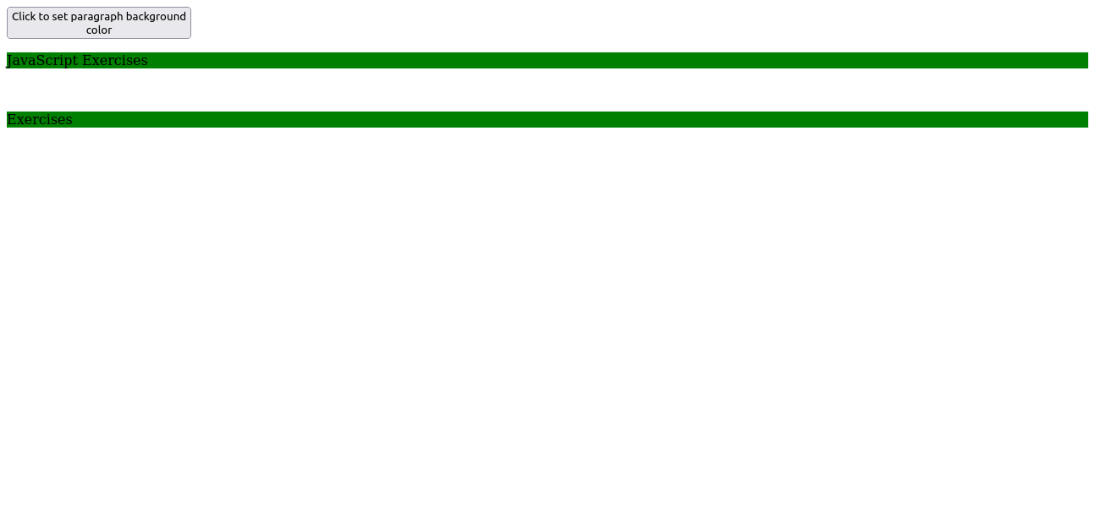

**2. Here is a sample html file with a submit button. Write a JavaScript function to get the value of the href, hreflang, rel, target, and type attributes of the specified link (using jQuery).**

<!DOCTYPE html>

<html>

<head>

<meta charset="utf-8" />

<script src="jquery.js"></script>

</head>

<body>

<p>

<a

id="w3r"

type="text/html"

hreflang="en-us"

rel="nofollow"

target="_self"

href="http://www.w3resource.com/"

>Exercise</a

>

</p>

<button onclick="getAttributes()">

Click here to get attributes value

</button>

<script>

function getAttributes(event) {

let text = `type : ${$("#w3r").attr("type")}

hreflang : ${$("#w3r").attr("hreflang")}

rel : ${$("#w3r").attr("rel")}

target : ${$("#w3r").attr("target")}

href : ${$("#w3r").attr("href")}

`;

alert(text);

}

</script>

</body>

</html>

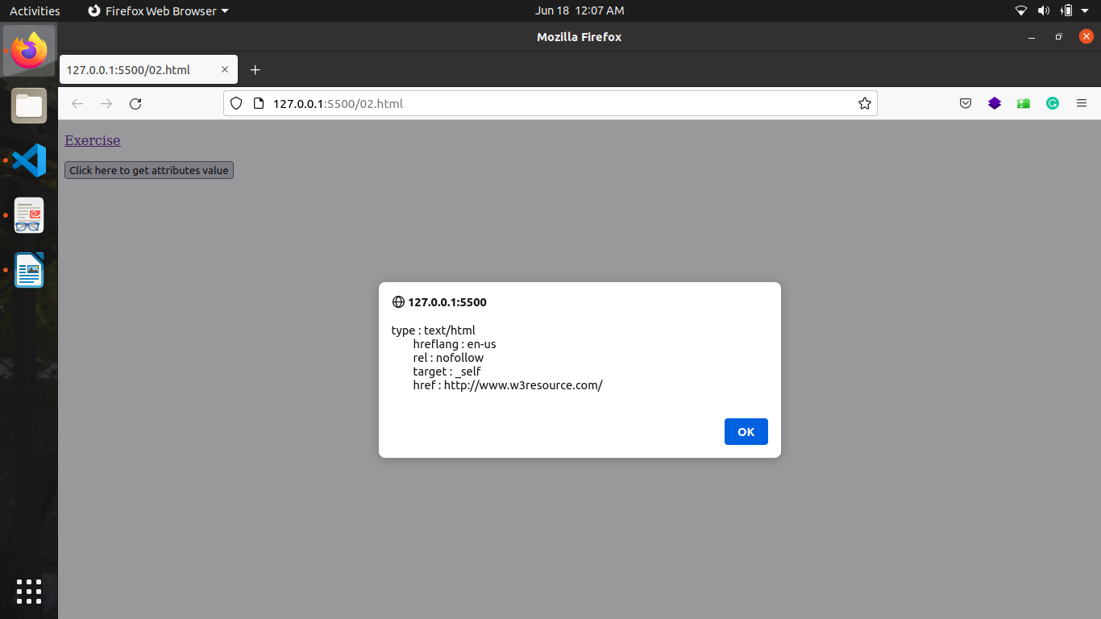

**3. Here is a sample html file with a submit button. Now modify the style of the**

**paragraph text (such as fontSize, fontFamily, color, etc. ) through jQuery code.**

<!DOCTYPE html>

<html>

<head>

<meta charset="utf-8" />

<title>JS DOM paragraph style</title>

<script src="jquery.js"></script>

</head>

<body>

<p id="text">jQuery Exercise</p>

<div>

<button id="jsstyle" onclick="js_style()">Style</button>

</div>

<script>

function js_style(event) {

$("#text").css("font-family", "MVBoli");

$("#text").css("color", "blue");

$("#text").css("font-weight", 900);

$("#text").css("font-size", 28);

}

</script>

</body>

</html>

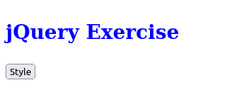

**4. Write a JavaScript function to add rows to a table by using jQuery.**

<!DOCTYPE html>

<html>

<head>

<meta charset="utf-8" />

<title>Insert row in a table</title>

<script src="jquery.js"></script>

</head>

<body>

<table id="sampleTable" border="1">

<tr>

<td>Row1 cell1</td>

<td>Row1 cell2</td>

</tr>

<tr>

<td>Row2 cell1</td>

<td>Row2 cell2</td>

</tr>

</table>

<br />

<input type="button" onclick="insert_Row()" value="Insert row" />

<script>

let i = 3;

$(document).ready(() => {

i = $("#sampleTable tr").length + 1;

});

function insert_Row(event) {

let markup = `

<tr>

<td> Row${i} cell1</td>

<td> Row${i} cell2</td>

</tr>

`;

$("#sampleTable").append(markup);

i++;

}

</script>

</body>

</html>

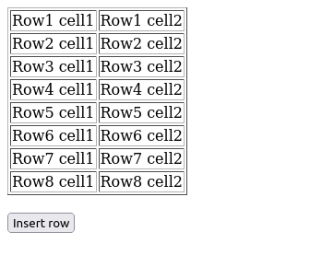

**5. Given the following HTML, create a script.js file to complete the given tasks**

**(using jQuery)**

**1. Add the necessary code to wait for the DOM to load to make sure that**

**anything you manipulate in the DOM has loaded. You can do this using**

**jQuery.**

**2. Replace the text "Change me" with "Hello World!".**

**3. When a user hovers over one of the colored boxes change the text to**

**display the color that is being hovered over.**

**4. Create a new div element.**

**5. Give your new div a class of purple and style it so that it has a**

**background color of purple.**

**6. Append your new div to the page to the section tag.**

<!DOCTYPE html>

<html lang="en">

<head>

<meta charset="UTF-8" />

<title>DOM Exercise</title>

<script src="jquery.js"></script>

<style>

div {

width: 50px;

height: 50px;

display: inline-block;

}

.brown {

background-color: brown;

}

.green {

background-color: green;

}

.blue {

background-color: blue;

}

.purple {

background-color: purple;

}

.yellow {

background-color: yellow;

}

.car1 {

background-color: #8c9c12;

}

.car2 {

background-color: #1da788;

}

.car1,

.car2 {

margin-left: 0;

}

</style>

</head>

<body>

<h1 id="change_heading">Change Me!</h1>

SELECTED COLOR <span class="selected">None!</span>

<section>

<div class="brown"></div>

<div class="green"></div>

<div class="blue"></div>

<div class="yellow"></div>

</section>

<h2>Race!</h2>

<button>Start the race!</button>

<br />

<div class="car1"></div>

<br />

<div class="car2"></div>

<script src="script.js"></script>

</body>

</html>

$(document).ready(() => {

$('#change_heading').text('Hello World!');

let div = `<div

class="purple"

></div>`;

$('section').append(div);

$('section *').on({

mouseenter: mouseEnter,

mouseleave: mouseLeave

});

function mouseEnter(event){

$('.selected').text(`${event.target.className}`);

}

function mouseLeave(){

$('.selected').text('None');

}

})

**6.Create a Tic Tac Toe game with two players. Following is a sample output**

**(using jQuery).**

<!DOCTYPE html>

<html lang="en">

<head>

<meta charset="UTF-8" />

<meta http-equiv="X-UA-Compatible" content="IE=edge" />

<meta name="viewport" content="width=device-width, initial-scale=1.0" />

<title>Tic Tac Toe Game</title>

<style>

td {

display: inline-flex;

justify-content: center;

align-items: center;

width: 200px;

height: 100px;

font-size: xx-large;

background-color: lightgray;

font-weight: bolder;

color: brown;

}

div {

width: 600px;

height: 100px;

display: flex;

justify-content: center;

align-items: center;

}

button {

width: 20%;

height: 40%;

font-size: large;

color: green;

border-radius: 10px;

background-color: greenyellow;

}

</style>

</head>

<body>

<table id="table">

<tr>

<td id="1"></td>

<td id="2"></td>

<td id="3"></td>

</tr>

<tr>

<td id="4"></td>

<td id="5"></td>

<td id="6"></td>

</tr>

<tr>

<td id="7"></td>

<td id="8"></td>

<td id="9"></td>

</tr>

</table>

<div>

<button type="button" onclick="restartGame()">Restart</button>

</div>

<script src="jquery.js"></script>

<script>

let x = true;

let text = "X";

$(document).ready(() => $("button").click());

function restartGame(event) {

$("td").click(td_click);

$("td").text("");

$("td").css("backgroundColor", "lightgray");

x = true;

text = "X";

}

function td_click(event) {

// debugger;

$(event.target).text(text);

let array = $("td")

.toArray()

.map((x) => x.innerText);

if (x) {

text = "O";

$(event.target).css("color", "blue");

if (check(array[0], array[1], array[2], "X")) win(1, 2, 3);

else if (check(array[3], array[4], array[5], "X")) win(4, 5, 6);

else if (check(array[6], array[7], array[8], "X")) win(7, 8, 9);

else if (check(array[0], array[3], array[6], "X")) win(1, 4, 7);

else if (check(array[1], array[4], array[7], "X")) win(2, 5, 8);

else if (check(array[2], array[5], array[8], "X")) win(3, 6, 9);

else if (check(array[0], array[4], array[8], "X")) win(1, 5, 9);

else if (check(array[2], array[4], array[6], "X")) win(3, 5, 7);

} else {

text = "X";

$(event.target).css("color", "green");

if (check(array[0], array[1], array[2], "O")) win(1, 2, 3);

else if (check(array[3], array[4], array[5], "O")) win(4, 5, 6);

else if (check(array[6], array[7], array[8], "O")) win(7, 8, 9);

else if (check(array[0], array[3], array[6], "O")) win(1, 4, 7);

else if (check(array[1], array[4], array[7], "O")) win(2, 5, 8);

else if (check(array[2], array[5], array[8], "O")) win(3, 6, 9);

else if (check(array[0], array[4], array[8], "O")) win(1, 5, 9);

else if (check(array[2], array[4], array[6], "O")) win(3, 5, 7);

}

x = !x;

$(event.target).off();

}

function win(a, b, c) {

$(`#${a},#${b},#${c}`).css("backgroundColor", "red");

$("td").off();

}

function check(a, b, c, lebel) {

return a == lebel && b == lebel && c == lebel;

}

</script>

</body>

</html>

