Capstone Project

The Battle of Neighborhoods (Week 1)

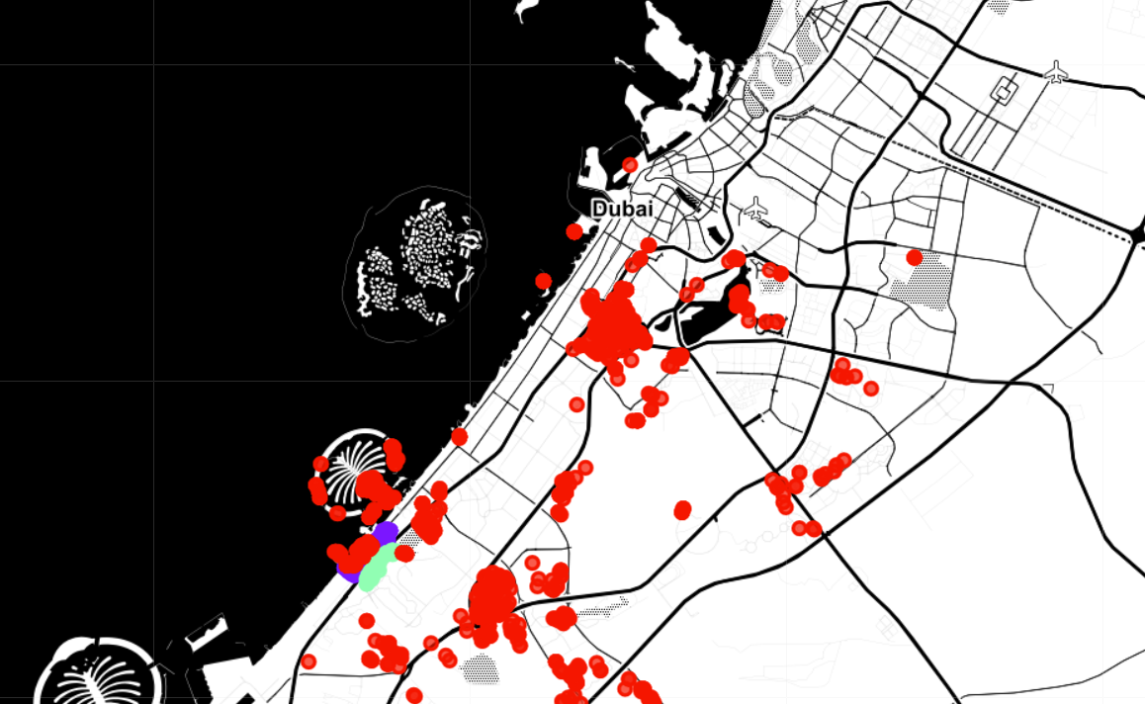

Date of submission: 18th February 2021

# Background

Dubai is a real estate hub, probably the only place in the word where you can get a studio apartment that comes with its own swimming pool and tennis court. In short, properties of all sizes and facilities are available.

# Business Problem

And having such large options makes its really difficult to choose the right ones that fits your residential needs or investment plans. A solution is required that could help stakeholders in pinning down neighbourhoods based over the facilities and amenities they provide and also understand any possible correlation between certain amenities and property value.

# Target Audience

1. People and investors planning to rent or buy properties
2. Real estate dealers

# Description of The Data

To resolve our problem, we need data of different properties across Dubai, their prices and amenities and facilities near to it.

# Source of The Data

1. **List of properties:**

The data is scraped from the real estate portal and it is anonymized. It consists of more than 1900+ properties containing 38 features. Its usage is licensed under CC0: Public Domain.

The data contains over 1900 records along with their geolocation and their prices. Some other information is also part of the dataset but not applicable to our use.

Link to dataset: <https://www.kaggle.com/dataregress/dubai-properties-dataset>

1. **Amenities and finicalities next to properties:**

We will utilize Foursquare API for scrap list of facilities and venues next to our properties, using their location part of our dataset.