In the Name of God



Machine Learning and Vision Lab

7th Lab

Pre report

Prof. Mohammadzade

Sajjad Hashembeiki

98107077

Dec 5th 2023

1. By normalizing the HOG feature vector, the descriptor becomes less sensitive to variations in illumination and also it helps us with reduce sensitivity to noise.
2. If LBP (binary) number has only two transitions from 0 to 1 or 1 to 0, it is called uniform, o.w., it is called non-uniform. If we allocate one bin for each uniform number and one bin for all non-uniform numbers, then instead of 256 bins, only 59 bins will be needed. (all zero and all ones are also considered as uniform)

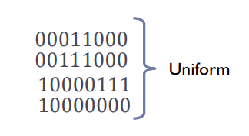Uniform LBP pattern is computationally more efficient and is more robust to noise.