## Activity Overview



In this activity, you will assess the attack vectors of a USB drive. You will consider a scenario of finding a USB drive in a parking lot from both the perspective of an attacker and a target.

USBs, or flash drives, are commonly used for storing and transporting data. However, some characteristics of these small, convenient devices can also introduce security risks. Threat actors frequently use USBs to deliver malicious software, damage other hardware, or even take control of devices. **USB baiting** is an attack in which a threat actor strategically leaves a malware USB stick for an employee to find and install to unknowingly infect a network. It relies on curious people to plug in an unfamiliar flash drive that they find.

Be sure to complete this activity before moving on. The next course item will provide you with a completed exemplar to compare to your own work.

## Scenario



Review the following scenario. Then complete the step-by-step instructions.

You are part of the security team at Rhetorical Hospital and arrive to work one morning. On the ground of the parking lot, you find a USB stick with the hospital's logo printed on it. There’s no one else around who might have dropped it, so you decide to pick it up out of curiosity.

You bring the USB drive back to your office where the team has virtualization software installed on a workstation. Virtualization software can be used for this very purpose because it’s one of the only ways to safely investigate an unfamiliar USB stick. The software works by running a simulated instance of the computer on the same workstation. This simulation isn’t connected to other files or networks, so the USB drive can’t affect other systems if it happens to be infected with malicious software.

## Step-By-Step Instructions



Follow the instructions and answer the question below to complete the activity.

### **Step 1: Access the template**

To use the template for this course item, click the link and select *Use Template*.

Link to template: [Parking lot USB exercise](https://docs.google.com/document/d/1jdI0FecPuabVB5ZI7na8C0Jm8J6bFlU76AEKD0T8dSw/template/preview?usp=sharing&resourcekey=0-BnHBngk9keuLxbaDs5koeQ)

OR

If you don’t have a Google account, you can download the template directly from the following attachment.

[Parking lot USB exercise](https://d3c33hcgiwev3.cloudfront.net/FaYPGP46RgCRkqgB8qui5Q_5bd476bd586d442e858eaf731a1d43f1_Parking-lot-USB-exercise.docx?Expires=1708473600&Signature=RbhzFV9gYumeqyUa7AnrgNJ~whksx4nC36rn2idxnW9-IZ4T2YjLf4R9IfdoHY0kw5BaKuX8BqYydp1CFg27TroQiSSabGOJbHAaeDd3-XTwTc14dHzpRlzmZFRK7AbsbnP0WwbR7w7LL0xrz8xD72ZVxaHQrxRtM10ppbWLQ9Y_&Key-Pair-Id=APKAJLTNE6QMUY6HBC5A)

[DOCX File](https://d3c33hcgiwev3.cloudfront.net/FaYPGP46RgCRkqgB8qui5Q_5bd476bd586d442e858eaf731a1d43f1_Parking-lot-USB-exercise.docx?Expires=1708473600&Signature=RbhzFV9gYumeqyUa7AnrgNJ~whksx4nC36rn2idxnW9-IZ4T2YjLf4R9IfdoHY0kw5BaKuX8BqYydp1CFg27TroQiSSabGOJbHAaeDd3-XTwTc14dHzpRlzmZFRK7AbsbnP0WwbR7w7LL0xrz8xD72ZVxaHQrxRtM10ppbWLQ9Y_&Key-Pair-Id=APKAJLTNE6QMUY6HBC5A)

### Step 2: Inspect the contents of the USB stick

You create a virtual environment and plug the USB drive into the workstation. The contents of the device appear to belong to Jorge Bailey, the human resource manager at Rhetorical Hospital.

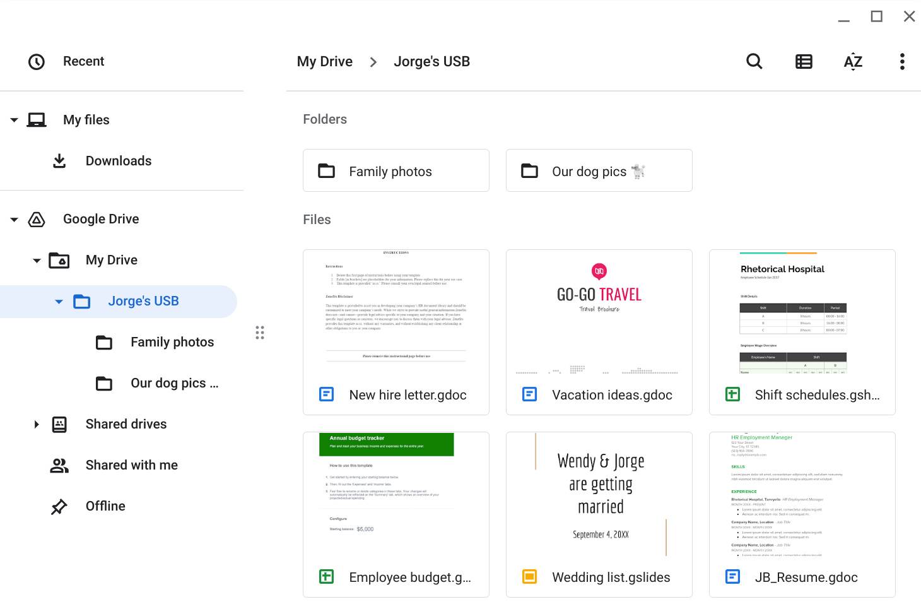

Jorge's drive contains a mix of personal and work-related files. For example, it contains folders that appear to store family and pet photos. There is also a new hire letter and an employee shift schedule.

Review the types of information that Jorge has stored on this device. Then, in the **Contents** row of the activity template, write **2-3 sentences** (40-60 words) about the type of information that's stored on the USB drive.

***Note:*** *USB drives often contain an assortment of personally identifiable information (PII). Attackers can easily use this sensitive information to target the data owner or others around them.*

### Step 3: Apply an attacker mindset to the contents of the USB drive

### Step 4: Analyze the risks of finding a parking lot USB

## What to Include in Your Response



Be sure to address the following criteria in your completed activity:

* 2-3 sentences about the types of information stored on the USB drive
* 2-3 sentences about how the information could be used against the owner and/or organization
* 3-4 sentences analyzing the risks of USB baiting attacks