**ACME Customer Security Hash**

Solution Design Document

**Date**: 23 November 2022

**Version**: 1.0

**Document Revision History**

|  |  |  |  |
| --- | --- | --- | --- |
| Version | Date | Change Summary | Author |
| 1.0 | 11/23/2022 | First Draft | Shiva |
| 2.0 | 11/24/2022 | Updated scenario | Shiva |
|  |  |  |  |
|  |  |  |  |
|  |  |  |  |
|  |  |  |  |

**Table of Contents**

1. Introduction 3

2. As- Is Process Description 3

2.1. Process Overview 3

2.2. Applications used in the process 3

2.3. As-Is Process Map 3

2.4. Detailed AS-Is Process Steps 4

3. To-Be Process Description 4

3.1. To-Be Detailed Process Map 5

3.2. Process details steps 5

3.3. Process Components 6

4. Infrastructure 6

5. Logging 6

6. High Level Test Cases 6

7. Exception Handling 6

8. Reporting 6

8.1. Stakeholders 6

8.2. Success Email Notification 6

8.3. Failure Email Notification 6

9. Proposed Automation checklist 6

10. Documentation 7

# Introduction

The purpose of document is to detail the solution definitions of the ACME Customer Security Hash process to meet the business needs of generating the security has for the work items.

# As- Is Process Description

The current Process of ACME Customer security Hash process is manual and listed below are the steps in which the current business process is being executed.



## Process Overview

Currently ACME client security hash will be calculated manually by interacting with both ACME application and SHA1 Application. An Automated process can help to generate the client security hash and complete the work items.

## Applications used in the process

The Systems in scope for this automation includes:

* ACME Web Application
* SHA1 Web Application
* MS Office

## As-Is Process Map

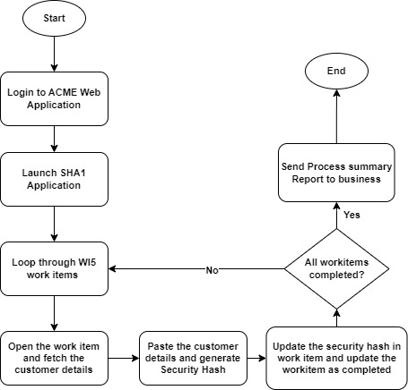

## Detailed AS-Is Process Steps

* Log into ACME Web Application.
* Launch the SHA1 portal.
* Navigate to work items in ACME Application
* Fetch all the work items.
* Filter work items with Status as ‘Open’ and Work Item type as ‘WI5’
* Loop through each WI5 work item.
  + Open the Work item
  + Fetch the customer details (Name, ID and Country)
  + Paste the customer details on SHA1 Website in the format (ID - Name – Country)
  + Generate the security hash
  + Navigate to ACME application and click on Update work item
  + Enter the generated client security hash in additional comments
  + Select the status as Completed
  + Save the work item.
* Repeat the same process for all work items.
* Send the process summary report to Business.

# To-Be Process Description



## To-Be Detailed Process Map

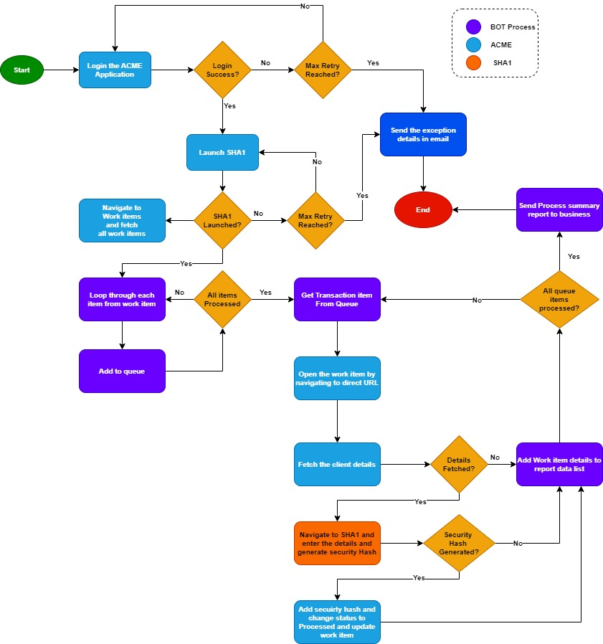

## Process details steps

|  |  |  |  |  |
| --- | --- | --- | --- | --- |
| Step | Activity | Steps | Positive Scenarios | Negative Scenarios |
| 1 | ACME Login | 1. Launch the ACME application in Browser 2. Validate if home page is already loaded. 3. If no, Enter the credentials to Sign in 4. Validate the home page | ACME application logged in successfully : Proceed to Step 2 | 1.**ACME application Sign in page not loaded:** Retry for 3 times. If still not loaded send critical email to business and stop the bot  2. **Invalid Credentials**:  Send critical email to business and application support team and stop the process  3.**Login failed due to unhandled exception**: Send Email to Support team and stop the BOT |
|  |  |  |  |  |
|  |  |  |  |  |
|  |  |  |  |  |

## Process Components

# Infrastructure

# Logging

# High Level Test Cases

# Exception Handling

# Reporting



## Stakeholders

## Success Email Notification

## Failure Email Notification

# Proposed Automation checklist

|  |  |
| --- | --- |
| Proposed System Checklist | Description |
| Applications Used |  |
| Inputs |  |
| Outputs |  |
| Interfaces |  |
| Controls |  |
| Config |  |
| Monitoring |  |

# Documentation