**ACME Customer Security Hash**

Process Definition Document

**Date**: 23 November 2022

**Version**: 1.0

**Document Revision History**

|  |  |  |  |
| --- | --- | --- | --- |
| Version | Date | Change Summary | Author |
| 1.0 | 11/23/2022 | First Draft | Shiva |
| 2.0 | 11/24/2022 | Updated scenario | Shiva |
|  |  |  |  |
|  |  |  |  |
|  |  |  |  |
|  |  |  |  |

**Table of Contents**

1. Business Problem – Description 3

1.1. Scope Module 3

1.2. Assumptions 3

2. High Level Process Description 3

3. Systems Involved 4

4. Process Flow 4

5. Process Overview – Details Steps 5

6. Possible Exceptions 9

6.1. Logic Exceptions 9

6.2. Business Exceptions 9

6.3. System Exceptions 10

7. Process Check List 10

# Business Problem – Description

Currently ACME client security hash will be calculated manually by interacting with both ACME application and SHA1 Application. An Automated process can help to generate the client security hash and complete the work items.

## Scope Module

The Systems in scope for this automation includes:

* ACME Web Application
* SHA1 Web Application
* MS Office

## Assumptions

* The BOT will run twice a day at 10:00 AM IST and 08:00 PM IST
* BOT will be given access to ACME Web Application
* BOT will be given access to the SHA1 Web Application

# High Level Process Description

* Log into ACME Web Application.
* Launch the SHA1 portal.
* Navigate to work items in ACME Application
* Fetch all the work items.
* Filter work items with Status as ‘Open’ and Work Item type as ‘WI5’
* Loop through each WI5 work item.
  + Open the Work item
  + Fetch the customer details (Name, ID and Country)
  + Paste the customer details on SHA1 Website in the format (ID - Name – Country)
  + Generate the security hash
  + Navigate to ACME application and click on Update work item
  + Enter the generated client security hash in additional comments
  + Select the status as Completed
  + Save the work item.
* Repeat the same process for all work items.
* Send the process summary report to Business.

# Systems Involved

|  |  |  |  |
| --- | --- | --- | --- |
| Application/System | Dev URL | UAT URL | PROD URL |
| ACME | https://acme-dev.uipath.com/login | https://acme-test.uipath.com/login | https://acme.uipath.com/login |
| SHA1 | http://www.sha1-online.com/ | http://www.sha1-online.com/ | http://www.sha1-online.com/ |

|  |  |
| --- | --- |
| Application/System | Access Role Needed |
| ACME | System Engineer |
| SHA1 | No Access – No Login |

# Process Flow

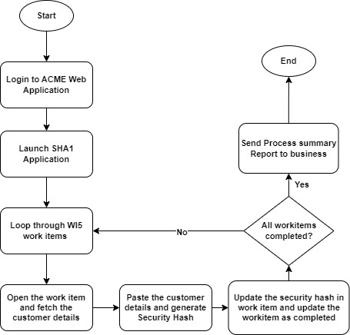

# Process Overview – Details Steps

**Step1:** Launch and Log into ACME Web Application in Browser.

**Step2**: Launch the SHA1 portal.

**Step3:** Navigate to work items in ACME Application.

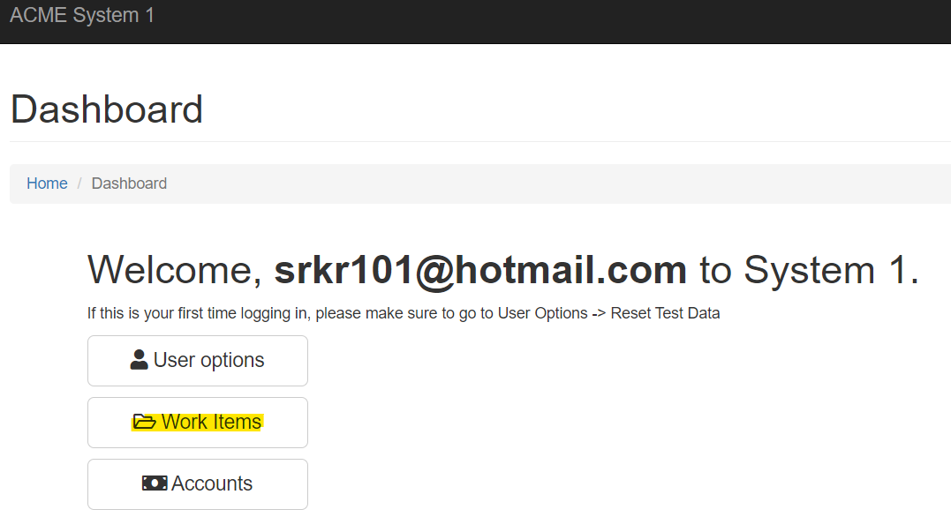

**Step4:** Open the work item with Status as ‘Open’ and Work Item type as ‘WI5’

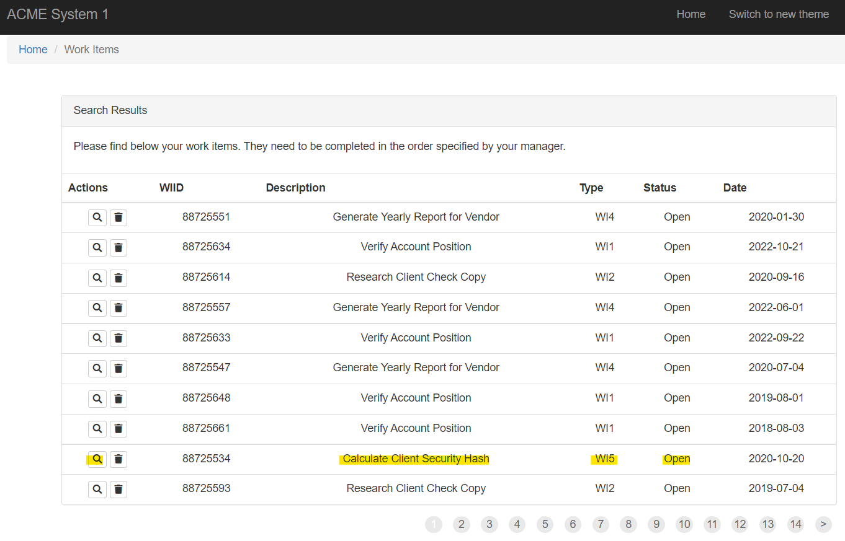

**Step5**: Fetch the customer details (Name, ID and Country)

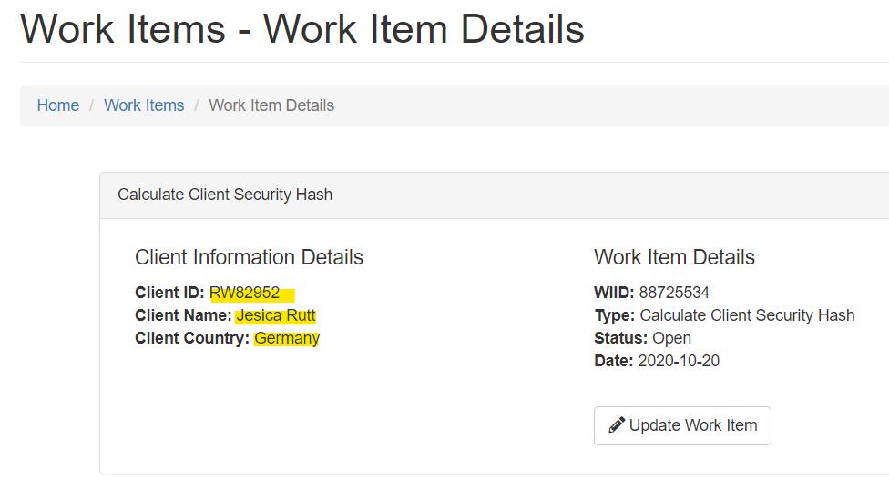

**Step 6**: Create customer string as Client ID – Client Name – Client Country

**Customer string**: RW82952- RW82952- Germany

**Step 7**: Paste the customer details on SHA1 Website and click on hash button

**Step 8**: Navigate to ACME application and click on Update work item

**Step 9**: Enter the generated client security hash in additional comments and Select the status as Completed

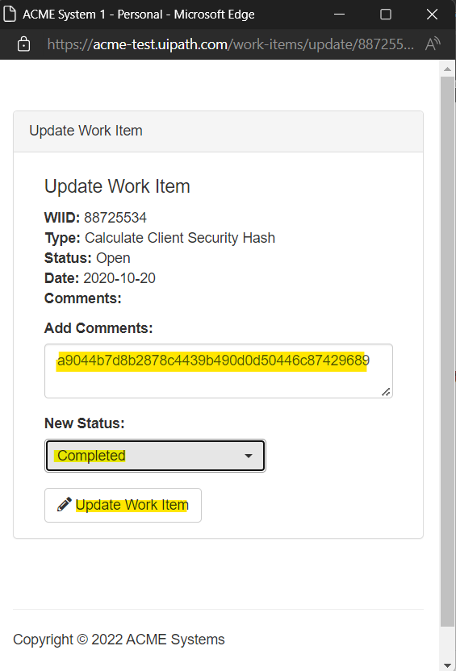

**Step 10**: Save the work item.

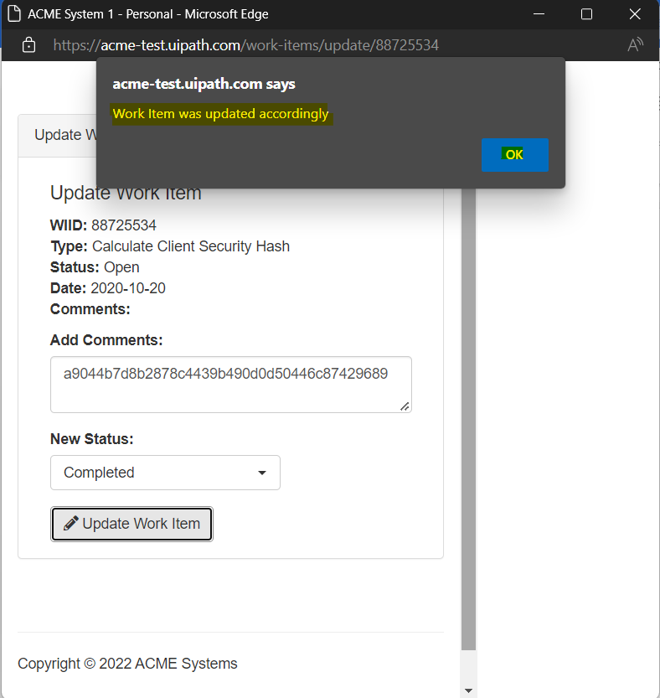

**Step 11**: Repeat Step 4 to Step 10 for all work items.

**Step 12**: Send the process summary report to Business.

# Possible Exceptions

## Login Exceptions

**Exception 1**: Invalid credentials while log into ACME.

**Action To Be Taken**: Send Email to RPA Support team and Business Team

## Business Exceptions

**Exception 1** : No WI5 work items available to process

**Action To Be Taken**: Send Email to Business

**Exception 2**: Client Data missing for work item

**Action To Be Taken**: List down all the records and send report as Email to Business

## System Exceptions

**Exception 1** : ACME application is down

**Action To Be Taken**: Send critical email to business

# Process Check List

|  |  |
| --- | --- |
| Key | Detail |
| Process Full Name | ACMEClientSecurityHash |
| Department | Finance |
| Role Required for performing the process | System Engineer |
| Process Schedule | Twice a day at 10:00 AM IST and 08:00 PM IST |
| No of item processes/day | 200 |
| Average handling time per item | 60 Sec |
| Peak Period(s) | NA |
| No of FTEs Supporting this activity | 5 |
| Level of exception rate | Low |
| Applications Used | ACME & SHA1 |
| Volume/Month | 4000 |
| Email/Distribution List to be used for Exception Notification | [Srkr101@hotmail.com](mailto:Srkr101@hotmail.com) |
| Any Restriction from sharing this document with other Project/Process Owner | NA |

# Documentation and References

* ACME Site map doc
* PDD document loation
* Security Hash generation document