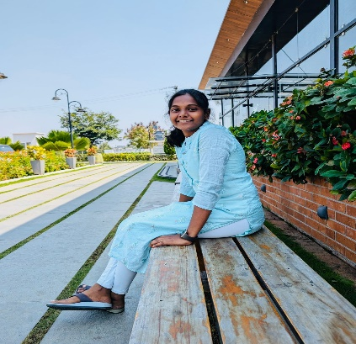
Dharanipriya S
Data Operator
Hey everyone,

I’m super excited to be part of the MSCI family! Just thought I’d share a little about myself.

I did all my schooling at URC Matriculation School, Erode, and later moved to PSG College of Arts and Science for my B Com degree. I graduated in 2023—those college days were some of the best in my life, filled with fun, laughter, and a few emotional moments too (thankfully, my friends were always there to lift my spirits!).

After college, I started working at CUB Pvt Ltd. in Tambaram as a cashier. I spent a year there (2023–2024), handling cash, opening and closing accounts, and managing modifications. Honestly, I enjoyed the work, especially dealing with Excel—tallying cash using formulas and focusing on getting things right. It felt rewarding!

While I was on the lookout for a new opportunity, a friend referred me to MSCI. I accepted the offer immediately and couldn’t be happier about it. The company’s vibe, reputation, and work environment really caught my attention. It feels like the perfect place to meet new people, learn new things, and grow.
I’m still figuring out the details of my role here, but I think it’ll be interesting—probably working with top companies, understanding how they operate, analysing business data, and presenting it in a way that’s useful for investors. Sounds exciting, right? Plus, I genuinely enjoy working with Excel, so I’m looking forward to tasks that challenge me.

Lately, I’ve been super curious about the stock market. I’d love to explore it more and hopefully grow into a role where I can keep learning, take on new challenges, and (fingers crossed) land a position with a great package that ticks off my wishlist!

Outside of work, I’m really into arts and crafts—especially making "best out of waste" stuff. I find it hard to throw away things that can be reused creatively. I also love surprising my friends with handmade gifts. Although I’m a bit introverted at first, once I’m comfortable, I open up a lot. I’m always eager to try out new things and learn along the way.

I’m also a big fan of exploring new places and trying different kinds of food (not a big eater, but definitely a variety lover!). Overall, I believe in living life with happiness and positivity.

Super thrilled to be here at MSCI and can’t wait to see what’s ahead. Definitely here to work not under pressure—but with a lot of pleasure!

That’s a little short and sweet about me!

