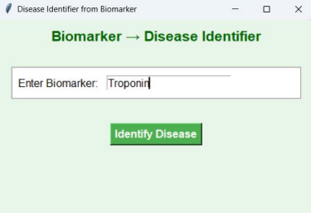Fig. 1: Homepage of Biomarker Database

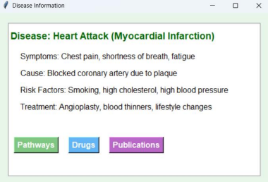Fig. 2: Disease identification
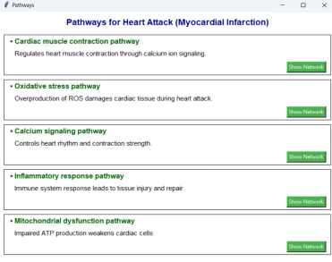Fig. 3: Pathway and description

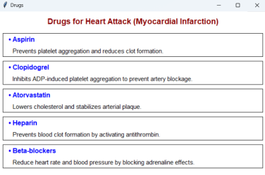Fig. 4: Drugs and description related disease
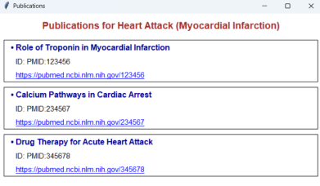Fig. 5: Publications related disease

Fig. 6: Research paper open from given link

