Project Title : **HappyTails – pet adoption and services**

**1.1. Abstract –**

HappyTails is a MERN-based web platform designed to streamline pet adoption and management by connecting pet owners, adopters, and administrators. The system provides a centralized and user-friendly solution where users can browse, list, and adopt pets, while admins can manage pet listings, adoption requests, and pet-related services. Additionally, the system integrates adoption request tracking, ensuring a transparent and structured process. The inclusion of pet services enhances the platform’s functionality by providing users access to essential pet care resources. HappyTails aims to simplify pet adoption and promote responsible pet care in a digital-first approach.

**1.2. Existing System and Need for System**

**1.2.1. Existing System –**

Currently, pet adoption and management are often handled through traditional methods such as social media posts, word-of-mouth, or offline pet shelters. But there are few limitations like limited service access, manual adoption process, no proper pet management, etc. Also there is no dedicated system where users can browse available pets and request adoptions efficiently.

**1.2.2. Need for the System –**

HappyTails aims to provide a web platform with multiple features. Admins can manage pet listings, approve/reject adoption requests, and update available services. Users can submit adoption requests directly, ensuring a structured and efficient process. A secure login system (Admin & User) to provide a personalized dashboard for each role. This system will streamline pet adoption, improve accessibility to pet services, and provide a centralized platform for pet lovers.

**1.3.** **Project Scope-**

The project involves developing a user-friendly website where users can browse available pets for adoption, submit adoption applications, and connect with shelters or pet owners. The platform will include an intuitive admin panel for managing pet listings, adoption requests, and user accounts. The platform will feature multiple modules, each designed to enhance the user experience and streamline pet adoption, pet care services, and e-commerce transactions. It will enable both pet owners and adopters to create and manage their profiles, track adoption requests, and communicate seamlessly. the platform will integrate pet care services, such as grooming and daycare centre listings, where users can explore service providers, view their offerings, and contact them. An e-commerce module will allow users to purchase pet food, toys, and accessories through a secure and user-friendly online store.

**1.4. Technology-**

**Frontend :** React

**Backend :** Node, Express

**Database :** MongoDB

* 1. **. Project Functions/Modules-**

1. **Admin module :** It will manage the platform’s operations, including pet listings, adoption requests, spa and daycare services, and e-commerce orders. Admin has to first login to the website. Admin will have a dedicated dashboard to oversee and control these functionalities. Assign pet availability status: Available, Adopted, Reserved. Maintain adoption history logs for pets and users. Admin can list spa and daycare services with prices, descriptions, and schedules. Admin can also edit the product details. Set stock quantity, price, and discount offers and verify successful payments.
2. **Pet Parent module :** It allows users (pet adopters and pet owners) to interact with the platform by browsing pets, submitting adoption requests, booking services, and shopping for pet-related products. User will have to register and login to the website with personal details.

* **Pet owners –** They can list their pets for adoption by uploading all the details. They can also edit or remove the listing. They can book grooming and daycare services. View pet food, toys, grooming kits, and accessories.
* **Pet adopters -**They can browse pets listed for adoption with images, breed, age, and details. They have to fill out an adoption form with details like home environment, experience with pets, and reason for adoption. They can view the status of their adoption request. They can also browse through daycare and grooming centres and check the available pet products.

1. **Grooming module :** It enables users to explore a curated list of pet spas and grooming centres based on their location. Users can view essential details such as the name, address, contact information, available services, pricing, and operating hours of each spa. It ensures seamless communication with service providers for booking appointments or asking questions.
2. **Daycare module :** It allows users to find daycare services for their pets, ensuring their pets receive proper care in a safe and comfortable environment while they are away. It provides a list of daycare centres and details of them. This module provides a convenient way to explore daycare centres, view their facilities, and contact them for bookings.
3. **Products module :** It allows users to browse, search, and purchase a variety of pet foods and toys. Each product listing includes detailed descriptions, images, pricing, and availability status. This module supports a seamless shopping experience with features like adding items to a cart, and secure checkout through multiple payment gateways.

**2.1. Feasibility Study**

**2.1.1. Technical Feasibility-**

The project will be developed using the MERN (MongoDB, Express.js, React.js, Node.js) stack, ensuring scalability, efficiency, and maintainability. MongoDB will handle pet listings, adoption requests, user profiles, and product inventories efficiently.

**2.1.2. Scalability-**

The system can be expanded with more services (vet consultations, pet insurance, etc.). The platform can be easily operated and maintained, making it operationally feasible.

**2.1.3. Operational Feasibility-**

The platform is user-friendly, with a simple UI/UX for pet parents, admins, and service providers. Admins manage pet listings, adoption approvals, and product inventory. Users (Pet Parents) browse pets, request adoptions, and shop for pet products. Service Providers manage grooming and daycare services.

**2.2. Objective of the System –**

The primary objective of HappyTails is to create a centralized, user-friendly, and efficient pet adoption and management platform using the MERN stack. The system aims to bridge the gap between pet owners, adopters, and administrators, making pet adoption smoother and more accessible. Few key objectives are for enabling pet listings, dashboard for admin and users, provide access for pet services, etc. It aims to create a reliable and efficient platform that simplifies the pet adoption process while also promoting responsible pet care.

**2.3. Users of the system –**

* Admin :

**Role:** Manages the entire platform, including pet listings, adoption requests, and product inventory. Admin can Approve, edit, and delete pet listings, Approve or reject adoption requests, Manage product listings in the eCommerce section, Oversee pet services, Handle user complaints and platform maintenance, etc.

* Users (Pet parent):

**Role:** Browse, adopt, and add pets for adoption, as well as purchase pet products. They can Browse pet listings and view pet details, Submit adoption requests for pets, Add their own pets for adoption, Purchase pet product, etc.

* Visitors (unregistered users):

**Role:** Explore services and product catalogs before signing up. They can view pet product listings in the products section, Browse available pet services, Register and login to access full features, etc.

**3.1. System Requirements –**

**3.1.1 Functional Requirements**

1. User management : Users and admins must be able to register and log in securely. Users can view and request adoption of listed pets. Admins can manage pet listings and adoption requests.
2. Pet listing and management : Users can add pets for adoption, including details like name, breed, age, type, and description. Admins can add, edit, or remove pet listings. The system should display all pets (both user-added and admin-added) in a structured format.
3. Adoption request handling : Users can submit adoption requests for a pet. Admins can approve or reject adoption requests. Users can view the status of their adoption requests.
4. Service lisitng : Only admins can add, edit, and delete pet services (e.g., veterinary, grooming, training). Users can view available pet services.
5. Dashboard functionalities : Users should have a dashboard displaying their added pets and adoption requests. Admins should have a dashboard to manage pet listings, adoption requests, and services.
6. Feedback : Users should be notified of the status of their adoption requests. Admins can send responses to adoption requests.

**3.1.2. Non-Functional Requirements**

1. Performance : The system should handle multiple users simultaneously without lag. The database should efficiently store and retrieve pet and user data.
2. Security : User passwords must be securely hashed and stored. Only authorized users (admins) should be able to modify critical data. Adoption request details should be protected from unauthorized access.
3. Usability : The platform should have an intuitive and easy-to-navigate interface.
4. Scalability : The system should allow future enhancements, such as adding pet categories, search filters, or chat features.
5. Reliability : The system should ensure minimal downtime and recover from failures quickly. All user actions (adoption requests, pet additions, etc.) should be accurately recorded.

**3.2. Entity Relationship Diagram –**

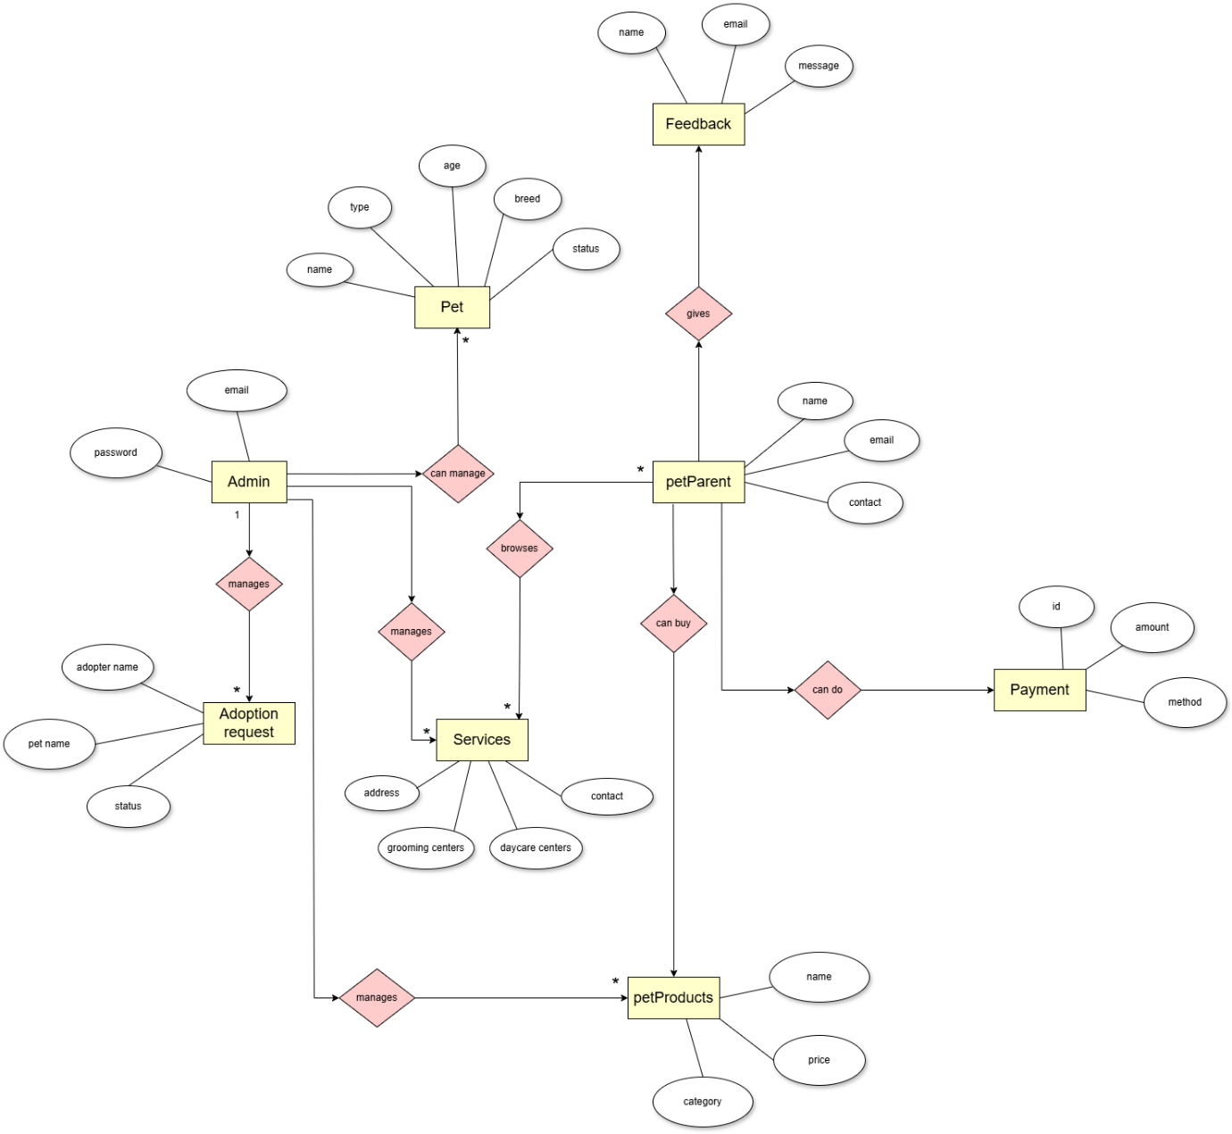

**3.3 Use Case Diagram-**

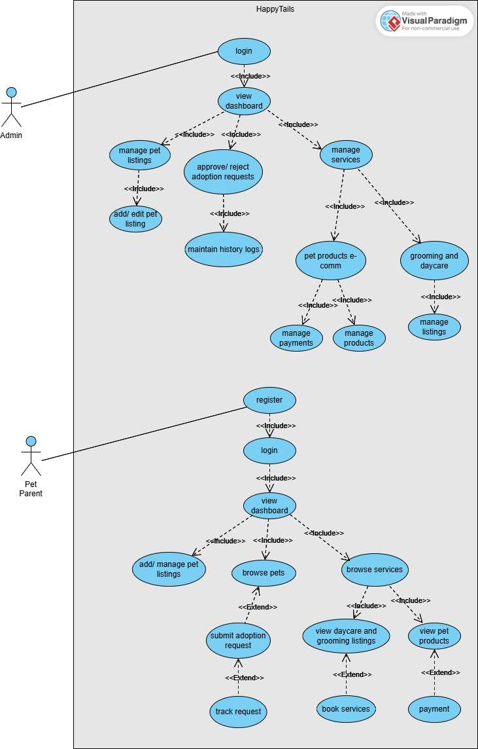

**3.4. Class Diagram-**

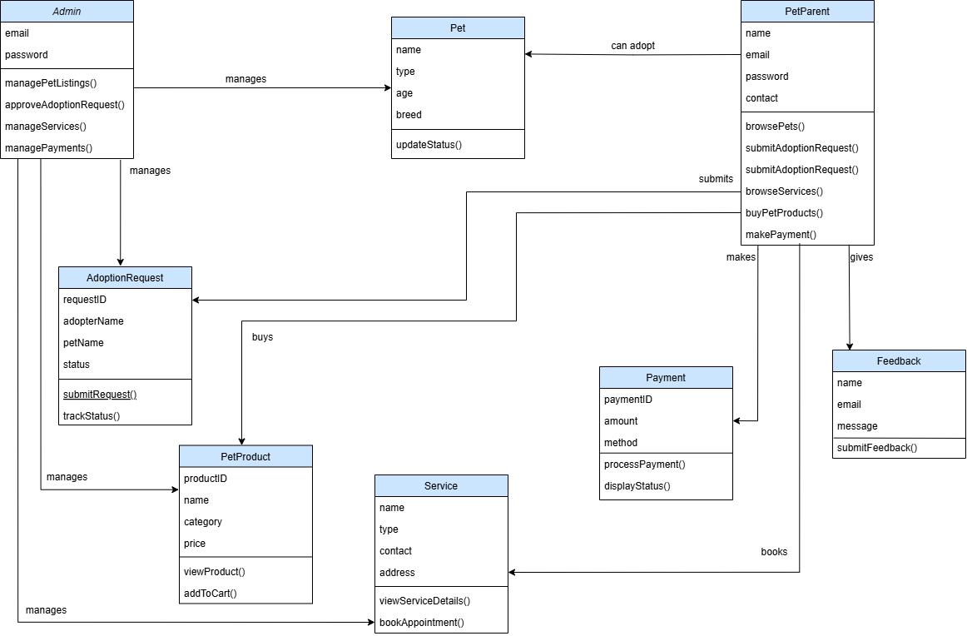

**3.5. Activity Diagram-**

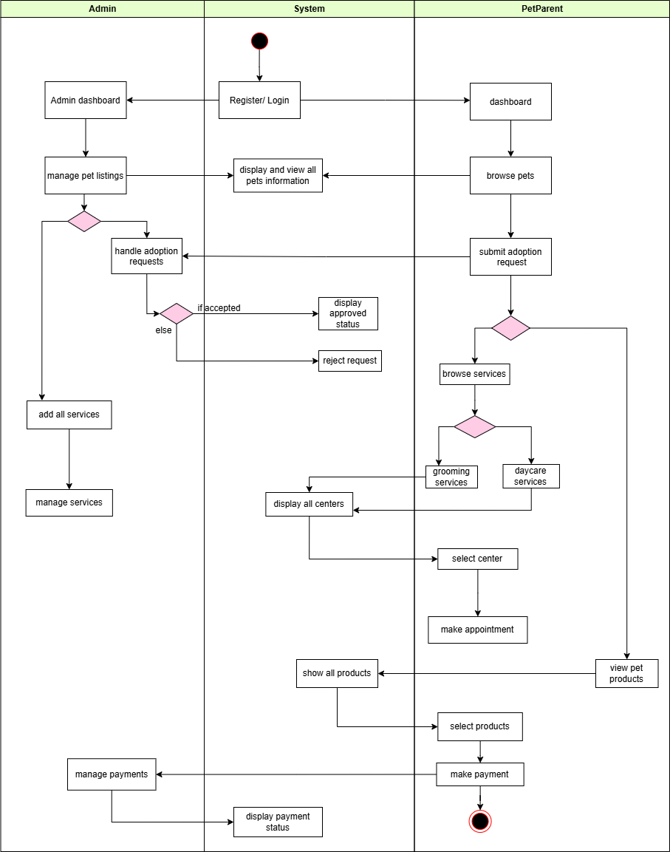

**3.6. Deployment Diagram-**

**3.7. Module Hierarchy Diagram-**

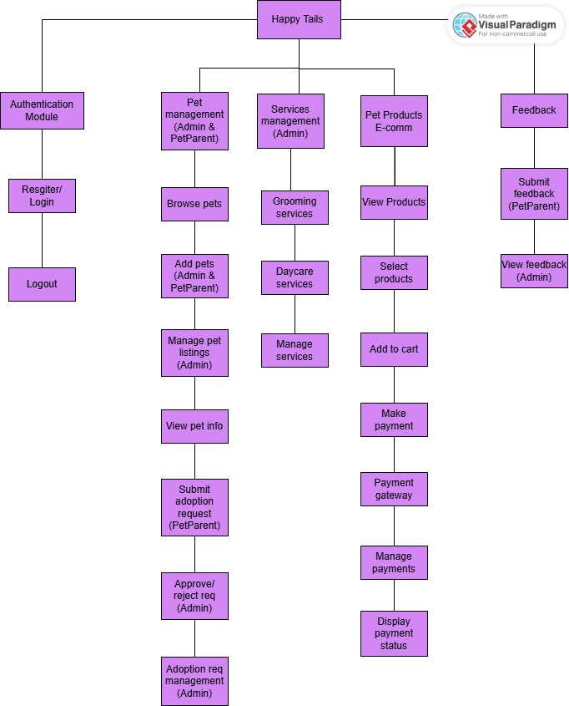

**3.7. Sample Input and Output Screens-**

**1. Home page**

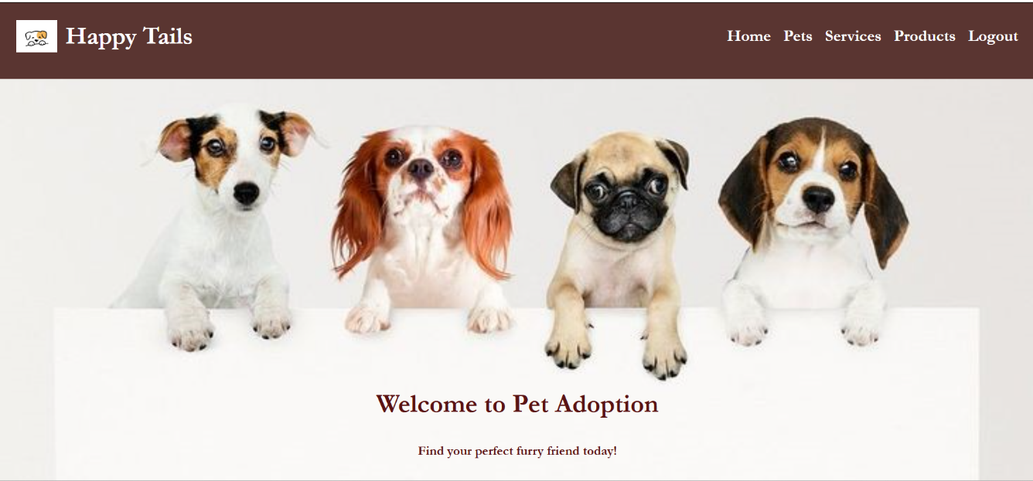

**2. Login page**

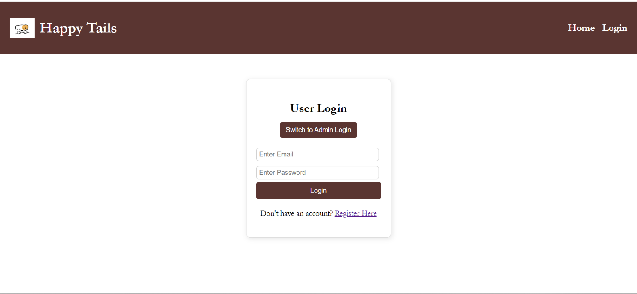

**3. Services page**

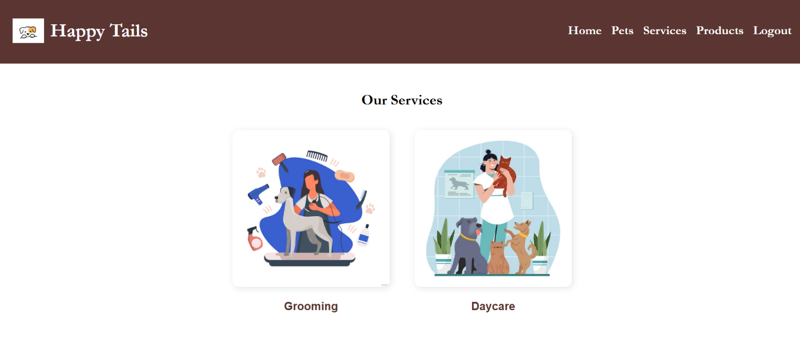

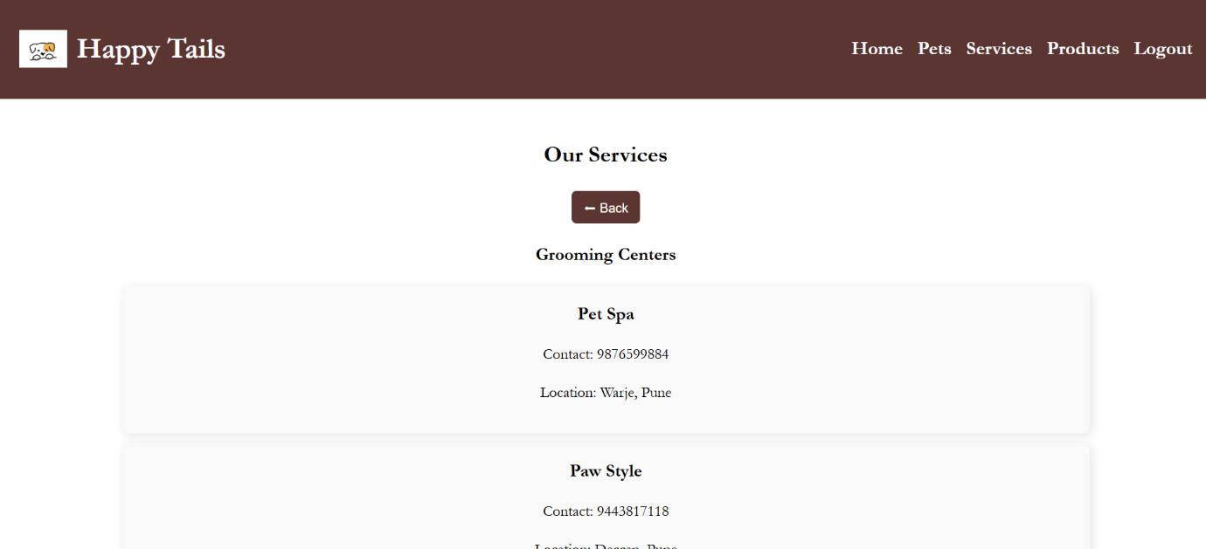

**4. Admin Dashboard**

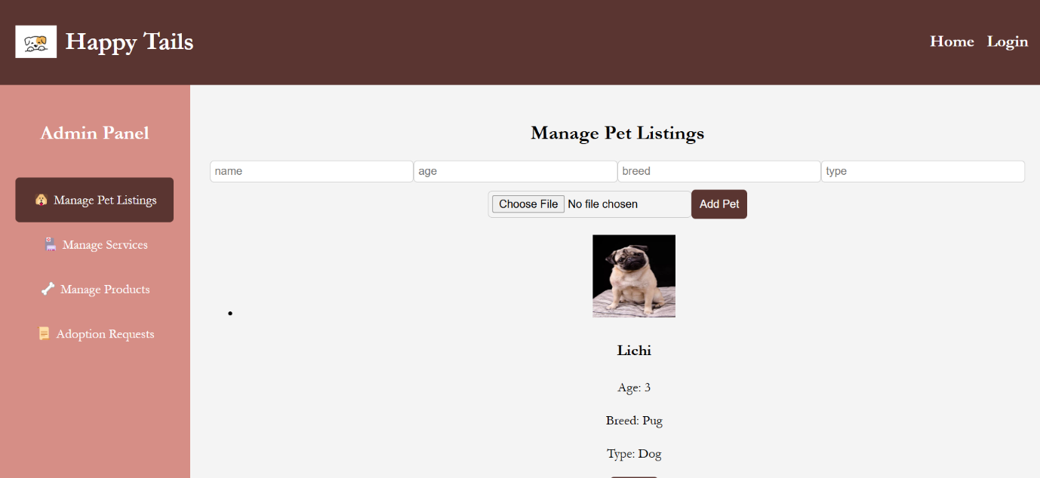

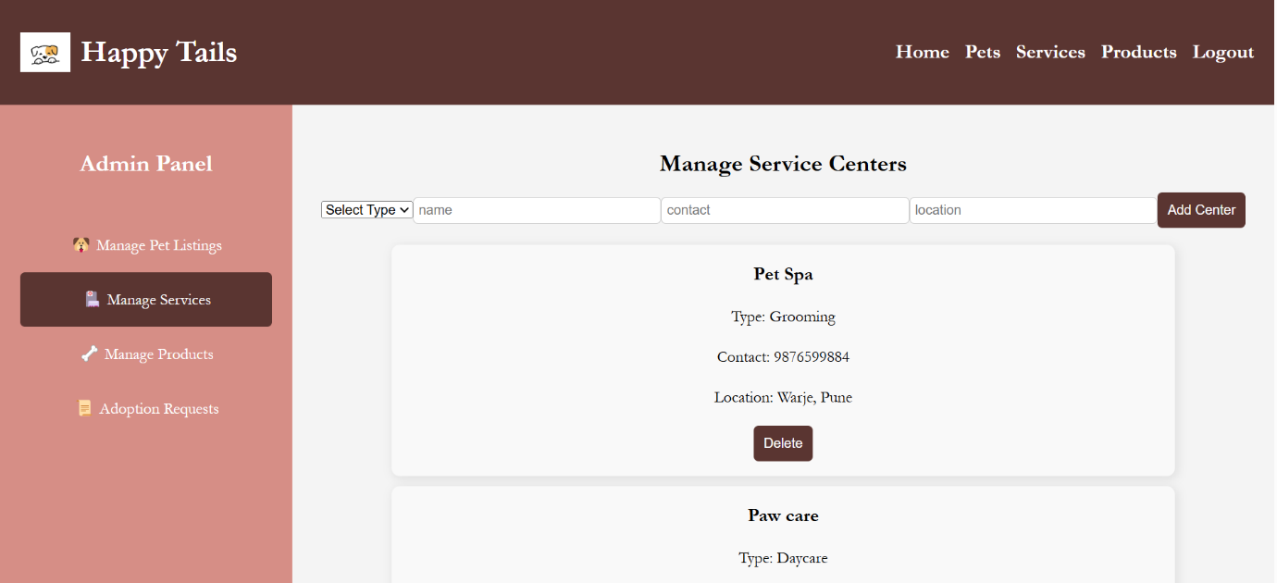

**5. Pets page**

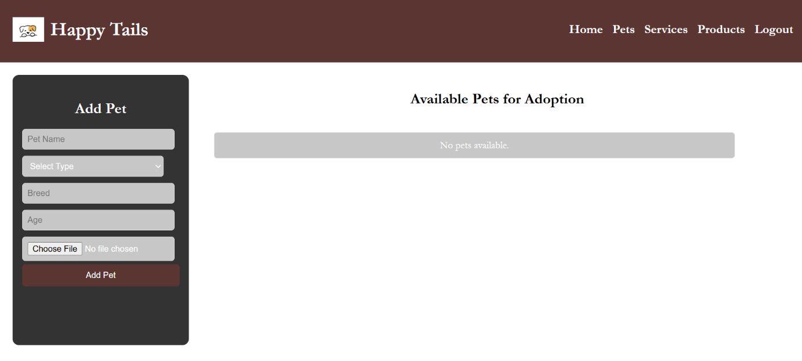

**Name- Sakshi Nikalje**

**Roll No- 2301119**

**Guide Name – Dr. Jayashree Patil**