SAVEETHA COLLEGE OF ENGINEERING
Department of Electronics and Communication Engineering

COMMUNICATION NETWORKS
Course Code: 19EC412

SKILL ASSESSMENT 2
RIP Routing Protocol
Simulation using Cisco Packet Tracer

Student Name | Sakthivel
Register Number | 212223060238
Course Code | 19EC412
Course Name | Communication Networks
Submission Date | 31 May 2026
Faculty | Dr. Asha S

1. Introduction to RIP Routing Protocol
Routing Information Protocol (RIP) is one of the oldest and most widely used dynamic routing protocols in computer networks. It is classified as a Distance Vector Routing Protocol, which means each router maintains a routing table that lists the best known path to every destination network, measured in terms of hop count.
RIP was first defined in 1988 through RFC 1058 and later updated as RIPv2 in RFC 2453, which added support for subnet masks and authentication. RIP operates at the Network Layer (Layer 3) of the OSI model and is used to exchange routing information between routers within the same Autonomous System (AS).

1.1 Key Characteristics of RIP
- Uses hop count as the metric (maximum 15 hops; 16 = unreachable)
- Sends full routing table updates every 30 seconds to all neighbors
- Simple to configure and understand, suitable for small networks
- Supports both classful (RIPv1) and classless (RIPv2) routing
- Uses the Bellman-Ford algorithm for path computation

1.2 RIP Versions
RIP has two major versions currently in use:
Feature | RIPv1 | RIPv2
Subnet Mask | Not supported (Classful) | Supported (Classless)
Authentication | None | MD5 / Plain text
Multicast | Broadcast (255.255.255.255) | Multicast (224.0.0.9)
VLSM Support | No | Yes
RFC | RFC 1058 | RFC 2453

2. How RIP Works
RIP uses the Bellman-Ford distance vector algorithm. Each router periodically broadcasts its entire routing table to directly connected neighbors. Neighbors update their own tables based on received information, selecting the path with the lowest hop count. If a route is not refreshed within a timeout period, it is marked as unreachable and eventually removed.

2.1 RIP Message Types
- Request Message: Sent by a router to ask neighbors for their routing tables when it first comes online.
- Response Message: Sent in reply to a request, or periodically (every 30 seconds) to share the full routing table with neighbors.

2.2 RIP Timers
RIP uses four key timers that govern its behavior:
Timer | Duration | Description
Update Timer | 30 sec | Interval between routing table broadcasts to neighbors
Invalid Timer | 180 sec | Time after which a route is declared invalid if not refreshed
Hold-down Timer | 180 sec | Prevents routing loops by ignoring certain updates for a period
Flush Timer | 240 sec | Time after which an invalid route is removed from the table

2.3 RIP Loop Prevention Mechanisms
- Split Horizon: A router does not advertise a route back out of the interface from which it was learned.
- Poison Reverse: Instead of suppressing a route, the router advertises it with a metric of 16 (infinity) back to the source.
- Triggered Updates: When a route metric changes, an update is sent immediately without waiting for the next update timer.
- Hold-down Timer: Prevents accepting updates for a recently failed route for a fixed duration.

3. Configuring RIP on Cisco Routers
RIP is configured on Cisco routers using IOS (Internetwork Operating System) commands through the Command Line Interface (CLI). Below is the standard configuration procedure for RIPv2.

3.1 Step-by-Step Configuration
- Step 1: Enter Privileged EXEC Mode by typing enable.
- Step 2: Enter Global Configuration Mode using configure terminal.
- Step 3: Enable RIP routing process using the command router rip.
- Step 4: Set the version to 2 with version 2.
- Step 5: Disable auto-summarization using no auto-summary to support VLSM.
- Step 6: Declare directly connected networks using the network command.

3.2 Configuration Commands (Router R1)
Router> enable
Router# configure terminal
Router(config)# router rip
Router(config-router)# version 2
Router(config-router)# no auto-summary
Router(config-router)# network 192.168.1.0
Router(config-router)# network 192.168.12.0

3.3 Verification Commands
Command | Purpose
show ip route | Displays the routing table with RIP-learned routes
show ip protocols | Shows RIP process details and timers
debug ip rip | Displays real-time RIP update messages
show running-config | Verifies the applied RIP configuration
ping <destination IP> | Tests connectivity between routers/PCs

4. Network Topology and IP Addressing
The simulation consists of two routers (R1 and R2) connected via a serial/FastEthernet link. Each router is connected to a switch, and each switch connects to three PCs. RIP is configured on both routers to dynamically exchange routing information.

4.1 Network Layout
- Router R1 (2811): Gateway for the 192.168.1.0/24 network (LAN 1)
- Router R2 (2811): Gateway for the 192.168.2.0/24 network (LAN 2)
- WAN Link: 192.168.12.0/24 connecting R1 and R2
- Switch 1 (2960): Connected to R1, serving PC4, PC5, PC6
- Switch 2 (2960): Connected to R2, serving PC7, PC8, PC9

4.2 IP Address Table
Device | Interface | IP Address | Network
R1 | Fa0/1 (LAN) | 192.168.1.1 | 192.168.1.0/24
R1 | Fa0/0 (WAN) | 192.168.12.1 | 192.168.12.0/24
R2 | Fa0/1 (LAN) | 192.168.2.1 | 192.168.2.0/24
R2 | Fa0/0 (WAN) | 192.168.12.2 | 192.168.12.0/24
PC4 | NIC | 192.168.1.10 | 192.168.1.0/24
PC5 | NIC | 192.168.1.20 | 192.168.1.0/24
PC6 | NIC | 192.168.1.30 | 192.168.1.0/24
PC7 | NIC | 192.168.2.10 | 192.168.2.0/24
PC8 | NIC | 192.168.2.20 | 192.168.2.0/24
PC9 | NIC | 192.168.2.30 | 192.168.2.0/24

4.3 RIP Route Propagation
After RIP is configured on both routers, the routing tables are automatically updated. R1 learns about the 192.168.2.0/24 network via R2, and R2 learns about the 192.168.1.0/24 network via R1. This allows all PCs on both LANs to communicate with each other through the routers.

5. Advantages, Disadvantages and Applications

5.1 Advantages of RIP
- Simple configuration and easy to understand for beginners and small networks.
- Vendor-neutral protocol supported by virtually all routers and operating systems.
- Automatically adapts to network topology changes through dynamic routing updates.
- Low computational overhead compared to link-state protocols like OSPF.
- RIPv2 supports VLSM and CIDR, making it more flexible than RIPv1.

5.2 Disadvantages of RIP
- Maximum hop count of 15 limits RIP to small and medium-sized networks.
- Slow convergence: updates every 30 seconds mean it takes time to reflect topology changes.
- Routing loops can occur despite prevention mechanisms in larger networks.
- Bandwidth consumption: full routing tables are sent every 30 seconds regardless of changes.
- Does not consider link bandwidth or delay when selecting routes (only hop count).

5.3 Comparison: RIP vs OSPF vs EIGRP
Feature | RIP | OSPF | EIGRP
Algorithm | Bellman-Ford | Dijkstra (SPF) | DUAL
Metric | Hop Count | Cost (Bandwidth) | Composite
Max Hops | 15 | Unlimited | Unlimited
Convergence | Slow | Fast | Very Fast
Scalability | Small | Large | Large
Standard | Open | Open | Cisco Proprietary

5.4 Real-World Applications
- Used in small enterprise networks and branch office environments.
- Employed as a teaching and learning protocol in networking labs and courses.
- Suitable for home routers and small ISP edge networks.
- Legacy networks that were built before modern link-state protocols became standard.

6. Simulation Output
The following screenshot shows the RIP simulation performed in Cisco Packet Tracer on a laptop. The network consists of two routers (R1, R2), two switches, and six PCs. The routing table of Router R2 is displayed in the terminal window, showing RIP-learned routes.
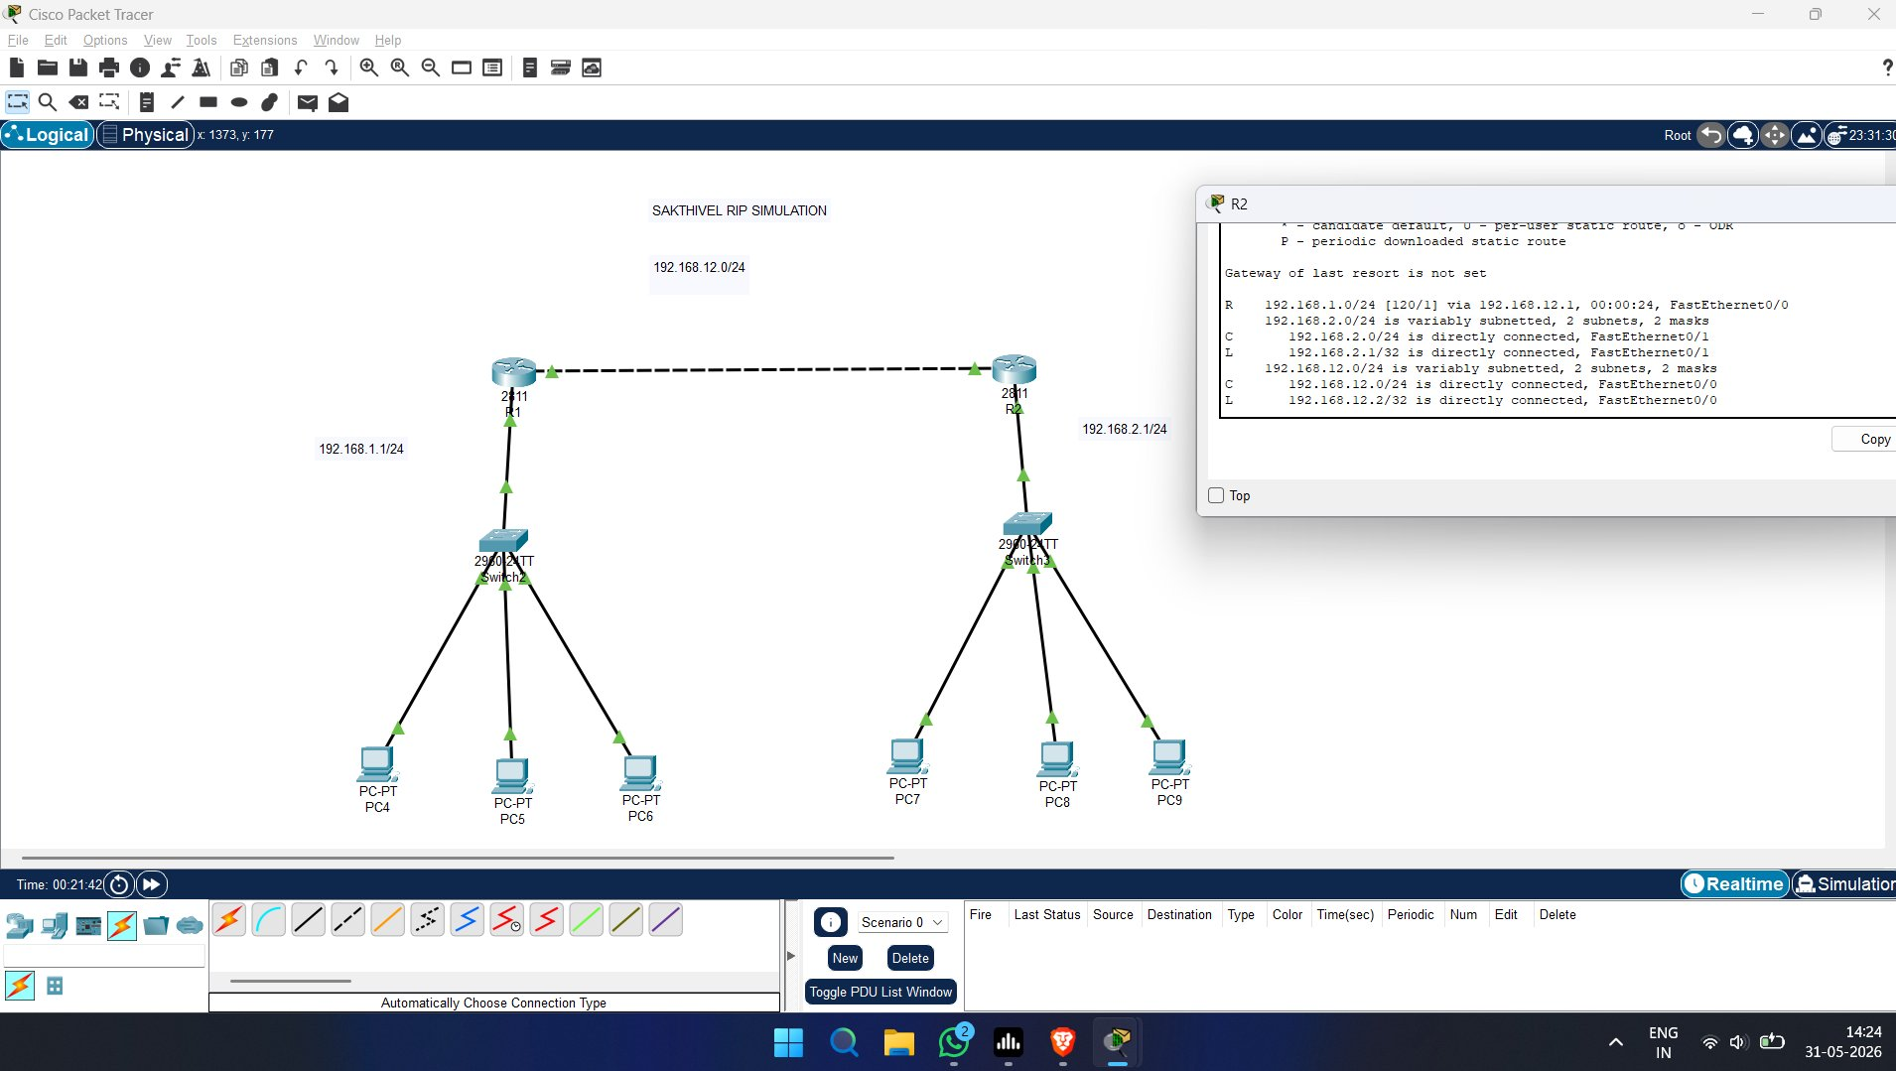
Figure 1: RIP Simulation in Cisco Packet Tracer — Router R2 Routing Table

6.1 Routing Table Analysis (Router R2)
The routing table shown in the simulation output confirms successful RIP configuration:
- R 192.168.1.0/24 [120/1] via 192.168.12.1 — RIP learned route to LAN 1, metric 1 hop, via R1.
- C 192.168.2.0/24 — Directly connected network (LAN 2) on FastEthernet0/1.
- C 192.168.12.0/24 — Directly connected WAN link on FastEthernet0/0.
- L 192.168.2.1/32 — Local address of R2 on the LAN interface.
- L 192.168.12.2/32 — Local address of R2 on the WAN interface.
The administrative distance of 120 confirms these routes were learned via RIP. The metric [120/1] indicates one hop to reach the 192.168.1.0/24 network.

7. Conclusion
This experiment demonstrated the configuration and verification of the RIP (Routing Information Protocol) on a simulated network using Cisco Packet Tracer. RIP successfully established dynamic routing between two routers, enabling full communication across two separate LAN segments connected through a WAN link.
The simulation confirmed that RIP automatically propagates routing information, eliminates the need for manual static routes, and adapts to network topology. While RIP is simple and easy to configure, its limitation to 15 hops and slow convergence make it more appropriate for small-scale networks.
This practical exercise reinforced the theoretical concepts of distance vector routing, hop count metrics, and the Bellman-Ford algorithm taught in the Communication Networks course (19EC412).

