TECHNICAL REPORT
CSMA/CD
Carrier Sense Multiple Access with Collision Detection
Real-Time Scenario Analysis, Working Mechanism & Flow Diagrams

Subject  Computer Networks | Topic  MAC Layer Protocol

2025

1. Introduction to CSMA/CD
In any network where multiple devices share a common communication medium, a fundamental question arises: how do we prevent multiple devices from transmitting at the same time and corrupting each other's data? Carrier Sense Multiple Access with Collision Detection (CSMA/CD) is the elegant protocol that solves exactly this problem in traditional Ethernet networks.

CSMA/CD is a Media Access Control (MAC) protocol defined in the IEEE 802.3 standard. It governs how devices on a shared Ethernet bus decide when to transmit, how to detect when two transmissions have collided, and how to recover gracefully from such collisions. Before the widespread adoption of full-duplex switched Ethernet, CSMA/CD was the backbone of virtually every corporate network, factory automation system, and internet infrastructure worldwide.

Key Definition
CSMA/CD = Carrier Sense + Multiple Access + Collision Detection
• Carrier Sense: Listen before you talk — check if the medium is free
• Multiple Access: Many devices share the same physical medium
• Collision Detection: If two speak at once, both detect it and stop immediately

▶ 1.1 Historical Background
CSMA/CD was developed at Xerox PARC in the early 1970s by Robert Metcalfe and David Boggs, who built it into the first Ethernet implementation. The protocol was inspired by the ALOHA system used in Hawaiian radio networks, and it was formalized into the IEEE 802.3 standard in 1980. For over two decades, virtually all Ethernet networks — from 10BASE2 (Thin Ethernet) to 100BASE-TX (Fast Ethernet) — operated under CSMA/CD rules.

▶ 1.2 Where Is CSMA/CD Used?
- Traditional coaxial bus Ethernet (10BASE2, 10BASE5)
- Half-duplex twisted-pair Ethernet (10BASE-T, 100BASE-TX) on hubs
- Industrial automation networks using shared coaxial media
- Legacy LAN segments still found in older buildings and factories
- Academic and simulation environments to understand MAC protocols

Note: Modern vs Legacy
Modern networks use full-duplex switched Ethernet where each device gets a dedicated point-to-point link to a switch — eliminating shared medium collisions entirely. CSMA/CD is disabled in full-duplex mode. However, understanding CSMA/CD remains essential for network engineers.

2. Network Topology & Components
CSMA/CD operates on a bus topology or a hub-based star topology where all devices effectively share a single collision domain. Understanding the physical layout is essential before diving into the protocol logic.

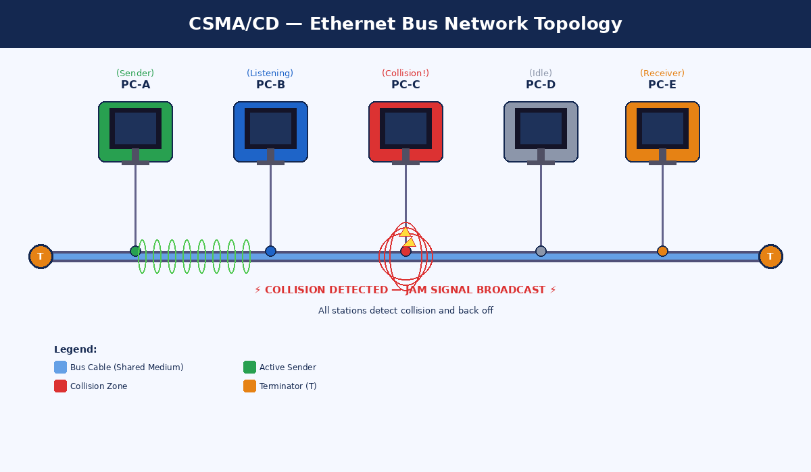
Figure 1 — Ethernet Bus Topology with 5 Nodes: Active Sender (A), Listener (B), Collision Zone (C), Idle (D), and Receiver (E). Terminators (T) prevent signal reflections at both cable ends.

▶ 2.1 Key Components of a CSMA/CD Network
Component | Role in CSMA/CD
Shared Bus / Hub | The common medium through which all signals travel. A hub simply repeats every signal to all ports — creating a shared collision domain.
Network Interface Card (NIC) | Each device's hardware that implements the full CSMA/CD algorithm — sensing, transmitting, detecting, jamming, and backing off.
Terminators | Resistors at each end of a coaxial bus that absorb signals and prevent reflections that would create phantom collisions.
Transceiver | Hardware that converts digital signals to electrical/optical signals and monitors the medium for carrier and collisions.
Preamble (64 bits) | The first 64 bits of every Ethernet frame — used to synchronize receiving stations' clocks before data arrives.

3. Detailed Working Mechanism
The CSMA/CD algorithm operates through five distinct phases. Each phase is carefully designed to maximize channel utilization while ensuring fair access and reliable data delivery. Below we walk through each phase with technical precision.

▶ Phase 1 — Carrier Sense (CS)
Before transmitting any data, a station must listen to the channel to determine whether it is currently in use. The NIC monitors the electrical voltage level on the bus:
- If the channel is IDLE (no signal detected) → the station may begin transmission
- If the channel is BUSY (carrier signal detected) → the station must wait (defer)
- The station enters 'deferred mode' and continues monitoring until the channel goes idle, then begins a 96-bit-time Inter-Frame Gap (IFG) wait before attempting transmission

▶ Phase 2 — Multiple Access (MA)
Multiple Access simply means that many stations share the same physical medium. There is no central controller or token — any station can attempt transmission whenever it senses the channel as idle. This creates the possibility of simultaneous transmissions, which is why collision detection is essential.

▶ Phase 3 — Transmission Begins
When a station gets the green light (idle channel + IFG elapsed), it begins transmitting its Ethernet frame bit by bit onto the shared medium. Key constraints:
- Minimum frame size: 64 bytes (512 bits) — this is critical for collision detection
- Maximum frame size: 1518 bytes (standard), 9018 bytes (jumbo frames)
- The station must continue monitoring the channel during transmission
Why 64 bytes minimum? The minimum frame size ensures that the transmission lasts at least as long as the round-trip propagation delay of the network. This guarantees that a colliding station's jamming signal reaches the original transmitter before it finishes sending — making collision detection possible.

▶ Phase 4 — Collision Detection (CD)
While transmitting, the NIC compares the signal it is sending with the signal it reads back from the bus. In a healthy transmission, these should match. If two stations transmit simultaneously:
- The signals overlap and interfere, creating a voltage level that is approximately double the normal level
- The NIC detects this discrepancy between transmitted and read-back signal
- Collision detection typically occurs within 2 × propagation delay (worst case ~51.2 µs for 10 Mbps Ethernet)

▶ Phase 5 — JAM Signal & Back-off
Once a collision is detected, the following sequence occurs in rapid succession:
- The detecting station immediately STOPS transmitting data
- It broadcasts a 32-bit JAM signal (a predetermined bit pattern) to ensure ALL stations on the network detect the collision — not just those that were transmitting
- The JAM signal propagates throughout the entire collision domain
- ALL stations receiving the JAM signal abort their current reception, discard the corrupted frame
- Transmitting stations invoke the Binary Exponential Back-off algorithm to determine when to retry

4. CSMA/CD Algorithm Flowchart
The following flowchart illustrates the complete CSMA/CD decision process from the perspective of a single station attempting to send a frame. Every decision point, retry loop, and termination condition is shown.

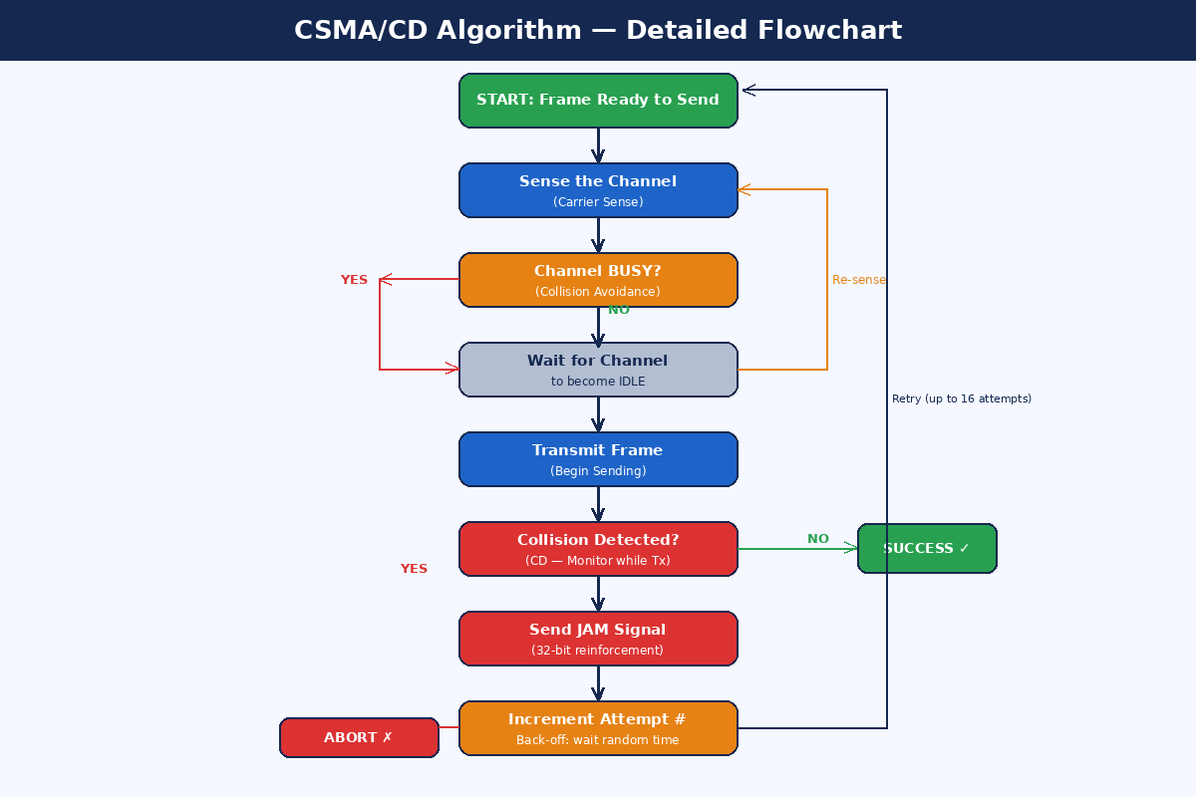
Figure 2 — Complete CSMA/CD Algorithm Flowchart showing all decision points: Carrier Sense, Transmission, Collision Detection, JAM Signaling, and Binary Exponential Back-off with success/abort outcomes.

▶ 4.1 Algorithm States Summary
State | Fill in Color (Figure) | Description
IDLE / SENSE | Blue | Station monitors channel; no transmission in progress
TRANSMIT | Green | Frame data being sent; collision monitoring active
COLLIDE | Red | Collision detected; JAM signal being broadcast
BACK-OFF | Orange | Random wait period before retry attempt
SUCCESS | Green (right) | Frame delivered; channel released
ABORT | Red (left) | 16 retries exceeded; frame dropped; upper layer notified

5. Real-Time Collision Scenario & Timeline
To understand CSMA/CD at a deep level, let us trace through a complete real-world collision event between two stations — Station A (Engineering PC sending a 2MB CAD file) and Station B (Accounts PC sending an invoice) — on a shared 10 Mbps Ethernet segment.

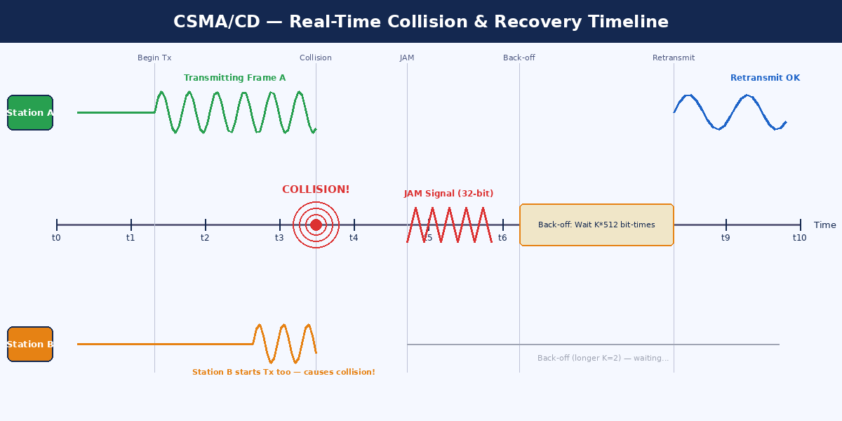
Figure 3 — Real-Time Collision & Recovery Timeline: Station A and Station B both sense the channel idle and begin transmitting simultaneously. A collision occurs, JAM signal is broadcast, both stations back off with different random delays, and Station A retransmits successfully.

▶ 5.1 Step-by-Step Collision Event
Time | Event | Technical Detail
t=0 | Channel is IDLE | Both Station A and B sense no carrier signal. IFG (96-bit gap) elapses.
t=1 | Station A begins TX | Station A starts transmitting frame at 10 Mbps. Preamble + SFD sent first.
t=2.8 | Station B also senses IDLE | Signal from Station A has not yet propagated to Station B — propagation delay is non-zero.
t=2.8 | Station B begins TX | Station B starts transmitting its own frame, unaware of Station A's ongoing transmission.
t=3.7 | Collision Occurs | The two signals meet and overlap on the bus. Voltage anomaly is created at the point of collision.
t=3.7 | Both NICs detect | Both Station A and B detect the discrepancy between sent and received signals. CD fires.
t=3.7 | JAM Signal Broadcast | Both transmitters send 32-bit JAM pattern. All stations receive JAM and discard current frame.
t=4.5 | Back-off: Station A | Station A draws K=1 from uniform[0,1]. Waits 1 × 512 bit-times = 51.2 µs.
t=4.5 | Back-off: Station B | Station B draws K=2 from uniform[0,3]. Waits 2 × 512 bit-times = 102.4 µs — longer wait.
t=8.8 | Station A Retransmits | Channel is idle. Station A begins retransmission. No collision — frame delivered successfully.
t=10+ | Station B Retransmits | Station B's back-off expires. Senses busy (A is TX). Defers. Transmits after A completes.

6. Binary Exponential Back-off Algorithm
The Binary Exponential Back-off (BEB) algorithm is the heart of CSMA/CD's fairness and congestion management. It determines how long a station waits before retrying after a collision — using randomness and exponential growth to prevent repeated collisions.

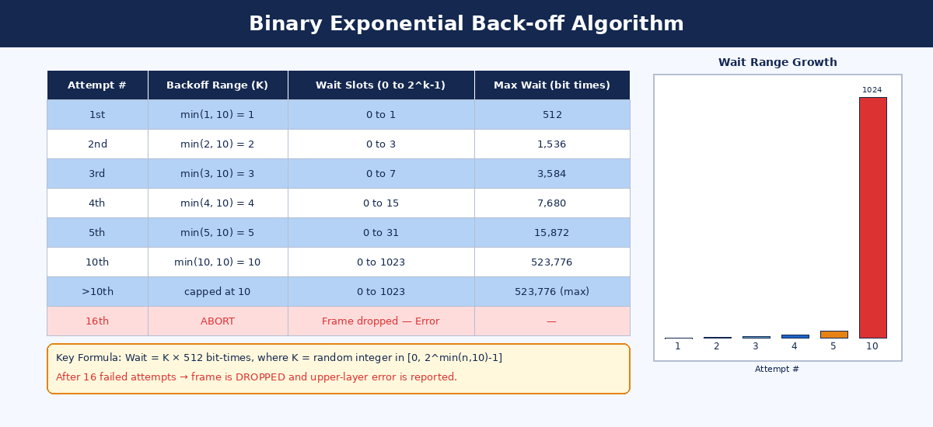
Figure 4 — Binary Exponential Back-off Table and Growth Chart. Notice how the wait range doubles with each successive collision, dramatically reducing the probability of repeated collisions as network congestion increases.

▶ 6.1 How BEB Works — The Mathematics
BEB Formula
Wait = K × 512 bit-times
where K = random integer drawn uniformly from [ 0, 2^min(n,10) − 1 ]
and n = number of collision attempts so far for this frame
Maximum retries = 16. After 16 failures → ABORT. Frame is dropped.

▶ 6.2 Why Exponential Growth?
The exponential growth of the back-off range is a mathematically proven approach to handling network congestion:
- First collision: each station picks from {0, 1} — 50% chance they pick different values and don't collide again
- Second collision: range grows to {0, 1, 2, 3} — 75% chance of different values
- After 10 collisions: range is {0, ..., 1023} — 99.9%+ chance of avoiding re-collision
- The cap at 10 prevents wait times from growing unboundedly in highly congested networks

▶ 6.3 Key Properties of BEB
- Randomness: Different stations pick different K values, breaking the symmetry that caused the collision
- Fairness: Stations with fewer previous collisions have statistically shorter waits, preventing starvation
- Congestion adaptation: Under high load, the exponential growth ensures the network self-regulates
- Bounded retry: Maximum 16 attempts prevents a faulty device from monopolizing the medium indefinitely

Real Example: Bit Time at 10 Mbps
1 bit time = 100 nanoseconds = 0.1 microseconds at 10 Mbps
Slot time = 512 bit-times = 51.2 microseconds
After 5 collisions: K drawn from [0, 31] → maximum wait = 31 × 51.2 µs = 1.587 ms
After 10 collisions: K drawn from [0, 1023] → maximum wait = 1023 × 51.2 µs ≈ 52 ms

7. Real-World Office Network Scenario
To ground CSMA/CD in a practical context, consider a typical corporate office environment from the early 2000s — a 12-station Ethernet LAN connected through a hub, running at 10 Mbps on Category-5 twisted pair cabling. This single hub creates one large collision domain for all connected devices.

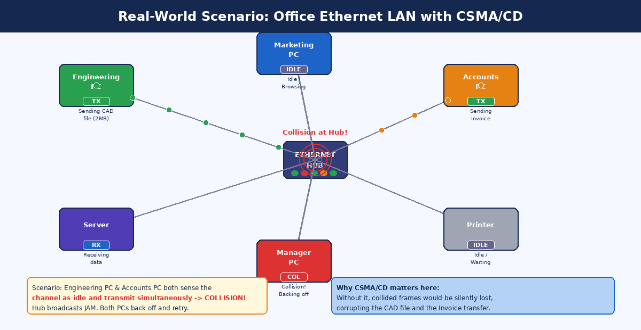
Figure 5 — Office LAN Scenario: Engineering PC (sending 2MB CAD file) and Accounts PC (sending invoice) collide at the hub. The JAM signal reaches all stations. Station B backs off longer, allowing Station A to retransmit first.

▶ 7.1 Real Scenario Walkthrough — The Morning File Transfer
Monday morning at 9:02 AM. Multiple employees begin their workday simultaneously. Here is what happens inside the network:

9:02:00.000 — The CAD File Transfer
The Engineering PC begins uploading a 2MB AutoCAD drawing to the server. The NIC senses the channel: IDLE. It begins transmitting at 10 Mbps. The frame propagates outward through the hub.

9:02:00.000023 — The Invoice Email
23 microseconds later, the Accounts PC also needs to send an invoice via email. Its NIC checks the channel — and because the Engineering PC's signal has not yet propagated to the Accounts PC's port on the hub (propagation delay!), it reads: IDLE. It begins transmitting too.

9:02:00.000037 — Collision at the Hub!
The two signals collide inside the hub. The hub's electrical signal becomes corrupted — neither frame can be decoded. Both NICs detect the anomaly: they see a signal that doesn't match what they sent. The COLLISION DETECTION circuit fires.

9:02:00.000037 — JAM Signal Broadcast
Both the Engineering PC and the Accounts PC immediately cease data transmission and each sends a 32-bit JAM signal. The hub amplifies and broadcasts this to all 12 ports. Every computer on the network receives the JAM, discards whatever corrupted frame fragment it received, and enters a wait state.

9:02:00.000051 — Back-off Phase
The Engineering PC draws K=1 and waits 51.2 µs. The Accounts PC draws K=3 and waits 153.6 µs. Other idle stations simply wait and watch.

9:02:00.000103 — Successful Retransmission
Engineering PC's back-off expires first. It senses the channel: IDLE. It retransmits the frame. This time, it completes successfully. The server receives the CAD file chunk without error. The Accounts PC eventually gets its turn after Engineering PC finishes, and the invoice email goes through as well — total disruption: 0.1 milliseconds.

8. Performance Analysis & Limitations

▶ 8.1 Throughput vs. Load
CSMA/CD performance degrades non-linearly as network load increases. The key metric is channel utilization — the fraction of time the channel carries useful data (as opposed to collisions, JAM signals, and back-off gaps):

Network Load | Collision Rate | Effective Throughput | User Experience
< 30% | Very Low | ~90-95% of rated speed | Excellent — no noticeable delays
30-60% | Low-Moderate | ~70-85% of rated speed | Good — occasional micro-delays
60-80% | Moderate-High | ~50-65% of rated speed | Noticeable slowdown, retries frequent
> 80% | Very High | < 40% of rated speed | Poor — network thrashing, timeouts possible

▶ 8.2 Key Limitations of CSMA/CD
- Collision Domain Size: The entire network stops when a collision occurs — more stations = more collisions
- Distance Constraints: Maximum cable length is limited by propagation delay (must detect collision before finishing minimum-size frame)
- Half-Duplex Only: CSMA/CD requires that a station either sends or receives — not both simultaneously
- Scalability: Performance degrades sharply with more than 20-30 active nodes on one collision domain
- No Priority: All stations have equal access — no mechanism to prioritize critical traffic (VoIP, video)

▶ 8.3 CSMA/CD vs. Modern Alternatives
Feature | CSMA/CD (Ethernet) | CSMA/CA (Wi-Fi) | Token Ring
Collision Handling | Detect and recover | Avoid before transmit | No collisions possible
Medium | Wired (coax/UTP) | Wireless | Wired (ring)
Performance under load | Degrades rapidly | Degrades gracefully | Consistent
Complexity | Simple, low overhead | Moderate overhead | High overhead
Still in use? | Legacy/industrial | Ubiquitous (Wi-Fi) | Virtually extinct

9. Conclusion
CSMA/CD is a beautifully elegant solution to the fundamental problem of shared-medium network access. By combining three simple principles — listen before speaking, detect when collisions happen, and back off with increasing randomness — it achieves a self-organizing, fair, and reliable data sharing protocol that powered the internet's physical layer for decades.

While modern full-duplex switched Ethernet has made CSMA/CD obsolete in data centers and corporate networks, its principles live on in wireless protocols (CSMA/CA in 802.11 Wi-Fi), industrial networks, and as the conceptual foundation for understanding any contention-based access control system.

Key Takeaways
1. CSMA/CD operates in three phases: Sense → Transmit → Detect+Recover
2. The JAM signal ensures ALL stations know about a collision — not just those that caused it
3. Binary Exponential Back-off is a probabilistic, self-regulating congestion control mechanism
4. Minimum frame size (64 bytes) is mathematically derived from propagation delay constraints
5. CSMA/CD works best at low network loads (<30%); modern switched networks avoid it entirely

— End of Report —

