|  |
| --- |
|  |
|  |
|  |

**\*application_name System Manual**

|  |
| --- |
|  |
|  |
|  |

**January xth, 202x**

|  |  |  |  |
| --- | --- | --- | --- |
| **Document Sign-off** | | | |
| No. | Reviewer | Date | Signature |
|  |  |  |  |
|  |  |  |  |
|  |  |  |  |
|  |  |  |  |
|  |  |  |  |
|  |  |  |  |
|  |  |  |  |

|  |  |  |  |
| --- | --- | --- | --- |
| **Revision History** | | | |
| Rev. | Description of Revision | Authorized by | Effective Date |
|  |  |  |  |
|  |  |  |  |
|  |  |  |  |
|  |  |  |  |
|  |  |  |  |
|  |  |  |  |
|  |  |  |  |
|  |  |  |  |
|  |  |  |  |
|  |  |  |  |

TABLE OF CONTENTS

**1. GENERAL INFORMATION 1**

**1.1 Navigation 1**

**1.2 Overview 3**

**1.3 *project_name ASSET PROJECT Menu 3**

1.3.1 Navigation 3

1.3.2 Overview 4

1.3.3 Working Step 4

1.3.3.1 *Example Search project 4

**2. *PROJECT/ASSET_NAME 6**

**2.1 *SCREEN_NAME 6**

2.1.1 Navigation 6

2.1.2 Overview 6

2.1.3 Working Steps 7

2.1.3.1 *example Configuration 7

**TABLE OF FIGURES**

Figure 1 User Management’s Home Page 1

Figure 2 PTTEP Sign in menu 1

Figure 3 PTTEP Sign in Window 2

Figure 4 After sign in 2

Figure 5 Example application 3

Figure 6 First page in application 3

Figure 7 *project/asset_name Project menu 4

Figure 8 *project/asset_name Project window 4

Figure 9 Search bar (*project/asset_name Project) 5

Figure 10 Example Screen 5

Figure 9 *screen_name menu 6

Figure 10 *screen_name Screen 7

Figure 11 *button_name button (*screen_name) 7

Figure 12 *button_name button (*screen_name) 8

Figure 13 **** Configuration to set up **** (*screen_name) 8

# GENERAL INFORMATION

## Navigation

Open web browser and enter URL <http://delorean.apps.pttep.com>, the application will display the screen as shown in Figure 1.

Figure 1 User Management’s Home Page

If the application require user to login, user can login to PTTEP User, use password from PTTEP AD as shown in figure 2 and figure 3.

Figure 2 PTTEP Sign in menu

User needs to specified Email and Password and click ‘Sign in’ button, the application will navigate the user to Delorean Homepage which will display the list of application that user can access as shown in Figure 3 and the application will show as figure 4.

Figure 3 PTTEP Sign in Window

Figure 4 After sign in

Click the button as shown in figure 5 and the application will show as figure 6.

Figure 5 Example application

## Overview

This user manual explains about *application_name working process. User can learn how to use the application correctly.

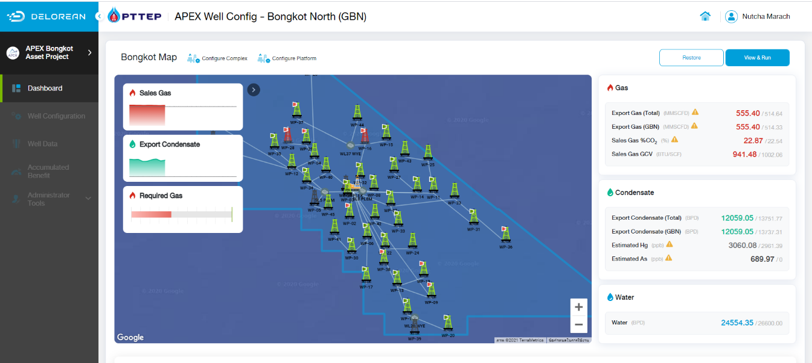

Figure 6 First page in application

## *project_name ASSET PROJECT Menu

### Navigation

Choose the “*project/asset_name Project**”** menu as shown in figure 7, and the application is shown as figure 8.

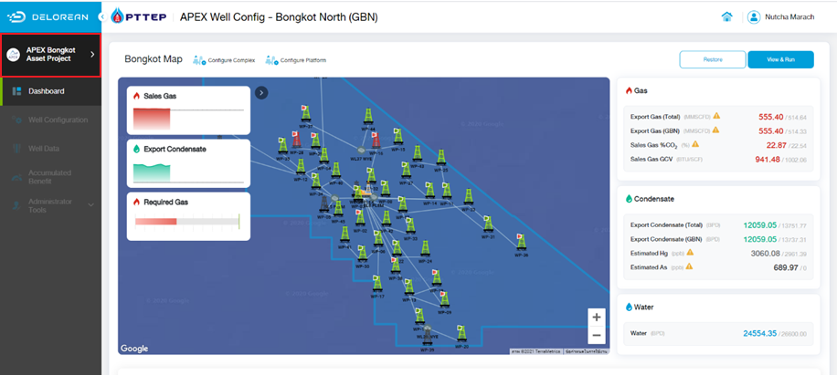

Figure 7 *project/asset_name Project menu

Figure 8 *project/asset_name Project window

### Overview

This menu can be accessed from any screen and it allows user to change the currently viewing project. Which in turn allows the user to configure and view data of the projects.

### Working Step

#### *Example Search project

* Specify Criteria
  + Project name
* Then click **A screenshot of a computer

  Description automatically generated** button to search data as shown in figure 9.

Figure 9 Search bar (*project/asset_name Project)

* When user click *project/asset_name (*acronym or abbreviation) in Search bar (figure 9), and the application will show as figure 10.

Figure 10 Example Screen

# *PROJECT/ASSET_NAME

## *SCREEN_NAME

### Navigation

Choose *screen_namemenu as shown in figure 9, the application will show as figure 10.

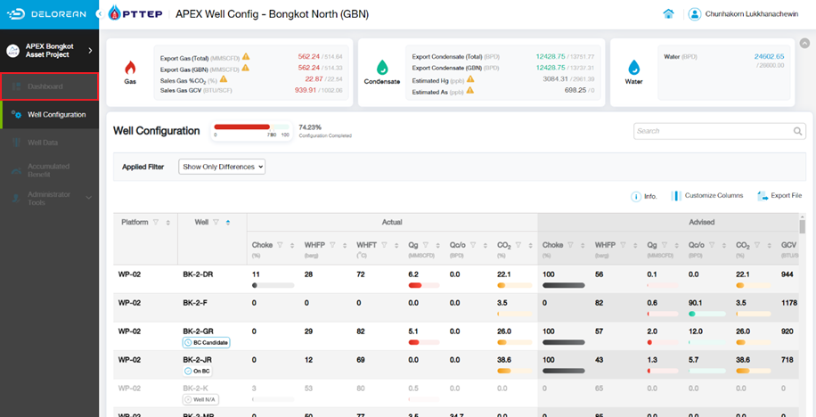

Figure 9 *screen_name menu

### Overview

*screen_name screen allows to view and export file of “****” and “****” data, configure **** and ****.

REMARK: ****.

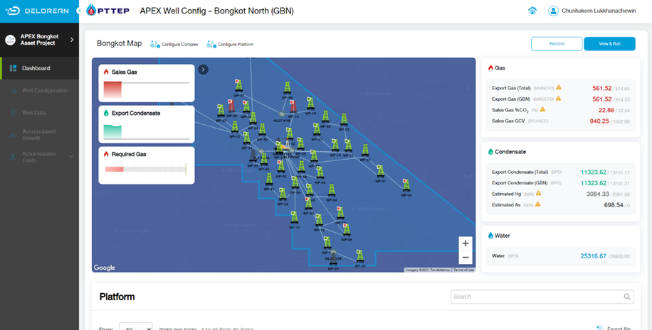

Figure 10 *screen_name Screen

### Working Steps

#### *example Configuration

* Click on  button as shown in figure 11.

Figure 11 *button_name button (*screen_name)

* Click on  button as shown in figure 12, the application will show as figure 13.

Figure 12 *button_name button (*screen_name)

Figure 13 **** Configuration to set up **** (*screen_name)

* Specify criteria as follows
  + *criteria name
    - *specific criteria
    - ****
    - ****
    - ****
* Click on  button to save data. If user doesn’t want to save click  to go back to main screen.