# Pattern Kalman Filtering

## Bounding box edge coordinates

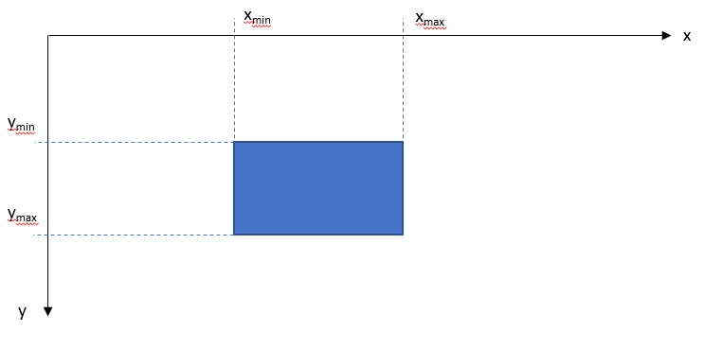

Pattern location (bounding box) is determined by four edge coordinates: xmin, xmax, ymin and ymax. vxmin, vxmax, vymin and vymax are corresponding velocities.

Each edge coordinate is filtered separately and identically. xmin is used here as an example.

State equation in differential form:

State equation in difference form:

where is the time increment and Gaussian noise with covariance R:

Measurement equation

where is Gaussian noise with covariance matrix Q:

Kalman filter initialization:

where xmin (0) is the first location measurement.

Kalman filter update: