Search in Encrypted Data Project
Secure Data Management 2011-2012
Peter Wagenaar
Tjeerd Boerman s0118400

Table of Contents
Search in Encrypted Data Project 1
Introduction 1
Solution Overview 1
Use cases 1
Requirements 1
Search Algorithm 1
Architecture 1
Client 2
Server 2
Tradeoffs 2

Introduction
This report describes the prototype system that was the end result of the “Search in Encrypted Data” assignment of the Secure Data Management course. Its design and implementation took place during the fall of 2011. With this document – and the full source code that goes with it – we intend to give the reader an overview of the system, the algorithms at the heart of it, and the choices that motivated its design.
For the assignment we consider a scenario of a financial consultant that uses a cloud storage service to store the financial data of his clients. The cloud storage server is considered to be honest but curious, meaning it will learn – and possibly disclose - anything it can from the data that is stored on it, but never forge or tamper with the data. Clients of the consultant need to be able to store and search in their own data on the server, and the consultant should have be able to do the same for all data. In order to prevent data leakage, the consultant requires all data to be stored in encrypted form. Our goal is to design and implement a system that enables the consultant and clients to do this.

Solution Overview
Solution design introduction...

Use cases
- Supported use cases

Requirements
- Resulting requirements

Data Model
Any scheme that enables search in encrypted data must define a data model that defines the format of the data in the system. This data model implies what kinds of unencrypted data are supported, and in conjunction with the search scheme it defines the types of search that are supported, and what the smallest search unit is. An example of a data model is that of a text document. If the search scheme entails that every word in the document is encrypted separately, then the smallest search unit might be a word.
From the requirements it is not immediately clear what kinds of data the consultant and client are dealing with, so we have to make a few assumptions. First, we assume all search queries are textual. Text queries are the bread and butter of any search scheme, and they should easily suffice for this scenario. Second, we assume the stakeholders require the data to be structured, in order to be able to categorize or group the data of each client. The attentive reader will know the most prevalent structured and textual data format is XML today, and this is the format of choice for our data model.
By opting for XML data as the format of the unencrypted system input and output, we enable the use of search schemes that have been proven to work on XML. Working with XML data in a relational context – such as an SQL database – requires a conversion to take place. The scheme by Brinkman et al. includes a way to store XML data in a relational database and execute queries on it efficiently. Below we describe the conversion algorithm in detail.

Preprocess XML
When an XML file is entered by the client or the consultant, it first undergoes a transformation step that changes the structure of the tree. An XML file consists of a tree of nodes with parent/child relationships, and each node can have attributes and text values. The next conversion step does not work well with mixed content – a node that has both nodes and text as its children – or attributes, so we transform text values and attributes into normal nodes. Figure 1 shows the input and output of this algorithm.
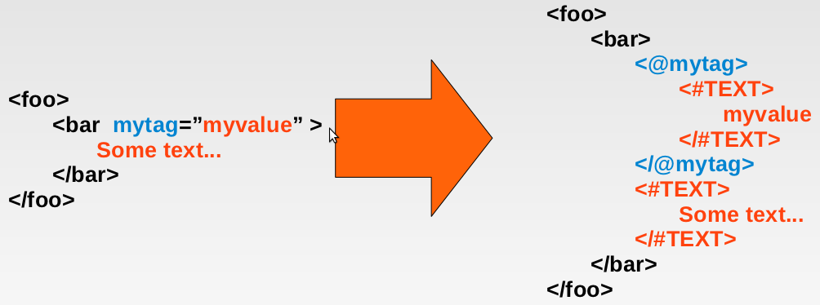Figure 1: The first step of the XML conversion algorithm.
Input is any valid XML document that needs to be uploaded to the storage server. First any attributes are converted to normal nodes, where the tag name is the attribute name with an at-sign (@) prefixed to it. This uniquely identifies it as an attribute node, and it also matches the syntax that is used in the XML query language XPath to search for specific attribute values:
//foo/bar[@mytag=”myvalue”]
Textual data such as the string “Some text...” is encoded in a normal node with tag name #TEXT and the textual data as the tag value. The resulting document is not valid XML anymore, but it has the important property that everything is represented as a node, and no node contains both a textual value and a node value. After this transformation is executed, the output document is used as input for the next step.

Row Conversion
In order to store XML in a relational database the tree structure needs to be encoded somehow. An efficient method is to encode the location of each node using three integer values called pre, post and parent. A pre value denotes the order of nodes when the tree is traversed using the preorder traversal method. Analogously, the post values denotes the order of the nodes for postorder traversal. Finally the parent value of a node is the pre value of its parent node, where the root of the tree is assigned a parent of -1.
Using this method to find the location values of the nodes in our example tree we find the values displayed in Figure 2.

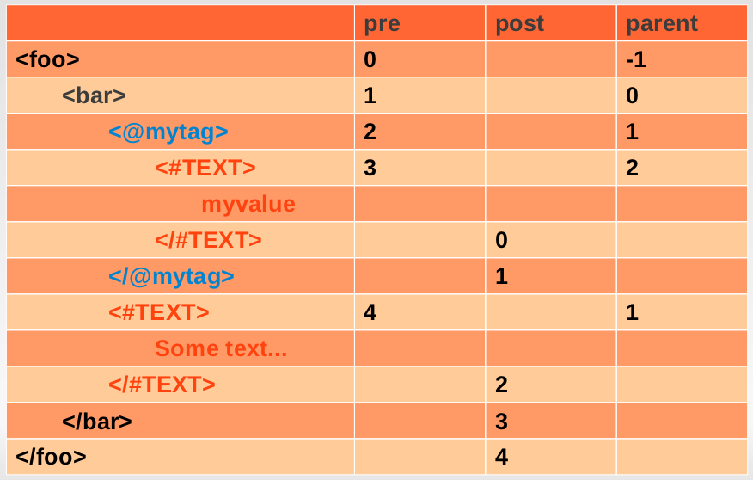Figure 2: This step encodes the location of each node with three integer values.
Finally, each node in the tree is converted to a row. The result consists of five rows – one for each node – and is displayed in Figure 3. All rows combined contain the information required to fully reconstruct the tree.
The attentive reader might notice that no row has both a tag and a value originating from the input file, and how the text values can be 'inlined' in their parent node. Although a valid point for this example tree, our approach has two upsides. One advantage is that it enable mixed content, but at least as relevant is that textual strings are uniformly encoded. If one would decide to extend the search scheme to be able to search for specific words in tag values, then having a uniform format for all strings is convenient, if not required.

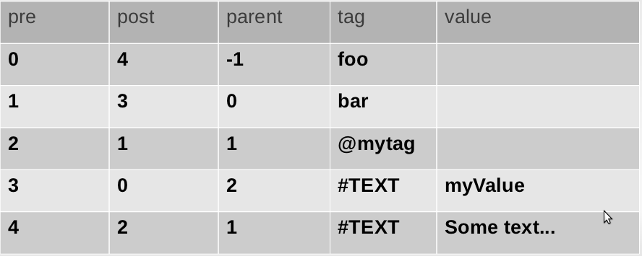Figure 3: The final results is a set of five rows, and these rows can be used to reconstruct the original XML tree.

System Design
- Resulting requirements

Architecture
- high level overview

Client
- client internals

Server
- server internals

Search Algorithm
For the prototype implementation we have used the algorithm described by Brinkman et al. The paper provides – with a few reference papers – a detailed description of the search scheme. In this section we describe the algorithm, which is displayed in Figure 4, in detail.
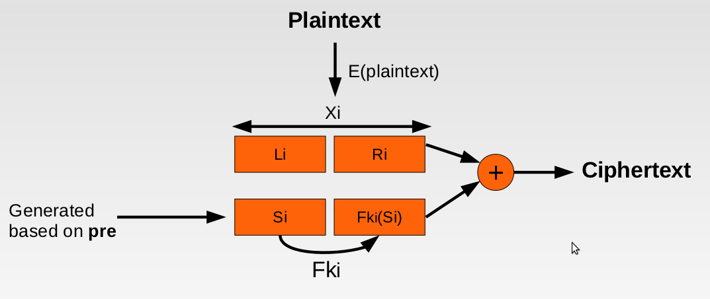Figure 4: An overview of the searchable encryption algorithm.

Encoding the XML input results in a set of rows, where each row codes for one XML node. The information in each row that is relevant to the algorithm is the pre value, the tag and the value. Both tag and value are encrypted separately, where they are used as the plaintext value.

Plaintext Encryption

We individually treat each step in the encryption process. First, the plaintext value is encrypted using AES-128 encryption. Each

Tradeoffs and Choices
- pros and cons
- XML format, why? Other formats? Tradeoffs?
- Search scheme: why?
- Other queries? Easy
- does it scale?

Discussion
- replay attax
- key revocation
- het is makkelijk stuk te maken...

Efficient Tree Search in Encrypted Data, Brinkman et al., Information System Security, 2006

