RT charactersitics
$$R_{NTC}=4.7k×(\frac{3.3V}{V_{temp}}-1)$$

Clarke transformation
$$I_{α}=\frac{2}{3}(I_{a}-\frac{1}{2}I_{b}-\frac{1}{2}I_{c})$$
$$I_{β}=\frac{2}{3}(\frac{\sqrt{3}}{2}I_{b}-\frac{\sqrt{3}}{2}I_{c})$$

Park transformation
$$I_{d}=I_{α}cosθ+I_{β}sinθ$$
$$I_{q}={-I}_{α}sinθ+I_{β}cosθ$$

Inverse Park Transformation
$$I_{α}=I_{d}cosθ-I_{q}sinθ$$
$$I_{β}=I_{d}sinθ+I_{q}cosθ$$

Inverse Clarke Transformation
$$a=α$$
$$b=-\frac{1}{2}α+\frac{\sqrt{3}}{2}β$$
$$c=-\frac{1}{2}α-\frac{\sqrt{3}}{2}β$$

SVPWM
$$V_{ref}=\sqrt{{V_{α}}^{2}+{V_{β}}^{2}}$$
$$γ=\tan^{-1}{\frac{V_{β}}{V_{α}}}$$

Timers T1, T2
$$T_{1}=T_{s}×\sqrt{3}\frac{V_{ref}}{V_{bus}}×\sin{(\frac{π}{3}-γ)}$$
$$T_{2}=T_{s}×\sqrt{3}\frac{V_{ref}}{V_{bus}}×\sin{(γ)}$$

Sector 1
$$T_{z}=\frac{T_{0}}{2}$$
$$T_{X}=T_{1}+T_{Z}$$
$$T_{Y}=T_{2}+T_{Z}$$
$$T_{W}=T_{1}+T_{2}+T_{Z}$$
$$D_{A}=\frac{T_{A}}{T_{s}}, D_{B}=\frac{T_{B}}{T_{s}}, D_{C}=\frac{T_{C}}{T_{s}}$$
170 MHz
- TIM2
- TIM1 – ARR
Dead time = 500ns*(1/170MHz) ~ 85… = 85

Current sensing
$$Type equation here.$$

Motor Control Project
Updates
- Read Vbus
- Can read temperature individually, if I try to read both VBus and ESC temperature then ADC stops working with monitor and tune
- Fixed the above problem by changing the “Analog to Digital Converter” block from “trigger and read results” to “read results only”. I now manually trigger the ADC conversion using TIM. This solved that issue and I can multiple sensors in the same DMA line
- Added 50us task for FOC, had to change the model from FreeRTOS to Baremetal

25/09/26
- Successfully modelled Clarke, Park, inverse Park, and inverse Clarke transformations in order to convert from AC to DC control.
27/09/26
- Implemented SVPWM which converts V_alpha, V_Beta to Da, Db, Dc duty ratios to obtain the Vref
29/09/26
- Changed signal datatype from double to single since it was slowing down the 50us task
  - Single – 4 bytes, double 8 bytes. Almost double the RAM memory

- Working on implementing task execution timer.
  - Data watchpoint (DWT) can be used to measure how long a task takes to execute

12/10/26
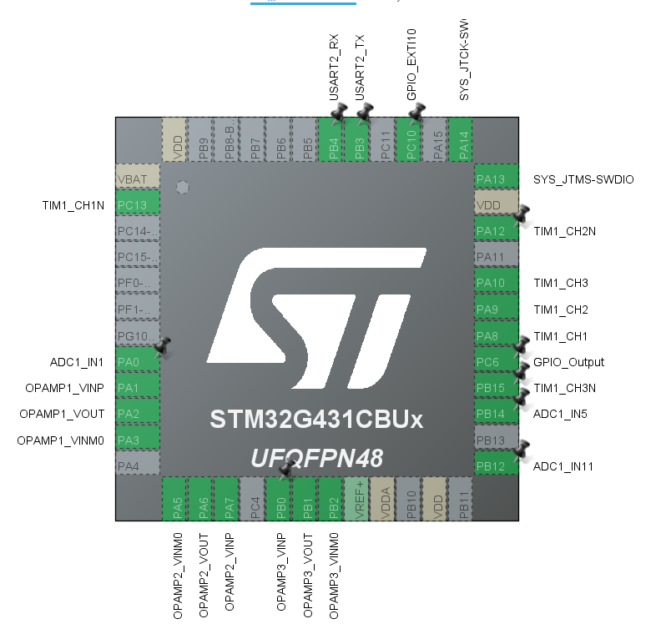
Pin stacking to enable ADC1_IN3 on PA2

- LL_OPAMP_Enable is not configured automatically in Simulink, although it configures the OPAMP1/2/3 it does not enable them – therefore need to add custom code to call the function to enable the configured pins

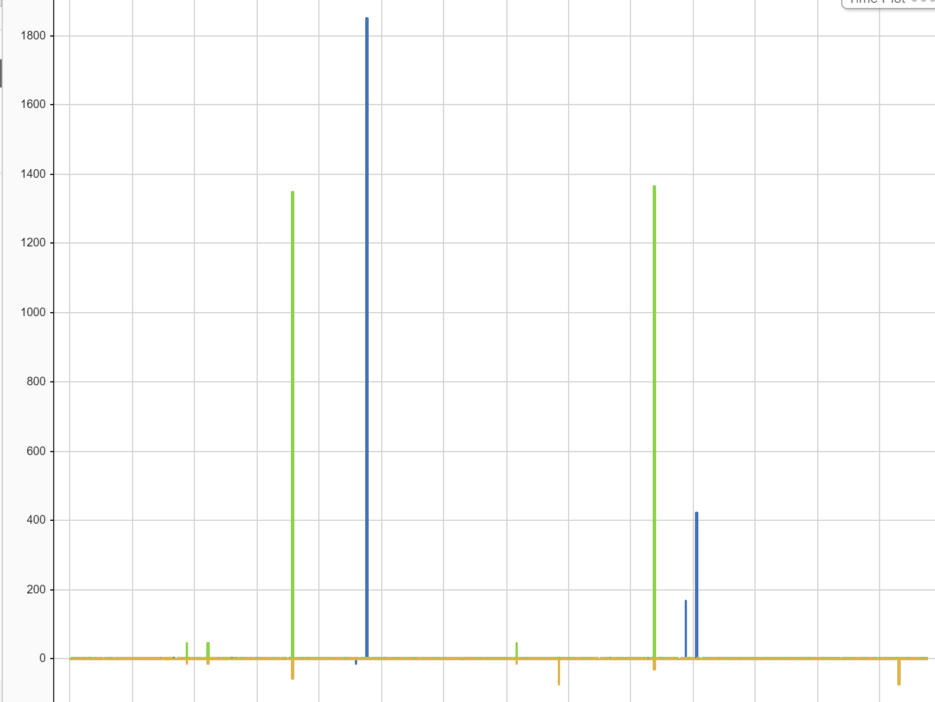
ADC1 and ADC2 phase current can cause this noisy readings at times – not sure whats causing it
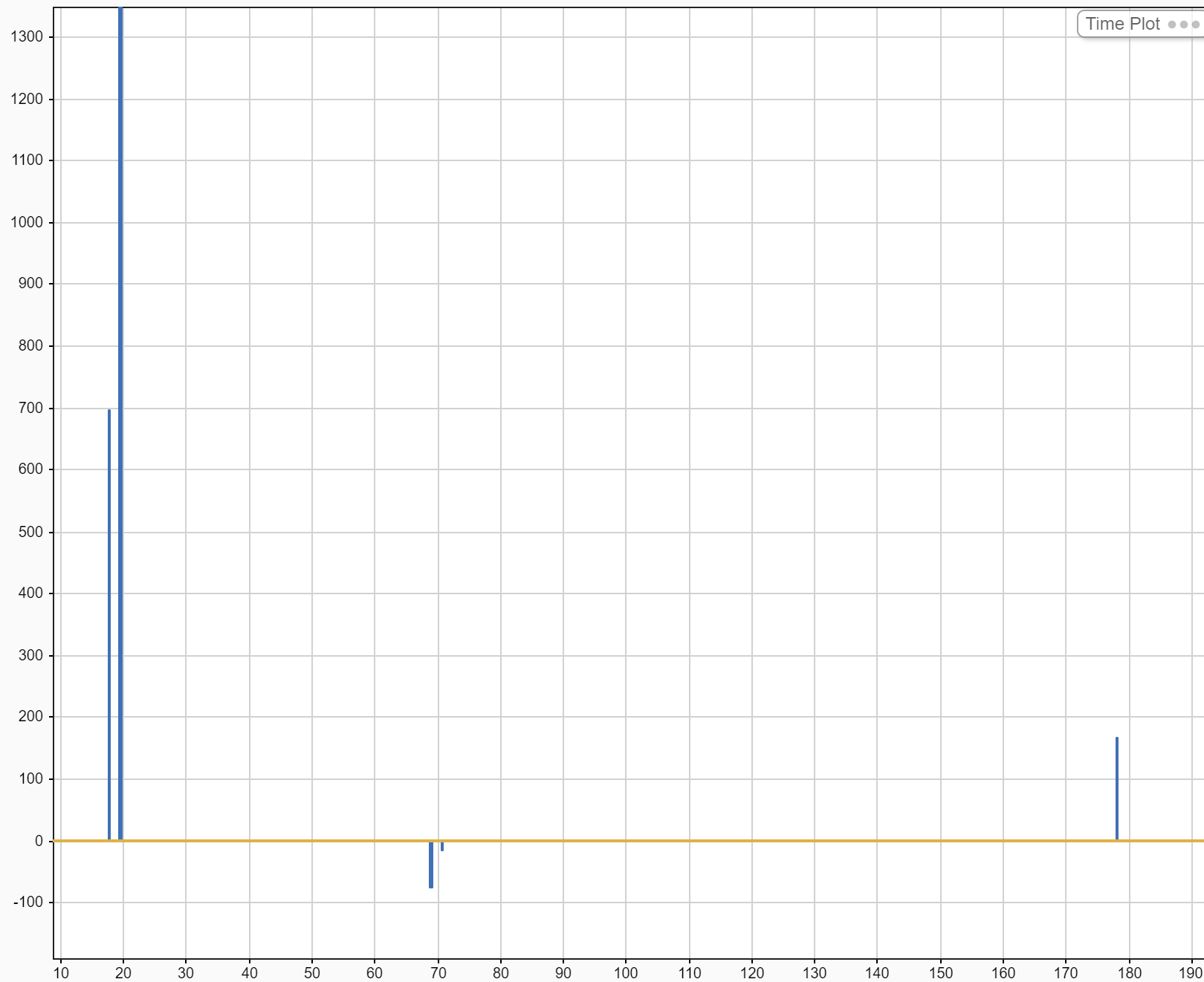
Improved with Status feature but Phase U from ADC1 can still get this noisy measurement

Issues
- External mode viewing can cause the chip to slow down.
  - FIX – Use STM32CubeMonitor
- Random readings of phase currents within 50us task
  - FIX – TIM1 wasn’t synchronised with the 50us task so at times the ADC wasn’t ready when we reading the results, therefore USED ISR using the same TIMER which that read phase currents and that reduced fixed the issue

